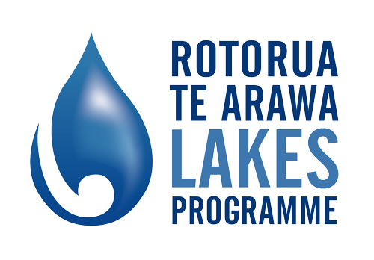

***Vision and draft Strategy for the Lakes of the Rotorua district***

***Whāia te pae tawhiti kia tata, whakamaua te pae tata kia tīna!***

*Strive for your long term objective so that it may draw closer, once within reach grasp it!*

*The Rotorua Te Arawa lakes are important to our district, they are important to our region and they are important nationally. They are our key tourism attraction for this area. They are often regarded as the jewels in our crown.*

*Kevin Winters*

***Mayor Rotorua District Council and Chair Rotorua Te Arawa Lakes Strategy Group***

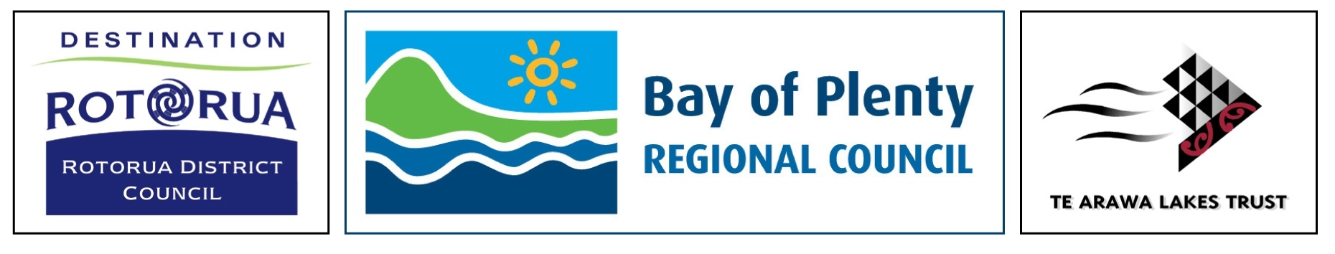

Whakapapa - Background

*The lakes are an important environmental and economic asset. We need to make sure we are protecting our lakes and using them in a sustainable way. For me the vision of the Rotorua lakes means that we continually undertake work to ensure our lakes are as clean as can be.*

*John Cronin*

***Chair Bay of Plenty Regional Council***

In 1998 a Lakes Strategy Working Group comprising the Chairman of the Te Arawa Māori Trust Board, the Chairman of Environment Bay of Plenty and the Mayor of Rotorua District Council began developing a Lakes Management Strategy. The Strategy was an important step in addressing problems arising from the lack of coordination between those involved in managing the lakes.

The purpose of the Strategy was to provide an agreed vision for the lakes of the Rotorua district, unite efforts and focus resources to achieve that vision.

In August 2000, the Lakes Strategy Working Group adopted the Strategy for the Lakes of the Rotorua district. This document set out why people value the Rotorua Te Arawa lakes, their concerns and a vision for the future of the lakes.

***The lakes of the Rotorua district and their catchments are preserved and protected for the use and enjoyment of present and future generations, while recognising and providing for the traditional relationship of Te Arawa with their ancestral lakes.***

In preparing the Strategy, individuals and organisations across the district were asked what they wanted to see achieved for our lakes and catchments. They were asked to identify goals for the future, and what could be done to protect our lakes.

The status and importance of the Strategy was formalised through the Deed of Settlement[1] and the Lakes Settlement Act[2]. In that Act, a joint committee called the Rotorua Te Arawa Lakes Strategy Group (the Group) was established between Rotorua District Council, Te Arawa Lakes Trust and the Bay of Plenty Regional Council. This Group is charged with providing leadership in relation to implementing the vision of the Strategy.

***Me huri whakamuri, Ka titiro whakamua-***

*In order to plan for the future, we must look to the past*

Haere I mua Whakakotahi – Moving Forward as One

The Strategy is now over ten years old and although the Strategy’s vision is as relevant today as it was, relationships, knowledge and innovation have evolved since the Strategy was developed. Achievements and gains have been made. Partnerships are strengthening and developing.

A refreshed Strategy has been developed that retains the original vision. This next Strategy builds on the commitment of partner organisations to provide an integrated and holistic direction for the management of the lakes catchments.

The community have been involved in the scoping of this Strategy which provides a pathway of what the community and partner organisation want to achieve and a framework for action.

The purpose of this Strategy is to achieve the original vision and work under an overarching goal of co-management[3].

The Strategy aims to be clear, simple and easily understood. Although it sets out how the partner organisations will deliver the vision, the Strategy belongs to everyone who has an interest in the lakes now and in the future. This includes iwi, the lakes communities and lake users, as well as our future generations.

*For Te Arawa particularly, the lakes are part of us.*

*The lakes are important to us historically, traditionally and also in terms of the future and I may use this word in inverted commas “the future wealth” it can bring to this region in helping the development of our economy.*

*The Mauri and what it means to me is that we have a responsibility that we ensure the lakes are in a state of preparedness to assist our people to live.*

*Toby Curtis*

***Chairman Te Arawa Lakes Trust***



This section of the strategy aims to be respectful of what has gone before yet signal where we are heading.

Has this been captured, or should we say more? What else would you like us to say?

Reach of the Strategy

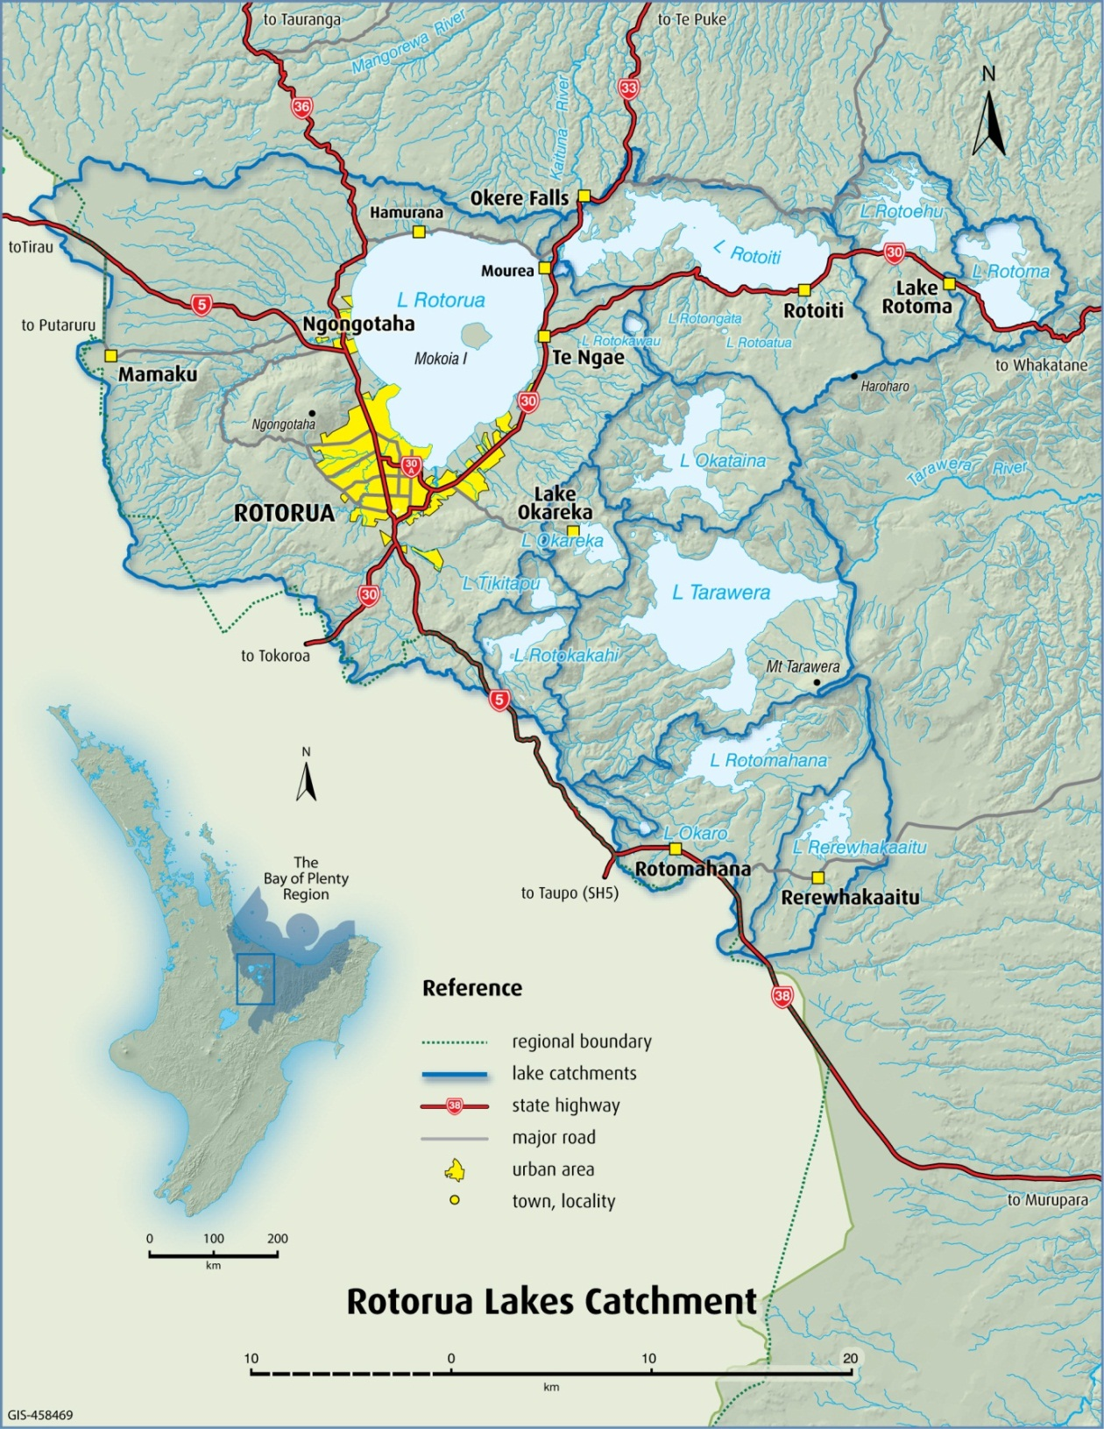The area that this Strategy applies to is the Rotorua lakes catchment. The catchment area includes the rivers, streams, tributaries and land area that feed into the 12 lakes catchments. However what happens in these catchments has downstream effects (Kaituna River, Maketū Estuary and Tarawera River). The Strategy acknowledges the concept Mai i nga maunga ki te moana - from the mountains to the sea.[4]

***The Rotorua lakes catchment includes:***

Lake Ōkāreka

Lake Ōkaro (or Ngakaro)

Lake Ōkataina (Te Moana-i-kataina-a-Te-Rangikaroro)

Lake Rerewhakaaitu

Lake Rotoehu

Lake Rotoiti (Te Roto-kite-a-Ihenga-i-Ariki-ai-a Kahumatamomoe)

Lake Rotokakahi4

Lake Rotomā

Lake Rotomahana

Lake Rotorua (Te Rotorua-nui-a-Kahumatamomoe)

Lake Tarawera

Lake Tikitapu

Setting for the Strategy

Alongside the geographical area, which the Strategy relates to, we need to be mindful of the operational setting the Strategy sits in.

While the Strategy reflects the community’s aspirations for the lakes, specific planning and regulatory documents will be important for achieving the Strategy’s vision. For example, the regulatory tools in the Regional Policy Statement, Regional Water and Land Plan and District Plan are critical for reducing nutrients entering the lakes.

The Strategy connects all the partner agencies and guides how they will manage the Rotorua lakes catchments. Although water quality is a key consideration, the Strategy supports a holistic approach and considers how best to achieve all aspects of the vision.

The following diagram provides an overview of the interrelationships that operate around the Strategy.

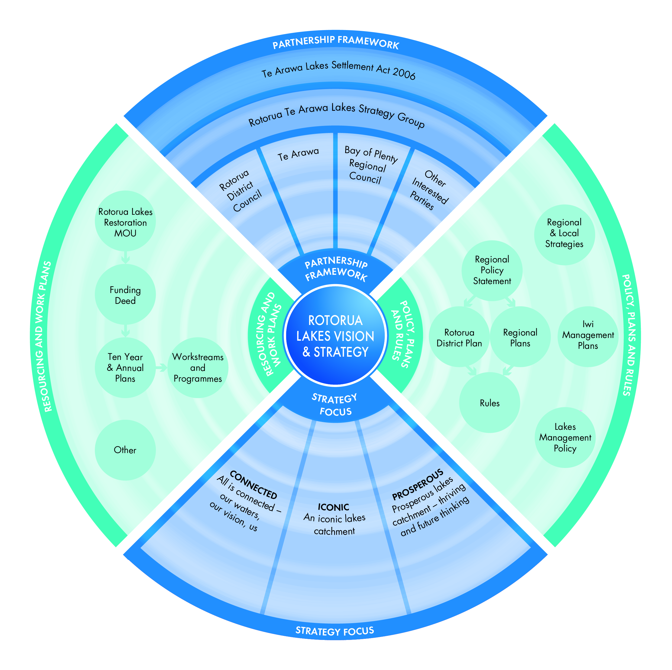



Does this diagram help you understand how the Strategy fits within the bigger picture?

Our vision

The lakes of the Rotorua district and their catchments are preserved and protected for the use and enjoyment of present and future generations, while recognising and providing for the traditional relationship of Te Arawa with their ancestral lakes.

Matakite:

E tiakina ana, e manaakitia ana hoki ngā roto o te rohe o Te Arawa hei painga mō tātau me ngā whakatipuranga e ara mai nei, ā, me te aro anō ki te hononga tuku iho o Te Arawa ki ō rātau roto

What does the vision mean?

The Strategy reflects the community vision for the future of the Rotorua lakes and therefore is broad in scope. It is aspirational and challenges partner organisations to deliver. In order to achieve the vision we must have a shared understanding of what the Strategy means.

In the original Lake’s Strategy, four key elements formed the essence of the vision: protection, use, enjoyment and management. These elements and achieving the right balance between them continues to be of fundamental importance to the community.

Consultation with the community has provided a modern interpretation of the four key elements to implement the vision. The revised key elements are:

* connected
* iconic
* prosperous

This Strategy seeks to achieve the vision through outcome and goal setting for each of these three elements

What the community told us

The following table reflects what the community told us they want the new Strategy for the Rotorua lakes to contain under each key element of the vision and also identifies how the community felt this would be achieved.

Existing initiatives that contribute towards achieving these outcomes were also acknowledged through consultation.

|  |  |  |  |
| --- | --- | --- | --- |
| **Ways to deliver the vision of the Strategy – What the community told us** | | | |
|  | **Connected** | **Iconic** | **Prosperous** |
| **What do we want to achieve?** | * Agencies working together * Mountains to sea approach (streams, lakes, Kaituna, Maketū, Tarawera) * Better understanding of issues * Community involvement (He Tangata – the people together) * Iwi relationships recognised and provided for | * Better water quality * Reduction of nutrient loss to water * Positive experiences for those using the lakes catchments * Innovative solutions * Protection, restoration and enhancement * Lakes catchments as a healthy food basket * Healthy ecosystems | * Quality of life * Best use of resources * Balance of conflicting aspirations * Economic development alongside enhanced lakes * Sustainable industry * Cultural prosperity |
| **How will we**  **do it?** | * Provide opportunities for meaningful engagement and involvement * Educate community on issues * Communicate progress and recognise efforts * Promote awareness of role of leaders * Adaptive catchment management principles and approach * Encourage community initiatives * Assess efficiency of resources designated to lakes management | * Review current focus, targets and approach * Protect, restore & enhance catchments so that they contribute to the four wellbeings * Investigate all methods of improving water quality * Manage existing and future land use to enhance water quality * Enforce On-site Effluent Treatment rules * Effective land use planning | * Identify and investigate opportunities for economic development, innovative employment and niche products * A management framework that enables new enterprises * Promote the lake and their activities * Use of industry research and knowledge |
| **What will it take?** | * Education programmes * An engaged community - shared understanding of issues, approaches and agreed targets * Catchment based management * Funding, resources and expertise * Collaborative governance - leadership, role models and programme champions * Voluntary programmes | * Better land use management * Better nutrient management * Compatible land use * Research and development of technology * Industrial innovation * Science based actions * Monitoring and compliance | * Green growth technologies * Use of regional assets and local investment * Value added commodities * Identification of new commercial activities * Compatible land use * Partnerships - research and development * Celebrate uniqueness of catchments to community and tourists |
| **What’s already being done?** | * Existing partnerships - MOU’s, terms of references, reporting processes and areas of influence * Supporting collaboration in Council’s Ten Year Plans | * Lakes Recreation Strategy * Implementation of Rotorua Lakes Programme * Science to support water quality initiatives * Water quality objectives set in the Regional Water and Land Plan | * Addressing land use change through District Plan * Giving effect to economic growth strategies, iwi strategic and business plans * Supporting economic development through Council’s Ten Year Plans |
| **Opportunity for more effective communication, regular review, monitoring and reporting** | | | |

How will we work together?

The community confirmed they want a collaborative and participatory process in developing and implementing the Strategy.

Guiding principles

The following principles give guidance on our approach to the management of the lakes catchments. To achieve our vision, we will be:

* Focused on outcomes – a clear purpose
* Transparent and fully accountable – a clear process for delivery and identified lines of responsibility
* Grounded in best knowledge (including mātauranga and science) and open to full a range of solutions
* Kaitiaki of the lakes catchments – managing the lakes for future generations
* Seeking to provide certainty for the future – ensuring stakeholders and landowners are involved in planning for their future
* Partnership driven – engaging with agents of change by drawing on their skills, knowledge and energy. We will nurture existing relationships and build new ones
* Agile – flexible in our approach and delivery. Able to adapt to changing science, economics, technology and behaviours

Delivery of the Strategy

The Strategy is intended to guide but not direct the work of the partner organisations including:

* Communication
* Community engagement and action
* Process development
* Policy development
* Consolidation of knowledge base including further science and Mātauranga
* Improvement plans

Implementing the aspirational view of the Strategy will need to be considered pragmatically and in relation to what the community can afford.

The planning processes of the partner organisations will be used to specifically identify which actions are to be progressed and to consider new opportunities, changes to priorities, shifts in focus or emerging risks.

The partner organisations recognise that for the Strategy to be successful we need to work more with iwi, businesses and community to achieve the vision as they also have a role to play in delivery.

Progress made on delivering the Strategy’s vision, outcome statements, goals and targets will be assessed annually and reported to the Rotorua Te Arawa Lakes Strategy Group.

Life of the Strategy

This Strategy is a living document that shows a pathway ahead but not the exact steps or when they will be taken.

The Strategy will be reviewed every ten years following its adoption to ensure the path we are on is taking us in the right direction.

Connected

**Outcome statement: All is connected - our waters, our vision, us.**

Connectedmeans a management framework is in place to enable statutory authorities, the community, iwi, businesses and individuals to work together to achieve agreed long term goals for the lakes of the Rotorua district. To do this everyone must be well informed on the issues at hand and feel empowered to be part of the solution.

***Mā pango, mā whero e oti ai te mahi***

*Through cooperation the work will be complete*

Connected recognises the links between the land, rivers, streams, lakes, groundwater and surface water. Management of the catchments need to reflect these connections as well as recognise different lakes may require different solutions.

We are all connected to the lakes catchments spiritually, economically, socially, culturally and environmentally. Te Arawa and other iwi have a traditional relationship with the lakes, surrounding water bodies and land - their physical survival and spiritual well-being depended on their natural environment.



Have we captured all of the key aspects of the **connected** outcome statement?

What else would you like us to say about connected?

*The lakes are part of us. Every nook and cranny we have a name for, they are named after prominent ancestors and those names are still used today as though they are still living.*

*Toby Curtis*

***Chairman Te Arawa Lakes Trust***

Key focus areas

* Working together in partnership
* Recognising lakes catchment complexity
* Integrating Te Arawa/iwi values

|  |  |  |
| --- | --- | --- |
| **Goal 1:** The Lakes Strategy is implemented collaboratively | | |
| **Targets** | **Possible Indicators** | **Possible Data Sources** |
| 1. In 2013, a Communications and Engagement Plan between partner organisations is developed and being implemented. 2. By 2015, there are positive relationships between all lakes communities and partner organisations. 3. By 2018, delivery of Strategy goals are achieved through partnership with key community groups, organisations and iwi. | * Reported confidence with Strategy implementation * Reported satisfaction with level of engagement * Number of policies/strategies that consider the Lakes Strategy * Number of joint initiatives within the catchments community * $ value available for funding community initiatives * Number of coordinated actions between partner organisations * Number of formal protocols between partners, industry groups, community groups and iwi | * Informant interviews on the Strategy development process and levels of engagement * Baseline surveys – How the community feels now about engagement? Future survey – How the community feels in three years? * Funding sources * Partner organisation reporting * Strategies and work streams |
| **Goal 2:** The community is engaged and informed about lakes catchment issues | | |
| 1. In 2013, information needs of catchments community identified and benchmarks set. 2. By 2015, information is delivered to lakes communities in response to information needs. | * Number of education programmes/initiatives/ campaigns * Number of survey respondents who can identify lakes catchments issues * Percentage of community who believe they are knowledgeable about lakes catchments issues | * Existing perception surveys * Future surveys – How they rate their knowledge of lakes issues? |
| **Goal 3:** Knowledge is linked to action and adaption occurs | | |
| 1. By 2014, an adaptive catchment management process is working including annual review, monitoring and reporting on strategy related initiatives. 2. By 2016, decision making will be undertaken considering experience, narrative, relationships (past, present and future), robust science, mātauranga, socio-economic knowledge. | * Number of predictive tools and models available for catchment based management * Reported confidence in knowledge information systems * Number of guideline documents to direct catchments management * Range of relevant water and land use attributes and characteristics considered in resource management decisions including experience, narrative, relationships (past present and future), robust science, mātauranga, socio-economic knowledge | * Research and development industries * Eco-servicing trends * Adaptive catchment management process developed and implementation of it monitored * Auditing of Rotorua Te Arawa Lakes Strategy Group and partner organisations decision making * Improved knowledge base incorporating baseline survey – What is our knowledge on the lakes catchments? And future survey – What knowledge is available in three years? |

|  |  |  |
| --- | --- | --- |
| **Goal 4:** The lakes catchment is managed through Te Arawa values | | |
| **Targets** | **Possible Indicators** | **Possible Data Sources** |
| 1. In 2013, there is an agreed protocol between partner organisations defining terms of Te Arawa engagement and involvement in lakes catchments management. 2. By 2015, waahi tapu and significant sites management plans for the lakes catchments have been completed. 3. Lakes catchments management reflects Te Arawa values. | * Reported level of access to Te Arawa knowledge and values * Shared level of understanding that Te Arawa values underpin the Strategy * Number of policies requiring consideration of Te Arawa values * Percentage of projects and programmes that have been developed with Te Arawa involvement * Te Arawa Lakes Settlement recognised in policy and plan development * Number of Te Arawa who participate in mātauranga collectives * Level of Te Arawa satisfaction that lakes catchments management reflects Te Arawa values * Number of Te Arawa members engaged in catchments monitoring | * Iwi surveys * Partner organisation surveys and reporting   Are any of the goals and targets that have been identified for **connected** more important than others, or are they all equally important?  Who do you think might be responsible for achieving each of the targets? |

Iconic

**Outcome Statement: An iconic lakes catchment.**

Iconic means the lakes catchments are significant for the right reasons. The lakes are accessible and well utilised. The lakes catchments offer abundant lifestyle opportunities and are managed so that everyone can enjoy them.

People want to use the lakes because they provide a unique visual, recreational and cultural experience. The lakes catchments are a top tourist and visitor destination.

The natural environment is thriving and symbolises New Zealand’s clean green image. The lakes catchments offer a healthy food basket. Water quality keeps getting better - the ways we are achieving this include appropriate land use management and leading edge solutions.

***Toitu te wai, Toitu a Papatuanuku, Toitu te Tangata***

*If the water is healthy, Mother Earth will be healthy, and the people will be healthy*

Key Focus areas



Have we captured all of the key aspects of the **iconic** outcome statement?

What else would you like us to say about iconic?

* Use and enjoyment
* Water quality
* Natural environment

|  |  |  |
| --- | --- | --- |
| **Goal 5:** The lakes catchment offers residents and lake users a range of high quality experiences | | |
| **Targets** | **Possible Indicators** | **Possible Data Sources** |
| 1. In 2013, resident and user experience has been rated and benchmarks set. 2. By 2015, an action plan is developed to ensure high quality experiences for residents and lake users. | * Percentage of catchments residents who have access to lakes * Number of people using lakes * Reported satisfaction from lake users * Reported confidence that lakes catchments attributes are being managed * Number of lake closures due to algal blooms * Number of lake closures due to events * Reported level of satisfaction with lakes events management | * Lake user surveys – who is using the lakes, for what reason and how they rate their experience? * Tourism statistics * Review of Recreation Strategy * Lakes Recreation Forum feedback * Harbourmaster reports * Landscape assessment for consent applications |
| **Goal 6:** Nutrient inputs are reduced to levels which ensures water quality meets community expectations | | |
| 1. In 2013, a programme of actions for land use change and best practice land management is developed and agreed. 2. Annual review and reporting against existing initiatives to improve water quality. 3. Annual water quality targets are met for all lakes. | * Number of lakes and rivers that meet Water Quality Index for contact recreation and ecological health * Percentage reduction in nutrient loss from land to lake * Percentage of land area implementing agreed best practice * Level of support for community initiatives * Action plans developed for each lake if required | * Scientific monitoring * Lake user surveys - Is the water inviting? Can we swim there? Can we see our feet when we stand in the water? * Enforcement or uptake of land management provisions * Ecosystem services * Council benchmarking * Review of action plans * Land use change agreements * Households reticulated |

|  |  |  |
| --- | --- | --- |
| **Goal 7:** The health of ecosystems including habitat for kai roto has improved since 2013 | | |
| **Targets** | **Possible Indicators** | **Possible Data Sources** |
| 1. In 2013, the baseline health of ecosystems is established. 2. By 2015, an ecosystems and kai roto programme of actions is commenced and reported. 3. By 2020, monitored improvements in the health of ecosystems including habitat for kai roto.   Are any of the goals and targets that have been identified for **iconic** more important than others, or are they all equally important?  Who do you think might be responsible for achieving each of the targets? | * Percentage increase of catchments area planted in indigenous species * Percentage increase of catchments area in wetlands * Number of species and ecosystems in the catchments with endangered or of concern status * Number of pest plant and animal in the catchments * Reported confidence in kai roto enduring over time * Level of regeneration of indigenous plant species in the lakes * Level of restoration and revitalisation of native fisheries | * Baseline health of ecosystems: * Habitat loss, fragmentation and degradation * Pests and weeds * Ecosystem diversity and resilience * Threatened species * Catch rates/fish and game monitoring * Plenty of watercress * Anecdotal evidence – can we gather kai roto like our tipuna did? * Mahinga kai project between Te Arawa Lakes Trust and NIWA * Ecosystem servicing trends |

Prosperous

**Outcome statement: Prosperous lakes catchment - thriving and future thinking**

Prosperous means the lakes catchments offer an enriching quality of life and healthy living. The community is proud of their catchment as a place to live in, play in and call their own.

***Ko nga roto ko au, ko au nga roto***

*I am the lakes and the lakes are me*

A vibrant well-functioning community is supported by clean water and land. These resources need to be managed for existing and future generations. There is active and positive engagement to find solutions to improving the environment.

Cultural prosperity for Te Arawa signifies a strong ahi kaa - whānau, marae and hapū communities are able to maintain and practice their tikanga, traditional practices, knowledge, stories, karakia, and spiritual associations.

***Whilst a growing economy simply expands, a developing economy improves.***

Whilst growing the economy is outside the scope of this Strategy, the way we want the economy to grow is clear. Sustainability is the basis of economic aspiration and achievement. Future thinking explores new concepts, new ideas and new ways to grow the economy in a way that is good for people, the economy and the lakes catchments environment. New ways to capitalise on the iconic lakes catchments are encouraged.

The lakes catchments communities are resilient and well placed to cope with change. Landowners and entrepreneurs can make sound economic decisions as they understand the regulatory framework within which they are operating now and the future.

Key focus areas

* Sustainable economic opportunities and innovation
* Whanau/marae/hapū development



Have we captured all of the key aspects of the **prosperous** outcome statement?

What else would you like us to say about prosperous?

* Certainty

|  |  |  |
| --- | --- | --- |
| **Goal 8:** A developing lakes catchment economy that supports resource use efficiency and improved water quality | | |
| **Targets** | **Possible Indicators** | **Possible Data Sources** |
| 1. Sector initiatives are established to encourage innovative solutions to achieve positive economic and environmental results. 2. Planning provisions support sustainable initiatives 3. By 2015, a resource use efficiency report with recommendations is complete. 4. By 2020, improved resource efficiency and water quality. | * Number of sustainable initiatives developed (including codes of practice, agreed best practices) * Level of support and uptake of sustainable initiatives including   + level of funding for research and development   + number of joint ventures between industry, iwi and resource management agencies   + number of tertiary education and research partnerships to drive innovation and sustainable entrepreneurship * Number of new sustainable industries * Level of support for sustainable initiatives through planning and regulatory provisions | * Surveys * Planning and policy documents * Industry sectors and growth * Research and development expenditure * Reporting on the Rotorua Economic Growth Strategy * Water demand, allocation and productivity – how much water is used to produce a given output * Renewable energy consumption e.g. geothermal, biofuel from algae ponds |
| **Goal 9:** A lakes catchment management framework that enables iwi to pursue sustainable business ideas and initiatives | | |
| 1. By 2015, opportunities and challenges to whānau/marae/hapū economic development around the lakes catchments have been identified. 2. Whānau/marae/hapu are supported in pursuing commercial opportunities related to the lakes catchments. | * Number and type of new programs/services started by marae/hapū * Number of persons employed by marae/hapū ventures and tribal businesses * Number of hapū members starting private businesses * Dollar value of grants or investments in marae/hapū/whānau businesses * Reported incidents of regulatory barriers to iwi economic development | * Surveys * Hui * Iwi collectives |

|  |  |  |
| --- | --- | --- |
| **Goal 10:** The lakes catchment makes a positive contribution to lake communities’ sense of pride and belonging | | |
| **Targets** | **Possible Indicators** | **Possible Data Sources** |
| 1. By 2015, lakes catchments communities’ sense of pride and belonging is rated, benchmarks set and priority areas for improvement identified. 2. Annual reporting and review against existing initiatives. | * Perceived sense of pride and belonging | * Perception surveys |
| **Goal 11:** A lakes catchment management framework that provides certainty and enables landowners to plan for their future | | |
| 1. In 2013, a programme for interventions including incentives and regulations is clearly communicated to stakeholders. 2. There is provision for transition between status quo and any new regulatory regime. | * Range of options available to landowners * Level of understanding by landowners on interventions * Level of communication between management agencies and landowners   Are any of the goals and targets that have been identified for **prosperous** more important than others, or are they all equally important?  Who do you think might be responsible for achieving each of the targets?   * Number of applications for incentive funding * Amount of lead in time before regulation takes effect | * Intervention framework * Surveys * Funding sources * Partner organisation reporting |

How do we know if the Strategy has been successful?

* Clear shared vision delivered through partnerships
* Agreed pathway for long-term improvement
* Framework for integrated management
* Consistent messaging
* Informed decision making
* Innovative thinking

Future legacies of this Strategy

* Empowered lakes catchments communities
* Understanding and demonstration of the traditional, cultural and spiritual significance and relationship of the Lakes to Te Arawa
* Lakes are a treasured taonga – promoted and protected appropriately
* Vibrant, healthy lands and water ways
* Native fisheries are restored and revitalised
* Lakes to swim in and gather food from
* People want to live, play and do business in the lakes catchments

Glossary

**Adaptive Catchment Management** - a process in which the understanding of systems and management approaches are tested and applied one after another until the best set of management options is reached.

**Kai roto –** food gathered from the lakes

**Kaitiaki** – A person or agent who cares for taonga; may be spiritual or physical. Guardian, steward, but the meaning of Kaitiaki in practical application may vary between different hapū and iwi.

**Mātauranga -** education, knowledge, wisdom, understanding, skill.

**Rotorua Te Arawa Lakes Strategy Group -** a joint committee established between Rotorua District Council, Te Arawa Lakes Trust and the Bay of Plenty Regional Council.

**Waahi Tapu** – A place sacred to Māori in the traditional, spiritual, religious, ritual or mythological sense.

1. Deed of Settlement 2004 of the Te Arawa Lakes Historical Claims and remaining Annuities Issues
2. Te Arawa Lakes Settlement Act 2006
3. The overriding intent of co-management has carried over from the existing Strategy which states: *Establish in partnership with Te Arawa a co-management framework that achieves the best integrated management.*
4. Under legal guardianship of the Rotokakahi Control Board.