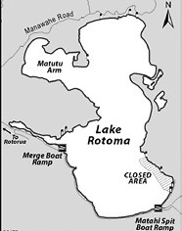

LAKE ROTOMA Partial Lake Closure

MATAHI - 5 - 6 Feb 2023

Open Water Swim-Team Shorebreak

The public are advised that **Team Shorebreak** will be hosting an **Open Water Swim** requiring a **partial lake closure of Lake Rotomā (Matahī)** from **5pm Sat 5th to 4pm Sun 6th Feb 2023.**

**The Water Ski Access Lane and Personal Water Craft at Matahi will be closed** to the public during the lake closure period. The **Matahi Spit boat ramp** remains open.

The closed area is shown above, posted on site, and can be viewed at the following website: [**www.rotorualakes.co.nz/lake-events-and-closures**](http://www.rotorualakes.co.nz/lake-events-and-closures)

**During the closure period, no unauthorised vessels or persons are permitted in the closed area.** Any queries to the Duty Harbourmaster **Ph 0800 5 KNOTS (55 66 87).**

JonJon Peters

BOP Harbourmaster