This NMP applies to: [Consent applicant’s/holder’s name]
at: [property address]
Property Identification Number: [PIN]
Consent Number: [RMXX-XXX]
Date signed: [Date]
Consent applicant/holder declaration
I [Insert Name] confirm that:
- The information that I have supplied to Bay of Plenty Regional Council (BOPRC) and the Land Use Advisor for the development of this Nutrient Management Plan (NMP) is correct, and
- The nutrient management actions, as outlined in this NMP, have been authorised by me.

Signed: Date:

Document preparation and quality assurance
Land Use Advisor declaration
I [Insert Name], of [Insert Text] confirm that:
- I am a suitably qualified and experienced person as defined in the Bay of Plenty Regional Natural Resources Plan (RNRP),
- I have viewed the property and consulted with the consent applicant/
holder (s) in the development of this NMP,
- The modelled scenario is feasible and accurately represents the proposed farm system, and
- I certify that this NMP has been prepared in accordance with Schedule LR Six – Nutrient Management Plan requirements of the Bay of Plenty Regional Natural Resources Plan.

Signed: Date:

BOPRC quality assurance process (BOPRC to complete)
OVERSEER® analyses reviewed by:* | Name: [Name]
 | Position: Nutrient Management Officer
Nutrient Management Plan (NMP) reviewed by: | Name: [Name]
 | Position: Land Management Officer
*OVERSEER® analyses are reviewed for consistency with the latest BOPRC and OVERSEER® data input protocols.

Contents
Section 1 Property details 1
1.1 Farm and consent holder/applicant details (Schedule LR Six) 1
1.2 Property area 1
1.3 Legal details for land parcels 1
1.4 Property Considerations 2
1.5 General farm overview 3
1.6 Full property map showing boundaries of property. 4
Section 2 Nitrogen targets 5
2.1 Nitrogen loss targets in OVERSEER® version [x.x.x]. 5
2.2 Losses by OVERSEER® analyses 5
2.3 RL R1 (Rule 11) nutrient loss targets in OVERSEER® version [x.x.x] 6
2.4 OVERSEER® block map showing N-losses 7
Section 3 Nutrient management 8
3.1 OVERSEER® analysis description and nitrogen allocation actions/limits for 2022-2027 8
3.2 Actions to achieve nitrogen Managed Reduction Targets by July 1st for the following years: 9
3.3 Records to demonstrate compliance with nitrogen targets and mitigation actions / limits 10
3.4 Good Management Practices for nitrogen and phosphorus management 11
3.5 Phosphorus management of Soil Olsen P levels 13
3.6 Property specific actions for nitrogen and phosphorus management – identifying Critical Source Areas 14
3.7 Fertiliser management 16
3.8 Water Management 16
3.9 Effluent management 17
3.10 Stockholding Area Management 17
Section 4 Nutrient Management Plan reviews 18
Section 5 Greenhouse Gas Emissions 19
5.1 Greenhouse Gas Emissions in OVERSEER® version [x.x.x]. 19

- Property details
  - Farm and consent holder/applicant details (Schedule LR Six)
Consent applicant’s/holder’s name: | [Business trading name]
Physical address of property: | [Physical address]
Name of contact person: | [Name]
Consent applicant’s/holder’s postal address: | [Postal Address]
Consent applicant’s/holder’s home phone: | [Home phone]
Consent applicant’s/holder’s mobile phone: | [Mobile phone]
Consent applicant’s/holder’s email: | [Email]
Description of ownership structure: | [e.g. Trust, corporate entity etc – if Trust, Trustees’ names should be included; if corporate entity provide companies number, etc]
Farm identifier as provided by BOPRC: | [PIN Number]
Name and contact details of the person responsible for managing the property/farming enterprise if different from consent holder/ applicant described above: | [Name]  [Mobile phone]  [Email]
  - Property area
Total property area:

Total property area in Lake Rotorua groundwater catchment subject to nutrient rules as shown in Map LR 1:
Effective area* in Lake Rotorua groundwater catchment subject to nutrient rules as shown in Map LR 1:
*Based on 01-04 benchmarked landuse, unless superseded by an agreement.

  - Legal details for land parcels
Legal owner(s) | Legal description | Certificate of Title number | Owned or leased?

  - Property Considerations
Type | Yes/No | File number  (if relevant) | Brief details
Environmental Programme (RMP/LIA/BMP/EP)
Archaeological sites
Rotorua Airport – Obstacle Limitation
SNA/ONLF
Existing consents
Existing BOPRC covenants or encumbrances (gorse/incentives/other)
Wetland Extent identified GeoView layers
Other considerations to land use (Priority Biodiversity Sites, QEII, Nga Whenua Rahui Kawenata, DOC land, Te Ture Whenua Maori Act Land, Settlement Land as defined in RNRP )

  - General farm overview
Description of topography, soils, challenges, advantages, farm system, catchment context and any environmental measures that may have already been implemented. This description is intended to give a background to the farming system and will not be regulated or QA’d by BOPRC. It is the responsibility of the Land Use Advisor and the landowner to ensure any data in this section is consistent with Section 3 of this NMP.
[General farm overview]

  - Full property map showing boundaries of property.
Full property map provided by BOPRC.
This must include a map(s) or aerial photograph at a scale that clearly shows:
- the boundaries of the property.
- a block map for the property/farming enterprise.

- Nitrogen targets
The following tables are based on requirements 3 and 4 in Schedule LR Six: Nutrient Management Plan requirements of the Regional Natural Resources Plan, which are mandatory minimum requirements of a Nutrient Management Plan.
  - Nitrogen loss targets in OVERSEER® version [x.x.x].
Timeframe | Area in Lake Rotorua groundwater catchment |  |  |  | Total farm business enterprise
 | Area: |  |  |  | Area:
 | Nitrogen target |  | Modelled N Losses |  | Modelled N losses
2022-2027 Start Point |  | kg N |  | kg N |  | kg N
 |  | kg N/ha |  | kg N/ha |  | kg N/ha
2027-2032 MRT |  | kg N |  | kg N |  | kg N
 |  | kg N/ha |  | kg N/ha |  | kg N/ha
2032 NDA |  | kg N |  | kg N |  | kg N
 |  | kg N/ha |  | kg N/ha |  | kg N/ha
  - Losses by OVERSEER® analyses
Does the farm have multiple OVERSEER® analyses? Y ☐/N ☐
Table 2.2 is not required and can be deleted if N is selected.
Timeframe | Management unit name PIN No. | Management unit name PIN No. | Management unit name PIN No.
2022-2027 Start Point
2027-2032 MRT
2032 NDA

  - RL R1 (Rule 11) nutrient loss targets in OVERSEER® version [x.x.x]

Was the property benchmarked under Rule 11 of the Regional Water and Land Plan?
Y ☐/N ☐

Is a portion of the property within another RL R1 (Rule 11) lake catchment? Y ☐/N ☐
(RL R1 (Rule 11) lakes: Lake Rotoiti, Lake Ōkāreka, Lake Rotoehu, Lake Ōkaro)

Table 2.3 is not required and can be deleted if N is selected.
Annual nutrient limit | Area (ha) | Rule 11 nitrogen allocation |  | Rule 11 phosphorus allocation | Modelled nutrient losses  in Rule 11 catchment
 |  | Total  kg N | Total  kg P |  | Total  kg N | Total  kg P
Rule 11

  - OVERSEER® block map showing N-losses
Full property N-losses map to be provided by BOPRC.

- Nutrient management
The following management objectives are based on Clause 5 in Schedule LR Six: Nutrient Management Plan of the Natural Resources Management Plan.
The below series of tables set out a pathway, including a schedule of mitigation actions, land use limits and OVERSEER® (or other model) input parameters that will achieve compliance with the nitrogen targets in Section 2 of this NMP.
Reporting year is a one year period from 1st of July to 30th of June.
  - OVERSEER® analysis description and nitrogen allocation actions/limits for 2022-2027
Refer to User Guide for instructions. https://www.rotorualakes.co.nz/resources
- Maximum number of stock and class of stock that will be on property at any time.
[Insert text - No more than XX]
[Insert text - Stock on property no earlier than XX and off no later than XX month]
[OR Insert text and table - “no more than figures shown in table below” within the text box if preferred. (Ie. screen shot of OVERSEER® stock calendar).]
- Maximum fertiliser amounts and descriptions that will be applied during any calendar year.
[Insert text - No more than XX per ha, applied in XX months, on XX Overseer Blocks]
- Production.
[Insert text]
- Maximum cropping areas during any reporting year (if any).
[Insert text - No more than XX ha of crop per year]
- Maximum feed imports during any reporting year.
[Insert text - No more than XX kg/DM]
- Infrastructure at any time (e.g. stand-off pad, herd home, feed pad) and timing of use (if applicable).
[Insert text]
- Other
[Insert text]

  - Actions to achieve nitrogen Managed Reduction Targets by
July 1st for the following years:
2027 to 2032 proposed actions/limits
Maintain same limits as set out in Section 3.1 but adhere to the following additional reductions:
- [Insert text - Reduced from XX to no more than XX]
- [Insert text - Reduced from XX to no more than XX]
- [Insert text - Reduced from XX to no more than XX]

2032+ proposed actions/limits
Maintain same limits as set out in Section 3.1 but adhere to the following additional reductions:
- [Insert text - Reduced from XX to no more than XX]
- [Insert text - Reduced from XX to no more than XX]
- [Insert text - Reduced from XX to no more than XX]

  - Records to demonstrate compliance with nitrogen targets and mitigation actions / limits
Auditable source documents must be kept as proof of compliance with targets and mitigation actions. Tick any record types you intend to keep to demonstrate compliance.
Record types retained by land occupier | Y | N
Production*: [Specify] | ☐ | ☐
Livestock numbers by month, age, weight, class, breed and movements on/off farm*. | ☐ | ☐
Dates for calving, lambing, fawning and weaning^. | ☐ | ☐
Fertiliser type, amount, timing, and rates per block*. | ☐ | ☐
Records of fertiliser equipment maintenance and calibration^. | ☐ | ☐
Supplementary feed origin, amount, type*, storage and destination (stock classes fed and located on farm)^. | ☐ | ☐
Crops grown: Crop types and yield*, paddock location (map), planting dates, months of harvest or grazing, stock grazed regrassing date, fertiliser applications, crop rotation history^. | ☐ | ☐
Infrastructure: Feed infrastructure, in-shed feeding (months of usage), stand-off, feed or wintering (pads or barns), timing and nature of usage^. | ☐ | ☐
Plantain (only required if Plantain is going to be used as a mitigation through OVERSEER®): Seed type, amount, timing, and rates per block*. | ☐ | ☐
Plantain (only required if Plantain is going to be used as a mitigation through OVERSEER®): Percentage per block calculated using DairyNZ visual assessment guidelines for Plantain^. | ☐ | ☐
Soil test results*: Dairy required every 2 years, Drystock every 3 years. | ☐ | ☐
Other: [Specify] | ☐ | ☐
^Farmer diary records or equivalent will suffice.
*Invoices/dockets or equivalent are required.

  - Good Management Practices for nitrogen and phosphorus management
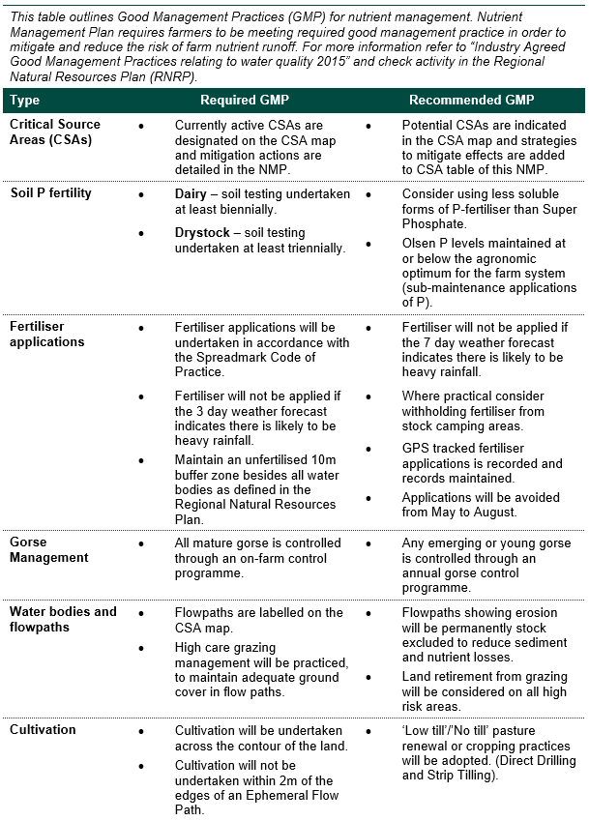
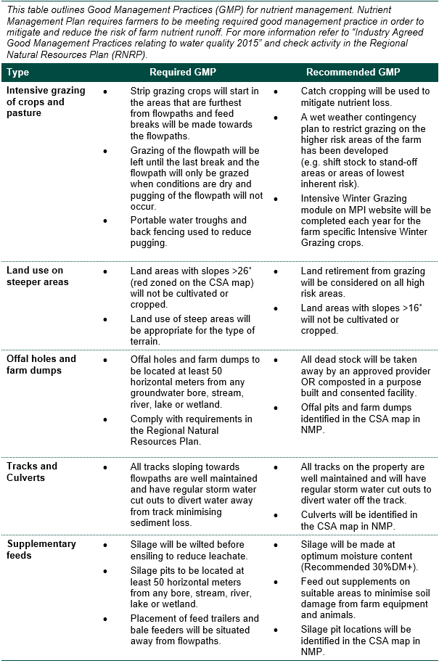
  - Phosphorus management of Soil Olsen P levels
Higher than agronomic optimum soil Olsen P levels have a direct correlation to higher phosphorus loss to water. Please record soil Olsen P values on pastoral/cropping blocks along with action and timeframe to manage higher than optimum levels.
Date last soil test occurred: [Insert date]
OVERSEER® block name | Current Olsen P | *Recommended maximum Olsen P | Action and timeframe
 |  | [20-30 for ash, or 35-45 for pumice] | [Insert text - Soil test completed in 2 years time if dairy or 3 years time if drystock - or action to maintain optimum soil Olsen P level]
*Reference https://www.fertiliser.org.nz/Site/resources/booklets

  - Property specific actions for nitrogen and phosphorus management – identifying Critical Source Areas
Insert CSA spreadsheet here.

Insert CSA map here

Optional as recommended in Section 3.4 GMP Table: Landowner can request the inclusion of Infrastructure mapping (Feed pads, Stand-off pads, offal pits, farm dumps, silage pits, and effluent pond location) along with High Risk grazing areas into the CSA map.

  - Fertiliser management
Fertiliser storage and application risks, and mitigation:
[Insert text]
[Insert text]
Note for Dairy Farmers: National Environmental Standards for Freshwater: Managing synthetic nitrogen fertiliser use.
From 1 July 2021, a resource consent is required to apply more than 190 kg N/ha/year of synthetic nitrogen fertiliser to grazing land.
Dairy farmers must collect records of fertiliser purchased and used for the year ended
30 June 2022 and report to councils by 31 July 2022 and each year after that.

Confirmation of compliance with fertiliser management requirements: | Y | N
Is fertiliser applied by farmer or farm employee? | ☐ | ☐
Is fertiliser applied by contractor? | ☐ | ☐
Fertiliser will be applied at all times in accordance with the Code of Practice for Nutrient Management 2013 (or as updated): | ☐ | ☐
Fertiliser will be applied at all times in accordance with the Spreadmark Code of Practice 2015 (or as updated): | ☐ | ☐
Fertiliser will be applied with spreading equipment that is maintained and self-calibrated to Spreadmark Code of Practice standards: | ☐ | ☐
More info can be found here: https://www.fertiliser.org.nz/site/code-of-practice/
or here: https://fertqual.co.nz/
  - Water Management
Does the property have a water take? Y ☐/N ☐
Is water used for milk cooling and dairy shed wash down? Y ☐/N ☐
Does the property have a water meter? Y ☐/N ☐
Does the property use water for irrigation? Y ☐/N ☐ Areas where irrigation is used:
Water take consent (if relevant):
[Insert text]

How is water use managed in a way that minimises water losses?
[Insert text]

Steps that will be taken to ensure water irrigation systems at the property are managed in a way that minimises nitrogen losses?
[Insert text]
[Insert text]
  - Effluent management
Does the property have an effluent system? Y ☐/N ☐ If N delete table below:
Effluent consent number:
[Insert text]
Effluent system description:
[Insert text - Effluent System description]
Steps that will be taken to manage risks associated with the operation of effluent systems at the property:
[Insert text]
[Insert text]

  - Stockholding Area Management
Regulations 12 – 14 of the Resource Management (National Environmental Standards for Freshwater) Regulations 2020 (NES) set out new requirements for Stockholding Areas. The definition in the NES of stockholding areas includes stand-off pads, loafing pads, winter pads and feed pads, but does not include stockyards, milking sheds, wintering barns, calf sheds or sacrifice paddocks.
Does the property have any Stockholding Area, which matches the definition above?
Y ☐/N ☐ If N delete table below:
Is the stockholding area base sealed or proposed to be sealed? Y ☐/N ☐
[Insert text]
Distance from the stockholding area to a waterbody, drain or bore:
[Insert text]
Is effluent collected, stored and disposed of in accordance with a regional plan rule or farm dairy effluent discharge consent? Y ☐/N ☐
[Insert text]
How are the Stockholding Areas proposed to be managed in a way that minimises nutrient losses from the property?
[Insert text]
Hours used per day and months of use?
[Insert text]

- Nutrient Management Plan reviews
This section is for your information only and it repeats Clause 8 in Schedule LR Six: Nutrient Management Plan requirements of the RNRP:
Nutrient Management Plans shall be updated:
- at no more than five yearly intervals from 1 June 2017, and
- in response to a significant farm system change, and
- in response to the addition or removal of leased land or land with contractual arrangements in support of a property/farming enterprise, or
- on the transfer of Nitrogen Discharge Allocation, or
- on the transfer of Managed Reduction Offsets to meet a Managed Reduction Target, or
- by agreement with the Chief Executive of the Bay of Plenty Regional Council.
All updated Nutrient Management Plans must meet the intent of the original Nutrient Management Plan and include an updated nitrogen budgeting file.
The Regional Natural Resources Plan (RNRP) defines:
Significant farm system change: A change in farm system that alters the inputs, methods or areas being used in the management of the property/farming enterprise where the scale of change means that the Nutrient Management Plan is no longer a realistic representation of the farm system or the predicted discharge exceeds that in the Nutrient Management Plan.
Suitably qualified and experienced person: A person who:
- implements OVERSEER® input best practice and uses standard protocols recognised and approved by the Bay of Plenty Regional Council including those specific to the
Lake Rotorua groundwater catchment; and
- has completed both the “Intermediate” and the “Advanced” courses in “Sustainable Nutrient Management in New Zealand Agriculture” conducted by Massey University and has at least five years’ work experience in a land use/farm advisory role; or
- is approved in writing by the Chief Executive (or delegate thereof) of the Bay of Plenty Regional Council.

- Greenhouse Gas Emissions
Section 5 Greenhouse Gas Emissions (GHG) is not a requirement of the Regional Natural Resources Plan or your Land Use Resource Consent.
In October 2019, central government agreed to a proposal ‘He Waka Eke Noa’ from the primary sector to work together to develop a system for measuring, managing and reducing agricultural greenhouse gas emissions, rather than simply putting farm products in the Emissions Trading Scheme. More info can be found on this website: www.hewakaekenoa.nz.
Section 5 of this NMP is based on ‘He Waka Eke Noa’ requirement for all farms to have greenhouse gas emissions reported in their Farm Environment Plans by 2025.
  - Greenhouse Gas Emissions in OVERSEER® version [x.x.x].
Reporting period | Total farm business enterprise
 | Area: [x.x.x]
 | Methane GHG Emissions |  | Nitrous oxide GHG Emissions |  | Carbon dioxide GHG Emissions
2022 Modelled Farm System |  | eCO₂/t/yr |  | eCO₂/t/yr |  | eCO₂/t/yr
2027 Modelled Farm System |  | eCO₂/t/yr |  | eCO₂/t/yr |  | eCO₂/t/yr
2032 Modelled Farm System |  | eCO₂/t/yr |  | eCO₂/t/yr |  | eCO₂/t/yr
The estimated values for each gas are converted to kg of carbon dioxide equivalent per hectare per year so they can be compared with each other and other GHG reporting tools.
Have greenhouse gas figures been taken from the property’s OVERSEER® analysis? Y ☐/N ☐
If N what GHG reporting tool or calculator has been used?
Has the default settings for estimating GHG energy footprint been used? Y ☐/N ☐
If N the actual inputs need to be used to override fuel, fertiliser application, transportation, and electricity footprints.
Has the carbon stock tool been used for tree blocks in OVERSEER®? Y ☐/N ☐

Options to help reduce your GHG emissions can be found on these websites:
www.tools.business.govt.nz/climate/
www.dairynz.co.nz/environment/climate-change/ways-to-reduce-emissions/
www.beeflambnz.com/knowledge-hub/module/climate-change
More information on your property specific GHG emission profile can be found at www.overseer.org.nz under the reports section in the analysis.

