Lake RotoEHU

Kōura AND MORIHANA MONITORING PROGRAMME 2020 - 2022

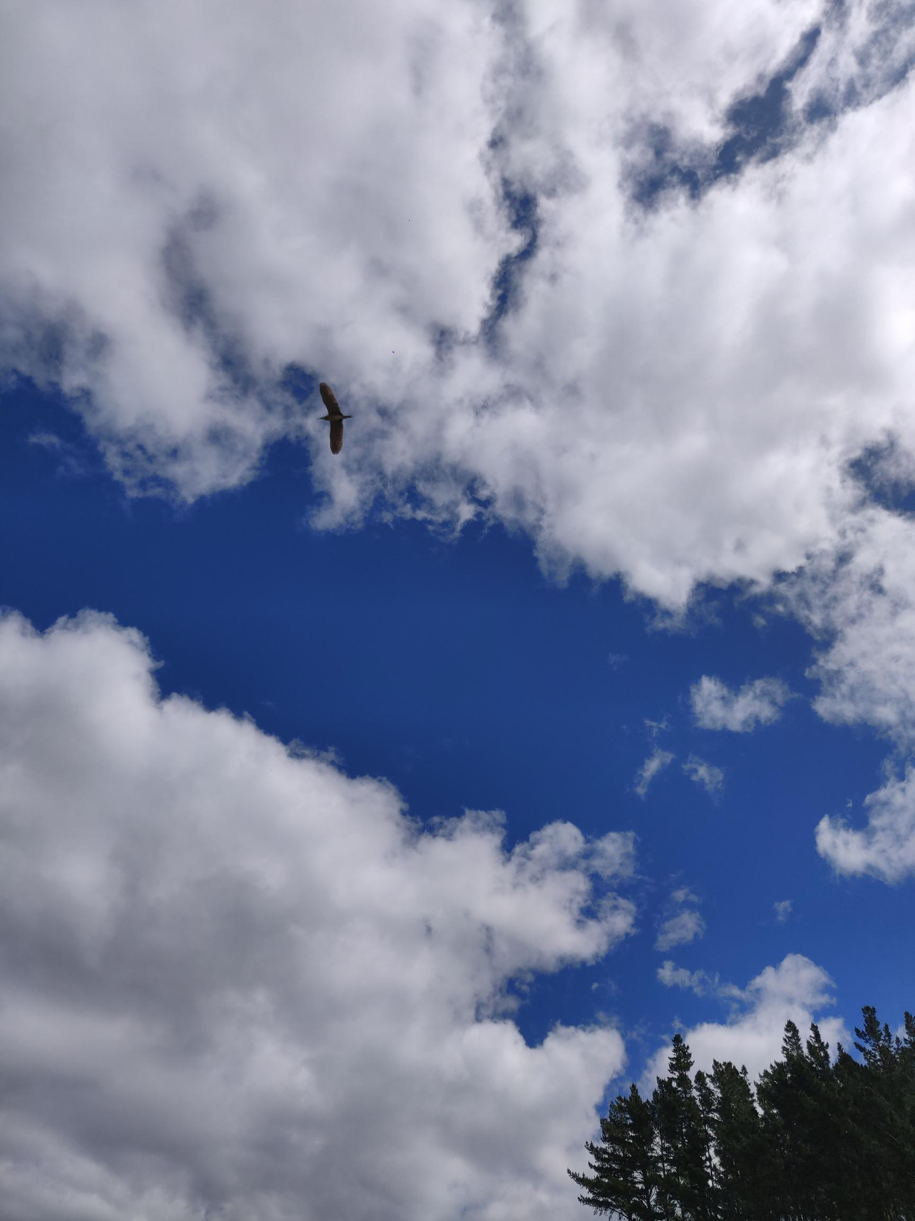

REPORT NUMBER 9 PREPARED FOR BAY OF PLENTY REGIONAL COUNCIL
Ian Kusabs & Associates Ltd
Rotorua, New Zealand
April 2022

LAKE ROTOEHU:
KŌURA AND MORIHANA MONITORING PROGRAMME 2020-2022

Authors:
Ian Kusabs (Ian Kusabs and Associates Ltd)

Prepared for:
Bay of Plenty Regional Council

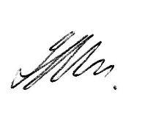
Released by:
Dr Ian Kusabs
Principal Scientist
Ian Kusabs & Associates Ltd
21 Summit Road, RD5
Lake Ōkāreka, Rotorua 3076

Mobile: +64 272772651
Email: ian@kusabs.co.nz

Date: 7 April 2022
Status: Final

Citation
Kusabs, I.A. (2022). Lake Rotoehu kōura and morihana monitoring programme 2020 - 2022. Report number 9 prepared for Bay of Plenty Regional Council. Ian Kusabs and Associates Ltd, Rotorua, New Zealand.
Cover image
A matuku or Australasian bittern (Botaurus poiciloptilus) flying over the Waitangi wetland, 14 October 2021. The matuku is considered by the Department of Conservation as a threatened- nationally critical species (most severely threatened, facing an immediate high risk of extinction). Photo: I. Kusabs.

All rights reserved. This publication may not be reproduced or copied in any form without the permission of the client. Such permission is to be given only in accordance with the terms of the client's contract with Ian Kusabs & Associates Ltd.

Table of Contents

EXECUTIVE SUMMARY iii
List of Figures v
List of Tables v
INTRODUCTION 1
Aims and objectives 2
Study area 2
METHODS 3
Tau kōura construction and use 3
Kōura collection 3
Fish sampling 4
Kōura and morihana measurements 4
Data analysis 4
RESULTS 5
Kōura 5
Abundance, biomass and distribution 5
Comparison with previous spring surveys - abundance, biomass and distribution 6
Size 7
Percentage females, breeding size with eggs and soft shells 9
Morihana 9
DISCUSSION 11
Kōura abundance and distribution 11
Morihana 12
CONCLUSIONS AND RECOMMENDATIONS 13
ACKNOWLEDGEMENTS 14
REFERENCES 14

EXECUTIVE SUMMARY

Lake Rotoehu is a eutrophic lake that has suffered from cyanobacteria blooms since the 1990s. The Bay of Plenty Regional Council have implemented a number of in lake treatments and nutrient management strategies in the catchment to improve water quality.
Kōura (freshwater crayfish) and morihana (goldfish) are considered taonga (treasured) species by Te Arawa. Moreover, freshwater crayfish are also widely recognised as an important ecological component of freshwater ecosystems as they have a dominating influence on community structure.
The principal aim of this monitoring programme is to determine trends in kōura population characteristics in Lake Rotoehu. This report provides an in-depth analysis of Lake Rotoehu kōura monitoring data from 2020 to 2022 and a comparison with previous surveys carried out from 2011 to 2019. A secondary purpose of this study was to collect morihana and kōura to determine the effects of alum (aluminium sulphate) dosing on these species in the Waitangi Stream (morihana) and Lake Rotoehu (kōura). Morihana abundance and size data for 2020 and 2021 were analysed and compared to samples collected from 2016 to 2019.
The kōura population in Lake Rotoehu was sampled using two tau kōura, composed of 10 whakaweku each, in spring (13 November 2020 and 14 October 2021) and summer (27 January 2021, 9 February 2022). Five standard-mesh fyke nets were used to sample morihana in the lower reaches of the Waitangi Stream on 22 September 2020 and 14 October 2021.
Kōura abundance and biomass were far lower in 2020 and 2021 than in previous surveys. In Lake Rotoehu, kōura catches are typically highest in spring when kōura are active and the lake is not subject to stratification (and hypolimnetic deoxygenation) events. In spring 2020, a total of 53 kōura (mean CPUE = 1.3 kōura whakaweku⁻¹) were captured, while 32 kōura (mean CPUE = 0.8 kōura whakaweku⁻¹) were collected in 2021/22. In comparison, 318 kōura were collected in spring 2019 at a mean CPUE of 8.4 kōura whakaweku⁻¹. An analysis of kōura depth distribution shows that stratification occurred in spring in both 2020 and 2021, this had not occurred in previous spring surveys. For example, in the 2011 to 2019 spring surveys, kōura were collected from all 10 whakaweku at depths down to 12 m. However, in the 2020 and 2021 spring samplings, kōura were not found on whakaweku set at depths greater than 8.9 m and 7 m in October 2021. Kōura are affected by low dissolved oxygen levels and move in to shallow (more oxygenated) waters when this occurs. This movement of kōura into the shallows does not result in a corresponding increase in kōura CPUE from the shallower whakaweku.
Morihana were relatively abundant, and easily captured, at the confluence of the Waitangi Stream and Lake Rotoehu. Morihana catches in 2021 were lower than in previous surveys but this was due to sampling gear modifications (i.e., waterbird protection measures) rather than a change in the morihana population.
It is recommended that the spring and summer kōura monitoring surveys continue. The spring survey (typically when catches are highest) provides information on kōura population dynamics, while the summer survey provides an insight into the effects of hypolimnetic deoxygenation (and lake restoration measures) on kōura distribution. Moreover, the tau kōura is an effective (and safe, given the poor water quality) method of collecting the kōura samples required for the University of Waikato.

List of Figures

Figure 1 Map of Lake Rotoehu showing the approximate locations of the kōura monitoring sites, Rotoehu East and Rotoehu West, and the morihana collection site at the confluence of the Waitangi Stream and Lake Rotoehu (red star). 2
Figure 2 Schematic diagram of the tau kōura. The depth and length of tau are indicative and can be varied depending on lake bathymetry. 3
Figure 3 Mean CPUE for kōura captured in two tau kōura (n = 10 whakaweku) set in Lake Rotoehu, 22 November 2011 to 9 February 2022. Light bars = East site; shaded bars = West site. 5
Figure 4 (A) Mean CPUE (n) and (B) mean estimated BPUE (g) for kōura captured in two tau kōura (each composed of 10 whakaweku) retrieved in the spring in Lake Rotoehu from 22 November 2011 to 14 October 2021. Note: summer data was not included due to the effects of hypolimnetic deoxygenation and the low numbers of kōura recorded. 6
Figure 5 Length-frequency distribution of kōura subsamples (n= 51) collected from two tau kōura each composed of 10 whakaweku retrieved from Lake Rotoehu on 13 November 2020 (n= 33) and 14 October 2021 (n= 18). 8
Figure 6 Box-and-whisker plot showing mean (x), median (horizontal line), interquartile range (box), distance from upper and lower quartiles times 1.5 interquartile range (whiskers), outliers (>1.5× upper or lower quartile) of kōura captured on tau kōura (composed of 10 whakaweku x 2 sites) deployed in Lake Rotoehu from 2011 to 2021. 8
Figure 7 Length-frequency distribution of morihana (goldfish) captured in four standard mesh fyke nets set at the confluence of the Waitangi Stream and Lake Rotoehu, from 22 to 23 September 2020. Results for 2021 were not included due to the low numbers of morihana captured. 10

List of Tables

Table 1 Mean CPUE, mean estimated biomass and maximum depth for kōura captured in two tau kōura (n = 10 whakaweku each) deployed in Lake Rotoehu, 13 November 2020, 27 January 2021, 14 October 2021 and 9 February 2022 and for the spring (n = 10 samplings) and summer periods, 2011 – 2022 (n = 9 samplings). Standard deviation in brackets. 5
Table 2 Mean size and range of kōura captured in two tau kōura (n = 10 whakaweku each) deployed in Lake Rotoehu and retrieved on 13 November 2020, 27 January 2021, 14 October 2021 and 9 February 2022 and for the spring (N = 10 samplings) and summer periods, 2011–2022 (N = 9 samplings). SD in brackets. – = no kōura collected. 7
Table 3 Number of kōura sampled, mean percentage of females, mean percentage of breeding size females with eggs or hatchlings (defined as > 17 mm OCL) and mean percentage of kōura with soft shells. Subsamples taken from two tau kōura (comprised of 10 fern bundles each) set in Lake Rotoehu, and for the spring (N = 10 samplings) and summer periods, 2011–2022 (N = 9 samplings). SD in brackets. # = mean of means. 9
Table 4 Mean CPUE, mean total length and size range of morihana captured in five standard fyke nets set at the confluence of the Waitangi Stream and Lake Rotoehu, 28 September 2016 to 14 October 2021. FL = fork length. Standard deviation in brackets. # - Introduction of waterbird protection measures. 10

INTRODUCTION
Lake Rotoehu is a eutrophic lake that exceeds its specified trophic level index (TLI) as specified in the Bay of Plenty Regional Council (BOPRC) Regional Water and Land Plan. Lake Rotoehu is a shallow, polymictic lake that has suffered from cyanobacteria blooms for the past two decades. The BOPRC have implemented a number of in-lake treatments and nutrient management strategies in the catchment to improve lake water quality.
Kōura (Paranephrops planifrons) are a ‘keystone’ species in many New Zealand waterways and have various ecological functions, which in turn influence other fauna and flora. They also support important fisheries in many Te Arawa lakes e.g., lakes Ōkataina, Rotomā and Tarawera (Hiroa 1921; Kusabs and Quinn 2009). In pre-European times, Lake Rotoehu supported a valuable kōura fishery (Stafford 1996), but now, kōura are no longer harvested from Lake Rotoehu for human consumption (Pers. comm. W. Emery).
Morihana (Carassius auratus) is the common aquarium goldfish, sometimes known as carp. The name morihana was derived from the name of Sub-Inspector H. Morrison of the Armed Constabulary who introduced them into Lake Taupō in 1872. Morihana are valued by Māori as a source of food (particularly in the past) and were used as rongoā (health food). The Waitangi Stream is considered one of the most important areas for harvesting morihana in the Te Arawa Lakes region (Pers. comm. W. Emery).
Regular kōura monitoring surveys have been undertaken in Lake Rotoehu since 2011. These surveys found that the lake supports a moderately abundant population of small and medium sized kōura. Initially, the purpose of these surveys was to determine the effects of the various lake restoration measures on kōura population dynamics and distribution. However, following the decommissioning of destratifiers in 2015, kōura monitoring was reduced from four times (seasonal) to twice (spring and summer) per year. The rationale for biannual sampling was that the spring survey (typically when catches are highest) would provide data on kōura population parameters, whereas the summer survey would provide an insight into the effects of hypolimnetic deoxygenation on kōura depth distribution. Given the poor water clarity and frequent blue green algae blooms, the tau kōura would also be a convenient (and safe) means of collecting kōura samples for elemental (i.e., aluminium) analysis by the University of Waikato.

Aims and objectives
The principal aim of this monitoring programme is to determine trends in kōura population characteristics in Lake Rotoehu and the objectives to:
- carry out tau kōura surveys in spring (2020, 2021) and autumn (2021, 2022) and compare them with previous surveys carried out from 2011 to 2019.
- collect morihana and kōura for elemental analysis (by the University of Waikato) to determine the effects of alum dosing in the Waitangi Stream.
- Analyse morihana abundance and size data and compare with that recorded from the 2016 to 2019 surveys.

Study area
Lake Rotoehu has a surface area of 795 ha, an average depth of 8.2 m and a maximum depth of 13.5 m. It is located approximately 40 km north east of Rotorua and has a small residential community, most residing around Otautu Bay and Kennedy Bay (Figure 1). Approximately 40% of the lake catchment is in pasture with the rest in plantation forestry and native bush. The Waitangi Soda Spring (Waitangi Stream) beside the lake is a natural geothermal stream used for bathing.
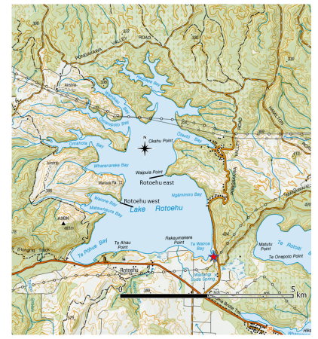
Figure 1 Map of Lake Rotoehu showing the approximate locations of the kōura monitoring sites, Rotoehu East and Rotoehu West, and the morihana collection site at the confluence of the Waitangi Stream and Lake Rotoehu (red star).

METHODS

Tau kōura construction and use
The kōura population in Lake Rotoehu was sampled using the tau kōura (Figure 2) a traditional Māori method of harvesting kōura in the Te Arawa and Taupō lakes (Hiroa 1921; Kusabs and Quinn 2009).
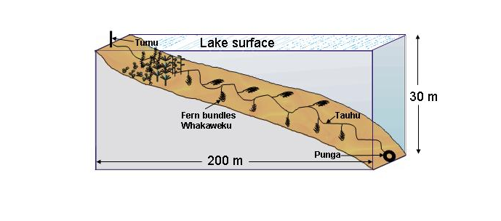
Figure 2 Schematic diagram of the tau kōura. The depth and length of tau are indicative and can be varied depending on lake bathymetry.

Two tau kōura were set in Lake Rotoehu, one each on the eastern (Rotoehu East; 38°01’03” S 176°32’05” E) and western sides (Rotoehu West; 38°01’23” S 176°31’26” E) of the lake (Figure 1). Each tau kōura was comprised of 10 whakaweku (bracken fern, Pteridium esculentum, bundles) each with c. 10 dried fronds per whakaweku (Figure 2). The bracken fern fronds were bound together using 250 mm length industrial strength cable ties and were attached using synthetic lashing (hay baling twine ~ 2.5 m long) to a 250 m length of sinking anchor rope and set. One end of the bottom line was attached to a large boulder on the shoreline while the lake end was anchored to the lake bottom using a concrete-filled tyre. Tau kōura at Rotoehu East and Rotoehu West were set in water depths ranging from 4 to 12 m and 8 to 12 m, respectively. Whakaweku were renewed (using freshly cut bracken fronds) and deployed on 20 July 2020 and 2 August 2021. Tau kōura were retrieved on 13 November 2020 and 27 January 2021 (2020-2021 season) and 14 October 2021 and 9 February 2022 (2021-2022 season).

Kōura collection
Harvesting was achieved by lifting the shore end of the rope and successively raising each whakaweku while moving along the tauhu (bottom line) in a boat. A kōrapa (large net) was placed beneath the whakaweku before it was lifted out of the water. The whakaweku was then shaken to dislodge all kōura from the fern into the kōrapa. The whakaweku was then returned to the water.

Fish sampling
Fyke nets were used to capture morihana in Lake Rotoehu at Te Wairoa Bay, where the Waitangi Stream enters the lake (~ 38°01’59” S 176°32’53” E). Four-standard mesh fyke nets consisting of two compartments, 15 mm mesh (knot-to-knot), a leader length of 2.5–3 m, and a height of 50 cm (measured at first hoop). The leader-end of each net was attached to a stake, while the cod-end was anchored to the lake bottom using a 2.5 kg dive weight. In the 2021 survey, buoys were added to each net chamber to provide an air space for waterbirds that inadvertently entered the nets, to prevent them from drowning. The nets were baited with cheese, set overnight and lifted the following morning. The catch was sorted, identified to species, and number and size of fish recorded.

Kōura and morihana measurements
Kōura were counted and orbit-carapace length (OCL) of each kōura was measured using Vernier callipers (± 0.5 mm). Sex was recorded as male, female or indeterminate for those < 12 mm OCL (where sex could not be determined). Kōura were assessed for shell softness (soft or hard) and reproductive state (presence of eggs or hatchlings). After processing, all kōura were returned to the water in close proximity to the tau kōura except for 10 kōura that were retained for elemental analysis at the University of Waikato (UoW). Catch per unit effort (CPUE) was defined as the number of kōura per whakaweku and biomass per unit effort (BPUE) as estimated wet weight (g) of kōura per whakaweku. A power regression equation (previously determined for this species was used to estimate kōura wet weight (g):
W(g) = 0.000648 OCL (mm)^{3.0743}
Morihana were anaesthetized, counted, and measured for fork length (FL) to the nearest 1 mm. Most fish were then allowed to recover and released immediately back into the water (Figure 3). Fifteen morihana were retained for elemental analysis. Catch per unit effort (CPUE) was defined as the number of fish per fyke net.

Data analysis
Kōura population data from this study (2020 - 2022) were compared with 21 previous surveys carried out between 2009 and 2020 (Kusabs & Butterworth 2014, 2015, Kusabs et al. 2015, Kusabs 2016, 2017, 2018, 2019, 2020). Linear regression was used to determine trends in kōura population parameters (CPUE and BPUE). The Kolmogorov-Smirnov test for normality was used to determine whether the variables were normally distributed. Where necessary, data was log transformed to approximate the normal distribution, if the transformed data was still not normally distributed then the Mann-Whitney U Test was used. Data analysis and visualization was performed using Daniel’s XL Toolbox add in for Excel, version 7.3.2 (Kraus 2014).

RESULTS

Kōura

Abundance, biomass and distribution
A total of 53 kōura at a mean CPUE of 1.3 (SD 0.4) kōura whakaweku⁻¹ were captured in 2020/21 survey and 32 at a mean CPUE of 0.8 (SD 2.0) kōura whakaweku⁻¹ in the 2021/22 survey (Table 1). While estimated mean biomass-per-unit-effort (BPUE) were 18.8 g (SD 43.1) kōura whakaweku⁻¹ for 2020/21 and 15.1 g (SD 38.9) kōura whakaweku⁻¹ for 2021/2022 (Figure 3). In contrast to previous years, there were no differences in kōura CPUE or BPUE between sites or seasons, most probably due to the low numbers of kōura collected (Table 1).
Table 1 Mean CPUE, mean estimated biomass and maximum depth for kōura captured in two tau kōura (n = 10 whakaweku each) deployed in Lake Rotoehu, 13 November 2020, 27 January 2021, 14 October 2021 and 9 February 2022 and for the spring (n = 10 samplings) and summer periods, 2011 – 2022 (n = 9 samplings). Standard deviation in brackets.
Date |  | Mean CPUE (n) |  |  | Mean BPUE (g) |  |  | Max depth of kōura (m)
 |  | East | West |  | East | West |  | East | West
13 November 2020 |  | 1.3 (1.7) | 2.0 (4.4) |  | 17.9 (26.0) | 39.2 (83.5) |  | 8.9 | 8.6
27 January 2021 |  | 0.9 (1.7) | 1.1 (2.6) |  | 11.6 (24.0) | 26.1 (61.7) |  | 8.8 | 7.7
14 October 2021 |  | 1.6 (2.2) | 0.2 (0.4) |  | 29.8 (42.3) | 3.7 (8.0) |  | 8.6 | 7.0
9 February 2022 |  | 0.0 | 1.4 (3.1) |  | 0.0 | 27.1 (62.5) |  | 8.9 | 7.7
Spring 2011 - 2021 |  | 28.3 (27.0) | 14.8 (17.9) |  | 277.8 (304.3) | 154.1 (171.8) |  | 12.0 | 12.0
Summer 2011 - 2022 |  | 6.6 (11.0) | 3.2 (8.2) |  | 89.9 (157.7) | 56.1 (138.6) |  | 11 | 11.1

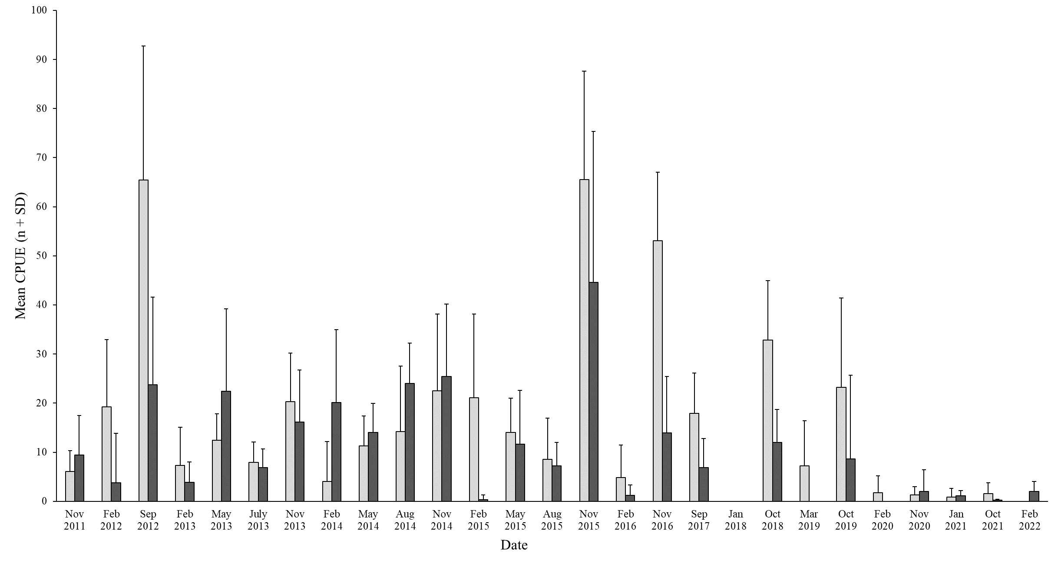
Figure 3 Mean CPUE for kōura captured in two tau kōura (n = 10 whakaweku) set in Lake Rotoehu, 22 November 2011 to 9 February 2022. Light bars = East site; shaded bars = West site.

Comparison with previous spring surveys - abundance, biomass and distribution
Kōura abundance and biomass were lower at both sampling sites in 2020 and 2021 compared to previous years (Figs. 4A & 4B). Mean kōura CPUE in spring decreased by -94% from 15.9 kōura whakaweku⁻¹ in 2019 to 0.9 kōura whakaweku⁻¹ in 2021 (P < .01) (Fig. 3) While, mean BPUE decreased by -91% from 176.2 g (2019) to 16.7 g kōura whakaweku⁻¹ (2021) (P < .01) (Fig. 3). Kōura abundance and biomass recorded in spring have also declined noticeably (but not significantly) from 2011 to 2022 (Figs. 4A & 4B).

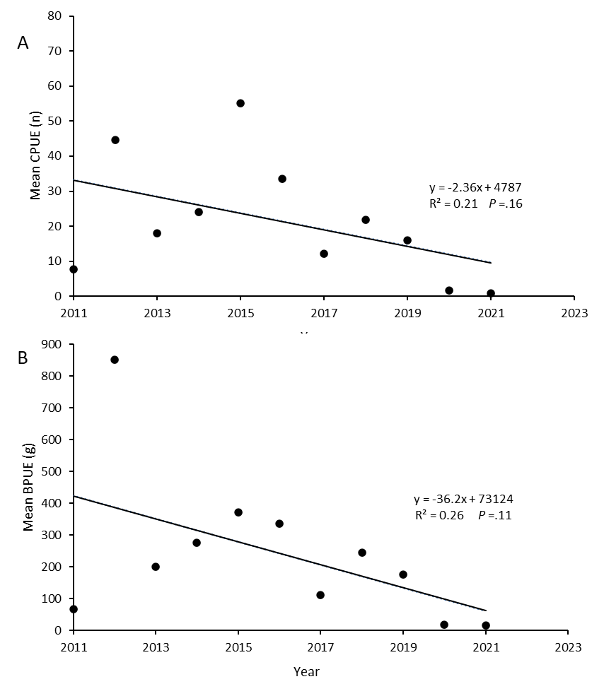

Figure 4 (A) Mean CPUE (n) and (B) mean estimated BPUE (g) for kōura captured in two tau kōura (each composed of 10 whakaweku) retrieved in the spring in Lake Rotoehu from 22 November 2011 to 14 October 2021. Note: summer data was not included due to the effects of hypolimnetic deoxygenation and the low numbers of kōura recorded.

Size
Length frequency analysis showed that the kōura population in Lake Rotoehu was composed mainly of small and medium sized kōura (Fig. 5). In the November 2020 survey, the mean OCL of kōura was 24.5 (SD 5.4) mm at Rotoehu East and 27.9 (SD 5.2) mm at Rotoehu West, whereas in the October 2020 survey, the mean OCL of kōura was 26.8 (SD 6.4) mm at Rotoehu East and 28.0 (SD 2.8) mm at Rotoehu West. These were similar to the 2011 to 2021 long-term spring averages of 22.3 (SD 6.0) mm OCL and 23.0 (SD 5.5) mm OCL for the east and west sites, respectively (Table 2). In the spring surveys, kōura ranged in size from 11 to 37 mm OCL in November 2020 and 14 to 42 mm OCL in October 2021, consistent with the long-term averages (Table 2; Fig. 6). However, unlike previous summer surveys, there was an absence of small sized kōura in the 2021 and 2022 surveys, with the smallest kōura captured in January 2021 being 19 mm OCL and 20 mm OCL in February 2022 (Table 2; Fig. 6).

Table 2 Mean size and range of kōura captured in two tau kōura (n = 10 whakaweku each) deployed in Lake Rotoehu and retrieved on 13 November 2020, 27 January 2021, 14 October 2021 and 9 February 2022 and for the spring (N = 10 samplings) and summer periods, 2011–2022 (N = 9 samplings). SD in brackets. – = no kōura collected.
Date |  | Mean OCL (mm ± SD) |  |  | Size range (OCL) mm
 |  | East | West |  | East | West
13 November 2020 |  | 24.5 (5.4) | 27.9 (5.2) |  | 17 - 32 | 11 - 37
27 January 2021 |  | 24.9 (4.2) | 29.5 (5.7) |  | 19 - 32 | 20 - 37
14 October 2021 |  | 26.8 (6.4) | 28.0 (2.8) |  | 14 - 42 | 26 - 30
9 February 2022 |  | – | 27.8 (4.8) |  | – | 20 - 36
Spring 2011-2021 |  | 22.3 (6.0) | 23.0 (5.5) |  | 10 - 43 | 8 - 39
Summer 2011-2022 |  | 24.3 (5.7) | 27.0 (5.8) |  | 12 - 43 | 14 - 40

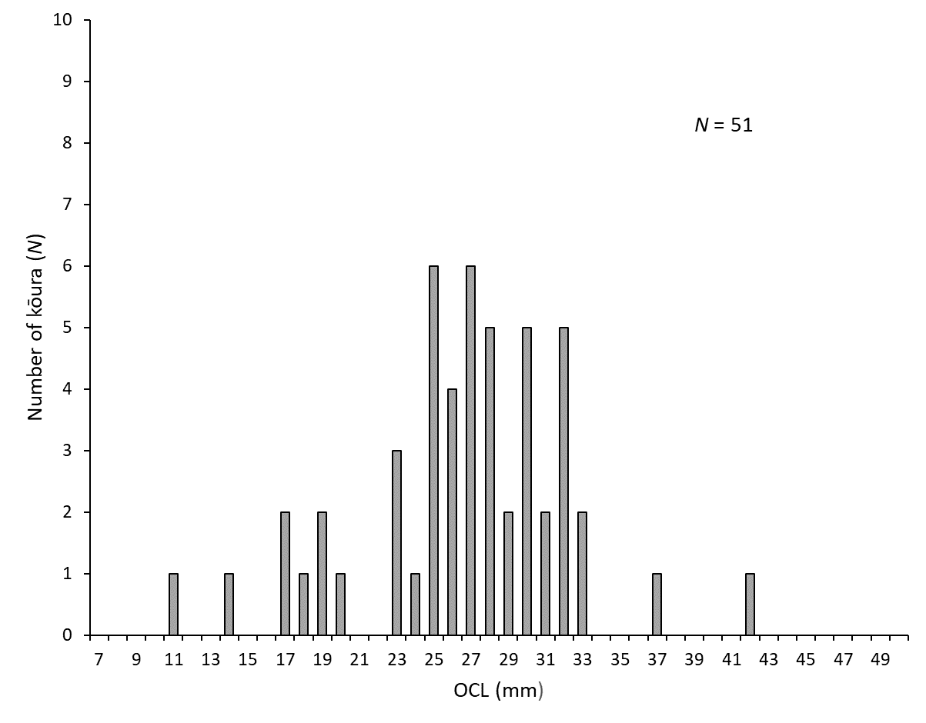
Figure 5 Length-frequency distribution of kōura subsamples (n= 51) collected from two tau kōura each composed of 10 whakaweku retrieved from Lake Rotoehu on 13 November 2020 (n= 33) and 14 October 2021 (n= 18).

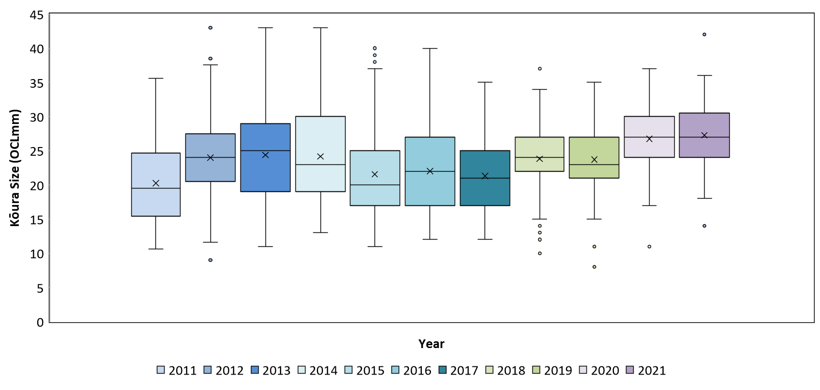
Figure 6 Box-and-whisker plot showing mean (x), median (horizontal line), interquartile range (box), distance from upper and lower quartiles times 1.5 interquartile range (whiskers), outliers (>1.5× upper or lower quartile) of kōura captured on tau kōura (composed of 10 whakaweku x 2 sites) deployed in Lake Rotoehu from 2011 to 2021.

Percentage females, breeding size with eggs and soft shells
Female to male ratios ranged from 19% in October 2021 at Rotoehu East to 79% in February 2022 at Rotoehu West, however these may be due to the low sample sizes (Table 3). Females with eggs were collected in November 2020 at both sites (Rotoehu East 50% and Rotoehu West 25%) and at the Rotoehu East site (33%) in October 2021 (Table 3). Females with eggs ranged from 25 to 32 mm OCL, similar to previous years (15 to 40 mm OCL). Kōura with soft shells were present at both sites ranging from 0 to 63% (Table 3). The 63% recorded at the Rotoehu East site in October 2021 was most probably due to the low sample size (n = 16) (Table 3).
Table 3 Number of kōura sampled, mean percentage of females, mean percentage of breeding size females with eggs or hatchlings (defined as > 17 mm OCL) and mean percentage of kōura with soft shells. Subsamples taken from two tau kōura (comprised of 10 fern bundles each) set in Lake Rotoehu, and for the spring (N = 10 samplings) and summer periods, 2011–2022 (N = 9 samplings). SD in brackets. # = mean of means.
Date |  | Number of kōura sampled |  |  | % Female |  |  | % Breeding size females with eggs# |  |  | Size range of breeding females (OCL; mm) |  |  |  | % Soft shells#
 |  | East | West |  | East | West |  | East | West |  | East | West |  | East |  | West
13 November 2020 |  | 14 | 20 |  | 30.8 | 63.2 |  | 50.0 | 25.0 |  | 26 - 32 |  | 26 - 31 |  | 14.3 |  | 25.0
27 January 2021 |  | 10 | 11 |  | 44.4 | 36.4 |  | 0 | 0 |  |  |  |  |  | 20.0 |  | 18.2
14 October 2021 |  | 16 | 2 |  | 18.8 | 50.0 |  | 33.3 | 0 |  | 25 |  |  |  | 62.5 |  | 0
9 February 2022 |  | 0 | 14 |  | - | 78.6 |  | - | 0 |  |  |  |  |  | - |  | 7.1
Spring 2011-2021 |  | 1236 | 974 |  | 51.3 | 47.2 |  | 29.6 | 21.8 |  | 20 - 40 |  | 17 - 34 |  | 14.0 |  | 11.0
Summer 2011-2022 |  | 577 | 214 |  | 49.8 | 50.5 |  | 0 | 0 |  |  |  |  |  | 15.5 |  | 11.2

Morihana
Morihana were abundant in the lower reaches of the Waitangi Stream in September 2020 with a mean CPUE of 29.2 fish net⁻¹ recorded, the second highest recorded since surveys began in 2016 (Table 4). In contrast, the mean CPUE of 5.8 fish net⁻¹ in 2021 was the lowest recorded since surveys began in 2016. It should be noted that catches in 2021 were affected by the provision of waterbird protection measures, which affected the efficacy of the nets. In 2020, morihana ranged in size from 62 to 260 mm with a mean size of 145 mm (FL), while in 2021 size ranged from 80 to 210 mm with a mean size of 145 mm (Table 4). Length frequency analysis showed that most morihana were between 140 and 170 mm in length (Figure 7).

Table 4 Mean CPUE, mean total length and size range of morihana captured in five standard fyke nets set at the confluence of the Waitangi Stream and Lake Rotoehu, 28 September 2016 to 14 October 2021. FL = fork length. Standard deviation in brackets. # - Introduction of waterbird protection measures.
Date | Number of nets | Water Temp | Mean CPUE | Mean Length | Size Range
 | N | ºC |  | (FL; mm) | (FL; mm)
28 September 2016 | 5 | 22 | 34.4 (32.9) | 123.7 (42.6) | 56 - 270
19 September 2017 | 5 | 17.2 | 24.0 (29.8) | 118.1 (24.2) | 63 - 225
24 October 2018 | 4 | 22 | 23.8 (9.7) | 123.6 (43.8) | 70 - 220
3 October 2019 | 4 | 15 - 18 | 24.0 (35.5) | 138.2 (31.4) | 61 - 200
22 September 2020 | 5 | 16.7 – 18.4 | 29.2 (25.8) | 145.1 (36.9) | 62 - 260
14 October 2021# | 5 | 16.7 | 5.8 (4.1) | 136.2 (37.1) | 80 - 210

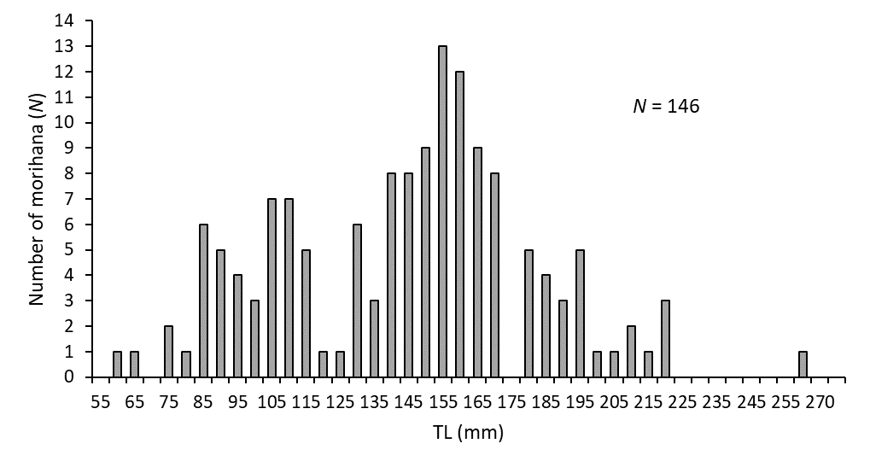
Figure 7 Length-frequency distribution of morihana (goldfish) captured in four standard mesh fyke nets set at the confluence of the Waitangi Stream and Lake Rotoehu, from 22 to 23 September 2020. Results for 2021 were not included due to the low numbers of morihana captured.

DISCUSSION

Kōura abundance and distribution
Despite persistent water quality issues Lake Rotoehu has, until recently, continued to support a moderately abundant population of small and medium sized kōura. However, kōura abundance and biomass were drastically lower in 2020 and 2021 compared to previous surveys. In Lake Rotoehu, kōura catches are typically highest in spring and lowest in summer when the lake is subject to stratification and hypolimnetic deoxygenation of the bottom waters. From an examination of kōura depth distribution it appears that stratification (and deoxygenation) is now occurring earlier than in previous years. In spring sampling carried out from 2016 to 2019, kōura were collected from all 10 whakaweku to depths of ~12 m, however, in 2020 and 2021, kōura were not found on whakaweku set at depths greater than 8.9 m. This was most probably due to low dissolved oxygen (DO) levels at the two tau kōura sites.
Analysis of Limnotrack data showed that DO levels started to decline in Lake Rotoehu in October 2021 and were generally ≤5 DO mg/l, in depths below 7 m, from November 2021 to February 2022. This is somewhat later than our spring sampling which was carried out in mid-October 2021. However, the location of the monitoring buoy (in the middle of Lake Rotoehu) would not account for localised conditions at the tau kōura sites. For example, deployment of dissolved oxygen loggers in the western basin of Lake Rotoiti showed DO levels <5 mg/l at a depth of 15 m for much of February and March 2020, whereas, at the monitoring buoy site (at the ‘narrows’) for the same period DO levels <5 mg/L below a water depth of 24 m (Kusabs 2020a). In addition, kōura are affected by low DO levels and begin to exhibit symptoms of oxygen stress below 5 DO mg/L (Devcich 1979) moving into shallow (more oxygenated) habitats when this occurs (Kusabs and Butterworth 2011). It is possible that a progressive fall in DO levels may, in itself, ‘trigger’ the movement of kōura into shallower depths, as by not doing so they risk being stranded in a hypoxic environment. Interestingly, the movement of kōura into shallower water depths does not result in a corresponding increase in CPUE in the shallower whakaweku. This is consistent with a study by (Kusabs et al. 2015a) who also found no corresponding increase in kōura catch rates in three other Te Arawa lakes (lakes Rotoiti, Ōkāreka, Rotokakahi) that experienced summer deoxygenation events. It is evident, however, that kōura are able to survive in Lake Rotoehu despite poor summer water quality conditions.
Nevertheless, the effects of declining water quality on the kōura population in Lake Rotoehu is of increasing concern. A recent survey found that kōura were no longer present in Lakes Ngāhewa, Ngāpouri, Ōkaro and Tutaeinanga (Kusabs 2017a). These small, highly eutrophic lakes also have poor water quality and frequently experience nuisance cyanobacteria blooms. Kōura extirpation from these lakes has been attributed to stressors associated with the eutrophication process i.e., anoxia, elevated ammoniacal-N concentrations and release of hydrogen sulphide (Parkyn et al. 2011).
Similar declines in kōura abundance have also been reported in lakes Rotoiti and Rotorua, which have been attributed to the establishment of predatory brown bullhead catfish (Kusabs 2021). However, no catfish have been captured in our annual morihana netting surveys carried out at Te Wairoa Bay and no evidence of catfish was detected in an environmental DNA survey conducted in May 2021 by the BOPRC (Pers. comm. W. Anaru, TALT). It is therefore highly unlikely that catfish are responsible for the decline in kōura abundance in Lake Rotoehu.

Morihana
The confluence of the Waitangi Stream and Lake Rotoehu is considered one of the most important morihana harvesting areas in the Rotorua region (Pers. comm. W. Emery). Over the past 4 years or so, this area has been subjected to fluctuating water levels and a major reduction in raupō (Typha orientalis). Despite these habitat changes, the morihana catch rate has remained remarkably consistent ranging from 24 to 34 fish per fyke net. However, in 2021 the mean CPUE decreased to 6 morihana per fyke net. This decrease is most likely due to the implementation of waterbird protection measures i.e., the addition of buoys in the fyke net compartments to provide air spaces for waterbirds, such as threatened (nationally vulnerable) dabchicks (Poliocephalus rufopectus), rather than a change in the morihana population.

CONCLUSIONS AND RECOMMENDATIONS
Kōura abundance and biomass were far lower in 2020 and 2021 compared to previous surveys carried out from 2011 to 2019. An examination of kōura depth distribution shows that stratification (and deoxygenation) is now occurring in the spring, resulting in a reduction in available kōura habitat and consequently lower kōura catches. Morihana catches were also lower than in previous years but this is almost certainly due to sampling gear modifications (i.e., waterbird protection measures) rather than a change in the morihana population.
It is recommended that kōura monitoring surveys continue. The spring survey (typically when catches are highest) provides information on kōura population dynamics, while the summer survey provides an insight into the effects of hypolimnetic deoxygenation (and lake restoration measures) on kōura distribution in Lake Rotoehu. Moreover, the tau kōura is an effective method of collecting the kōura samples required for elemental analysis by the University of Waikato.

ACKNOWLEDGEMENTS
Thanks to Andy Bruere from the BOPRC for project liaison. Thanks to Joe Butterworth, Anthony Waiomio and Morgan Bidois for fieldwork assistance.

REFERENCES
Devcich, A. A. (1979). An ecological study of Paranephrops planifrons (White) (Decapoda: Parastacidae) in Lake Rotoiti, North Island, New Zealand. University of Waikato Hamilton, New Zealand.

Hiroa, T. R. (1921). Māori food supplies of Lake Rotorua, with methods of obtaining them, and usages and customs appertaining thereto. Transactions of the New Zealand Institute 26, 429–451.

Kraus, D. (2014). Consolidated data analysis and presentation using an open-source add-in for the Microsoft Excel® spreadsheet software. Medical Writing, 23, 25-28.

Kusabs, I. A. (2017). Lake Rotoehu kōura and morihana monitoring programme 2016-2017. Report number 6 prepared for Bay of Plenty Regional Council. Ian Kusabs and Associates Ltd, Rotorua, New Zealand.

Kusabs, I. A. (2017a). Lake Ngāpouri, Ngāhewa and Tutaeinanga - Monitoring of kōura and common bully using the tau kōura. Report prepared for Waikato Regional Council. Rotorua, New Zealand.

Kusabs, I. A. (2018). Lake Rotoehu kōura and morihana monitoring programme 2017-2018. Report number 7 prepared for Bay of Plenty Regional Council. Ian Kusabs and Associates Ltd, Rotorua, New Zealand.

Kusabs, I. A. (2020). Lake Rotoehu kōura and morihana monitoring programme 2019-2020. Report number 8 prepared for Bay of Plenty Regional Council. Ian Kusabs and Associates Ltd, Rotorua, New Zealand.

Kusabs, I. A. (2020a). Ōhau River diversion wall; monitoring of kōura and kākahi populations in the Ōkere Arm and Lake Rotoiti. Report number 14 prepared for the Bay of Plenty Regional Council. Ian Kusabs and Associates Ltd. Rotorua, New Zealand.

Kusabs, I. A. (2021). Ōhau River diversion wall; monitoring of kōura and kākahi populations in the Ōkere Arm and Lake Rotoiti. Report number 15 prepared for the Bay of Plenty Regional Council. Ian Kusabs and Associates Ltd. Rotorua, New Zealand.

Kusabs, I. A., and Quinn, J. M. (2009). Use of a traditional Māori harvesting method, the tau kōura, for monitoring kōura (freshwater crayfish, Paranephrops planifrons) in Lake Rotoiti, North Island, New Zealand. New Zealand Journal of Marine and Freshwater Research 43.

Kusabs, I. A. and Butterworth, J. (2014). Monitoring of kōura populations in Lake Rotoehu and comments on the effects of lake restoration measures. Report number 1 prepared for Bay of Plenty Regional Council. Ian Kusabs and Associates Ltd, Rotorua, New Zealand.

Kusabs, I. A. and Butterworth, J. (2015). Monitoring of kōura populations in Lake Rotoehu and comments on the effects of lake restoration measures. Report number 2 prepared for Bay of Plenty Regional Council. Ian Kusabs and Associates Ltd, Rotorua, New Zealand.

Kusabs, I. A. and Butterworth, J. (2016). Monitoring of kōura populations in Lake Rotoehu and comments on the effects of lake restoration measures. Report number 4 prepared for Bay of Plenty Regional Council. Ian Kusabs and Associates Ltd, Rotorua, New Zealand.

Kusabs, I. A., Hicks, B. J., Quinn, J. M. and Hamilton, D. P. (2015). Sustainable management of freshwater crayfish (kōura, Paranephrops planifrons) in Te Arawa (Rotorua) lakes, North Island, New Zealand. Fisheries Research 168.

Kusabs, I. A., Quinn, J. M., and Hamilton, D. P. (2015a). Effects of benthic substrate, nutrient enrichment and predatory fish on freshwater crayfish (kōura, Paranephrops planifrons) population characteristics in seven Te Arawa (Rotorua) lakes, North Island, New Zealand. Marine and Freshwater Research 66.

Kusabs, I., and Butterworth, J. (2011). Kōura abundance and distribution in Lake Rotorua and potential effects of hypolimnetic dosing and sediment capping. Report prepared for Bay of Plenty Regional Council. Ian Kusabs & Associates Ltd, Rotorua, New Zealand.

Parkyn, S. M., Hickey, C. W., and Clearwater, S. J. (2011). Measuring sub-lethal effects on freshwater crayfish (Paranephrops planifrons) behaviour and physiology: laboratory and in situ exposure to modified zeolite. Hydrobiologia 661, 37–53.

Stafford, D. M. (1996). Landmarks of Te Arawa. Volume 2: Rotoiti, Rotoehu and Rotomā. Reed Books: Auckland.

The BOPRC are required (under resource consent 65966) to monitor the effects of alum dosing on kōura, goldfish and macroinvertebrates from the Waitangi Stream, Lake Rotoehu.
Mann-Whitney U test
At the time of writing no data was available for 2020 to 2021.
Facing high risk of extinction in the medium term.

