Lake RotoEHU

Kōura AND MORIHANA MONITORING PROGRAMME 2018 -2019

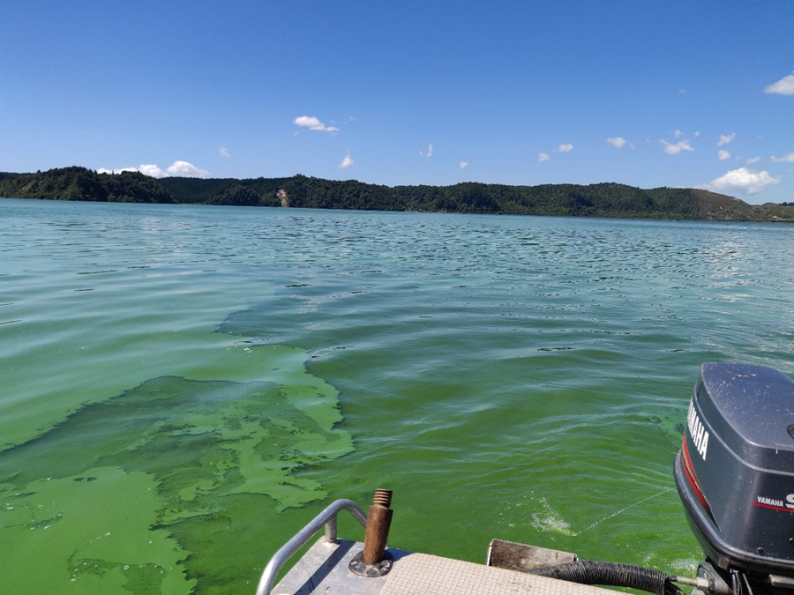
REPORT NUMBER 7 PREPARED FOR BAY OF PLENTY REGIONAL COUNCIL

Ian Kusabs & Associates Ltd
Rotorua, New Zealand
April 2019

Citation

Kusabs, I.A. (2018). Lake Rotorua kōura and morihana monitoring programme 2018 - 2019. Report number 7 prepared for Bay of Plenty Regional Council. Ian Kusabs and Associates Ltd, Rotorua, New Zealand.

Cover image
Blue green algae bloom Lake Rotoehu, 2 March 2019 (Ian Kusabs).

Table of Contents

EXECUTIVE SUMMARY iii
List of Figures iv
List of Tables iv
INTRODUCTION 1
Objectives 2
Study area 2
METHODS 3
Tau kōura construction and use 3
Kōura collection 4
Fish sampling 4
Kōura and morihana measurements 4
RESULTS 5
Kōura 5
Abundance, biomass and distribution 5
Size 6
Percentage females, breeding size with eggs and soft shells 7
Morihana 7
DISCUSSION 9
Kōura abundance and distribution 9
Kōura female to male ratio 10
Restoration measures 10
Morihana 10
CONCLUSIONS AND RECOMMENDATIONS 11
ACKNOWLEDGEMENTS 12
REFERENCES 12

EXECUTIVE SUMMARY

Lake Rotoehu is a eutrophic lake that has suffered from cyanobacteria blooms since the 1990s. The Bay of Plenty Regional Council is leading the restoration and protection programme for the lake and have implemented a number of in lake treatments and nutrient management strategies in the catchment to improve water quality.
Kōura (freshwater crayfish) and morihana (goldfish) are considered taonga (treasured) species by Te Arawa. Freshwater crayfish are also widely recognised as an important ecological component of freshwater ecosystems as they have a dominating influence on community structure.
The aims of this study were to: (1) carry out spring and summer kōura monitoring surveys, (2) monitor morihana in the lower reaches of Waitangi Stream, and (3) collect kōura and morihana samples for elemental analysis by the University of Waikato.
The kōura population in Lake Rotoehu was sampled using the tau kōura in spring (24 October 2018) and summer (2 March 2019). Four standard-mesh fyke nets were used to sample morihana in the lower reaches of the Waitangi Stream from 23 to 24 October 2018.
Kōura were relatively abundant in Lake Rotoehu in spring with a total of 415 collected (mean CPUE = 21.8 kōura whakaweku-1). However, only 65 kōura (mean CPUE = 5.6 kōura whakaweku-1) were collected in the summer survey. This continues the trend of relatively high catches in spring and very low catches in summer.
Morihana were relatively abundant (and easily captured) at the confluence of the Waitangi Stream and Lake Rotoehu. Morihana ranged in size from 70 to 220 mm with many of edible size >100 mm.
It is recommended that the spring and summer kōura monitoring surveys continue. The spring survey (typically when catches are highest) provides information on kōura population dynamics, while the summer survey provides an insight into the effects of hypolimnetic deoxygenation (and lake restoration measures) on kōura distribution in Lake Rotoehu. Moreover, the tau kōura is an effective (and safe given the poor water quality) method of collecting the kōura samples required for the University of Waikato.

List of Figures

Figure 1 Map of Lake Rotoehu showing the approximate locations of the kōura monitoring sites, Rotoehu East and Rotoehu West, and the morihana collection site (red star). 2
Figure 2 Schematic diagram of the tau kōura. The depth and length of tau are indicative and can be varied depending on lake bathymetry. 3
Figure 3 Mean CPUE for kōura captured in two tau kōura (n = 10 whakaweku) set in Lake Rotoehu, 22 November 2011 to 2 March 2019. Light bars = East site; shaded bars = West site. 5
Figure 4 Length-frequency distribution of kōura subsamples (N= 318) collected from two tau kōura each composed of 10 whakaweku retrieved from Lake Rotoehu on 24 October 2019 and 2 March 2019. 6
Figure 5 Length-frequency distribution of morihana (goldfish) captured in four standard mesh fyke nets set at the confluence of the Waitangi Stream, Lake Rotoehu, on 24 October 2018. 8
Figure 6 A brightly coloured morihana (goldfish) captured at the confluence of the Waitangi Stream and Lake Rotoehu, 24 October 2018. 8
Figure 7 (A) Hornwort fouling on a whakaweku, August 2015 (B) Retrieving the tau kōura on 2 March 2019 in a blue green algae bloom with very little hornwort on the whakaweku. 9

List of Tables

Table 1 Mean CPUE and biomass for kōura captured in two tau kōura (N = 10 whakaweku each) deployed in Lake Rotoehu, 24 October 2018 and 3 March 2019 and for the spring (N=8 samplings) and summer periods, 2011–2019 (N=7 samplings). SD in brackets. 5
Table 2 Mean size and range of kōura captured in two tau kōura (N = 10 whakaweku each) deployed in Lake Rotoehu, 24 October 2018 and 3 March 2019 and for the spring (N=8 samplings) and summer periods from 2011–2019 (N=7 samplings). SD in brackets. 6
Table 3 Number of kōura sampled, mean percentage of females, mean percentage of breeding size females with eggs or hatchlings (defined as > 17 mm OCL) and mean percentage of kōura with soft shells. Subsamples taken from two tau kōura (comprised of 10 fern bundles each) set in Lake Rotoehu, 24 October 2018 and 3 March 2019 and for the spring (N=8 samplings) and summer periods from 2011–2019 (N=7 samplings). SD in brackets. # = mean of means. 7
Table 4 Mean CPUE, mean total length and size range of morihana captured in five standard fyke nets set at the confluence of the Waitangi Stream and Lake Rotoehu, 28 September 2016, 19 September 2017 and 24 October 2018. FL = fork length. Standard deviation in brackets. 7

INTRODUCTION
Lake Rotoehu is a eutrophic lake that exceeds its specified trophic level index (TLI) as specified in the Bay of Plenty Regional Council (BOPRC) Regional Water and Land Plan. Rotoehu is shallow, polymictic lake that has suffered from cyanobacteria blooms for the past two decades. The BOPRC have implemented a number of in lake treatments and nutrient management strategies in the catchment to improve lake water quality.
Kōura (Paranephrops planifrons) are a ‘keystone’ species in many New Zealand waterways and have various ecological functions, which in turn influence other fauna and flora. They also support important fisheries in many Te Arawa lakes e.g., lakes Rotoiti, Rotomā and Tarawera (Hiroa 1921; Kusabs and Quinn 2009). In pre-European times Lake Rotoehu supported a valuable kōura fishery (Stafford 1996). But now, kōura are no longer harvested for human consumption (Pers. comm. W. Emery).
Morihana (Carassius auratus) is the common, aquarium goldfish, sometimes known as carp. The name morihana was derived from the name of Sub-Inspector H. Morrison of the Armed Constabulary who introduced them into Lake Taupō in 1872. Morihana are valued by Māori as a source of food and (in the past) were used as rongoā (health food). The Waitangi Stream is considered one of the most important areas for harvesting morihana in the Rotorua region (Pers. comm. W. Emery).
Regular kōura monitoring surveys have been undertaken in Lake Rotoehu since 2011. These surveys found that the lake supports a moderately abundant population of small and medium sized kōura. Initially, the purpose of these surveys was to determine the effects of the various lake restoration measures on kōura population dynamics and distribution. However, following the decommissioning of the destratifiers, kōura monitoring was reduced from four times (seasonal) to twice (spring and summer) per year. The rationale for this was that the spring survey (typically when catches are highest) provides data on kōura population dynamics, while the summer survey would provide information on the effects of hypolimnetic deoxygenation on kōura distribution. Given the poor water clarity and blue green algae blooms, the tau kōura would also be a convenient (and safe) means of collecting kōura samples for elemental (i.e., aluminium) analysis by the University of Waikato.

Objectives
The aims of this study, therefore, were to: (1) carry out spring and summer kōura monitoring surveys, (2) monitor morihana in the lower reaches of Waitangi Stream, and (3) collect kōura and morihana samples for the University of Waikato.

Study area
Lake Rotoehu has a surface area of 795 ha, an average depth of 8.2 m and a maximum depth of 13.5 m. It is located approximately 40 km north east of Rotorua and has a small residential community, most residing around Otautu Bay and Kennedy Bay (Figure 1). Approximately 40% of the lake catchment is in pasture with the rest in plantation forestry and native bush. The Waitangi Soda Spring beside the lake is a natural geothermal stream used for bathing.
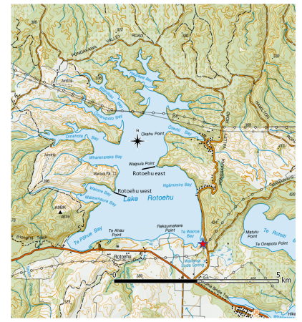
Figure 1 Map of Lake Rotoehu showing the approximate locations of the kōura monitoring sites, Rotoehu East and Rotoehu West, and the morihana collection site (red star).

METHODS

Tau kōura construction and use
The kōura population in Lake Rotoehu was sampled using the tau kōura (Figure 2) a traditional Māori method of harvesting kōura in the Te Arawa and Taupō lakes (Hiroa 1921; Kusabs and Quinn 2009).
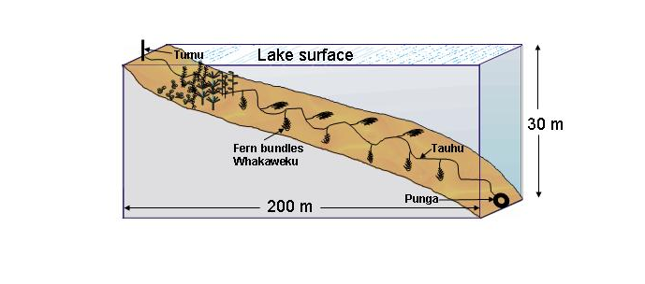
Figure 2 Schematic diagram of the tau kōura. The depth and length of tau are indicative and can be varied depending on lake bathymetry.

Two tau kōura were set in Lake Rotoehu, one each on the eastern (Rotoehu East; 38°01’03” S 176°32’05” E) and western sides (Rotoehu West; 38°01’23” S 176°31’26” E) of the lake (Figure 1). Each tau kōura was comprised of 10 whakaweku (bracken fern, Pteridium esculentum, bundles) each with c. 10 dried fronds per whakaweku (Figure 2). The bracken fern fronds were bound together using 250 mm length industrial strength cable ties and were attached using hay baling twine (~ 2.5 m long) to a 250 m length of sinking anchor rope and set. One end of the bottom line was attached to a large boulder on the shoreline while the lake end was anchored to the lake bottom using a concrete filled tyre. Tau kōura at Rotoehu East and Rotoehu West were set in water depths ranging from 4 to 11 m and 8 to 11.5 m, respectively. Whakaweku were renewed (using freshly cut bracken fronds) and deployed on 25 July 2018 and the tau kōura retrieved on 24 October 2018 (spring) and 2 March 2019 (summer).
Whakaweku (fern bundles) were deployed on 14 July 2017 and retrieved on 3 November 2017 and 18 February 2018. After kōura had been collected on 18 February, whakaweku were immediately replaced with new bracken fern. The tau kōura were then retrieved on 18 February 2018 and 17 May 2018. On 29 August 2018, the tau kōura was retrieved, kōura collected, and whakaweku replaced with fresh bracken fern. The tau kōura was then retrieved on 26 November 2018. Harvesting was achieved by lifting the shore end of the rope and successively raising each whakaweku while moving along the tauhu (bottom line) in a boat. A kōrapa (landing net) was placed beneath the whakaweku before it was lifted out of the water. The whakaweku was then shaken to dislodge all kōura from the fern into the kōrapa. The whakaweku were then returned to the water. The kōura were then collected and placed into labelled (2 litre) plastic containers to keep kōura shaded and calm before processing.

Kōura collection
Harvesting was achieved by lifting the shore end of the rope and successively raising each whakaweku while moving along the tauhu (bottom line) in a boat. A kōrapa (large net) was placed beneath the whakaweku before it was lifted out of the water. The whakaweku was then shaken to dislodge all kōura from the fern into the kōrapa. The whakaweku was then returned to the water.

Fish sampling
Fyke nets were used to capture morihana in Lake Rotoehu at Te Wairoa Bay, where the Waitangi Stream enters the lake (~ 38°01’59” S 176°32’53” E). The four-standard mesh fyke nets consisted of two compartments, 15 mm mesh (knot-to-knot or square mesh), a leader length of 2.5–3 m, and a height of 50 cm (measured at first hoop/D-ring). The leader end of the fyke nets was attached to a stake, near the lake shore while the cod-end was anchored to the lake bottom using a 2.5 kg dive weight. The nets were baited with cheese and set on the afternoon of 23 October 2018, left overnight and lifted the following morning. The catch was sorted, identified to species, and the number and size of fish recorded.

Kōura and morihana measurements
Kōura were counted and orbit-carapace length (OCL) of each kōura was measured using Vernier callipers (± 0.2 mm). Sex was recorded as male, female or indeterminate for those < 12 mm OCL (where sex could not be determined). Kōura were assessed for shell softness (soft or hard) and reproductive state (presence of eggs or hatchlings). If large numbers were captured then subsamples of the population were taken. After processing, all kōura were returned to the water in close proximity to the tau kōura. Catch per unit effort (CPUE) was defined as the number of kōura per whakaweku and biomass per unit effort (BPUE) as estimated wet weight (g) of kōura per whakaweku.
A power regression equation previously determined for this species (Riordan 2000) was used to estimate kōura wet weight (g):
W(g) = 0.000648 OCL (mm)^{3.0743}
Morihana were anaesthetized, counted, and measured for fork length (FL) to the nearest 1 mm. Most fish were then allowed to recover and released immediately back into Lake Rotoehu (Figure 3). Fifteen morihana were retained for elemental analysis at the University of Waikato. Catch per unit effort (CPUE) was defined as the number of fish per fyke net.

RESULTS

Kōura

Abundance, biomass and distribution
A total of 415 kōura were captured in October, but only 65 kōura in March (Table 1; Figure 3). This continues the trend of relatively high catches in spring and low catches in summer. Furthermore, kōura were (as in previous years) more abundant at Rotoehu East than at Rotoehu West, with a mean catch-per-unit-effort (CPUE) of 33 kōura whakaweku⁻¹ and 12 kōura whakaweku⁻¹, respectively (Table 1; Figure 3). The mean biomass-per-unit-effort (BPUE) estimates were also higher at Rotoehu East with 361 g whakaweku⁻¹ recorded in the October survey compared to 142 g whakaweku⁻¹ at Rotoehu West (Table 1; Figure 3).

Table 1 Mean CPUE and biomass for kōura captured in two tau kōura (N = 10 whakaweku each) deployed in Lake Rotoehu, 24 October 2018 and 3 March 2019 and for the spring (N=8 samplings) and summer periods, 2011–2019 (N=7 samplings). SD in brackets.
Date |  | Mean CPUE (n) |  |  | Mean BPUE (g) |  |  | Max depth of kōura (m)
 |  | East | West |  | East | West |  | East | West
24 October 2018 |  | 32.8 (12.1) | 12.0 (6.7) |  | 360.6 (173.0) | 141.5 (85.0) |  | 11.0 | 11.5
3 March 2019 |  | 7.2 (9.2) | 0.0 (0.0) |  | 86.9 (107.4) | 0.0 |  | < 9.2 | < 8.3
Spring 2011-2019 |  | 35.9 (26.9) | 19.5 (18.3) |  | 346.3 (319.5) | 211.0 (173.1)
Summer 2011-2019 |  | 9.0 (12.3) | 4.2 (9.5) |  | 120.0 (176.4) | 72.5 (159.9)

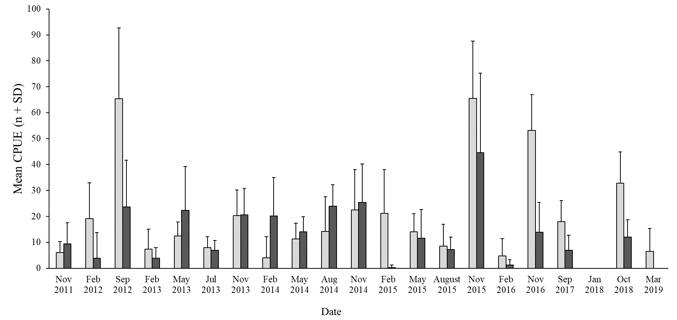
Figure 3 Mean CPUE for kōura captured in two tau kōura (n = 10 whakaweku) set in Lake Rotoehu, 22 November 2011 to 2 March 2019. Light bars = East site; shaded bars = West site.

Size
Length frequency analysis showed that the kōura population in Lake Rotoehu was composed mainly of small and medium sized kōura (Figure 4). In the October survey, the mean OCL of kōura was 23.5 mm at Rotoehu East and 24.2 mm at Rotoehu West, slightly higher than the long-term spring averages for 2011 to 2019 (Table 2). Kōura ranged in size from 10 to 37 mm OCL in October 2018, consistent with the long-term averages (Table 2). Too few kōura were captured in March 2019 to compare with previous summer surveys.
Table 2 Mean size and range of kōura captured in two tau kōura (N = 10 whakaweku each) deployed in Lake Rotoehu, 24 October 2018 and 3 March 2019 and for the spring (N=8 samplings) and summer periods from 2011–2019 (N=7 samplings). SD in brackets.
Date |  | Mean OCL (mm ± SD) |  |  | Size range (OCL) mm
 |  | East | West |  | East | West
24 October 2018 |  | 23.5 (5.2) | 24.2 (4.3) |  | 10 – 34 | 13 – 37
2 March 2019 |  | 23.3 (5.1) | – |  | 15 - 35 | –
Spring 2011-2019 |  | 22.0 (6.2) | 23.1 (5.6) |  | 10 - 43 | 9 - 39
Summer 2011-2019 |  | 24.2 (5.7) | 26.8 (5.9) |  | 12 - 43 | 14 - 40

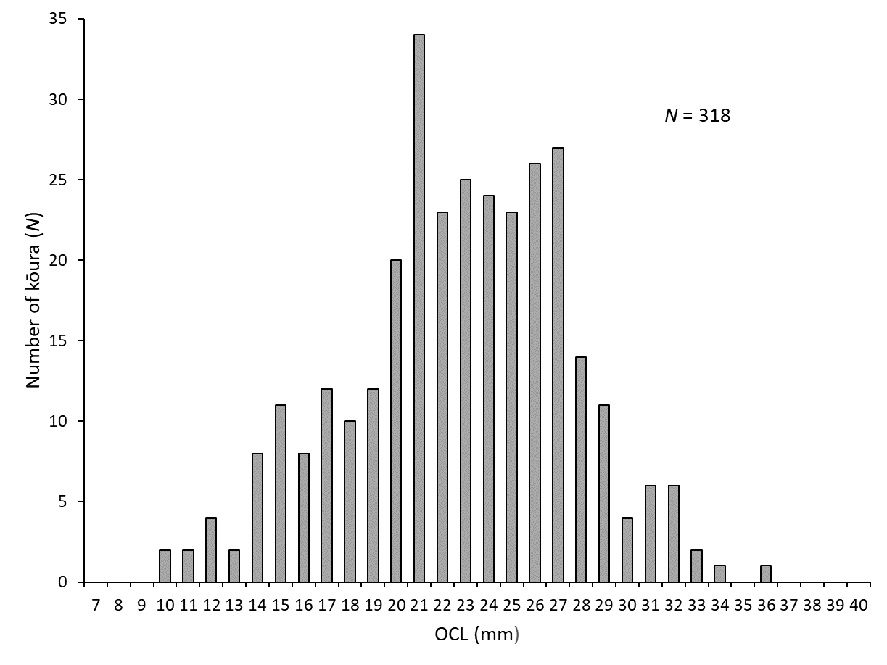
Figure 4 Length-frequency distribution of kōura subsamples (N= 318) collected from two tau kōura each composed of 10 whakaweku retrieved from Lake Rotoehu on 24 October 2019 and 2 March 2019.

Percentage females, breeding size with eggs and soft shells
Female to male ratios ranged from 39.6% in October (Rotoehu West) to 60.0% in March (Rotoehu East) (Table 3). Females with eggs were collected in October at both sites where 17.5% (Rotoehu East) and 13.6% (Rotoehu West) of female kōura of breeding size had eggs or hatchlings (Table 3). Females with eggs ranged from 22 to 33 mm OCL, similar to previous years. Kōura with soft shells were present at both sites ranging from 6.2 to 11.6%, consistent with the long-term average (Table 3).

Table 3 Number of kōura sampled, mean percentage of females, mean percentage of breeding size females with eggs or hatchlings (defined as > 17 mm OCL) and mean percentage of kōura with soft shells. Subsamples taken from two tau kōura (comprised of 10 fern bundles each) set in Lake Rotoehu, 24 October 2018 and 3 March 2019 and for the spring (N=8 samplings) and summer periods from 2011–2019 (N=7 samplings). SD in brackets. # = mean of means.
Date |  | Number of kōura sampled |  |  | % Female |  |  | % Breeding size females with eggs# |  |  | % Soft shells#
 |  | East | West |  | East | West |  | East | West |  | East | West
24 October 2018 |  | 142 | 112 |  | 47.1 | 39.6 |  | 17.5 | 13.6 |  | 6.3 | 11.6
2 March 2019 |  | 65 | - |  | 60 | - |  | 0 | - |  | 6.2 | -
Spring 2011-2019 |  | 1102 | 880 |  | 49.5 | 46.5 |  | 24.9 | 25.9 |  | 7.1 | 10.4
Summer 2011-2019 |  | 550 | 189 |  | 52.1 | 49.2 |  | 0 | 0 |  | 9.5 | 10.2

Morihana
Morihana were abundant in the lower reaches of the Waitangi Stream with a mean CPUE of 23.8 fish net⁻¹ (Table 4). Morihana ranged in size from 70 to 220 mm with a mean size of 124 mm (FL) (Table 4). Length frequency analysis showed that most morihana were between 70 and 95 mm in length (Figure 5).
Table 4 Mean CPUE, mean total length and size range of morihana captured in five standard fyke nets set at the confluence of the Waitangi Stream and Lake Rotoehu, 28 September 2016, 19 September 2017 and 24 October 2018. FL = fork length. Standard deviation in brackets.
Date | Number of nets | Water Temp | Mean CPUE | Mean Length | Size Range
 | N | ºC |  | (FL; mm) | (FL; mm)
28 September 2016 | 5 | 22 | 34.4 (32.9) | 123.7 (42.6) | 56 - 270
19 September 2017 | 5 | 17.2 | 24.0 (29.8) | 118.1 (24.2) | 63 - 225
24 October 2018 | 4 | 22 | 23.8 (9.7) | 123.6 (43.8) | 70 - 220
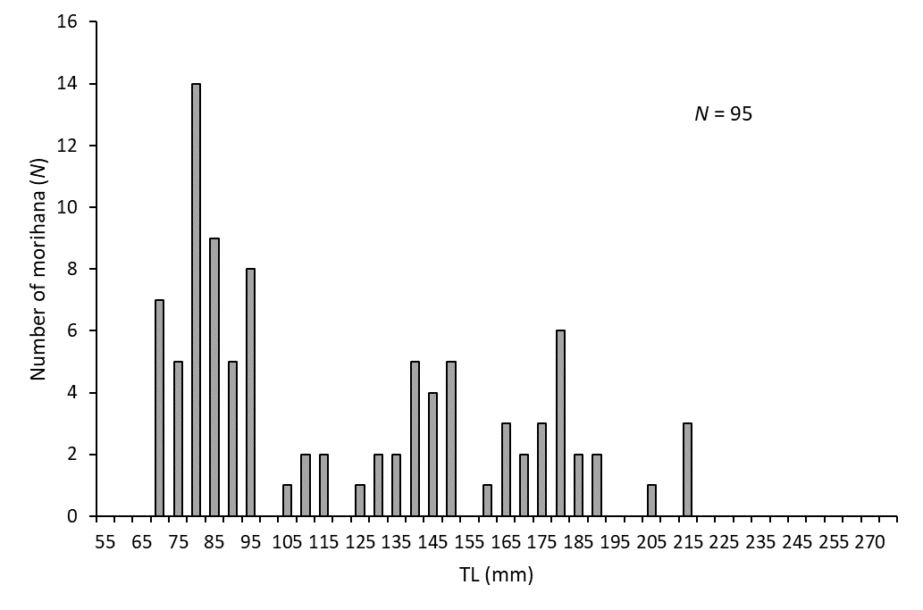
Figure 5 Length-frequency distribution of morihana (goldfish) captured in four standard mesh fyke nets set at the confluence of the Waitangi Stream, Lake Rotoehu, on 24 October 2018.

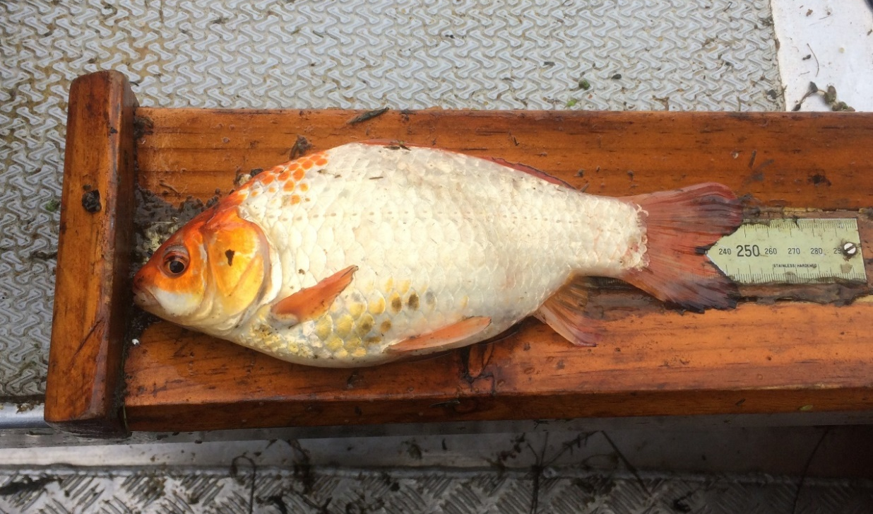
Figure 6 A brightly coloured morihana (goldfish) captured at the confluence of the Waitangi Stream and Lake Rotoehu, 24 October 2018.

DISCUSSION

Kōura abundance and distribution
Lake Rotoehu continues to support a moderately abundant population of small and medium sized kōura. However, unlike previous surveys, there was relatively little hornwort (Ceratophyllum demersum) fouling of the tau kōura (Figure 7A). This suggests that the lake has undergone a regime change from a macrophyte (aquatic weed) dominated phase to a phytoplankton dominated phase (Figure 7B).
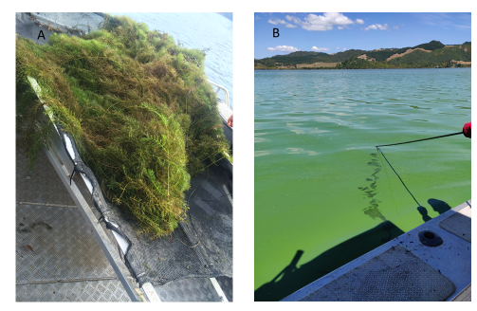
Figure 7 (A) Hornwort fouling on a whakaweku, August 2015 (B) Retrieving the tau kōura on 2 March 2019 in a blue green algae bloom with very little hornwort on the whakaweku.

Last year no kōura were collected in the summer (January 2018) survey. It was, therefore, pleasing to find that kōura were still present (at both sites) in the October 2018 survey. Moreover, kōura CPUEs were very similar to the long-term spring average for 2011 to 2019. Nonetheless, the trend of relatively high catches in spring and very low catches over the summer continues. This is most probably due to the prolonged periods of hot, calm weather conditions over the past two summers, which have resulted in stratification and hypolimnetic deoxygenation of the bottom waters.
Kōura are affected by low DO levels and begin to exhibit symptoms of oxygen stress below 5 DO mg L¹ (Devcich 1979) moving into shallow (more oxygenated) waters when this occurs (Kusabs and Butterworth 2011). Interestingly, the movement of kōura into the shallows does not result in a corresponding increase in CPUE in the shallower whakaweku. This is consistent with a study by (Kusabs et al. 2015) who also found no corresponding increase in kōura catch rates in three other Te Arawa lakes (lakes Rotoiti, Ōkāreka, Rotokakahi) that experienced summer deoxygenation events. It is evident, however, that kōura are able to survive in Lake Rotoehu despite poor summer water quality conditions. Nevertheless, the effects of declining water quality on the kōura population in Lake Rotoehu is of increasing concern.
A recent survey found that kōura were no longer present in Lakes Ngāhewa, Ngāpouri, Ōkaro and Tutaeinanga in the Rotorua lakes district (Kusabs 2017). These small, highly eutrophic lakes also have poor water quality and frequently experience nuisance cyanobacteria blooms. Kōura extirpation from these lakes has been attributed to stressors associated with the eutrophication process i.e., anoxia, elevated ammoniacal-N concentrations and release of hydrogen sulphide (Parkyn et al. 2011).

Kōura female to male ratio
The ratio of female to male Rotoehu koura was approximately 1:1. This is consistent with data collected from six Rotorua lakes, Rotorua, Rotoiti, Ōkāreka, Rotokakahi, Rotomā and Tarawera, where female kōura comprised 52.3% of sub samples collected (Kusabs unpublished PhD data). However, female kōura in Lake Rotoehu appear to breed at a smaller size than those found in in other Rotorua lakes. Interestingly, this is the only Te Arawa lake where berried kōura < 20 mm OCL have been found, including a female of 15 mm OCL, similar in size to stream-dwelling populations (Parkyn 2000).

Restoration measures
It was anticipated that lake restoration measures would improve kōura habitat in Lake Rotoehu by reducing hypolimnetic deoxygenation, thereby increasing the amount of habitat available in the summer and autumn. However, low catches over the past two summers (2017/18 and 2018/19) have shown that there has been little, if any, improvement in the amount of available habitat for kōura during this period.

Morihana
Morihana were abundant at the confluence of the Waitangi Stream and Lake Rotoehu. This is of interest as the Waitangi Stream is considered one of the most important morihana harvesting areas in the Rotorua region (Pers. comm. W. Emery). Morihana ranged in size from 70 to 220 mm with many of edible size >100 mm. The morihana catch rate (~24 fish net⁻¹) in this year’s survey was the same as in 2017.

CONCLUSIONS AND RECOMMENDATIONS
Lake Rotoehu continues to support a moderately abundant population of small and medium sized kōura. Nevertheless, the trend of relatively high catches in spring and very low catches over summer continues. This is most probably due to the prolonged periods of hot, calm weather conditions, which have resulted in stratification and hypolimnetic deoxygenation of the bottom waters. The effects of declining water quality on the kōura population is of increasing concern.
It is recommended that kōura monitoring surveys continue. The spring survey (typically when catches are highest) provides information on kōura population dynamics, while the summer survey provides an insight into the effects of hypolimnetic deoxygenation (and lake restoration measures) on kōura distribution in Lake Rotoehu. Moreover, the tau kōura is an effective method (and safe given the poor water quality) of collecting the kōura samples required for elemental analysis by the University of Waikato.

ACKNOWLEDGEMENTS
Thanks to Andy Bruere and Karla Kereopa from the BOPRC for project liaison. Thanks to Joe Butterworth and David Fryxell for fieldwork assistance.

REFERENCES
Devcich, A. A. (1979). An ecological study of Paranephrops planifrons (White) (Decapoda: Parastacidae) in Lake Rotoiti, North Island, New Zealand. University of Waikato Hamilton, New Zealand.

Hiroa, T. R. (1921). Māori food supplies of Lake Rotorua, with methods of obtaining them, and usages and customs appertaining thereto. Transactions of the New Zealand Institute 26, 429–451.

Kusabs, I. A. (2017). Lake Ngāpouri, Ngāhewa and Tutaeinanga - Monitoring of kōura and common bully using the tau kōura. Report prepared for Waikato Regional Council. Rotorua, New Zealand.

Kusabs, I. A., and Quinn, J. M. (2009). Use of a traditional Māori harvesting method, the tau kōura, for monitoring kōura (freshwater crayfish, Paranephrops planifrons) in Lake Rotoiti, North Island, New Zealand. New Zealand Journal of Marine and Freshwater Research 43.

Kusabs, I. A., Quinn, J. M., and Hamilton, D. P. (2015). Effects of benthic substrate, nutrient enrichment and predatory fish on freshwater crayfish (kōura, Paranephrops planifrons) population characteristics in seven Te Arawa (Rotorua) lakes, North Island, New Zealand. Marine and Freshwater Research 66.

Kusabs, I., and Butterworth, J. (2011). Kōura abundance and distribution in Lake Rotorua and potential effects of hypolimnetic dosing and sediment capping. Report prepared for Bay of Plenty Regional Council. Ian Kusabs & Associates Ltd, Rotorua, New Zealand.

Parkyn, S. M. (2000). Effects of native forest and pastoral land use on the population dynamics and trophic role of the New Zealand freshwater crayfish Paranephrops planifrons (Parastacidae). University of Waikato Hamilton, New Zealand.

Parkyn, S. M., Hickey, C. W., and Clearwater, S. J. (2011). Measuring sub-lethal effects on freshwater crayfish (Paranephrops planifrons) behaviour and physiology: laboratory and in situ exposure to modified zeolite. Hydrobiologia 661, 37–53.

Riordan, P. (2000). Population dynamics, habitat analysis, and food assimilation in the freshwater crayfish Paranephrops planifrons in a North Island stream. University of Waikato Hamilton, New Zealand.

Stafford, D. M. (1996). Landmarks of Te Arawa. Volume 2: Rotoiti, Rotoehu and Rotoma. Reed Books: Auckland.

The BOPRC are required (under resource consent 65966) to monitor the effects of alum dosing on kōura, goldfish and macroinvertebrates from the Waitangi Stream Lake Rotoehu.

