LaKES Rerewhakaaitu   
and ōkaro

Te Arawa Lakes - Kōura Monitoring Programme

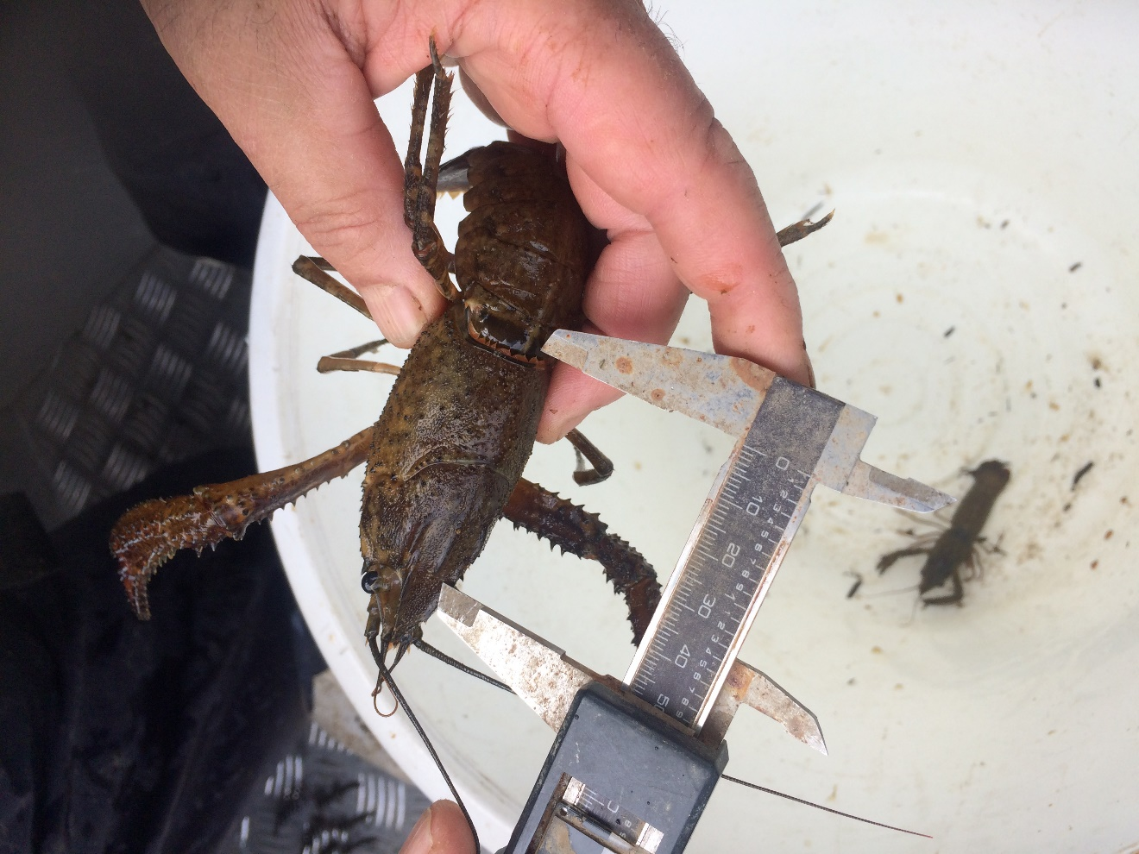

REPORT PREPARED FOR BAY OF PLENTY REGIONAL COUNCIL

Ian Kusabs & Associates Ltd

Rotorua, New Zealand

May 2017

Table of Contents

1 INTRODUCTION 1

1.1 Aims 2

2 STUDY AREA 2

3 METHODS 3

3.1 Tau kōura construction and use 3

3.2 Kōura collection and measurement 4

3.3 Comparison of kōura data with other Te Arawa lakes 6

4 RESULTS 6

4.1 Lake Rerewhakaaitu 6

4.1.1 Kōura abundance and biomass 6

4.1.2 Kōura size 7

4.1.3 Kōura - sex ratio 8

4.1.4 Egg-bearing females and moulting kōura 8

4.1.5 Common bullies 8

4.1.6 Other benthic invertebrates 8

4.2 Lake Ōkaro. 11

4.3 Comparison with other Te Arawa Lakes 11

5 DISCUSSION 13

5.1 Lake Rerewhakaaitu 13

5.2 Lake Ōkaro 14

6 Summary and conclusions 15

7 ACKNOWLEDGEMENTS 15

8 REFERENCES 15

Cover photo: A large (50 mm OCL) male kōura collected from Lake Rerewhakaaitu, 19 November 2016. I Kusabs.

List of figures

Figure 1 Schematic diagram of a tau kōura. The depth and length of tau are indicative and can be varied depending on lake bathymetry. 2

Figure 2 Map of Te Arawa Lakes showing location of lakes Rerewhakaaitu and Ōkaro. 3

Figure 3 Lakes Rerewhakaaitu and Ōkaro showing approximate locations of tau kōura sites. R1= Rerewhakaaitu Site One, R2 = Rerewhakaaitu Site Two, O1 = Ōkaro site one. 4

Figure 4 Ian Kusabs constructing whakaweku (fern bundles) for deployment in lakes Rerewhakaaitu and Ōkaro. 5

Figure 5 Joe Butterworth attaching the tauhu (bottom line of a tau kōura) to a waratah in Lake Rerewhakaaitu. Given the fluctuating water levels in Lake Rerewhakaaitu a branch was attached to the waratah to make the tau kōura easier to find. 6

Figure 6 Length frequency distribution of kōura (n = 69) captured on two tau kōura (2 x 10 whakaweku) set in Lake Rerewhakaaitu, Rotorua. Whakaweku were deployed on 4 February 2016 and retrieved on 30 March 2016, 21 June 2016, 19 November 2016 and 21 February 2017. 8

Figure 7 Mean Catch per unit effort (+ SE) of common bullies captured on two tau kōura (2 x 10 whakaweku) set in Lake Rerewhakaaitu. Whakaweku were deployed on 4 February 2016 and retrieved on 30 March 2016, 21 June 2016, 19 November 2016 and 21 February 2017. Light bars represent site R1 = Rerewhakaaitu site one and dark bars site R2= Rerewhakaaitu site two. 9

Figure 8 Dragonfly nymphs collected from a tau kōura set in Lake Rerewhakaaitu, 21 June 2016. 9

Figure 9 Kōura collected from a tau kōura set in Lake Rerewhakaaitu, 19 November 2016. 10

Figure 10 Mean Catch per unit effort (+ SE) of common bullies captured in tau kōura (2 x 10 whakaweku) set in Lake Ōkaro. Whakaweku were deployed on 4 February 2016 and retrieved on 30 March 2016, 21 June 2016, 19 November 2016, and 21 February 2017. 11

Figure 11 Mean catch-per-unit-effort (CPUE; mm + SD; 10 whakaweku x two sites) of kōura collected in twelve Te Arawa lakes. Lakes ordered in terms of increasing (approximately) Chl-a concentration. 12

Figure 12 Mean biomass-per-unit-effort (BPUE; g + SD; 10 whakaweku x two sites) of kōura collected in twelve Te Arawa lakes. Lakes ordered in terms of increasing (approximately) Chl-a concentration. 12

Figure 13: Mean orbit carapace length (mm + SD; 10 whakaweku x two sites) of kōura collected in eight Te Arawa lakes. Lakes ordered in terms of increasing (approximately) Chl-a concentration. 13

Figure 14 Iron floc on surface ~ 2cm thick, Lake Rerewhakaaitu (Photo credit; Max Gibbs, NIWA). 14

List of tables

Table 1 Sampling site, grid reference and approximate location of kōura monitoring sites, lakes Rerewhakaaitu and Ōkaro, March 2016 to February 2017. 4

Table 2 Lake, month/year sampled and source of kōura data for 12 Te Arawa lakes. 6

Table 3 Mean CPUE (n + SD) and biomass (g + SD) for kōura captured in two tau kōura (comprised of 10 whakaweku) set in Lake Rerewhakaaitu, 30 March 2016 to 21 February 2017. 6

Table 4 Mean OCL (mm + SD) and range (mm) and percentage of females for kōura captured in two tau kōura (comprised of 10 whakaweku) set in Lake Rerewhakaaitu, 30 March 2016 to 21 February 2017. 7

# 1 INTRODUCTION

The Bay of Plenty Regional Council (BOPRC) is leading the restoration and protection programme for Te Arawa lakes. Monitoring is an essential component of this programme and the BOPRC carry out both monthly and continuous monitoring (University of Waikato operated monitoring buoys) of algae, water quality (temperature, dissolved oxygen, nutrients), sediments and zooplankton. In 2016, the BOPRC committed to regular monitoring of kōura (freshwater crayfish, *Paranephrops planifrons*) in the Te Arawa lakes henceforth known as the Te Arawa lakes kōura monitoring programme.

Kōura are the largest bottom living crustacean and an important ecological component of the Te Arawa lakes. They are also an important mahinga kai species for Te Arawa iwi (Hiroa 1921; Stafford 1996) supporting customary fisheries particularly in some of the lakes. Freshwater crayfish are considered a keystone species in many freshwater ecosystems acting as predators, shredders, and detritivores (Nyström 2002). In addition, crayfish increasingly feature as indicator species because of their important role in aquatic ecosystem food webs and their iconic and heritage values (Reynolds and Souty-Grosset 2012).

Until recently, there was a lack of quantitative information on kōura abundance and ecology which made it difficult for iwi and government agencies to manage kōura populations in New Zealand lakes. However, the recent development and use of the tau kōura, a traditional Māori harvesting method (Fig. 1), for monitoring (Kusabs and Quinn 2009) and research purposes (Parkyn *et al.* 2011; Clearwater *et al.* 2012; Wood *et al.* 2012) has greatly increased understanding of kōura populations in Te Arawa lakes. Kusabs *et al.* (2015b) found that kōura abundance and distribution in seven Te Arawa lakes was influenced by the combined effects of lake-bed sediments, lake morphology, and hypolimnetic deoxygenation. Furthermore, (Kusabs *et al.* 2015a) examined biological traits of Te Arawa lake kōura and used this data to determine fisheries regulations as part of the sustainable management of kōura in Te Arawa lakes.

Regular monitoring of kōura is important because it can answer conservation questions such as ‘How are kōura populations changing within the lakes?’ ’What are the changes over time?’ ‘How are kōura populations responding to lake restoration initiatives’ and ‘Where are the most important lakes and areas for kōura?’ Long-term monitoring of kōura populations, using the tau kōura method is currently undertaken in two Te Arawa lakes –Lake Rotoiti and Lake Rotoehu (Kusabs 2016a; Kusabs 2016b). However, no substantial kōura surveys have been carried out in the other eight Te Arawa Lakes since the 2009 PhD study by Kusabs (2015). Therefore, the purpose of the Te Arawa lakes kōura monitoring programme is to carry out regular surveys of kōura populations in all ten lakes in the BOPRC region. The lakes are to be monitored on a five-yearly basis, that is, two lakes per year, with lakes not already surveyed having priority i.e., lakes Ōkataina, Rerewhakaaitu, Rotomahana and Tikitapu (Table 1). The lakes surveyed in this year’s survey (2016 – 2017) were lakes Rerewhakaaitu and Ōkaro.

### 1.1 Aims

It is expected that kōura populations in the Te Arawa lakes will ultimately benefit from improvements in water quality. Therefore, the aims of this study are to provide baseline information on kōura populations in the lakes and to determine the effects of the various lake restoration measures (and improvements in water quality) on these populations. In addition, it is envisaged that information collected on kōura biological traits will be of use to the fisheries manager - Te Arawa Lakes Trust (TALT).

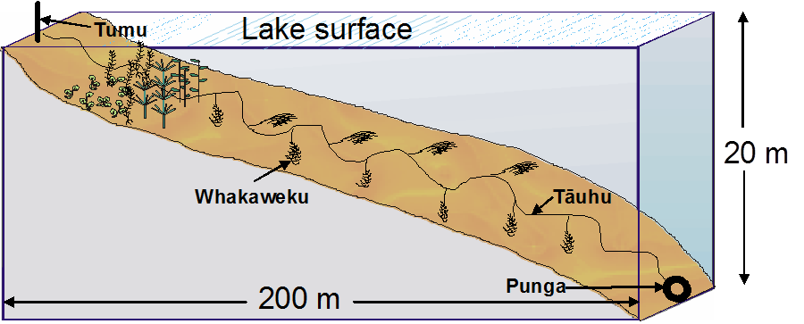

**Figure 1** Schematic diagram of a tau kōura. The depth and length of tau are indicative and can be varied depending on lake bathymetry.

# 2 STUDY AREA

Lakes Rerewhakaaitu and Ōkaro are in the Central North Island of New Zealand within the Taupo Volcanic Zone (Fig. 2).

Lake Rerewhakaaitu is a medium sized (5.3 km2), shallow, polymictic lake with an average depth of 7 m and maximum depth of 15 m. Lake Rerewhakaaitu is a mesotrophic lake and in 2016 had a Trophic Level Index (TLI) of 3.4.

Lake Ōkaro is a small (0.32 km2) lake with an average depth of 12.5 m and a maximum depth of 12.5 m. Lake Ōkaro is a eutrophic lake with a TLI in 2016 of 4.6, it has frequent nuisance cyanobacteria blooms driven by high nitrogen (N) and phosphorus (P) inputs from the catchment and a high internal phosphorus (P) load released from the sediments during summer stratiﬁcation.

In recent years, several in-lake and catchment restoration measures have been implemented to improve water quality in lakes Rerewhakaaitu and Ōkaro including; stream riparian restoration, industry best practice farm nutrient management, as well as wetland construction and alum dosing in Lake Ōkaro.

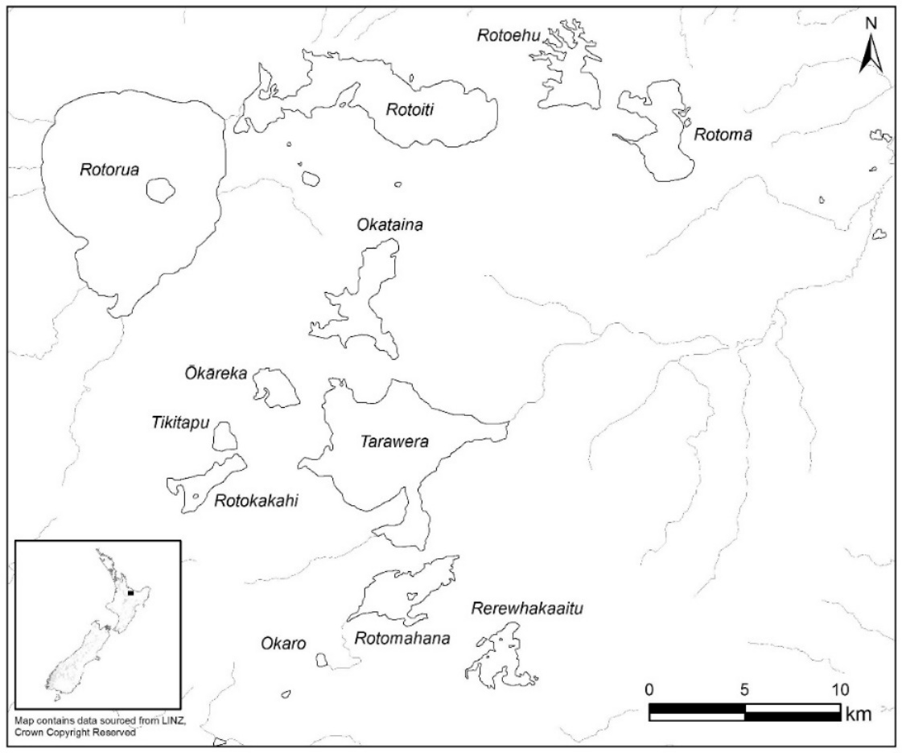

**Figure 2** Map of Te Arawa Lakes showing location of lakes Rerewhakaaitu and Ōkaro.

# 3 METHODS

### 3.1 Tau kōura construction and use

Kōura populations in lakes Rerewhakaaitu and Ōkaro were sampled using the tau kōura (Fig. 1) a traditional Māori method of harvesting kōura in the Te Arawa and Taupō lakes (Hiroa 1921; Kusabs and Quinn 2009). Two tau kōura were set in Lake Rerewhakaaitu and set in depths ranging from 2.5 m to 12.5 m (Table 1 & Fig. 3). Each tau kōura was comprised of 10 whakaweku (dried bracken fern; *Pteridium esculentum*, bundles), with c. 10 - 12 fern fronds per bundle, which were attached to a bottom line (a 250-m length of sinking anchor rope) (Table 1). In Lake Ōkaro, one tau kōura, with 20 whakaweku, was deployed in depths ranging from 2.0 m to 12.0 m (Table 1). Tau kōura were deployed on 4 February 2016 and the whakaweku left for approximately six weeks to allow kōura to colonise the fern before first retrieval. Tau kōura were retrieved on 30 March 2016, 21 June 2016, 19 November 2016 and 21 February 2017.

**Table 1** Sampling site, grid reference and approximate location of kōura monitoring sites, lakes Rerewhakaaitu and Ōkaro, March 2016 to February 2017.

|  |  |  |
| --- | --- | --- |
| Lake and  Sampling site | Latitude Longitude  (Decimal degrees) | Water depth  (m) |
| Rerewhakaaitu 1 | -38.286676 176 501386 | 2.5 – 9.0 |
| Rerewhakaaitu 2 | -38.290078 176.505999 | 6.0 - 12.5 |
| Ōkaro 1 | -38.299442 176.398167 | 2.0 – 12.0 |

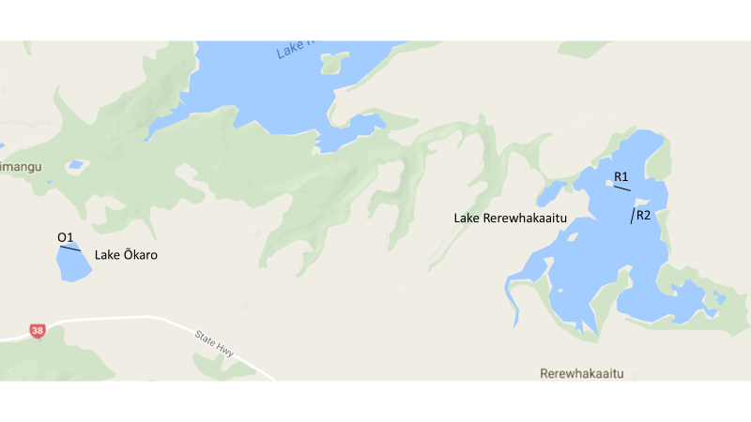

**Figure 3** Lakes Rerewhakaaitu and Ōkaro showing approximate locations of tau kōura sites. R1= Rerewhakaaitu Site One, R2 = Rerewhakaaitu Site Two, O1 = Ōkaro site one.

### 3.2 Kōura collection and measurement

Harvesting was achieved by lifting the shore end of the rope and successively raising each whakaweku while moving along the tauhu (bottom line) in a boat. A kōrapa (large net) was placed beneath the whakaweku before it was lifted out of the water. The whakaweku was then shaken to dislodge all kōura from the fern into the kōrapa. The whakaweku was then returned to the water. The kōura were then collected and placed into labelled (2 litre) plastic containers covered by lids to keep kōura shaded and calm before analysis.

All kōura were counted and assessed for shell softness (soft or hard) and those kōura >11 mm OCL[1] assessed for sex and reproductive state (presence of eggs or hatchlings). Orbit carapace length (OCL) of each kōura was measured using vernier callipers (± 0.5 mm). A power regression equation previously determined (Hicks and Riordan unpublished data) was used to estimate kōura wet weight (g) from OCL (mm):

Wet weight = 0.000648 OCL3.0743

Common bullies were counted. After processing, all kōura and common bullies were returned to the water in close proximity to the tau kōura. Catch per unit effort (CPUE) was defined as the number of kōura per whakaweku and biomass per unit effort (BPUE) as estimated wet weight (g) of kōura per whakaweku.

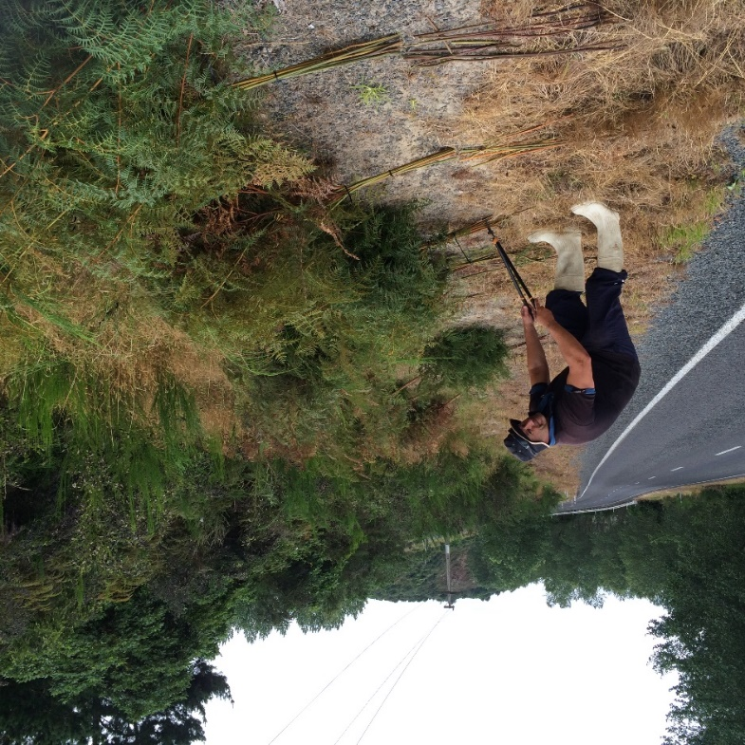

**Figure 4** Ian Kusabs constructing whakaweku (fern bundles) for deployment in lakes Rerewhakaaitu and Ōkaro.

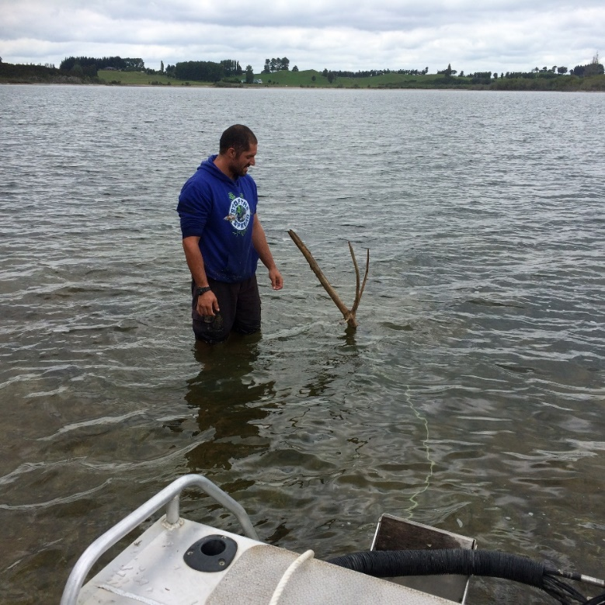

**Figure 5** Joe Butterworth attaching the tauhu (bottom line of a tau kōura) to a waratah in Lake Rerewhakaaitu. Given the fluctuating water levels in Lake Rerewhakaaitu a branch was attached to the waratah to make the tau kōura easier to find.

### 3.3 Comparison of kōura data with other Te Arawa lakes

Kōura data from lakes Rerewhakaaitu and Ōkaro was compared with 10 other Te Arawa lakes. The sources of this data were; lakes Rotomā, Tarawera, Ōkāreka, Rotokakahi (Kusabs 2015), Lake Rotoiti (Kusabs 2016b), Lake Rotoehu (Kusabs 2016a), Lake Rotorua (Kusabs unpub. data) and, lakes Ngāpouri, Ngāhewa and Tutaeinanga (Kusabs 2017) (Table 2).

**Table 2** Lake, month/year sampled and source of kōura data for 12 Te Arawa lakes.

|  |  |  |
| --- | --- | --- |
| Lake | Month/year sampled | Source |
| Ōkāreka | April, July, November 2009 | Kusabs 2015 |
| Ōkaro | March, June, November 2016; February 2017 | This report |
| Ngāhewa | December 2016 | Kusabs 2017 |
| Ngāpouri | December 2016 | Kusabs 2017 |
| Rerewhakaaitu | March, June, November 2016; February 2017 | This report |
| Rotoehu | May, August, November 2015; February 2016 | Kusabs 2016a |
| Rotoiti | March, May, August, November 2016 | Kusabs 2016b |
| Rotokakahi | April, July, November 2009 | Kusabs 2015 |
| Rotomā | April, July, November 2009 | Kusabs 2015 |
| Rotorua | July 2016, March 2017 | Kusabs unpub. data |
| Tarawera | April, July, November 2009 | Kusabs 2015 |
| Tutaeinanga | December 2016 | Kusabs 2017 |

# 4 RESULTS

### 4.1 Lake Rerewhakaaitu

## 4.1.1 Kōura abundance and biomass

Kōura were present in low numbers in Lake Rerewhakaaitu with a total of 71 kōura captured in the four surveys from 30 March 2016 to 21 February 2017 (Table 3). The highest mean CPUE of 1.8 kōura whakaweku-1 was recorded at site R1 in February while the highest mean BPUE of 34.5 g kōura whakaweku-1 was recorded at site R2 in November (Table 3).

**Table 3** Mean CPUE (n + SD) and biomass (g + SD) for kōura captured in two tau kōura (comprised of 10 whakaweku) set in Lake Rerewhakaaitu, 30 March 2016 to 21 February 2017.

|  |  |  |  |  |  |  |  |
| --- | --- | --- | --- | --- | --- | --- | --- |
| Date |  | Mean CPUE (*n* ± SD) | |  | Mean BPUE (g ±SD) | |  |
|  | R1 | R2 |  | R1 | R2 |  |
| 30 March 2016 |  | 0.2 (0.6) | 0.6 (1.6) |  | 7.8 (24.6) | 25.1 (69.3) |  |
| 21 June 2016 |  | 1.0 (0.8) | 0.8 (1.3) |  | 25.4 (33.7) | 29.6 (65.3) |  |
| 19 November 2016 |  | 1.1 (0.9) | 0.6 (0.5) |  | 8.9 (14.7) | 34.5 (38.6) |  |
| 21 February 2017 |  | 1.8 (1.6) | 1.0 (1.1) |  | 30.7 (48.6) | 31.9 (43.2) |  |

## 4.1.2 Kōura size

The mean OCL of all kōura collected in Lake Rerewhakaaitu during the study was 28.6 ± 10.5 mm (± 1 SD) with individuals ranging from 8 to 50 mm OCL (Table 4; Fig. 6). Males were significantly larger than females (ANOVA *p*= 0.008). The mean OCL of males was 31.6 ± 10.5 mm (± 1 SD) compared to 23.9 ± 6.6 mm (± 1 SD) for females. Three size classes were identified as cohorts in Lake Rerewhakaaitu (Fig. 6). The young-of-the-year (YOY) cohort ranged from 8 to ~15 mm. The age 1-year class was ~17 to 23 mm, the age 2-year class ~ 25 – 33 mm, and the age 3-year class ~ 36 – 44 mm. Numbers were too low to reliably identify year classes above these ages.

**Table 4** Mean OCL (mm + SD) and range (mm) and percentage of females for kōura captured in two tau kōura (comprised of 10 whakaweku) set in Lake Rerewhakaaitu, 30 March 2016 to 21 February 2017.

|  |  |  |  |  |  |  |  |  |  |  |
| --- | --- | --- | --- | --- | --- | --- | --- | --- | --- | --- |
| Date |  | Mean OCL (mm ±SD) | |  | OCL Range (mm) | |  | Female to male (%) | |  |
|  | R1 | R2 |  | R1 | R2 |  | R1 | R2 |  |
| 30 March 2016 |  | 34.0 (11.3) | 33.2 (12.4) |  | 26 - 42 | 14 - 50 |  | 50.0 (2) | 33.3 (6) |  |
| 21 June 2016 |  | 28.1 (10.1) | 33.6 (8.3) |  | 15 - 46 | 17 - 43 |  | 20.0 (10) | 12.5 (8) |  |
| 19 November 2016 |  | 20.2 (6.7) | 39.0 (9.2) |  | 13 - 31 | 23 - 50 |  | 36.4 (11) | 16.7 (6) |  |
| 21 February 2017 |  | 24.6 (9.6) | 31.2 (9.2) |  | 8 - 44 | 21 -43 |  | 56.3 (17) | 40.0 (9.2) |  |



**Figure 6** Length frequency distribution of kōura (*n* = 69) captured on two tau kōura (2 x 10 whakaweku) set in Lake Rerewhakaaitu, Rotorua. Whakaweku were deployed on 4 February 2016 and retrieved on 30 March 2016, 21 June 2016, 19 November 2016 and 21 February 2017.

## 4.1.3 Kōura - sex ratio

The overall ratio of female to male kōura in Lake Rerewhakaaitu was 34.8% (*n*= 69[2]). The percentage of females caught over the sampling period ranged from 12.5% to 56.3% (Table 4).

## 4.1.4 Egg-bearing females and moulting kōura

In Lake Rerewhakaaitu, two egg-bearing female kōura were present in June and two females with hatchlings were collected in November. Female kōura bearing hatchlings or eggs ranged in size from 23 to 31 mm OCL. Only a small number (n = 4) of soft-shelled kōura (all males) were collected. Kōura with soft shells were present in June (n = 1) and November (n = 3).

## 4.1.5 Common bullies

Common bullies (*Gobiomorphus cotidianus*) were present in moderate numbers in Lake Rerewhakaaitu with the highest catches recorded in June and November and the lowest in February and March (Fig. 7). Mean CPUE ranged from 1.0 to 14.9 bullies whakaweku-1.

## 4.1.6 Other benthic invertebrates

Dragonflies (Anisoptera[3]) and damselfly (Zygoptera) nymphs were abundant and collected on every sampling occasion in Lake Rerewhakaaitu (Fig. 8). Dragonfly nymphs were particularly common with the maximum number recorded ~ 470 collected from the tau kōura at site R2 in November 2016, a mean CPUE of 47 dragonflies whakaweku-1.



**Figure 7** Mean Catch per unit effort (+ SE) of common bullies captured on two tau kōura (2 x 10 whakaweku) set in Lake Rerewhakaaitu. Whakaweku were deployed on 4 February 2016 and retrieved on 30 March 2016, 21 June 2016, 19 November 2016 and 21 February 2017. Light bars represent site R1 = Rerewhakaaitu site one and dark bars site R2= Rerewhakaaitu site two.

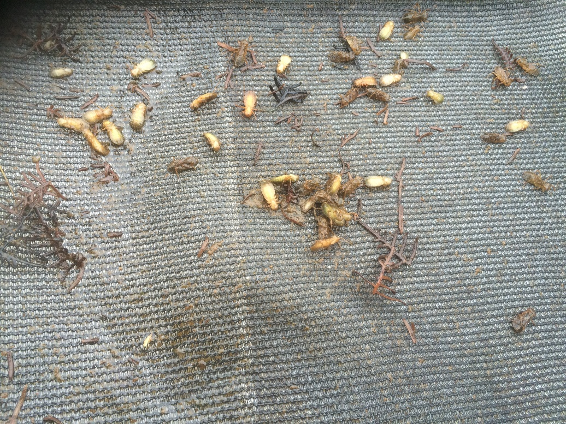

**Figure 8** Dragonfly nymphs collected from a tau kōura set in Lake Rerewhakaaitu, 21 June 2016.

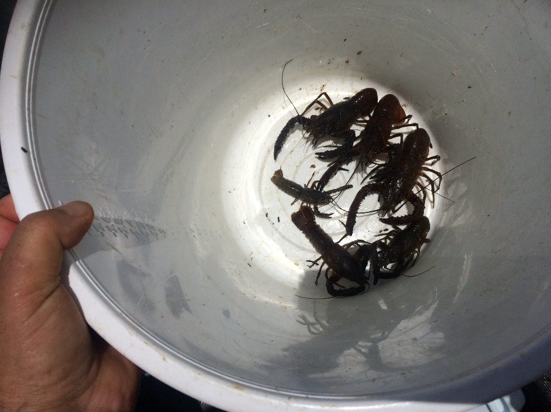

**Figure 9** Kōura collected from a tau kōura set in Lake Rerewhakaaitu, 19 November 2016.

### 4.2 Lake Ōkaro.

No kōura were captured in Lake Ōkaro. Common bullies were common and most numerous in June when the lake was mixed (Fig. 10). However, no bullies were captured below 5 m water depth in February, March, and November when the lake was stratified. Freshwater snails, dragonfly and damselfly nymphs were also common in Lake Ōkaro.



**Figure 10** Mean Catch per unit effort (+ SE) of common bullies captured in tau kōura (2 x 10 whakaweku) set in Lake Ōkaro. Whakaweku were deployed on 4 February 2016 and retrieved on 30 March 2016, 21 June 2016, 19 November 2016, and 21 February 2017.

### 4.3 Comparison with other Te Arawa Lakes

Lake Rerewhakaaitu kōura abundance was low compared to the other Te Arawa lakes where kōura have been recorded (Figs. 11 &12). Moreover, kōura were far less numerous in Lake Rerewhakaaitu when compared to Rotoehu and Rotorua, which are also shallow, polymictic lakes (Fig. 11). The mean CPUE of kōura in Lake Rerewhakaaitu was 0.9 kōura whakaweku-1 compared to 13.6 kōura whakaweku-1 in Lake Rotorua and 19.7 kōura whakaweku-1 in Lake Rotoehu (Fig. 11). Similarly, in terms of biomass, with a mean BPUE in Lake Rerewhakaaitu of 24.3 g whakaweku-1 compared to 301 g kōura whakaweku-1 in Lake Rotorua and 148 g whakaweku-1 in Lake Rotoehu (Fig. 12).

Although, low in number, Lake Rerewhakaaitu kōura were of large size with a mean OCL of 28.6 mm, the second highest in the Te Arawa lakes surveyed thus far (Fig. 13).



**Figure 11**  Mean catch-per-unit-effort (CPUE; mm + SD; 10 whakaweku x two sites) of kōura collected in twelve Te Arawa lakes. Lakes ordered in terms of increasing (approximately) Chl-*a* concentration.



**Figure 12**  Mean biomass-per-unit-effort (BPUE; g + SD; 10 whakaweku x two sites) of kōura collected in twelve Te Arawa lakes. Lakes ordered in terms of increasing (approximately) Chl-*a* concentration.



**Figure 13:** Mean orbit carapace length (mm + SD; 10 whakaweku x two sites) of kōura collected in eight Te Arawa lakes. Lakes ordered in terms of increasing (approximately) Chl-*a* concentration.

**5 DISCUSSION**

**5.1 Lake Rerewhakaaitu**

Kōura were present in low numbers in Lake Rerewhakaaitu with only 71 kōura captured in the four surveys from March 2016 to February 2017. Interestingly, kōura were far less numerous in Lake Rerewhakaaitu in comparison to Rotoehu and Rotorua, which are also shallow, polymictic lakes. The reason for this is unknown, however, it could be due to a ~2 cm layer of iron floc that blankets most of the bed of Lake Rerewhakaaitu (Max Gibbs, NIWA, unpub. data) (Fig. 14).

Iron oxide hydroxide, Fe(OH)3, is a form of iron that exits as an insoluble brown floc which settles to the sediment layer. Iron hydroxide can alter food quality, food availability, habitat structure and can attach to vital parts of animals, resulting in stress and tissue damage in benthic feeding macro-invertebrates and fish (Vuori 1995; Gerhardt A. 1995; Linton *et al.* 2007). Svobodová *et al.* (2012) reported a negative correlation between the presence of crayfish (*Austropotamobius torrentium* and *Astacus astacus*) and Fe and Al concentrations in water. Further, Svobodová *et al.* (2017) attributed the mass die-off of crayfish (*A. torrentium* and *A. astacus*) in the Kalabava Stream, Czech Republic, to extremely high concentrations of Al and Fe in the gills which resulted in hypoxia and osmoregulatory stress.

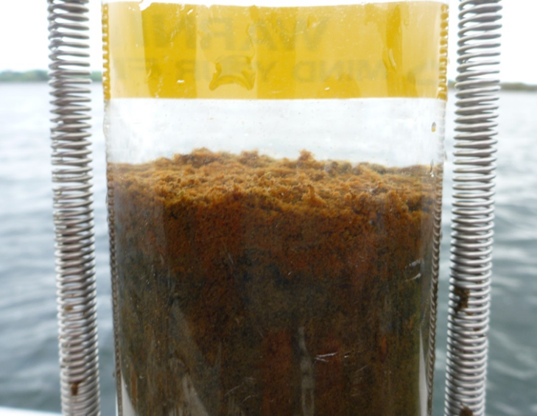

**Figure 14** Iron floc on surface ~ 2cm thick, Lake Rerewhakaaitu (Photo credit; Max Gibbs, NIWA).

Another interesting observation, when retrieving the tau kōura, was the extraordinary abundance of dragonfly larvae in Lake Rerewhakaaitu. The highest observed in any of the Te Arawa lakes (Author’s pers. obs.). Common bullies were present in moderate numbers in Lake Rerewhakaaitu with the highest catches recorded in June and November.

**5.2 Lake Ōkaro**

No kōura were collected in Lake Ōkaro in this study nor in previous surveys carried out in 2009 by Kusabs (2015). It appears, that despite improvements in water quality in the past five years or so that Lake Ōkaro still does not provide suitable conditions for kōura. Hypolimnetic deoxygenation is most likely the main cause of kōura extirpation. Kusabs *et al.* (2015b) found that hypolimnetic deoxygenation in conjunction with lake morphology appeared to indirectly affect kōura distribution in the sheltered, steep-sided lakes. Kōura were excluded from the deoxygenated hypolimnion of Lakes Ōkāreka, Rotokakahi, and Rotoiti in April when the lakes were stratified and concentrations of DO <5 mg L-1. Furthermore, periodic stratification events also cause intermittent hypolimnetic deoxygenation in Lake Rotorua (Burger *et al.* 2008; Trolle *et al.* 2011) which leads to the movement of kōura into shallower water (Kusabs and Butterworth 2011). In Lake Ōkaro dissolved oxygen concentrations regularly fall below 5 mg L-1 at a depth of 5 m affecting available habitat for kōura and fish such as common bullies.

**6 Summary and conclusions**

Lake Rerewhakaaitu supports a low abundance of large-sized kōura with only 71 kōura captured in four surveys from March 2016 to February 2017. Kōura were far less numerous in Lake Rerewhakaaitu in comparison to lakes Rotoehu and Rotorua, neighbouring shallow, polymictic lakes. It is probable that a ~2 cm layer of iron floc that blankets the bed of Lake Rerewhakaaitu is the reason for the low abundance of kōura in Lake Rerewhakaaitu. Iron hydroxide precipitates, (iron plaque layers), can decrease growth of food plants and when ingested can attach to gill and gut membranes, disturbing crayfish metabolism and mobility, thereby restricting foraging behaviour. Moreover, extremely high Fe levels can result in hypoxia, osmoregulatory stress and death.

No kōura were found in Lake Ōkaro despite recent improvements in water quality. The absence of kōura in this lake is due to multiple stressors associated with the eutrophication process, particularly rapid and prolonged hypolimnetic deoxygenation. Continued (and major) improvements in lake water quality are required before kōura populations can reestablish in this lake. It is envisaged that kōura in the inflowing tributary will provide a source of recruitment for the lakes when water quality conditions improve.

**7 ACKNOWLEDGEMENTS**

Thanks to Andy Bruere from the BOPRC for project liaison. Thanks also to Martina Katipa, Joe Butterworth and Willie Emery for fieldwork assistance and the Te Arawa Lakes Trust for their support of this programme.

**8 REFERENCES**

Burger, D. F., Hamilton, D. P., and Pilditch, C. A. (2008). Modelling the relative importance of internal and external nutrient loads on water column nutrient concentrations and phytoplankton biomass in a shallow polymictic lake. *Ecological Modelling* **211**, 411–423. doi:10.1016/j.ecolmodel.2007.09.028

Clearwater, S. J., Wood, S. A., Phillips, N. R., Parkyn, S. M., Ginkel, R. Van, and Thompson, K. J. (2012). Toxicity thresholds for juvenile freshwater mussels Echyridella menziesii and crayfish Paranephrops planifrons, after acute or chronic exposure to Microcystis sp. *Environmental Toxicology* **29**, 487–502. doi:10.1002/tox.21774

Gerhardt A., W. F. (1995). Effects of precipitations of iron hydroxides on Leptophlebia marginata (L.) (Insecta: Ephemeroptera) in the field 1995 133: *Archiv für Hydrobiology* **133**, 81–93.

Hiroa, T. R. (1921). Māori food supplies of Lake Rotorua, with methods of obtaining them, and usages and customs appertaining thereto. *Transactions of the New Zealand Institute* **26**, 429–451. Available at: http://rsnz.natlib.govt.nz/volume/rsnz_53/rsnz_53_00_005140.html

Kusabs, I. A. (2015). Kōura (*Paranephrops planifrons*) populations in the Te Arawa lakes: An ecological assessment using the traditional Māori tau kōura harvesting method and recommendations for sustainable management. University of Waikato Hamilton, New Zealand. Available at: http://hdl.handle.net/10289/9346

Kusabs, I. A. (2017). Lake Ngāpouri, Ngāhewa and Tutaeinanga - Monitoring of kōura and common bully using the tau kōura. Report prepared for Waiakto Regional Council. Rotorua, New Zealand. Available at: https://www.waikatoregion.govt.nz/assets/WRC/Services/publications/technical-reports/2017/TR201707.pdf

Kusabs, I. A. (2016a). Monitoring of kōura populations in Lake Rotoehu and comments on the effects of lake restoration measures. Report prepared for Bay of Plenty Regional Council. Rotorua, New Zealand.

Kusabs, I. A. (2016b). Ohau Channel Diversion Wall - Monitoring of kōura and kākahi populations in the Ōkere Arm and Lake Rotoiti. Report prepared for Bay of Plenty Regional Council. Rotorua, New Zealand.

Kusabs, I. A., Hicks, B. J., Quinn, J. M., and Hamilton, D. P. (2015a). Sustainable management of freshwater crayfish (koura, *Paranephrops planifrons*) in Te Arawa (Rotorua) lakes, North Island, New Zealand. *Fisheries Research* **168**. doi:10.1016/j.fishres.2015.03.015

Kusabs, I. A., Quinn, J. M., and Hamilton, D. P. (2015b). Effects of benthic substrate, nutrient enrichment and predatory fish on freshwater crayfish (koura, *Paranephrops planifrons*) population characteristics in seven Te Arawa (Rotorua) lakes, North Island, New Zealand. *Marine and Freshwater Research* **66**. doi:10.1071/MF14148

Kusabs, I., and Butterworth, J. (2011). Kōura abundance and distribution in Lake Rotorua and potential effects of hypolimnetic dosing and sediment capping. Report prepared for Bay of Plenty Regional Council. Ian Kusabs & Associates Ltd, Rotorua, New Zealand. Available at: http://www.boprc.govt.nz/media/270950/koura_abundance_and_distribution_in_lake_rotorua_and_potential_effects_of_hypolimnetic_dosing_and_sediment_capping_-_kusabs_and_butterworth_-_november_2011.pdf

Linton, T. K., Pacheco, M. A. W., McIntyre, D. O., Clement, W. H., and Goodrich-Mahoney, J. (2007). Development of bioassessment-based benchmarks for iron. *Environmental Toxicology and Chemistry* **26**, 1291–1298. doi:10.1897/06-431.1

Nyström, P. (2002). Ecology. In ‘Biology of freshwater crayfish’. (Ed D. M. Holdich.) pp. 192–235. (Blackwell Science: Oxford, UK.)

Parkyn, S. M., Hickey, C. W., and Clearwater, S. J. (2011). Measuring sub-lethal effects on freshwater crayfish (Paranephrops planifrons) behaviour and physiology: laboratory and in situ exposure to modified zeolite. *Hydrobiologia* **661**, 37–53. doi:10.1007/s10750-010-0241-8

Reynolds, J., and Souty-Grosset, C. (2012). ‘Management of freshwater biodiversity: crayfish as bioindicators’. (Cambridge University Press: Cambridge.)

Stafford, D. M. (1996). ‘Landmarks of Te Arawa. Volume 2: Rotoiti, Rotoehu and Rotoma’. (Reed Books: Auckland.)

Svobodová, J., Douda, K., Fischer, D., Lapšanská, N., and Vlach, P. (2017). Toxic and heavy metals as a cause of crayfish mass mortality from acidified headwater streams. *Ecotoxicology* **26**, 261–270. doi:10.1007/s10646-017-1760-0

Svobodová, J., Douda, K., Štambergová, M., Picek, J., Vlach, P., and Fischer, D. (2012). The relationship between water quality and indigenous and alien crayfish distribution in the Czech Republic: patterns and conservation implications. *Aquatic Conservation: Marine and Freshwater Ecosystems* **22**, 776–786. doi:10.1002/aqc.2262

Trolle, D., Hamilton, D. P., Pilditch, C. A., Duggan, I. C., and Jeppesen, E. (2011). Predicting the effects of climate change on trophic status of three morphologically varying lakes: Implications for lake restoration and management. *Environmental Modelling & Software* **26**, 354–370. doi:10.1016/j.envsoft.2010.08.009

Vuori, K.-M. (1995). Direct and indirect effects of iron on river ecosystems. *Annales Zoologici Fennici* **32**, 317–329. Available at: http://www.jstor.org/stable/23735702

Wood, S. A., Phillips, N. R., de Winton, M., and Gibbs, M. (2012). Consumption of benthic cyanobacterial mats and nodularin-R accumulation in freshwater crayfish (Paranephrops planifrons) in Lake Tikitapu (Rotorua, New Zealand). *Harmful Algae* **20**, 175–179. doi:10.1016/j.hal.2012.10.003

1. The sex of kōura < 11mm OCl could not be assessed in the field due to their small size.
2. Sex could not be determined for 2 kōura
3. infraorder