**Monitoring of kōura populations in Lake Rotoehu and comments on lake restoration measures**

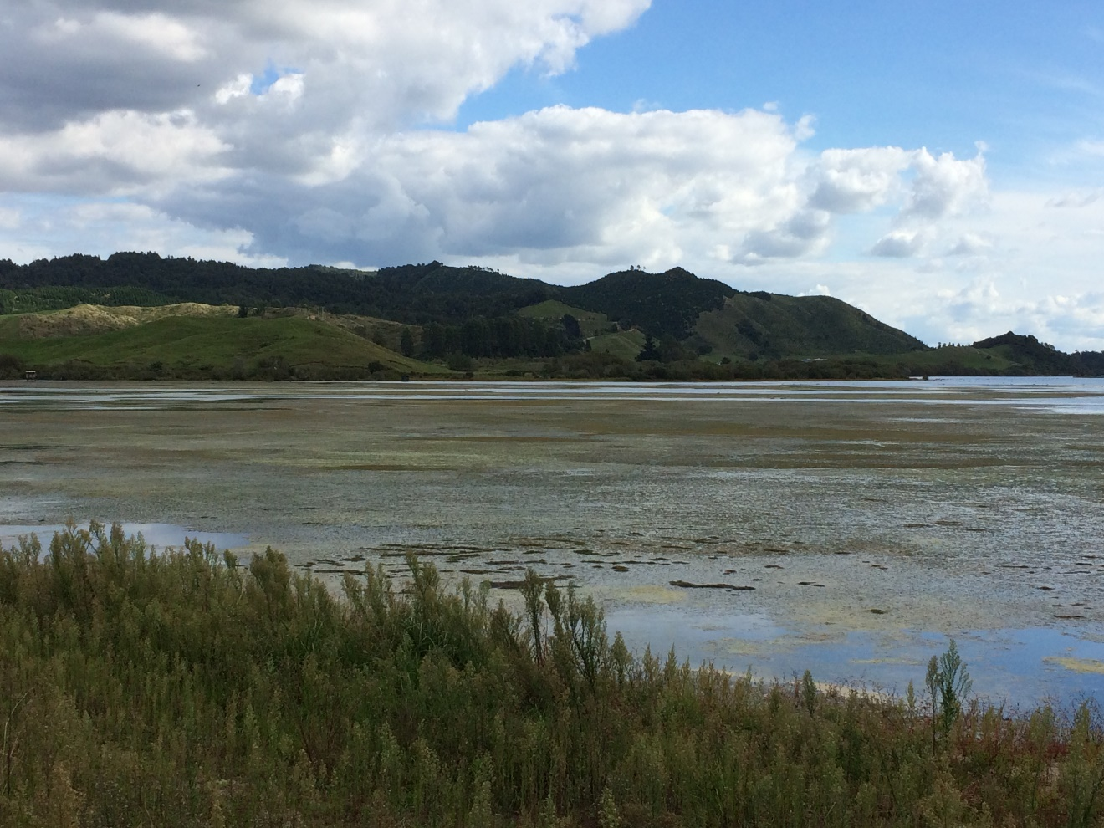

**REPORT NUMBER FIVE PREPARED FOR BAY OF PLENTY REGIONAL COUNCIL**

Ian Kusabs & Associates Ltd

Rotorua

New Zealand

July 2017

**TABLE OF CONTENTS**

1 INTRODUCTION 1

3 STUDY AREA 1

3 METHODS 3

3.1 Tau kōura construction and use 3

3.2 Kōura collection and measurement 4

4 RESULTS 5

4.1 Kōura abundance, biomass and distribution 5

4.2 Size 7

4.3 Percentage females, breeding size with eggs and soft shells 8

5 DISCUSSION 9

5.1 Kōura abundance and distribution 9

5.2 Size 11

5.3 Female to male ratio 11

6 CONCLUSIONS AND RECOMMENDATIONS 12

7 ACKNOWLEDGEMENTS 12

8 REFERENCES 13

Cover photo: Large growths of hornwort (Ceratophyllum demersum), Te Pōhue Bay, Lake Rotoehu.

List of figures

Figure 1: Map of Lake Rotoehu and catchment showing the approximate locations of the kōura monitoring sites Rotoehu East and Rotoehu West. Note: the destratifiers were decommissioned in June 2015. 2

Figure 2: Schematic diagram of the tau kōura. The depth and length of tau are indicative and can be varied depending on lake bathymetry. 3

Figure 3: CPUE (mean + SD) for kōura captured in two tau kōura (n = 10 whakaweku) set in Lake Rotoehu, 22 November 2011 to 16 November 2016. Light bars = East site; shaded bars = West site. 6

Figure 4: (A) Catch per unit effort (mean number + SD) and (B) biomass per unit effort (mean grams + SD) of kōura captured on tau kōura (composed of 10 whakaweku x two sites) set in 12 Te Arawa lakes. See section 3.3. for detail for kōura sampling details. Lakes ordered in terms of increasing Chl-a concentration. 10

Figure 5: Box-and-whisker plot showing median (horizontal line), interquartile range (box), distance from upper and lower quartiles times 1.5 interquartile range (whiskers), outliers (>1.5× upper or lower quartile) for kōura orbit carapace length (mm; 10 whakaweku x two sites) captured in Lake Rotoehu (May 2015, July 2015, November 2015 and February 2016) and seven other Te Arawa lakes (see section 3.3. for detail on kōura sampling details). Lakes ordered in terms of increasing Chl-a concentration. 11

List of tables

Table 1 Lake, month/year sampled and source of kōura data for 12 Te Arawa lakes. 4

Table 2: Mean CPUE (n + SD) and biomass (g + SD) for kōura captured in two tau kōura (comprised of 10 whakaweku) set in Lake Rotoehu, 22 November 2011 to 16 November 2016. Bold numbers indicate deoxygenation events. 5

Table 3: Mean OCL (mm ± SD) and range of kōura captured from two tau kōura (n = 10 whakaweku) set in Lake Rotoehu, 22 November 2011 to 16 November 2016. 7

Table 4: Sampling site, sampling month, number of kōura sampled, mean percentage of females, mean percentage of breeding size females with eggs or hatchlings (defined as > 17 mm OCL) and mean percentage of kōura with soft shells, in subsamples taken from two tau kōura (comprised of 10 fern bundles each) set in Lake Rotoehu, 22 November 2011 to 16 November 2016. * not calculated due to low sample numbers. 8

# 1 INTRODUCTION

Lake Rotoehu is shallow, polymictic lake that has suffered from cyanobacteria blooms since the 1990’s. The BOPRC has three in-lake treatments to improve water quality these are; floating wetlands, aquatic macrophyte harvesting in Lake Rotoehu as well as alum (aluminium sulphate) dosing of the Waitangi Stream. Artificial destratifiers were decommissioned in June 2015. Water quality, algae, zooplankton, sediments and kōura are monitored in order to determine the effect of the various lake restoration measures. Kōura are a ‘keystone’ species in many New Zealand waterways and have various ecological functions, which in turn influence other fauna and flora (Parkyn *et al.* 2001). They also support important customary fisheries in many central North Island lakes e.g., lakes Rotoiti, Rotomā, Tarawera and Taupō (Hiroa 1921; Kusabs and Quinn 2009). In pre-European times, Lake Rotoehu supported a valuable kōura fishery(Stafford 1996) but today, little, if any, kōura harvesting occurs (Pers. comm. W. Emery, Ngati Pikiao kaumatua).

In 2011 Ian Kusabs and Associates Ltd were contracted by the BOPRC to carry out a baseline survey of kōura populations in Lake Rotoehu (Kusabs and Butterworth 2013) to complement the existing monitoring programmes carried out by BOPRC and UOW. This baseline survey, and subsequent monitoring surveys (Kusabs and Butterworth 2013; Kusabs and Butterworth 2014; Kusabs and Butterworth 2015) reported that kōura were moderately abundant in Lake Rotoehu. It is expected that the kōura population will ultimately benefit from improvements in lake water quality. The purpose of this study, therefore, is to determine the effects of the lake restoration measures on kōura population characteristics and distribution in Lake Rotoehu.

# 3 STUDY AREA

Lake Rotoehu is a 795 ha lake formed along with Lake Rotomā by the Rotomā eruption approximately 8,500 years ago. Unlike Lake Rotomā, Lake Rotoehu is shallow; its average depth is 8.2 m and maximum depth 13.5 m.

In the 1960s, lake researchers noted that the algal production in the lake was occasionally sufficient to cause algal blooms to develop. This is an indication that Lake Rotoehu was nutrient enriched to probably a mesotrophic state about this time. Water clarity was reduced by about one metre, and the oxygen content in the bottom waters dropped to low levels in summer, into the 1970’s. This water quality change reflected the land use changes in the catchment over these decades from native bush and scrub to pasture (BOPRC 2007).

The lake water quality remained relatively constant at this mesotrophic state until 1993, when the nutrient levels in the lake doubled and the amount of algae in the lake quadrupled.

Since then, Lake Rotoehu has experienced cyanobacteria blooms every summer from 1993 – 1994 onwards, with an absence during the 2003 – 2004 summer. The cause of this increase in nutrients and algae is suspected to be from a 4.2 m drop in lake level combined with a warm summer and low wind speeds(BOPRC 2007). The lake level drop resulted in an increased concentration of nutrients in the lake, and when combined with warm, calm weather conditions may have caused long periods of deoxygenation of bottom waters, triggering nutrient releases from the lakebed sediment (BOPRC 2007).

Lake Rotoehu is located approximately 40 km north east of Rotorua and has a small residential community, most residing around Otautu Bay and Kennedy Bay (Fig. 1). Approximately 40% of the lake catchment is in pasture with the rest in plantation forestry and native bush. The Waitangi Soda Spring beside the lake is a natural geothermal pool used for bathing.

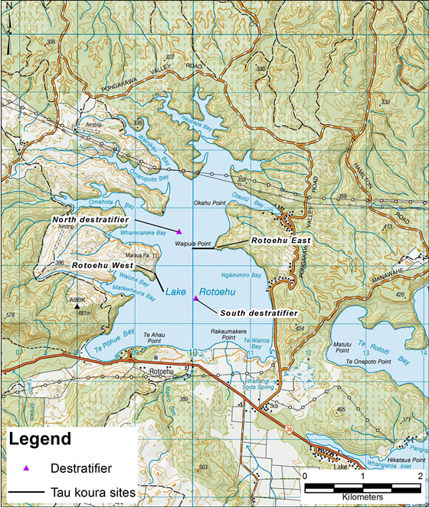

Figure 1: Map of Lake Rotoehu and catchment showing the approximate locations of the kōura monitoring sites Rotoehu East and Rotoehu West. Note: the destratifiers were decommissioned in June 2015.

# 3 METHODS

### 3.1 Tau kōura construction and use

The kōura population in Lake Rotoehu was sampled using the tau kōura (Fig. 2) a traditional Māori method of harvesting kōura in the Te Arawa and Taupō lakes (Hiroa 1921; Kusabs and Quinn 2009).

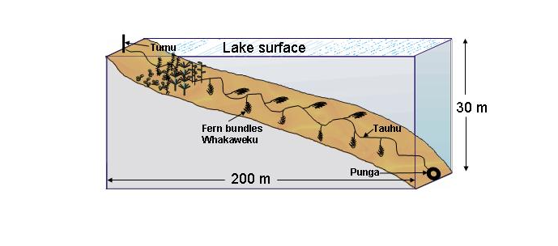

Figure 2: Schematic diagram of the tau kōura. The depth and length of tau are indicative and can be varied depending on lake bathymetry.

Two tau kōura were set in Lake Rotoehu, located on the eastern (Rotoehu East; NZTM 1910289.11 5786220.59) and western side (Rotoehu West; NZTM 1909363.00 5785684.52) of the lake (Fig. 1). Each tau kōura was comprised of 10 whakaweku (dried bracken fern, *Pteridium esculentum*, bundles) each with c. 10 dried fronds per whakaweku (Fig. 2). The bracken fern fronds were bound together using 250 or 300 mm length industrial strength cable ties and were attached using hay baling twine (approximately 2.5 m long) to a 250 m length of sinking anchor rope and set. One end of the bottom line was attached to a large boulder on the shoreline while the lake end was anchored to the lake bottom using a concrete filled tyre.

Tau kōura were set in areas that were free of high densities of invasive macrophyte beds, underwater obstructions, boulders, and reefs. The Rotoehu East and Rotoehu West tau kōura were set in water depths ranging from 4 to 11 m and 8 to 11.5 m, respectively. The tau kōura were left for at least one month to allow kōura to colonise the whakaweku.

### 3.2 Kōura collection and measurement

Harvesting was achieved by lifting the shore end of the rope and successively raising each whakaweku while moving along the tauhu (bottom line) in a boat. A korapa (large net) was placed beneath the whakaweku before it was lifted out of the water. The whakaweku was then shaken to dislodge all kōura from the fern into the korapa. The whakaweku was then returned to the water. The kōura were then collected and placed into labelled (2 litre) plastic containers covered by lids to keep kōura shaded and calm before analysis.

All kōura were counted and assessed for shell softness (soft or hard) and those kōura >11 mm OCL[1] assessed for sex and reproductive state (presence of eggs or hatchlings). If large numbers were captured then subsamples of the population were taken, typically involving measuring all kōura captured on every third whakaweku (e.g. 1, 3, 6, 9) or at least 100 individuals. Orbit carapace length (OCL) of each kōura was measured using vernier callipers (± 0.5 mm). A power regression equation was used to estimate kōura wet weight. After processing, all kōura were returned to the water in close proximity to the tau kōura. Catch per unit effort (CPUE) was defined as the number of kōura per whakaweku and biomass per unit effort (BPUE) as estimated wet weight (g) of kōura per whakaweku.

**3.3 Comparison of kōura data with other Te Arawa lakes**

Kōura data from Lake Rotoehu was compared with that from 10 other Te Arawa lakes. The most recent data for each lake was used. The sources of this data were; lakes Rotomā, Tarawera, Ōkāreka, Rotokakahi (Kusabs 2015), Lake Rotoiti (Kusabs 2016b), Lake Rotoehu (Kusabs 2016a), Lake Rotorua (Kusabs unpub. data) and, lakes Ngāpouri, Ngāhewa and Tutaeinanga (Kusabs 2017) (Table 1).

**Table 1** Lake, month/year sampled and source of kōura data for 12 Te Arawa lakes.

|  |  |  |
| --- | --- | --- |
| Lake | Month/year sampled | Source |
| Ōkāreka | April, July, November 2009 | Kusabs et al. 2015 |
| Ōkaro | March, June, November 2016; February 2017 | Kusabs 2017 |
| Ngāhewa | December 2016 | Kusabs 2017 |
| Ngāpouri | December 2016 | Kusabs 2017 |
| Rerewhakaaitu | March, June, November 2016; February 2017 | Kusabs 2017 |
| Rotoehu | May, August, November 2015; Feb & Nov 2016 | This report |
| Rotoiti | March, May, August, November 2016 | Kusabs 2016b |
| Rotokakahi | April, July, November 2009 | Kusabs 2015 |
| Rotomā | April, July, November 2009 | Kusabs 2015 |
| Rotorua | July 2016, March 2017 | Kusabs unpub. data |
| Tarawera | April, July, November 2009 | Kusabs 2015 |
| Tutaeinanga | December 2016 | Kusabs 2017 |

# 4 RESULTS

### 4.1 Kōura abundance, biomass and distribution

Kōura were abundant in Lake Rotoehu with a total of 1988 kōura captured in the four surveys from August 2015 to November 2016 (Table 2, Fig. 3). Once again the highest catches were recorded in spring (November) and the lowest in summer (February) (Table 2; Fig. 3). A mean catch per unit effort (CPUE) of 53.1 kōura whakaweku-1 was recorded at Rotoehu East in November 2016, the third highest since surveys began in 2011, while a mean CPUE of 13.1 kōura whakaweku-1 wasrecorded at the west site (Table 2; Fig. 3). A mean biomass per unit effort (BPUE) estimate of 413 g whakaweku-1 was recorded at the Rotoehu east site in November 2016, was the second highest recorded since surveys began in 2011 (Table 2; Fig. 3). In comparison, the mean BPUE of 182 g whakaweku-1 recorded at the Rotoehu west site was similar to the mean BPUE of 166182 g whakaweku-1 recorded at this site.

Table 2: Mean CPUE (n + SD) and biomass (g + SD) for kōura captured in two tau kōura (comprised of 10 whakaweku) set in Lake Rotoehu, 22 November 2011 to 16 November 2016. Bold numbers indicate deoxygenation events.

|  |  |  |  |  |  |  |  |  |  |
| --- | --- | --- | --- | --- | --- | --- | --- | --- | --- |
| Date |  | Mean CPUE (n) | |  | Mean BPUE (g) | |  | Max depth of kōura (m) | |
|  |  | East | West |  | East | West |  | East | West |
| 22 Nov 2011 |  | 6.1 (4.2) | 9.4 (8.1) |  | 37.5 (41) | 95.4 (102.7) |  | 11.0 | 11.5 |
| 24 Feb 2012 |  | 19.2 (13.7) | 3.8 (10) |  | 219.4 (171) | 61.7 (154.9) |  | 11.0 | 9.0 |
| 22 Sept 2012 |  | 65.4 (27.3) | 23.7 (17.9) |  | 888.5 (460.2) | 278.3 (200.3) |  | 11.0 | 11.5 |
| 7 Feb 2013 |  | **7.3 (7.8)** | **3.9 (4.1)** |  | 136.1 (148.6) | 84.4 (91.6) |  | **11.0** | **11.5** |
| 21 May 2013 |  | 12.4 (5.4) | 22.4 (16.8) |  | 192.6 (85.6) | 265.1 (183.7) |  | 11.0 | 11.5 |
| 31 July 2013 |  | 7.9 (4.2) | 6.9 (3.8) |  | 57.8 (32.7) | 47.4 (38.6) |  | 11.0 | 11.5 |
| 11 Nov 2013 |  | 20.3 (9.9) | 20.6 (10.1) |  | 263.0 (140.6) | 257.2 (139.0) |  | 11.0 | 11.5 |
| 14 Feb 2014 |  | **4.0 (8.2)** | 20.1 (14.9) |  | 68.3 (172.9) | 331.1 (260.7) |  | 11.0 | 11.5 |
| 22 May 2014 |  | 11.3 (6.1) | 14.0 (5.9) |  | 52.5 (60.9) | 176.5 (79.1 ) |  | 11.0 | 11.5 |
| 26 Aug 2014 |  | 14.2 (13.3) | 24.0 (8.2) |  | 119.5 (124.2) | 179.8 (89.1) |  | 11.0 | 11.5 |
| 28 Nov 2014 |  | 22.6 (15.6) | 25.4 (14.8) |  | 270.5 (192.9) | 283.0 (171.8) |  | 11.0 | 11.5 |
| 25 Feb 2015 |  | 21.1 (17.0) | **0.3 (1.0)** |  | 287.3 (268.9) | 2.6 (8.1) |  | 11.0 | **8.2** |
| 20-May-2015 |  | 14.0 (7.0) | 11.6 (11.0) |  | 128.6 (62.6) | 112.1 (98.6) |  | 11.0 | 11.5 |
| 04-Aug-2015 |  | 8.5 (8.4) | 7.2 (4.8) |  | 58.6 (57.7) | 60.0 (47.3) |  | 11.0 | 11.5 |
| 11-Nov-2015 |  | 65.5 (22.1) | 44.6 (30.7) |  | 371.5 (116.3) | 373.4 (252.2) |  | 11.0 | 11.5 |
| 27-Feb-2016 |  | 4.8 (6.7) | 1.2 (2.1) |  | 50.8 (74.1) | 27.9 (40.1) |  | 9.0 | 9.0 |
| 16 Nov 2016 |  | **53.1 (17.6)** | **13.9 (5.9)** |  | **412.7 (238.4)** | **181.5 (68.9)** |  | 11.0 | 11.5 |



Figure 3: CPUE (mean + SD) for kōura captured in two tau kōura (*n* = 10 whakaweku) set in Lake Rotoehu, 22 November 2011 to 16 November 2016. Light bars = East site; shaded bars = West site.

### 4.2 Size

Kōura ranged in size from 10 to 40 mm OCL from August 2015 to November 2016 (Table 3). The highest mean size, 27.6 mm OCL was recorded at Rotoehu West in February 2016 and lowest, 17.9 mm OCL, at Rotoehu East in August 2015 (Table 3).

Table 3: Mean OCL (mm ± SD) and range of kōura captured from two tau kōura (*n* = 10 whakaweku) set in Lake Rotoehu, 22 November 2011 to 16 November 2016.

|  |  |  |  |  |  |  |
| --- | --- | --- | --- | --- | --- | --- |
| Date |  | Mean OCL (mm ± SD) | |  | Size range (OCL) mm | |
|  |  | East | West |  | East | West |
| 22 November 2011 |  | 21.7 (5.7) | 18.1 (5.3) |  | 11 - 32 | 12 – 36 |
| 24 February 2012 |  | 22.5 (5.8) | 26.0 (4.1) |  | 12 – 38 | 18 – 34 |
| 22 September 2012 |  | 25.0 (5.1) | 23.7 (4.9) |  | 12 – 43 | 9 – 34 |
| 7 February 2013 |  | 27.6 (4.0) | 27.3 (4.1) |  | 21 – 40 | 20 – 39 |
| 21 May 2013 |  | 24.8 (6.9) | 22.8 (6.1) |  | 9 – 37 | 7 – 38 |
| 31 July 2103 |  | 19.0 (6.0) | 18.3 (6.3) |  | 8 – 32 | 10 – 31 |
| 11 November 2013 |  | 24.0 (6.3) | 23.8 (6.4) |  | 11 – 39 | 11 – 39 |
| 14 February 2014 |  | 26.1 (5.8) | 26.3 (6.6) |  | 17 – 43 | 14 – 40 |
| 22 May 2014 |  | 15.7 (5.7) | 23.1 (6.4) |  | 9 – 36 | 11 – 38 |
| 26 August 2014 |  | 19.4 (6.7) | 19.5 (6.8) |  | 11 – 40 | 12 – 40 |
| 28 November 2014 |  | 23.1 (7.3) | 22.9 (6.5) |  | 13 – 39 | 13 – 39 |
| 25 February 2015 |  | 24.9 (5.9) | 21.5 (3.5) |  | 15 – 40 | 18 – 25 |
| 20 May 2015 |  | 20.0 (7.1) | 21.3 (5.6) |  | 9 – 36 | 10 – 37 |
| 4 August 2015 |  | 17.9 (6.7) | 20.3 (5.4) |  | 10 – 36 | 11 – 35 |
| 11 November 2015 |  | 18.8 (5.2) | 21.4 (5.1) |  | 11 – 38 | 13 – 36 |
| 27 February 2016 |  | 22.8 (3.8) | 27.6 (6.1) |  | 16 – 35 | 18 – 38 |
| 16 November 2016 |  | 19.8 (6.2) | 24.2 ((5.5) |  | 12 - 40 | 14 - 38 |

### 4.3 Percentage ­females, breeding size with eggs and soft shells

Female to male ratios ranged from 36.8% in August 2015 to 54.7% in November 2016 (Table 4). Breeding sized females with eggs or hatchlings were captured in May, July and November (Table 4). Females with eggs were particularly abundant in August 2015 at both sampling sites where 45.5% and 33.3% of female kōura of breeding size had eggs or hatchlings (Table 4). Females with eggs ranged from 15 mm to 40 mm OCL. Kōura with soft shells were present on all sampling occasions and ranged from 2.1% to 11.7% (Table 4).

Table 4: Sampling site, sampling month, number of kōura sampled, mean percentage of females, mean percentage of breeding size females with eggs or hatchlings (defined as > 17 mm OCL) and mean percentage of kōura with soft shells, in subsamples taken from two tau kōura (comprised of 10 fern bundles each) set in Lake Rotoehu, 22 November 2011 to 16 November 2016. * not calculated due to low sample numbers.

|  |  |  |  |  |  |  |  |  |  |  |  |  |
| --- | --- | --- | --- | --- | --- | --- | --- | --- | --- | --- | --- | --- |
| Date |  | Number of kōura sampled | |  | % Female | |  | % Breeding size females with eggs/young | |  | % Soft shells | |
|  |  | East | West |  | East | West |  | East | West |  | East | West |
| 22 Nov 2011 |  | 61 | 94 |  | 52.5 | 51.1 |  | 6.3 | 21.9 |  | 4.9 | 10.6 |
| 24 Feb 2012 |  | 192 | 38 |  | 49.0 | 50.0 |  | 0.0 | 0.0 |  | 15.1 | 15.8 |
| 22 Sept 2012 |  | 236 | 132 |  | 57.2 | 56.8 |  | 68.2 | 56.3 |  | 3.4 | 11.1 |
| 7 Feb 2013 |  | 73 | 38 |  | 67.1 | 57.9 |  | 0.0 | 0.0 |  | 11.0 | 5.3 |
| 21 May 2013 |  | 104 | 126 |  | 57.1 | 60.2 |  | 72.5 | 63.6 |  | 7.7 | 11.9 |
| 31 July 2013 |  | 79 | 69 |  | 51.4 | 41.8 |  | 51.9 | 53.3 |  | 2.5 | 2.9 |
| 11 Nov 2013 |  | 112 | 114 |  | 46.8 | 46.9 |  | 59.1 | 56.8 |  | 7.1 | 7.0 |
| 14 Feb 2014 |  | 40 | 96 |  | 47.5 | 44.8 |  | 0.0 | 0.0 |  | 10.0 | 9.4 |
| 22 May 2014 |  | 113 | 140 |  | 57.1 | 55.8 |  | 53.3 | 60.0 |  | 6.2 | 2.9 |
| 26 Aug 2014 |  | 142 | 149 |  | 54.0 | 42.6 |  | 39.5 | 39.4 |  | 3.5 | 4.7 |
| 28 Nov 2014 |  | 127 | 126 |  | 55.1 | 45.2 |  | 18.0 | 0.0 |  | 14.2 | 8.7 |
| 25 Feb 2015 |  | 132 | 3 |  | 40.2 | - |  | 0.0 | - |  | 5.3 | - |
| 20 May 2015 |  | 140 | 116 |  | 55.9 | 50 |  | 58.8 | 38 |  | 12.9 | 6 |
| 4 Aug 2015 |  | 85 | 72 |  | 36.8 | 47.8 |  | 45.5 | 33.3 |  | 8.2 | 11.1 |
| 11 Nov 2015 |  | 150 | 131 |  | 54.7 | 50.4 |  | 12.5 | 9.4 |  | 7.3 | 4.6 |
| 27 Feb 2016 |  | 48 | 14 |  | 37.5 | 42.9 |  | 0 | * |  | 2.1 | * |
| 16 Nov 2016 |  | 154 | 103 |  | 53.6 | 43.7 |  | 7.7 | 20.5 |  | 4.5 | 11.7 |

# 

# 5 DISCUSSION

### 5.1 Kōura abundance and distribution

Lake Rotoehu continues to support a moderately abundant population of small sized kōura despite the occurrence of a lake-wide blue-green algae bloom and periodic deoxygenation of the bottom waters from 2011 to 2016. In general, the highest CPUE’s were recorded in the spring months and lowest in those summers when the lake stratified and the bottom waters became deoxygenated. Kōura are affected by low DO levels and begin to exhibit symptoms of oxygen stress below 5 DO mg L1 (Devcich 1979) moving into shallow (more oxygenated) waters when this occurs (Kusabs and Butterworth 2011). Interestingly, the movement of kōura into the shallows did not result in a corresponding increase in CPUE in the shallower (oxygenated) whakaweku. This is consistent with a study by Kusabs*, et al.* (2015b) who also found no corresponding increase in kōura catch rates in three other Te Arawa lakes (lakes Rotoiti, Ōkāreka, Rotokakahi) that experienced summer deoxygenation events.

**Comparison with other Te Arawa Lakes**

Lake Rotoehu ranks second in terms of relative abundance (mean CPUE) and fourth in relative biomass (mean BPUE) in the 12 Te Arawa lakes where tau kōura surveys have been undertaken (Fig. 4). In regard to kōura habitat, polymictic, shallow lakes such as Rotoehu appear to be more ‘resilient’ to the effects of eutrophication than monomictic, deep sided lakes e.g., Lake Ōkaro. The main reason being that shallow, polymictic lakes do not stratify for long periods and hence provide dissolved oxygen (DO) levels suitable for kōura most of the time. Kōura are affected by low DO levels and begin to exhibit symptoms of oxygen stress below 5 DO mg L-1 (Devcich 1979) moving into shallow (more oxygenated) waters when this occurs (Kusabs and Butterworth 2011).



Figure 4: (A) Catch per unit effort (mean number + SD) and (B) biomass per unit effort (mean grams + SD) of kōura captured on tau kōura (composed of 10 whakaweku x two sites) set in 12 Te Arawa lakes. See section 3.3. for detail for kōura sampling details. Lakes ordered in terms of increasing Chl-*a* concentration.

### 5.2 Size

In comparison to other Te Arawa lakes the mean OCL of Rotoehu kōura (20.6 mm) was similar to that recorded for kōura captured in Lake Rotokakahi (21.8 mm) but smaller than those in Ōkāreka, Rerewhakaaitu, Rotomā, Rotoiti, Rotorua, Tarawera and (Fig. 5). It appears that small-sized kōura comprise a higher proportion of the kōura populations in shallow, eutrophic lakes than in deeper lakes.



Figure 5: Box-and-whisker plot showing median (horizontal line), interquartile range (box), distance from upper and lower quartiles times 1.5 interquartile range (whiskers), outliers (>1.5× upper or lower quartile) for kōura orbit carapace length (mm; 10 whakaweku x two sites) captured in Lake Rotoehu (May 2015, July 2015, November 2015 and February 2016) and seven other Te Arawa lakes (see section 3.3. for detail on kōura sampling details). Lakes ordered in terms of increasing Chl-*a* concentration.

### 5.3 Female to male ratio

The ratio of female to male Rotoehu koura was approximately 1:1. This is consistent with data collected from six Rotorua lakes, Rotorua, Rotoiti, Ōkāreka, Rotokakahi, Rotomā and Tarawera, where female kōura comprised 52.3% of sub samples collected (Kusabs unpublished PhD data). However, female kōura in Lake Rotoehu appear to breed at a smaller size than those found in in other Rotorua lakes. Berried kōura were commonly recorded < 20 mm OCL, including a female of 15 mm OCL, a similar size to stream-dwelling populations (Parkyn 2000).

# 6 CONCLUSIONS AND RECOMMENDATIONS

Lake Rotoehu continues to support a moderately abundant population of small-sized kōura despite sporadic cyanobacteria blooms and dense growths of introduced macrophytes (i.e., hornwort *Ceratophyllum demersum*). The resilience of the kōura population is most due to the fact that it is polymictic and because the lake bed is comprised mainly of coarse sediments (sand and pebble sized particles). Nevertheless, kōura abundance and distribution in Lake Rotoehu have been adversely affected by hornwort invasion and eutrophication (i.e., hypolimnetic deoxygenation) resulting in a decrease in habitat available to kōura. On-going lake restoration measures should ultimately improve habitat for kōura in Lake Rotoehu by reducing hypolimnetic deoxygenation, thereby increasing the amount of available habitat in the summer and autumn.

It is recommended that monitoring of kōura in Lake Rotoehu be reduced to two surveys per year to be carried out in spring (November) and summer (February). The spring survey (typically when catches are highest) will provide information on Rotoehu kōura population dynamics, while the summer survey will provide information on the effects of hypolimnetic deoxygenation, and the various restoration measures, on kōura distribution in Lake Rotoehu. It also proposed that kōura samples be collected from the surveys for the University of Waikato for elemental analysis in order to determine the effects of alum dosing in the Waitangi Stream and Lake Rotoehu.

# 7 ACKNOWLEDGEMENTS

Thanks to Andy Bruere from the BOPRC for project liaison. Thanks also to Roger Bawden from Wildland Consultants for the map of Lake Rotoehu and Joe Butterworth for fieldwork assistance.

# 8 REFERENCES

BOPRC (2007). Lake Rotoehu Action Plan. *Environmental Publication 2007/19*. Available at: http://www.boprc.govt.nz/media/88456/finallakerotoehuactionplanlraphearingpanelchangesv7.pdf

Devcich, A. A. (1979). An ecological study of *Paranephrops planifrons* (White) (Decapoda: Parastacidae) in Lake Rotoiti, North Island, New Zealand. University of Waikato Hamilton, New Zealand.

Hiroa, T. R. (1921). Māori food supplies of Lake Rotorua, with methods of obtaining them, and usages and customs appertaining thereto. *Transactions of the New Zealand Institute* **26**, 429–451. Available at: http://rsnz.natlib.govt.nz/volume/rsnz_53/rsnz_53_00_005140.html

Kusabs, I. A. (2015). Kōura (*Paranephrops planifrons*) populations in the Te Arawa lakes: an ecological assessment using the traditional Māori tau kōura harvesting method and recommendations for sustainable management. University of Waikato Hamilton, New Zealand. Available at: http://hdl.handle.net/10289/9346

Kusabs, I. A. (2017). Lake Ngāpouri, Ngāhewa and Tutaeinanga - Monitoring of kōura and common bully using the tau kōura. Report prepared for Waiakto Regional Council. Rotorua, New Zealand. Available at: https://www.waikatoregion.govt.nz/assets/WRC/Services/publications/technical-reports/2017/TR201707.pdf

Kusabs, I. A. (2016a). Monitoring of kōura populations in Lake Rotoehu and comments on the effects of lake restoration measures. Report prepared for Bay of Plenty Regional Council. Rotorua, New Zealand.

Kusabs, I. A. (2016b). Ohau Channel Diversion Wall - Monitoring of kōura and kākahi populations in the Ōkere Arm and Lake Rotoiti. Report prepared for Bay of Plenty Regional Council. Rotorua, New Zealand.

Kusabs, I. A., and Quinn, J. M. (2009). Use of a traditional Māori harvesting method, the tau kōura, for monitoring kōura (freshwater crayfish, *Paranephrops planifrons*) in Lake Rotoiti, North Island, New Zealand. *New Zealand Journal of Marine and Freshwater Research* **43**. doi:10.1080/00288330909510036

Kusabs, I. A., Quinn, J. M., and Hamilton, D. P. (2015). Effects of benthic substrate, nutrient enrichment and predatory fish on freshwater crayfish (koura, *Paranephrops planifrons*) population characteristics in seven Te Arawa (Rotorua) lakes, North Island, New Zealand. *Marine and Freshwater Research* **66**. doi:10.1071/MF14148

Parkyn, S. M., Collier, K. J., and Hicks, B. J. (2001). New Zealand stream crayfish: functional omnivores but trophic predators? *Freshwater Biology* **46**, 641–652. doi:10.1046/j.1365-2427.2001.00702.x

Stafford, D. M. (1996). ‘Landmarks of Te Arawa. Volume 2: Rotoiti, Rotoehu and Rotoma’. (Reed Books: Auckland.)

1. The sex of kōura < 11mm OCl could not be assessed in the field due to their small size.