**Monitoring of kōura populations in Lake Rotoehu and comments on lake restoration measures**

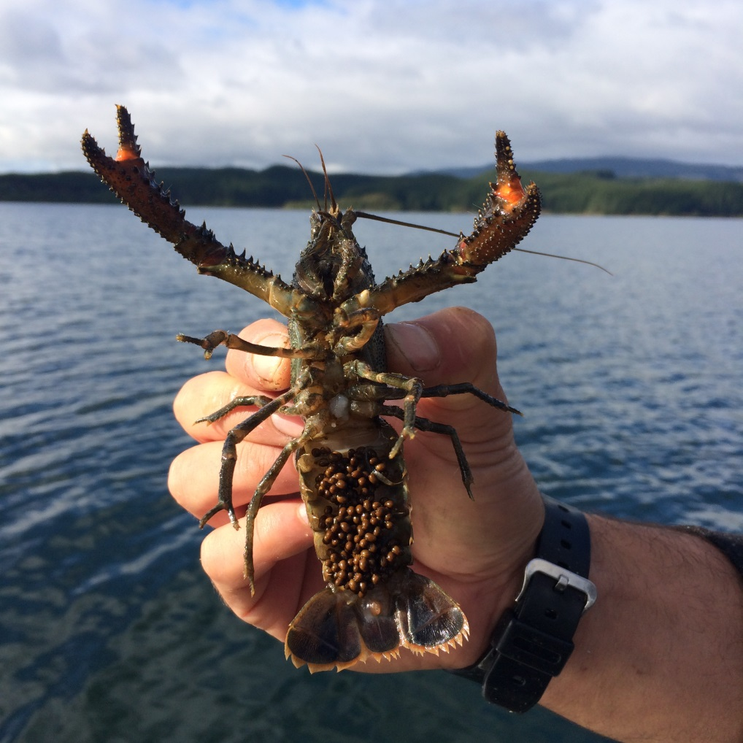

**REPORT PREPARED FOR BAY OF PLENTY REGIONAL COUNCIL**

Ian Kusabs1& Joe Butterworth2

1Ian Kusabs & Associates Ltd

2Joe Butterworth Contracting

May 2016

**TABLE OF CONTENTS**

1 INTRODUCTION 1

3 STUDY AREA 1

3 METHODS 3

3.1 Tau kōura construction and use 3

3.2 Kōura collection and measurement 4

4 RESULTS 4

4.1 Kōura abundance, biomass and distribution 4

4.2 Size 6

4.3 Percentage females, breeding size with eggs and soft shells 7

5 DISCUSSION 8

5.1 Kōura abundance and distribution 2011 to 2016 8

5.2 Size 10

5.3 Female to male ratio 11

6 CONCLUSIONS AND RECOMMENDATIONS 12

7 ACKNOWLEDGEMENTS 12

8 REFERENCES 13

Cover photo: A female kōura in breeding condition with eggs and a spermatophore, May 2015.I Kusabs.

List of figures

Figure 1: Map of Lake Rotoehu and catchment showing the approximate locations of the kōura monitoring sites Rotoehu East and Rotoehu West. 2

Figure 2: Schematic diagram of the tau kōura. The depth and length of tau are indicative and can be varied depending on lake bathymetry. 3

Figure 3: CPUE (mean + SD) for kōura captured in two tau kōura (comprising 10 whakaweku) set in Lake Rotoehu, 22 November 2011 to 27 February 2016. Light bars = East site; shaded bars = West site. 5

Figure 4: CPUE (mean + SD) of kōura captured in Rotoehu (2015 – 2016) compared to those recorded in April 2009 from seven Te Arawa lakes (two tau comprised of 10 fern bundles) (Kusabs*, et al.* 2015a; Kusabs*, et al.* 2015b). Lakes ordered in terms of increasing Chl-*a* concentration. 10

Figure 5: Mean orbit carapace length (mm + SD; 10 whakaweku x two sites) of kōura captured in eight Te Arawa lakes in April, July and November 2009 and Lake Rotoehu in May, July, November 2015 and February 2016 (Kusabs*, et al.* 2015a; Kusabs*, et al.* 2015b). Lakes ordered in terms of increasing Chl-*a* concentration. 11

List of tables

Table 1: Mean CPUE (n + SD) and biomass (g + SD) for kōura captured in two tau kōura (comprised of 10 whakaweku) set in Lake Rotoehu, 22 November 2011 to 27 February 2016. Bold numbers indicate deoxygenation events. 5

Table 2: Mean OCL (mm ± SD) and range of kōura captured from two tau kōura (*n* = 10 whakaweku) set in Lake Rotoehu, 22 November 2011 to 27 February 2016. 6

Table 3: Sampling site, sampling month, number of kōura sampled, mean percentage of females, mean percentage of breeding size females with eggs or hatchlings (defined as > 17 mm OCL) and mean percentage of kōura with soft shells, in subsamples taken from two tau kōura (comprised of 10 fern bundles each) set in Lake Rotoehu, 22 November 2011 to 25 February 2016. – not calculated due to low sample numbers. 7

# 1 INTRODUCTION

Lake Rotoehu is shallow, polymictic lake that has suffered from cyanobacteria blooms since the 1990’s. The BOPRC has four in-lake treatments to improve water quality these are; artificial destratification, floating wetlands, aquatic macrophyte harvesting, and alum dosing of the Waitangi Stream. Water quality, algae, zooplankton, sediments and kōura are monitored in order to determine the effect of the various lake restoration measures. Kōura are a ‘keystone’ species in many New Zealand waterways and have various ecological functions, which in turn influence other fauna and flora (Parkyn*, et al.* 1997). They also support important customary fisheries in many central North Island lakes e.g., lakes Rotoiti, Rotomā, Tarawera and Taupō. (Hiroa 1921; Kusabs and Quinn 2009). In pre-European times, Lake Rotoehu supported a valuable kōura fishery (Stafford 1996) but today, little, if any, kōura harvesting occurs (Pers. comm. W. Emery, Ngati Pikiao kaumatua).

In 2011 Ian Kusabs and Associates Ltd were contracted by the BOPRC to carry out a baseline survey of kōura populations in Lake Rotoehu (Kusabs and Butterworth 2013) to complement the existing monitoring programmes carried out by BOPRC and UOW. This baseline survey, and subsequent monitoring surveys (Kusabs and Butterworth 2013; Kusabs and Butterworth 2014; Kusabs and Butterworth 2015) reported that kōura were moderately abundant in Lake Rotoehu. It is expected that the kōura population will ultimately benefit from improvements in lake water quality. Therefore, the purpose of this study is to determine the effects of the various lake restoration measures on kōura population characteristics and distribution in Lake Rotoehu.

# 3 STUDY AREA

Lake Rotoehu is a 795 ha lake formed along with Lake Rotomā by the Rotomā eruption approximately 8,500 years ago. Unlike Lake Rotomā, Lake Rotoehu is shallow; its average depth is 8.2 m and maximum depth 13.5 m.

In the 1960s, lake researchers noted that the algal production in the lake was occasionally sufficient to cause algal blooms to develop. This is an indication that Lake Rotoehu was nutrient enriched to probably a mesotrophic state about this time. Water clarity was reduced by about one metre, and the oxygen content in the bottom waters dropped to low levels in summer, into the 1970’s. This water quality change reflected the land use changes in the catchment over these decades from native bush and scrub to pasture (BOPRC 2007).

The lake water quality remained relatively constant at this mesotrophic state until 1993, when the nutrient levels in the lake doubled and the amount of algae in the lake quadrupled.

Since then, Lake Rotoehu has experienced cyanobacteria blooms every summer from 1993 – 1994 onwards, with an absence during the 2003 – 2004 summer. The cause of this increase in nutrients and algae is suspected to be from a 4.2 m drop in lake level combined with a warm summer and low wind speeds (BOPRC 2007). The lake level drop resulted in an increased concentration of nutrients in the lake, and when combined with warm, calm weather conditions may have caused long periods of deoxygenation of bottom waters, triggering nutrient releases from the lakebed sediment (BOPRC 2007).

Lake Rotoehu is located approximately 40 km north east of Rotorua and has a small residential community, most residing around Otautu Bay and Kennedy Bay (Fig. 1). The rural community currently includes one dairy farm and sheep and beef grazing units. Land ownership is predominately Māori trusts, forestry interests and reserves. The lake is used for boating, trout fishing and wildfowl hunting. The Waitangi Soda Spring beside the lake is a natural geothermal pool used for bathing. Approximately 40% of the lake catchment is in pasture with the rest in plantation forestry and native bush.

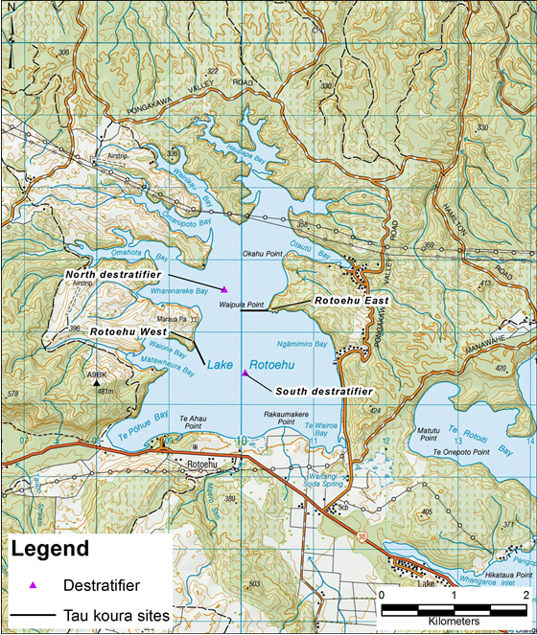

Figure 1: Map of Lake Rotoehu and catchment showing the approximate locations of the kōura monitoring sites Rotoehu East and Rotoehu West. Note: the destratifiers were decommissioned in June 2015.

.

# 3 METHODS

### 3.1 Tau kōura construction and use

The kōura population in Lake Rotoehu was sampled using the tau kōura (Fig. 2) a traditional Māori method of harvesting kōura in the Te Arawa and Taupō lakes (Hiroa 1921; Kusabs and Quinn 2009).

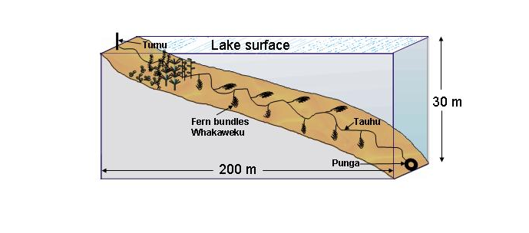

Figure 2: Schematic diagram of the tau kōura. The depth and length of tau are indicative and can be varied depending on lake bathymetry.

Two tau kōura were set in Lake Rotoehu, located on the eastern (Rotoehu East; NZTM 1910289.11 5786220.59) and western side (Rotoehu West; NZTM 1909363.00 5785684.52) of the lake (Fig. 1). Each tau kōura was comprised of 10 whakaweku (dried bracken fern, *Pteridium esculentum*, bundles) each with c. 10 dried fronds per whakaweku (Fig. 2). The bracken fern fronds were bound together using 250 or 300 mm length industrial strength cable ties and were attached using hay baling twine (approximately 2.5 m long) to a 250 m length of sinking anchor rope and set. One end of the bottom line was attached to a large boulder on the shoreline while the lake end was anchored to the lake bottom using a concrete filled tyre.

Tau kōura were set in areas that were free of high densities of invasive macrophyte beds, underwater obstructions, boulders, and reefs. The Rotoehu East and Rotoehu West tau kōura were set in water depths ranging from 4 to 11 m and 8 to 11.5 m, respectively. The tau kōura were left for at least one month to allow kōura to colonise the whakaweku.

### 3.2 Kōura collection and measurement

Harvesting was achieved by lifting the shore end of the rope and successively raising each whakaweku while moving along the tauhu (bottom line) in a boat. A korapa (large net) was placed beneath the whakaweku before it was lifted out of the water. The whakaweku was then shaken to dislodge all kōura from the fern into the korapa. The whakaweku was then returned to the water. The kōura were then collected and placed into labelled (2 litre) plastic containers covered by lids to keep kōura shaded and calm before analysis.

All kōura were counted and assessed for shell softness (soft or hard) and those kōura >11 mm OCL[1] assessed for sex and reproductive state (presence of eggs or hatchlings). If large numbers were captured then subsamples of the population were taken, typically involving measuring all kōura captured on every third whakaweku (e.g. 1, 3, 6, 9) or at least 100 individuals. Orbit carapace length (OCL) of each kōura was measured using vernier callipers (± 0.5 mm). A power regression equation was used to estimate kōura wet weight. After processing, all kōura were returned to the water in close proximity to the tau kōura. Catch per unit effort (CPUE) was defined as the number of kōura per whakaweku and biomass per unit effort (BPUE) as estimated wet weight (g) of kōura per whakaweku.

# 4 RESULTS

### 4.1 Kōura abundance, biomass and distribution

Kōura were abundant in Lake Rotoehu with a total of 1574 kōura captured in the four surveys from May 2015 to February 2016 (Table 1, Fig. 3). Once again the highest catches were recorded in spring (November) and the lowest in summer (February) (Table 1; Fig. 3). A mean Catch per unit effort (CPUE) of 65.51 kōura whakaweku-1 was recorded at Rotoehu East in November 2015, the highest since surveys began in 2011. The mean biomass per unit effort (BPUE) estimates of 371.5 and 373.4 g kōura whakaweku-1, recorded in November 2015, were also amongst the highest recorded since surveys began in 2011 (Table 1; Fig. 3). In contrast, kōura mean CPUE and BPUE estimates were low in summer (February 2016) due to lake stratification, with kōura present on the first five whakaweku of each tau kōura.

Table 1: Mean CPUE (n + SD) and biomass (g + SD) for kōura captured in two tau kōura (comprised of 10 whakaweku) set in Lake Rotoehu, 22 November 2011 to 27 February 2016. Bold numbers indicate deoxygenation events.

|  |  |  |  |  |  |  |  |  |  |
| --- | --- | --- | --- | --- | --- | --- | --- | --- | --- |
| Date |  | Mean CPUE (n) | |  | Mean BPUE (g) | |  | Max depth of kōura (m) | |
|  |  | East | West |  | East | West |  | East | West |
| 22 Nov 2011 |  | 6.1 (4.2) | 9.4 (8.1) |  | 37.5 (41) | 95.4 (102.7) |  | 11.0 | 11.5 |
| 24 Feb 2012 |  | 19.2 (13.7) | 3.8 (10) |  | 219.4 (171) | 61.7 (154.9) |  | 11.0 | 9.0 |
| 22 Sept 2012 |  | 65.4 (27.3) | 23.7 (17.9) |  | 888.5 (460.2) | 278.3 (200.3) |  | 11.0 | 11.5 |
| 7 Feb 2013 |  | **7.3 (7.8)** | **3.9 (4.1)** |  | 136.1 (148.6) | 84.4 (91.6) |  | **11.0** | **11.5** |
| 21 May 2013 |  | 12.4 (5.4) | 22.4 (16.8) |  | 192.6 (85.6) | 265.1 (183.7) |  | 11.0 | 11.5 |
| 31 July 2013 |  | 7.9 (4.2) | 6.9 (3.8) |  | 57.8 (32.7) | 47.4 (38.6) |  | 11.0 | 11.5 |
| 11 Nov 2013 |  | 20.3 (9.9) | 20.6 (10.1) |  | 263.0 (140.6) | 257.2 (139.0) |  | 11.0 | 11.5 |
| 14 Feb 2014 |  | **4.0 (8.2)** | 20.1 (14.9) |  | 68.3 (172.9) | 331.1 (260.7) |  | 11.0 | 11.5 |
| 22 May 2014 |  | 11.3 (6.1) | 14.0 (5.9) |  | 52.5 (60.9) | 176.5 (79.1 ) |  | 11.0 | 11.5 |
| 26 Aug 2014 |  | 14.2 (13.3) | 24.0 (8.2) |  | 119.5 (124.2) | 179.8 (89.1) |  | 11.0 | 11.5 |
| 28 Nov 2014 |  | 22.6 (15.6) | 25.4 (14.8) |  | 270.5 (192.9) | 283.0 (171.8) |  | 11.0 | 11.5 |
| 25 Feb 2015 |  | 21.1 (17.0) | **0.3 (1.0)** |  | 287.3 (268.9) | 2.6 (8.1) |  | 11.0 | **8.2** |
| 20-May-15 |  | 14.0 (7.0) | 11.6 (11.0) |  | 128.6 (62.6) | 112.1 (98.6) |  | 11.0 | 11.5 |
| 04-Aug-15 |  | 8.5 (8.4) | 7.2 (4.8) |  | 58.6 (57.7) | 60.0 (47.3) |  | 11.0 | 11.5 |
| 11-Nov-15 |  | 65.5 (22.1) | 44.6 (30.7) |  | 371.5 (116.3) | 373.4 (252.2) |  | 11.0 | 11.5 |
| 27-Feb-16 |  | **4.8 (6.7)** | **1.2 (2.1)** |  | **50.8 (74.1)** | **27.9 (40.1)** |  | **9.0** | **9.0** |



Figure 3: CPUE (mean + SD) for kōura captured in two tau kōura (comprising 10 whakaweku) set in Lake Rotoehu, 22 November 2011 to 27 February 2016. Light bars = East site; shaded bars = West site.

### 4.2 Size

Kōura ranged in size from 9 to 38 mm OCL in the 2015 to 2016 sampling programme (Table 2). The highest mean size, 27.6 mm OCL was recorded at Rotoehu West in February 2016 and lowest mean size, 17.9 mm OCL, at Rotoehu East in August 2015 (Table 2). The mean OCL for 2015 to 2016 (four months) was 20.3 (SD ± 6.0) smaller than the 21.3 (SD ± 7.0) recorded the 2014 to 2015 period.

Table 2: Mean OCL (mm ± SD) and range of kōura captured from two tau kōura (*n* = 10 whakaweku) set in Lake Rotoehu, 22 November 2011 to 27 February 2016.

|  |  |  |  |  |  |  |
| --- | --- | --- | --- | --- | --- | --- |
| Date |  | Mean OCL (mm ± SD) | |  | Size range (OCL) mm | |
|  |  | East | West |  | East | West |
| 22 November 2011 |  | 21.7 (5.7) | 18.1 (5.3) |  | 11 - 32 | 12 – 36 |
| 24 February 2012 |  | 22.5 (5.8) | 26.0 (4.1) |  | 12 – 38 | 18 – 34 |
| 22 September 2012 |  | 25.0 (5.1) | 23.7 (4.9) |  | 12 – 43 | 9 – 34 |
| 7 February 2013 |  | 27.6 (4.0) | 27.3 (4.1) |  | 21 – 40 | 20 – 39 |
| 21 May 2013 |  | 24.8 (6.9) | 22.8 (6.1) |  | 9 – 37 | 7 – 38 |
| 31 July 2103 |  | 19.0 (6.0) | 18.3 (6.3) |  | 8 – 32 | 10 – 31 |
| 11 November 2013 |  | 24.0 (6.3) | 23.8 (6.4) |  | 11 – 39 | 11 – 39 |
| 14 February 2014 |  | 26.1 (5.8) | 26.3 (6.6) |  | 17 – 43 | 14 – 40 |
| 22 May 2014 |  | 15.7 (5.7) | 23.1 (6.4) |  | 9 – 36 | 11 – 38 |
| 26 August 2014 |  | 19.4 (6.7) | 19.5 (6.8) |  | 11 – 40 | 12 – 40 |
| 28 November 2014 |  | 23.1 (7.3) | 22.9 (6.5) |  | 13 – 39 | 13 – 39 |
| 25 February 2015 |  | 24.9 (5.9) | 21.5 (3.5) |  | 15 – 40 | 18 – 25 |
| 20 May 2015 |  | 20.0 (7.1) | 21.3 (5.6) |  | 9 – 36 | 10 – 37 |
| 4 August 2015 |  | 17.9 (6.7) | 20.3 (5.4) |  | 10 – 36 | 11 – 35 |
| 11 November 2015 |  | 18.8 (5.2) | 21.4 (5.1) |  | 11 – 38 | 13 – 36 |
| 27 February 2016 |  | 22.8 (3.8) | 27.6 (6.1) |  | 16 – 35 | 18 – 38 |

### 4.3 Percentage ­females, breeding size with eggs and soft shells

As in previous years the overall ratio of females to males was approximately 1:1 (49.3%) of the subsamples recorded (Table 3). Female to male ratios ranged from 36.8% in August to 55.9% in May (Table 3). Breeding sized females with eggs or hatchlings were captured in May, July and November (Table 3). Females with eggs were particularly abundant in May 2015 at both sampling sites where 58.8% and 38% of female kōura of breeding size had eggs or hatchlings (Table 3). Females with eggs ranged from 18 mm to 34 mm OCL. Kōura with soft shells were present on all sampling occasions and ranged from 4.6% to 12.9% (Table 3).

Table 3: Sampling site, sampling month, number of kōura sampled, mean percentage of females, mean percentage of breeding size females with eggs or hatchlings (defined as > 17 mm OCL) and mean percentage of kōura with soft shells, in subsamples taken from two tau kōura (comprised of 10 fern bundles each) set in Lake Rotoehu, 22 November 2011 to 25 February 2016. – not calculated due to low sample numbers.

|  |  |  |  |  |  |  |  |  |  |  |  |  |
| --- | --- | --- | --- | --- | --- | --- | --- | --- | --- | --- | --- | --- |
| Date |  | Number of kōura sampled | |  | % Female | |  | % Breeding size females with eggs/young | |  | % Soft shells | |
|  |  | East | West |  | East | West |  | East | West |  | East | West |
| 22 Nov 2011 |  | 61 | 94 |  | 52.5 | 51.1 |  | 6.3 | 21.9 |  | 4.9 | 10.6 |
| 24 Feb 2012 |  | 192 | 38 |  | 49.0 | 50.0 |  | 0.0 | 0.0 |  | 15.1 | 15.8 |
| 22 Sept 2012 |  | 236 | 132 |  | 57.2 | 56.8 |  | 68.2 | 56.3 |  | 3.4 | 11.1 |
| 7 Feb 2013 |  | 73 | 38 |  | 67.1 | 57.9 |  | 0.0 | 0.0 |  | 11.0 | 5.3 |
| 21 May 2013 |  | 104 | 126 |  | 57.1 | 60.2 |  | 72.5 | 63.6 |  | 7.7 | 11.9 |
| 31 July 2013 |  | 79 | 69 |  | 51.4 | 41.8 |  | 51.9 | 53.3 |  | 2.5 | 2.9 |
| 11 Nov 2013 |  | 112 | 114 |  | 46.8 | 46.9 |  | 59.1 | 56.8 |  | 7.1 | 7.0 |
| 14 Feb 2014 |  | 40 | 96 |  | 47.5 | 44.8 |  | 0.0 | 0.0 |  | 10.0 | 9.4 |
| 22 May 2014 |  | 113 | 140 |  | 57.1 | 55.8 |  | 53.3 | 60.0 |  | 6.2 | 2.9 |
| 26 Aug 2014 |  | 142 | 149 |  | 54.0 | 42.6 |  | 39.5 | 39.4 |  | 3.5 | 4.7 |
| 28 Nov 2014 |  | 127 | 126 |  | 55.1 | 45.2 |  | 18.0 | 0.0 |  | 14.2 | 8.7 |
| 25 Feb 2015 |  | 132 | 3 |  | 40.2 | - |  | 0.0 | - |  | 5.3 | - |
| 20 May 2015 |  | 140 | 116 |  | 55.9 | 50 |  | 58.8 | 38 |  | 12.9 | 6 |
| 4 Aug 2015 |  | 85 | 72 |  | 36.8 | 47.8 |  | 45.5 | 33.3 |  | 8.2 | 11.1 |
| 11 Nov 2015 |  | 150 | 131 |  | 54.7 | 50.4 |  | 12.5 | 9.4 |  | 7.3 | 4.6 |
| 27 Feb 2016 |  | 48 | 14 |  | 37.5 | 42.9 |  | 0 | - |  | 2.1 | - |

# 5 DISCUSSION

### 5.1 Kōura abundance and distribution 2011 to 2016

Lake Rotoehu continues to support a moderately abundant population of small sized kōura despite the occurrence of a lake-wide blue-green algae bloom and periodic deoxygenation of the bottom waters from 2011 to 2016. In general, the highest CPUE’s were recorded in the spring months and lowest in those summers when the lake stratified and the bottom waters became deoxygenated. Kōura are affected by low DO levels and begin to exhibit symptoms of oxygen stress below 5 DO mg L1 (Devcich 1979) moving into shallow (more oxygenated) waters when this occurs (Kusabs and Butterworth 2011). Interestingly, the movement of kōura into the shallows did not result in a corresponding increase in CPUE in the shallower (oxygenated) whakaweku. This is consistent with a study by Kusabs*, et al.* (2015b) who also found no corresponding increase in kōura catch rates in three other Te Arawa lakes (lakes Rotoiti, Ōkāreka, Rotokakahi) that experienced summer deoxygenation events.

**Destratifier effects on kōura distribution**

In February 2015, Kusabs and Butterworth (2015) suggested that that the greater depth distribution of kōura at the east site (compared to the west site) may have been due to its close proximity (<0.3 km) to the North destratifier (Fig. 1). This hypothesis appears to be supported by the decommissioning of the North destratifier in June 2015, which coincided with a reduction in kōura depth distribution at the East site in February 2015. At both the East and West sites, kōura were only found on the first five whakaweku of each tau kōura, suggesting that low dissolved oxygen concentrations (<5 mg l-1) had excluded kōura from whakaweku set at depths in excess of 9 m.

**Macrophyte effects**

Hornwort is a brittle, poorly attached plant that has been reported to smother tau kōura, not only restricting kōura access to the whakaweku but also leading to the rapid decay of the fern itself (Kusabs*, et al.* 2013). However, the effect of hornwort on the kōura population and tau kōura efficacy in Lake Rotoehu is less certain. In Lake Rotoehu, kōura were commonly found even on those whakaweku smothered with hornwort; in fact, the hornwort seemed to provide favourable habitat for kōura. This contrasts with the situation in Lake Rotoiti where kōura were excluded from whakaweku heavily infested with hornwort. The reasons for this are unclear but it could be due to the polymictic nature of Lake Rotoehu which provides DO concentrations suitable for kōura most of the time. Nevertheless, excessive macrophyte growths are almost certainly detrimental to kōura abundance and distribution in Lake Rotoehu. Hessen*, et al.* (2004) reported that the introduction of *Elodea canadensis* resulted in a sudden decrease in crayfish (*Astacus astacus*) abundance in Lake Steinsfjorden (southeast Norway) with crayfish excluded from the shallow areas of the lake (where they were once abundant) because of dense stands of *Elodea*.

**Lake restoration measures and kōura**

At present, kōura populations in Lake Rotoehu are affected by hypolimnetic deoxygenation and excessive macrophyte growth, which reduce the amount of available kōura habitat. Measures to improve water quality in Lake Rotoehu should benefit kōura populations by reducing hypolimnetic deoxygenation, thereby increasing the amount of available habitat in the summer and autumn. A reduction in macrophytes would extend habitat for kōura particularly in the summer when the lake stratifies and dissolved oxygen concentrations are reduced in the bottom waters.

**Comparison with other Te Arawa Lakes**

In terms of relative abundance Rotoehu ranks in the middle of eight Te Arawa lakes where relative kōura abundance has been determined with Rotoehu mean CPUE higher than those recorded in Lakes Ōkaro, Ōkāreka, Tarawera and Rotokākāhi but lower than those in Lakes Rotorua, Rotomā and Rotoiti (Fig. 4). In regard to kōura habitat, polymictic, shallow lakes such as Rotoehu appear to be more ‘resilient’ to the effects of eutrophication than monomictic, deep sided lakes e.g., Lake Ōkaro. The main reason being that shallow, polymictic lakes do not stratify for long periods and hence provide dissolved oxygen (DO) levels suitable for kōura most of the time. Kōura are affected by low DO levels and begin to exhibit symptoms of oxygen stress below 5 DO mg L-1 (Devcich 1979) moving into shallow (more oxygenated) waters when this occurs (Kusabs and Butterworth 2011).



Figure 4: CPUE (mean + SD) of kōura captured in Rotoehu (2015 – 2016) compared to those recorded in April 2009 from seven Te Arawa lakes (two tau comprised of 10 fern bundles) (Kusabs*, et al.* 2015a; Kusabs*, et al.* 2015b). Lakes ordered in terms of increasing Chl-*a* concentration.

### 5.2 Size

In comparison to other Te Arawa lakes the mean OCL of Rotoehu kōura (20.3 mm) was similar to that recorded for kōura captured in lakes Rotorua (20.4 mm) and Rotokakahi (21.8 mm) but smaller than those in Rotomā, Rotoiti, Tarawera and Ōkāreka (Fig. 5). It appears that small-sized kōura comprise a higher proportion of the kōura populations in shallow, eutrophic lakes than in deeper lakes.



Figure 5: Mean orbit carapace length (mm + SD; 10 whakaweku x two sites) of kōura captured in eight Te Arawa lakes in April, July and November 2009 and Lake Rotoehu in May, July, November 2015 and February 2016 (Kusabs*, et al.* 2015a; Kusabs*, et al.* 2015b). Lakes ordered in terms of increasing Chl-*a* concentration.

### 5.3 Female to male ratio

The ratio of female to male Rotoehu koura was approximately 1:1. This is consistent with data collected from six Rotorua lakes, Rotorua, Rotoiti, Ōkāreka, Rotokakahi, Rotomā and Tarawera, where female kōura comprised 52.3% of sub samples collected (Kusabs unpublished PhD data). However, female kōura in Lake Rotoehu appear to breed at a smaller size than those found in in other Rotorua lakes. Berried kōura were commonly recorded < 20 mm OCL, including two females of 17.2 mm OCL, similar to stream-dwelling populations (Parkyn 2000).

# 6 CONCLUSIONS AND RECOMMENDATIONS

Lake Rotoehu continues to support a moderately abundant population of small-sized kōura despite sporadic cyanobacteria blooms and dense growths of introduced macrophytes (i.e., hornwort). The resilience of the kōura population is most due to the fact that it is polymictic and because the lake bed is comprised mainly of coarse sediments (sand and pebble sized particles). Nevertheless, kōura abundance and distribution in Lake Rotoehu have been adversely affected by hornwort invasion and eutrophication (i.e., hypolimnetic deoxygenation) resulting in a decrease in habitat available to kōura. On-going lake restoration measures should ultimately improve habitat for kōura in Lake Rotoehu by reducing hypolimnetic deoxygenation, thereby increasing the amount of available habitat in the summer and autumn.

It is recommended that monitoring of kōura in Lake Rotoehu be reduced to two surveys per year to be carried out in spring (November) and summer (February). The spring survey (typically when catches are highest) will provide information on Rotoehu kōura population dynamics, while the summer survey will provide information on the effects of hypolimnetic deoxygenation, and the various restoration measures, on kōura distribution in Lake Rotoehu. It also proposed that kōura samples be collected from the surveys for the University of Waikato for elemental analysis in order to determine the effects of alum dosing in the Waitangi Stream and Lake Rotoehu.

# 7 ACKNOWLEDGEMENTS

Thanks to Andy Bruere and Niroy Sumeran from the BOPRC for project liaison. Thanks also to Roger Bawden from Wildland Consultants for the map of Lake Rotoehu and Martina Katipa and Willie Emery for fieldwork assistance.

# 8 REFERENCES

BOPRC. 2007. Lake Rotoehu Action Plan. Environmental Publication 2007/19. Bay of Plenty Regional Council. Available from <http://www.boprc.govt.nz/media/88456/finallakerotoehuactionplanlraphearingpanelchangesv7.pdf> Accessed [23 September 2014].

Devcich, A.A. 1979. An ecological study of *Paranephrops planifrons* (White) (Decapoda: Parastacidae) in Lake Rotoiti, North Island, New Zealand. PhD, University of Waikato, Hamilton, New Zealand.

Hessen, D., Skurdal, J. and Braathen, J. 2004. Plant exclusion of a herbivore; crayfish population decline caused by an invading waterweed. Biological Invasions **6**, 133-140.

Hiroa, T.R. 1921. Māori food supplies of Lake Rotorua, with methods of obtaining them, and usages and customs appertaining thereto. Transactions of the New Zealand Institute **26**, 429-451.

Kusabs, I. and Butterworth, J. 2011. Kōura abundance and distribution in Lake Rotorua and potential effects of hypolimnetic dosing and sediment capping. Report prepared for Bay of Plenty Regional Council. Ian Kusabs & Associates Ltd, Rotorua, New Zealand.

Kusabs, I. and Butterworth, J. 2013. Kōura abundance and distribution in Lake Rotoehu. Report number 1 prepared for Bay of Plenty Regional Council. Ian Kusabs & Associates Ltd, Rotorua, New Zealand. 12 pp.

Kusabs, I. and Butterworth, J. 2014. Kōura abundance and distribution in Lake Rotoehu. Report number 2 prepared for Bay of Plenty Regional Council. Ian Kusabs & Associates Ltd, Rotorua, New Zealand.

Kusabs, I. and Butterworth, J. 2015. Monitoring of kōura populations in Lake Rotoehu and comments on the effects of lake restoration measures. Report number 3 prepared for Bay of Plenty Regional Council. Ian Kusabs & Associates Ltd, Rotorua, New Zealand. 12 pp.

Kusabs, I., Emery, W. and Butterworth, J. 2013. Ohau Channel Diversion Wall - An assessment of the kōura and kākahi populations in the Okere Arm and Lake Rotoiti. Report prepared for Bay of Plenty Regional Council. Ian Kusabs & Associates Ltd, Rotorua, New Zealand.

Kusabs, I.A., Hicks, B.J., Quinn, J.M. and Hamilton, D.P. 2015a. Sustainable management of freshwater crayfish (kōura, *Paranephrops planifrons*) in Te Arawa (Rotorua) lakes, North Island, New Zealand. Fisheries Research **168**, 35-46.

Kusabs, I.A. and Quinn, J.M. 2009. Use of a traditional Māori harvesting method, the tau kōura, for monitoring kōura (freshwater crayfish, *Paranephrops planifrons*) in Lake Rotoiti, North Island, New Zealand. New Zealand Journal of Marine and Freshwater Research **43**, 713-722.

Kusabs, I.A., Quinn, J.M. and Hamilton, D.P. 2015b. Effects of benthic substrate, nutrient enrichment and predatory fish on freshwater crayfish (kōura, Paranephrops planifrons) population characteristics in seven Te Arawa (Rotorua) lakes, North Island, New Zealand. Marine and Freshwater Research -.

Parkyn, S.M. 2000. Effects of native forest and pastoral land use on the population dynamics and trophic role of the New Zealand freshwater crayfish *Paranephrops planifrons* (Parastacidae). PhD thesis, University of Waikato, Hamilton, New Zealand.

Parkyn, S.M., Rabeni, C.F. and Collier, K.J. 1997. Effects of crayfish (*Paranephrops planifrons* : Parastacidae) on in-stream processes and benthic faunas: a density manipulation experiment. New Zealand Journal of Marine and Freshwater Research **31**, 685-692.

Stafford, D.M. 1996. Landmarks of Te Arawa. Volume 2: Rotoiti, Rotoehu and Rotoma. Reed Books, Auckland.

1. The sex of kōura < 11mm OCl could not be assessed in the field due to their small size.