Monitoring of kōura populations in Lake Rotoehu and comments on lake restoration measures

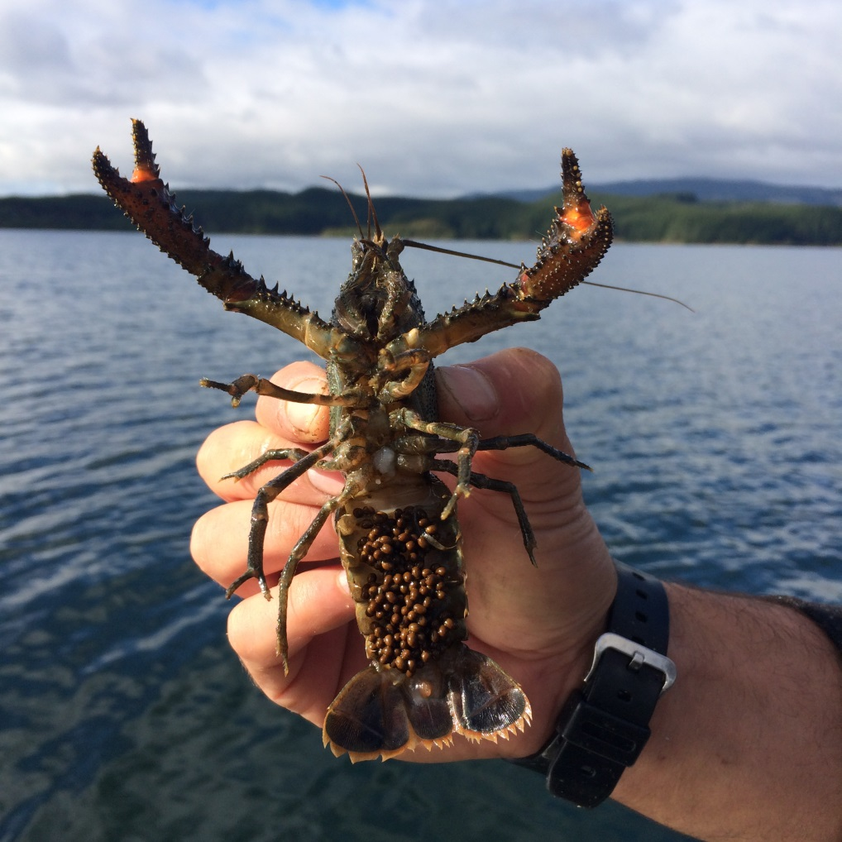

REPORT PREPARED FOR BAY OF PLENTY REGIONAL COUNCIL

Ian Kusabs¹& Joe Butterworth²
¹Ian Kusabs & Associates Ltd
²Joe Butterworth Contracting

May 2015

TABLE OF CONTENTS

1 INTRODUCTION 1
3 STUDY AREA 1
3 METHODS 3
3.1 Tau kōura construction and use 3
3.2 Kōura collection and measurement 4
4 RESULTS 4
4.1 Kōura abundance, biomass and distribution 4
4.2 Size 6
4.3 Percentage females, breeding size with eggs and soft shells 7
5 DISCUSSION 8
5.1 Kōura abundance and distribution 8
5.2 Size 10
5.3 Female to male ratio 10
6 CONCLUSION 11
7 ACKNOWLEDGEMENTS 11
8 REFERENCES 12

Cover photo: A female kōura in breeding condition with eggs and a spermatophore, May 2015.I Kusabs.

List of figures

Figure 1: Map of Lake Rotoehu and catchment showing the approximate locations of the kōura monitoring sites Rotoehu East and Rotoehu West. 2
Figure 2: Schematic diagram of the tau kōura. The depth and length of tau are indicative and can be varied depending on lake bathymetry. 3
Figure 3: CPUE (mean + SD) for kōura captured in two tau kōura (comprised of 10 whakaweku) set in Lake Rotoehu, 22 November 2011 to 25 February 2015. Light bars = East site; shaded bars = West site. 5
Figure 4: CPUE (mean + SD) of kōura captured in Rotoehu (2014 – 2015) compared to those recorded in April 2009 from seven Te Arawa lakes (two tau comprised of 10 fern bundles) (Kusabs, et al. 2015a; Kusabs, et al. 2015b). Lakes ordered in terms of increasing Chl-a concentration. 9
Figure 5: Mean orbit carapace length (mm + SD; 10 whakaweku x two sites) of kōura captured in eight Te Arawa lakes in April, July and November 2009 and Lake Rotoehu in May, July, November 2013, and February 2014 (Kusabs, et al. 2015a; Kusabs, et al. 2015b). Lakes ordered in terms of increasing Chl-a concentration. 10

List of tables

Table 1: Mean CPUE (n + SD) and biomass (g + SD) for kōura captured in two tau kōura (comprised of 10 whakaweku) set in Lake Rotoehu, 22 November 2011 to 25 February 2015. 5
Table 2: Mean OCL (mm ± SD) and range of kōura captured from two tau kōura (n = 10 whakaweku) set in Lake Rotoehu, 22 November 2011 to 25 February 2015. 6
Table 3: Sampling site, sampling month, number of kōura sampled, mean percentage of females, mean percentage of breeding size females with eggs or hatchlings (defined as > 17 mm OCL) and mean percentage of kōura with soft shells, in subsamples taken from two tau kōura (comprised of 10 fern bundles each) set in Lake Rotoehu, 22 November 2011 to 25 February 2015. 7

1 INTRODUCTION
Lake Rotoehu is shallow, polymictic lake that has suffered from cyanobacteria blooms since the 1990’s. The BOPRC has four in-lake treatments to improve water quality these are; artificial destratification, floating wetlands, aquatic macrophyte harvesting, and alum dosing of the Waitangi Stream. Water quality, algae, zooplankton, sediments and kōura are monitored in order to determine the effect of the various lake restoration measures. Kōura are a ‘keystone’ species in many New Zealand waterways and have various ecological functions, which in turn influence other fauna and flora (Parkyn, et al. 1997). They also support important customary fisheries in many central North Island lakes e.g., lakes Rotoiti, Rotomā, Tarawera and Taupō. (Hiroa 1921; Kusabs and Quinn 2009). In pre-European times, Lake Rotoehu supported a valuable kōura fishery (Stafford 1996) but today, little, if any, kōura harvesting occurs (Pers. comm. W. Emery, Ngati Pikiao kaumatua).
In 2011 Ian Kusabs and Associates Ltd were contracted by the BOPRC to carry out a baseline survey of kōura populations in Lake Rotoehu (Kusabs and Butterworth 2013) to complement the existing monitoring programmes carried out by BOPRC and UOW. This baseline survey, and subsequent monitoring surveys (Kusabs and Butterworth 2013; Kusabs and Butterworth 2014) reported that kōura were moderately abundant in Lake Rotoehu. It is expected that the kōura population will ultimately benefit from improvements in lake water quality. Therefore, the purpose of this study is to determine the effects of the various lake restoration measures on kōura population characteristics and distribution in Lake Rotoehu.

3 STUDY AREA
Lake Rotoehu is a 795 ha lake formed along with Lake Rotoma by the Rotoma eruption approximately 8,500 years ago. Unlike Lake Rotoma, Lake Rotoehu is shallow; its average depth is 8.2 m and maximum depth 13.5 m.
In the 1960s, lake researchers noted that the algal production in the lake was occasionally sufficient to cause algal blooms to develop. This is an indication that Lake Rotoehu was nutrient enriched to probably a mesotrophic state about this time. Water clarity was reduced by about one metre, and the oxygen content in the bottom waters dropped to low levels in summer, into the 1970’s. This water quality change reflected the land use changes in the catchment over these decades from native bush and scrub to pasture (BOPRC 2007).
The lake water quality remained relatively constant at this mesotrophic state until 1993, when the nutrient levels in the lake doubled and the amount of algae in the lake quadrupled.
Since then, Lake Rotoehu has experienced cyanobacteria blooms every summer from 1993 – 1994 onwards, with an absence during the 2003 – 2004 summer. The cause of this massive increase in nutrients and algae is suspected to be from a 4.2 m drop in lake level combined with a warm summer and low wind speeds (BOPRC 2007). The lake level drop resulted in an increased concentration of nutrients in the lake, and when combined with warm, calm weather conditions may have caused long periods of deoxygenation of bottom waters, triggering nutrient releases from the lakebed sediment (BOPRC 2007).
Lake Rotoehu is located approximately 40 km north east of Rotorua and has a small residential community, most residing around Otautu Bay and Kennedy Bay (Fig. 1). The rural community currently includes one dairy farm and sheep and beef grazing units. Land ownership is predominately Maori trusts, forestry interests and reserves. The lake is used for boating, trout fishing and wildfowl hunting. The Waitangi Soda Spring beside the lake is a natural geothermal pool used for bathing. Approximately 40% of the lake catchment is in pasture with the rest in plantation forestry and native bush. Pasture land use is comprised mainly of sheep and beef livestock farming, with a dairy farm on flat land to the southeast of the lake.
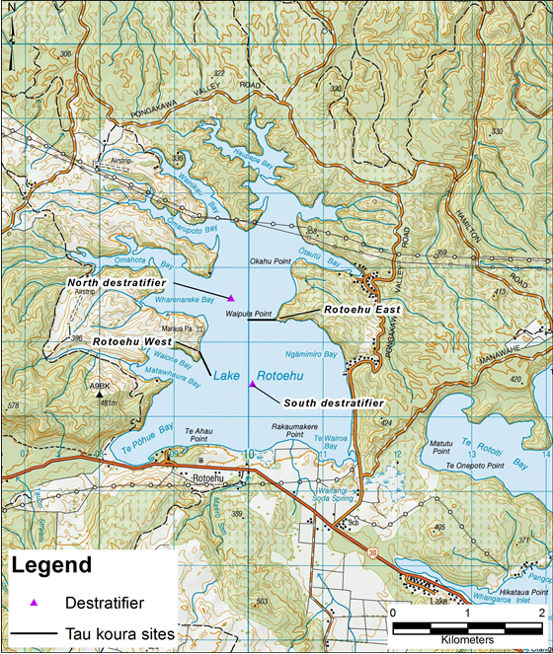
Figure 1: Map of Lake Rotoehu and catchment showing the approximate locations of the kōura monitoring sites Rotoehu East and Rotoehu West.

3 METHODS

3.1 Tau kōura construction and use
The kōura population in Lake Rotoehu was sampled using the tau kōura (Fig. 2) a traditional Māori method of harvesting kōura in the Te Arawa and Taupō lakes (Hiroa 1921; Kusabs and Quinn 2009).

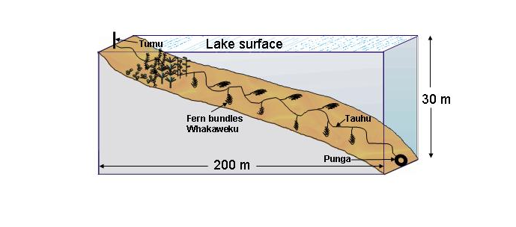
Figure 2: Schematic diagram of the tau kōura. The depth and length of tau are indicative and can be varied depending on lake bathymetry.

Two tau kōura were set in Lake Rotoehu, located on the eastern (Rotoehu East; NZTM 1910289.11 5786220.59) and western side (Rotoehu West; NZTM 1909363.00 5785684.52) of the lake (Fig. 1). Each tau kōura was comprised of 10 whakaweku (dried bracken fern, Pteridium esculentum, bundles) each with c. 10 dried fronds per whakaweku (Fig. 2). The bracken fern fronds were bound together using 250 or 300 mm length industrial strength cable ties and were attached using hay baling twine (approximately 2.5 m long) to a 250 m length of sinking anchor rope and set. One end of the bottom line was attached to a large boulder on the shoreline while the lake end was anchored to the lake bottom using a concrete filled tyre.
Tau kōura were set in areas that were free of high densities of invasive macrophyte beds, underwater obstructions, boulders, and reefs. The Rotoehu East and Rotoehu West tau kōura were set in water depths ranging from 4 to 11 m and 8 to 11.5 m, respectively. The tau kōura were left for at least one month to allow kōura to colonise the whakaweku.

3.2 Kōura collection and measurement
Harvesting was achieved by lifting the shore end of the rope and successively raising each whakaweku while moving along the tauhu (bottom line) in a boat. A korapa (large net) was placed beneath the whakaweku before it was lifted out of the water. The whakaweku was then shaken to dislodge all kōura from the fern into the korapa. The whakaweku was then returned to the water. The kōura were then collected and placed into labelled (2 litre) plastic containers covered by lids to keep kōura shaded and calm before analysis.
All kōura were counted and assessed for shell softness (soft or hard) and those kōura >11 mm OCL assessed for sex and reproductive state (presence of eggs or hatchlings). If large numbers were captured then subsamples of the population were taken, typically involving measuring all kōura captured on every third whakaweku (e.g. 1, 3, 6, 9) or at least 100 individuals. Orbit carapace length (OCL) of each kōura was measured using vernier callipers (± 0.5 mm). A power regression equation was used to estimate kōura wet weight. After processing, all kōura were returned to the water in close proximity to the tau kōura. Catch per unit effort (CPUE) was defined as the number of kōura per whakaweku and biomass per unit effort (BPUE) as estimated wet weight (g) of kōura per whakaweku.

4 RESULTS

4.1 Kōura abundance, biomass and distribution
Kōura were abundant in Lake Rotoehu with a total of 1329 kōura captured in the four surveys from May 2014 to February 2015 (Table 1, Fig. 3). In this year’s survey, the highest mean CPUE (25.4 kōura whakaweku⁻¹) and mean BPUE (283 g kōura whakaweku⁻¹) were recorded at Rotoehu West in November 2014 (Table 1). In contrast, the lowest mean CPUE (0.3 kōura whakaweku⁻¹) and mean BPUE (2.6 g kōura whakaweku⁻¹) were recorded at Rotoehu West in February 2015; the lowest means recorded since surveys began in 2011 (Table 1; Fig. 3). Kōura were found on the first whakaweku only, at a depth of 8.2m., suggesting that low dissolved oxygen concentrations (<5 mg l⁻¹) had excluded kōura from whakaweku set at depths in excess of about 8.5 m.
Mean CPUE ranged from 0.3 to 25.4 with an overall mean of 16.7 (SD ± 13.6) kōura whakaweku⁻¹ an increase on the 14.3 (SD ± 7.4) recorded in 2014 (Table 1, Fig. 3). Mean BPUE ranged from 2.6 to 287 with an overall mean BPUE of 173.4 g (SD ± 80.1) kōura whakaweku⁻¹ (Table 1).

Table 1: Mean CPUE (n + SD) and biomass (g + SD) for kōura captured in two tau kōura (comprised of 10 whakaweku) set in Lake Rotoehu, 22 November 2011 to 25 February 2015.

Date |  | Mean CPUE (n) |  |  | Mean BPUE (g) |  |  | Max depth of kōura (m)
 |  | East | West |  | East | West |  | East | West
22 Nov 2011 |  | 6.1 (4.2) | 9.4 (8.1) |  | 37.5 (41) | 95.4 (102.7) |  | 11 | 11.5
24 Feb 2012 |  | 19.2 (13.7) | 3.8 (10) |  | 219.4 (171) | 61.7 (154.9) |  | 11 | 9
22 Sept 2012 |  | 65.4 (27.3) | 23.7 (17.9) |  | 888.5 (460.2) | 278.3 (200.3) |  | 11 | 11.5
7 Feb 2013 |  | 7.3 (7.8) | 3.9 (4.1) |  | 136.1 (148.6) | 84.4 (91.6) |  | 11 | 11.5
21 May 2013 |  | 12.4 (5.4) | 22.4 (16.8) |  | 192.6 (85.6) | 265.1 (183.7) |  | 11 | 11.5
31 July 2013 |  | 7.9 (4.2) | 6.9 (3.8) |  | 57.8 (32.7) | 47.4 (38.6) |  | 11 | 11.5
11 Nov 2013 |  | 20.3 (9.9) | 20.6 (10.1) |  | 263.0 (140.6) | 257.2 (139.0) |  | 11 | 11.5
14 Feb 2014 |  | 4.0 (8.2) | 20.1 (14.9) |  | 68.3 (172.9) | 331.1 (260.7) |  | 11 | 11.5
22 May 2014 |  | 11.3 (6.1) | 14.0 (5.9) |  | 52.5 (60.9) | 176.5 (79.1 ) |  | 11 | 11.5
26 Aug 2014 |  | 14.2 (13.3) | 24.0 (8.2) |  | 119.5 (124.2) | 179.8 (89.1) |  | 11 | 11.5
28 Nov 2014 |  | 22.6 (15.6) | 25.4 (14.8) |  | 270.5 (192.9) | 283.0 (171.8) |  | 11 | 11.5
25 Feb 2015 |  | 21.1 (17.0) | 0.3 (1.0) |  | 287.3 (268.9) | 2.6 (8.1) |  | 11 | 8.2

Figure 3: CPUE (mean + SD) for kōura captured in two tau kōura (comprised of 10 whakaweku) set in Lake Rotoehu, 22 November 2011 to 25 February 2015. Light bars = East site; shaded bars = West site.

4.2 Size
Kōura ranged in size from 9 to 40 mm OCL in the 2014 to 2015 sampling programme (Table 2). The highest mean size, 24.9 mm OCL, and lowest mean size 15.7 mm OCL, were recorded at Rotoehu West in February 2015 and May 2014, respectively (Table 2). The mean OCL for 2014 to 2015 (four months) was 21.3 (SD ± 7.0) smaller than the 23.2 (SD ± 6.8) mm recorded for the 2013 to 2014 period.

Table 2: Mean OCL (mm ± SD) and range of kōura captured from two tau kōura (n = 10 whakaweku) set in Lake Rotoehu, 22 November 2011 to 25 February 2015.
Date |  | Mean OCL (mm ± SD) |  |  | Size range (OCL) mm
 |  | East | West |  | East | West
22 November 2011 |  | 21.7 (5.7) | 18.1 (5.3) |  | 11 - 32 | 12 – 36
24 February 2012 |  | 22.5 (5.8) | 26.0 (4.1) |  | 12 – 38 | 18 – 34
22 September 2012 |  | 25.0 (5.1) | 23.7 (4.9) |  | 12 – 43 | 9 – 34
7 February 2013 |  | 27.6 (4) | 27.3 (4.1) |  | 21 – 40 | 20 – 39
21 May 2013 |  | 24.8 (6.9) | 22.8 (6.1) |  | 9 – 37 | 7 – 38
31 July 2103 |  | 19.0 (6.0) | 18.3 (6.3) |  | 8 – 32 | 10 – 31
11 November 2013 |  | 24.0 (6.3) | 23.8 (6.4) |  | 11 – 39 | 11 – 39
14 February 2014 |  | 26.1 (5.8) | 26.3 (6.6) |  | 17 – 43 | 14 – 40
22 May 2014 |  | 15.7 (5.7) | 23.1 (6.4) |  | 9 – 36 | 11 – 38
26 August 2014 |  | 19.4 (6.7) | 19.5 (6.8) |  | 11 – 40 | 12 – 40
28 November 2014 |  | 23.1 (7.3) | 22.9 (6.5) |  | 13 – 39 | 13 – 39
25 February 2015 |  | 24.9 (5.9) | 21.5 (3.5) |  | 15 – 40 | 18 – 25

4.3 Percentage females, breeding size with eggs and soft shells
As in previous years the overall ratio of females to males was about 1:1 (49.8%) of the subsamples recorded in 2014 – 2015 survey programme (Table 3). Female to male ratios ranged from 40% in February to 57% in May (Table 3). Breeding sized females with eggs or hatchlings were captured in May, July and November but not in February (Table 3). Females with eggs were particularly abundant in May 2015 at both sampling sites where 60% and 53% of female kōura of breeding size had eggs or hatchlings (Table 3). Females with eggs ranged from 18 to 34 mm OCL. Kōura with soft shells were present on all sampling occasions and ranged from 2.9 to 14.2%, with the highest percentage recorded in November (Table 3).

Table 3: Sampling site, sampling month, number of kōura sampled, mean percentage of females, mean percentage of breeding size females with eggs or hatchlings (defined as > 17 mm OCL) and mean percentage of kōura with soft shells, in subsamples taken from two tau kōura (comprised of 10 fern bundles each) set in Lake Rotoehu, 22 November 2011 to 25 February 2015.
Date |  | Number of kōura sampled |  |  | % Female |  |  | % Breeding size females with eggs/young |  |  | % Soft shells
 |  | East | West |  | East | West |  | East | West |  | East | West
22 Nov 2011 |  | 61 | 94 |  | 52.5 | 51.1 |  | 6.3 | 21.9 |  | 4.9 | 10.6
24 Feb 2012 |  | 192 | 38 |  | 49.0 | 50.0 |  | 0 | 0 |  | 15.1 | 15.8
22 Sept 2012 |  | 236 | 132 |  | 57.2 | 56.8 |  | 68.2 | 56.3 |  | 3.4 | 11.1
7 Feb 2013 |  | 73 | 38 |  | 67.1 | 57.9 |  | 0 | 0 |  | 11.0 | 5.3
21 May 2013 |  | 104 | 126 |  | 57.1 | 60.2 |  | 72.5 | 63.6 |  | 7.7 | 11.9
31 July 2103 |  | 79 | 69 |  | 51.4 | 41.8 |  | 51.9 | 53.3 |  | 2.5 | 2.9
11 Nov 2013 |  | 112 | 114 |  | 46.8 | 46.9 |  | 59.1 | 56.8 |  | 7.1 | 7.0
14 Feb 2014 |  | 40 | 96 |  | 47.5 | 44.8 |  | 0 | 0 |  | 10.0 | 9.4
22 May 14 |  | 113 | 140 |  | 57.1 | 55.8 |  | 53.3 | 60.0 |  | 6.2 | 2.9
26 Aug 14 |  | 142 | 149 |  | 54.0 | 42.6 |  | 39.5 | 39.4 |  | 3.5 | 4.7
28 Nov 2014 |  | 127 | 126 |  | 55.1 | 45.2 |  | 18.0 | 0 |  | 14.2 | 8.7
25 Feb 2015 |  | 132 | 3 |  | 40.2 |  |  | 0 |  |  | 5.3

5 DISCUSSION

5.1 Kōura abundance and distribution
Lake Rotoehu continues to support a moderately abundant population of small sized kōura despite the occurrence of a lake-wide blue-green algae bloom over the summer/autumn (2014 – 2015). Kōura are affected by low DO levels and begin to exhibit symptoms of oxygen stress below 5 DO mg L⁻¹ (Devcich 1979) moving into shallow (more oxygenated) waters when this occurs (Kusabs and Butterworth 2011). In February 2015, kōura were excluded from the hypolimnion (>8.5 m water depth) at the Rotoehu West site by deoxygenation of the hypolimnion. In contrast, kōura distribution and abundance was not affected at the Rotoehu East site where kōura were collected from depths in excess of 11 m. It is unclear if the increased depth distribution of kōura at this site is due to its close proximity (<0.3 km) to the North destratifier (Fig. 1). Nevertheless, it does show the importance of relying on more than one site for monitoring kōura in Lake Rotoehu.
It is probable that kōura distribution is ‘squeezed’ from above, by light intensity, cormorant predation and biotic barriers created by invasive submerged macrophyte beds, and from below by hypoxia. At the Rotoehu West site the lake bed is gently sloping with hornwort beds extending from water depths of approximately 3 to 7 m this results in a relatively small amount of habitat between 7 m (the lowest most depth of the weed beds) and 8.5 m (the upper depth of hypoxia) available to kōura. In contrast, at the Rotoehu East site macrophyte beds are not present below a depth of approximately 4 m, due to the steeply sloping lake bed, and therefore more habitat is available to kōura even when the hypolimnion is hypoxic. Removal of introduced aquatic macrophyte beds would increase available habitat in the shallow littoral and may be an option to improve kōura abundance and distribution in Lake Rotoehu.
Hornwort is a brittle, poorly attached plant that has been reported to smother tau kōura, not only restricting kōura access to the whakaweku but also leading to the rapid decay of the fern itself (Kusabs, et al. 2013). However, the effect of hornwort on the kōura population and tau kōura efficacy in Lake Rotoehu is less certain. In Lake Rotoehu, kōura were commonly found even on those whakaweku smothered with hornwort; in fact, the hornwort seemed to provide favourable habitat for kōura. This contrasts with the situation in Lake Rotoiti where kōura were excluded from whakaweku heavily infested with hornwort. The reasons for this are unclear but it could be due to the polymictic nature of Lake Rotoehu which provides DO concentrations suitable for kōura most of the time. Nevertheless, excessive macrophyte growths are almost certainly detrimental to kōura abundance and distribution in Lake Rotoehu. Hessen, et al. (2004) reported that the introduction of Elodea canadensis resulted in a sudden decrease in crayfish (Astacus astacus) abundance in Lake Steinsfjorden (southeast Norway) with crayfish excluded from the shallow areas of the lake (where they were once abundant) because of dense stands of Elodea.
In regard to kōura habitat, polymictic, shallow lakes such as Rotoehu appear to be more ‘resilient’ to eutrophication effects than monomictic, deep sided lakes e.g. Lake Ōkaro. The main reason being that shallow, polymictic lakes do not stratify for long periods and hence provide dissolved oxygen (DO) levels suitable for kōura most of the time. Kōura are affected by low DO levels and begin to exhibit symptoms of oxygen stress below 5 DO mg L⁻¹ (Devcich 1979) moving into shallow (more oxygenated) waters when this occurs (Kusabs and Butterworth 2011).
In terms of relative abundance Rotoehu ranks in the middle of eight Te Arawa lakes where relative kōura abundance has been determined with Rotoehu mean CPUE higher than those recorded in Lakes Ōkaro, Ōkāreka, Tarawera and Rotokākāhi but lower than those in Lakes Rotorua, Rotomā and Rotoiti (Fig. 4).

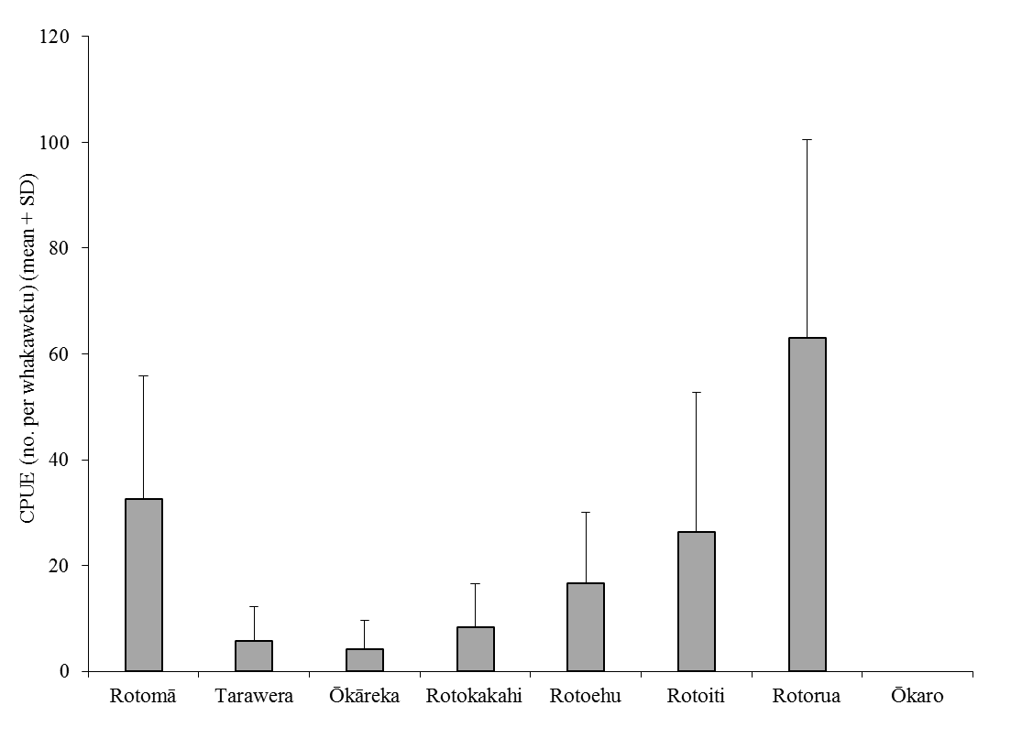
Figure 4: CPUE (mean + SD) of kōura captured in Rotoehu (2014 – 2015) compared to those recorded in April 2009 from seven Te Arawa lakes (two tau comprised of 10 fern bundles) (Kusabs, et al. 2015a; Kusabs, et al. 2015b). Lakes ordered in terms of increasing Chl-a concentration.

5.2 Size
In comparison to other Te Arawa lakes the mean OCL of Rotoehu kōura (21.3 mm) was similar to that recorded for kōura captured in lakes Rotorua (20.4 mm) and Rotokakahi (21.8 mm) but smaller than those in Rotomā, Rotoiti, Tarawera and Okareka (Fig. 5). It appears that small-sized kōura comprise a higher proportion of the kōura populations in shallow, eutrophic lakes than in deeper lakes.

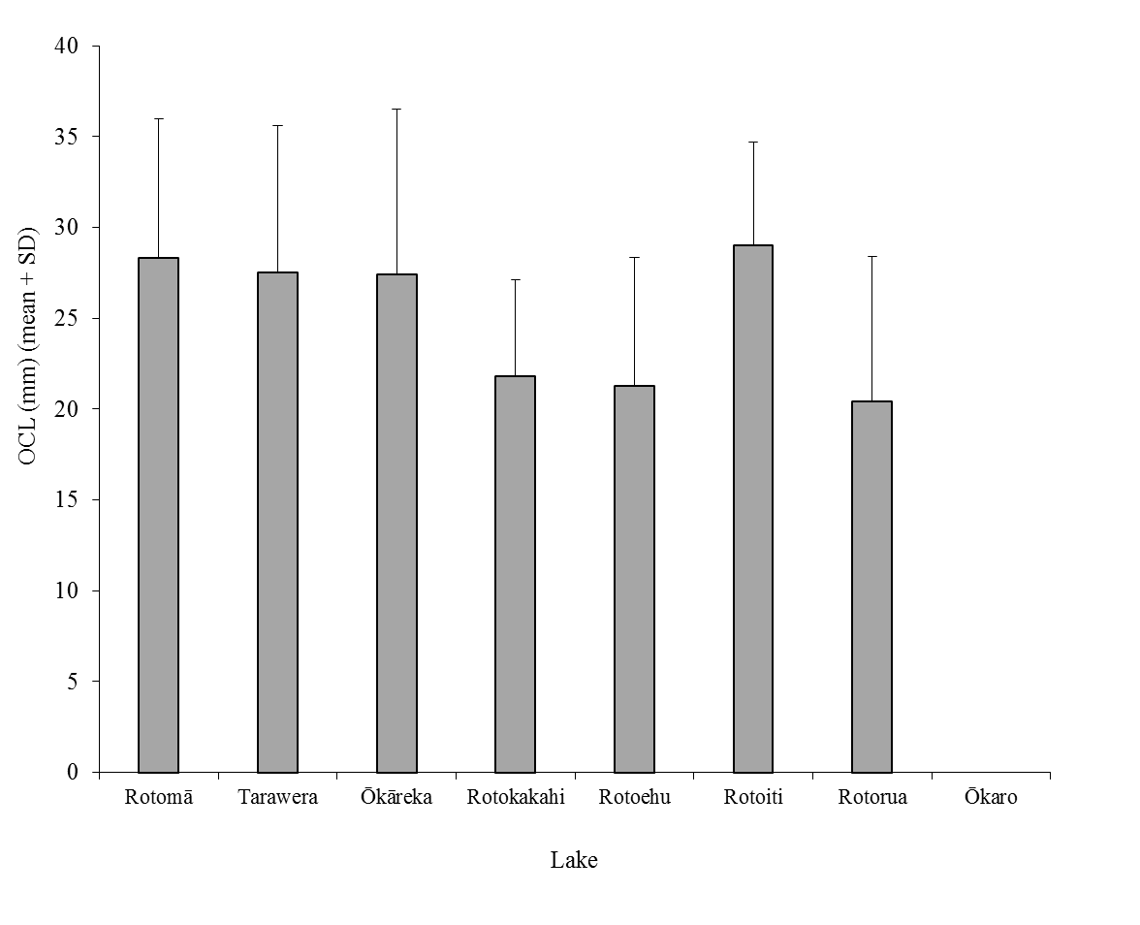
Figure 5: Mean orbit carapace length (mm + SD; 10 whakaweku x two sites) of kōura captured in eight Te Arawa lakes in April, July and November 2009 and Lake Rotoehu in May, July, November 2013, and February 2014 (Kusabs, et al. 2015a; Kusabs, et al. 2015b). Lakes ordered in terms of increasing Chl-a concentration.

5.3 Female to male ratio
The ratio of female to male Rotoehu koura was approximately 1:1. This is consistent with data collected from six Rotorua lakes, Rotorua, Rotoiti, Okareka, Rotokakahi, Rotoma and Tarawera, where female kōura comprised 52.3% of sub samples collected (Kusabs unpublished PhD data). However, female kōura in Lake Rotoehu appear to breed at a smaller size than those found in in other Rotorua lakes. Berried kōura were commonly recorded < 20 mm OCL, including two females of 17.2 mm OCL, similar to stream-dwelling populations (Parkyn 2000).

6 CONCLUSION
Lake Rotoehu continues to support a moderately abundant population of small-sized kōura despite sporadic cyanobacteria blooms and dense growths of introduced macrophytes (i.e., hornwort). The resilience of the kōura population is most due to the fact that it is polymictic and because the lake bed is comprised mainly of coarse sediments (sand and pebble sized particles). Nevertheless, kōura abundance and distribution in Lake Rotoehu have been adversely affected by hornwort invasion and eutrophication (i.e., hypolimnetic deoxygenation) resulting in a decrease in habitat available to kōura. On-going lake restoration measures should ultimately improve habitat for kōura in Lake Rotoehu.

7 ACKNOWLEDGEMENTS

Thanks to Andy Bruere and Gloria Zamora from the BOPRC for project liaison. Thanks also to Roger Bawden from Wildland Consultants for the map of Lake Rotoehu and Trevor Huriwai, Willie Emery and Martina Katipa for fieldwork assistance.

8 REFERENCES

BOPRC. 2007. Lake Rotoehu Action Plan. Environmental Publication 2007/19. Bay of Plenty Regional Council. Available from http://www.boprc.govt.nz/media/88456/finallakerotoehuactionplanlraphearingpanelchangesv7.pdf Accessed [23 September 2014].
Devcich, A.A. 1979. An ecological study of Paranephrops planifrons (White) (Decapoda: Parastacidae) in Lake Rotoiti, North Island, New Zealand. PhD, University of Waikato, Hamilton, New Zealand.
Hessen, D., Skurdal, J. and Braathen, J. 2004. Plant exclusion of a herbivore; crayfish population decline caused by an invading waterweed. Biological Invasions 6, 133-140.
Hiroa, T.R. 1921. Māori food supplies of Lake Rotorua, with methods of obtaining them, and usages and customs appertaining thereto. Transactions of the New Zealand Institute 26, 429-451.
Kusabs, I. and Butterworth, J. 2011. Kōura abundance and distribution in Lake Rotorua and potential effects of hypolimnetic dosing and sediment capping. Report prepared for Bay of Plenty Regional Council. Ian Kusabs & Associates Ltd, Rotorua, New Zealand.
Kusabs, I. and Butterworth, J. 2013. Kōura abundance and distribution in Lake Rotoehu. Report prepared for Bay of Plenty Regional Council. Ian Kusabs & Associates Ltd, Rotorua, New Zealand.
Kusabs, I. and Butterworth, J. 2014. Kōura abundance and distribution in Lake Rotoehu. Report prepared for Bay of Plenty Regional Council. Ian Kusabs & Associates Ltd, Rotorua, New Zealand.
Kusabs, I., Emery, W. and Butterworth, J. 2013. Ohau Channel Diversion Wall - An assessment of the kōura and kākahi populations in the Okere Arm and Lake Rotoiti. Report prepared for Bay of Plenty Regional Council. Ian Kusabs & Associates Ltd, Rotorua, New Zealand.
Kusabs, I.A., Hicks, B.J., Quinn, J.M. and Hamilton, D.P. 2015a. Sustainable management of freshwater crayfish (kōura, Paranephrops planifrons) in Te Arawa (Rotorua) lakes, North Island, New Zealand. Fisheries Research 168, 35-46.
Kusabs, I.A. and Quinn, J.M. 2009. Use of a traditional Māori harvesting method, the tau kōura, for monitoring kōura (freshwater crayfish, Paranephrops planifrons) in Lake Rotoiti, North Island, New Zealand. New Zealand Journal of Marine and Freshwater Research 43, 713-722.
Kusabs, I.A., Quinn, J.M. and Hamilton, D.P. 2015b. Effects of benthic substrate, nutrient enrichment and predatory fish on freshwater crayfish (kōura, Paranephrops planifrons) population characteristics in seven Te Arawa (Rotorua) lakes, North Island, New Zealand. Marine and Freshwater Research -.
Parkyn, S.M. 2000. Effects of native forest and pastoral land use on the population dynamics and trophic role of the New Zealand freshwater crayfish Paranephrops planifrons (Parastacidae). PhD thesis, University of Waikato, Hamilton, New Zealand.
Parkyn, S.M., Rabeni, C.F. and Collier, K.J. 1997. Effects of crayfish (Paranephrops planifrons : Parastacidae) on in-stream processes and benthic faunas: a density manipulation experiment. New Zealand Journal of Marine and Freshwater Research 31, 685-692.
Stafford, D.M. 1996. Landmarks of Te Arawa. Volume 2: Rotoiti, Rotoehu and Rotoma. Reed Books, Auckland.

The sex of kōura < 11mm OCl could not be assessed in the field due to their small size.

