**Lake Rotorua**

**Kōura AND KĀKAHI MONITORING PROGRAMME 2020**

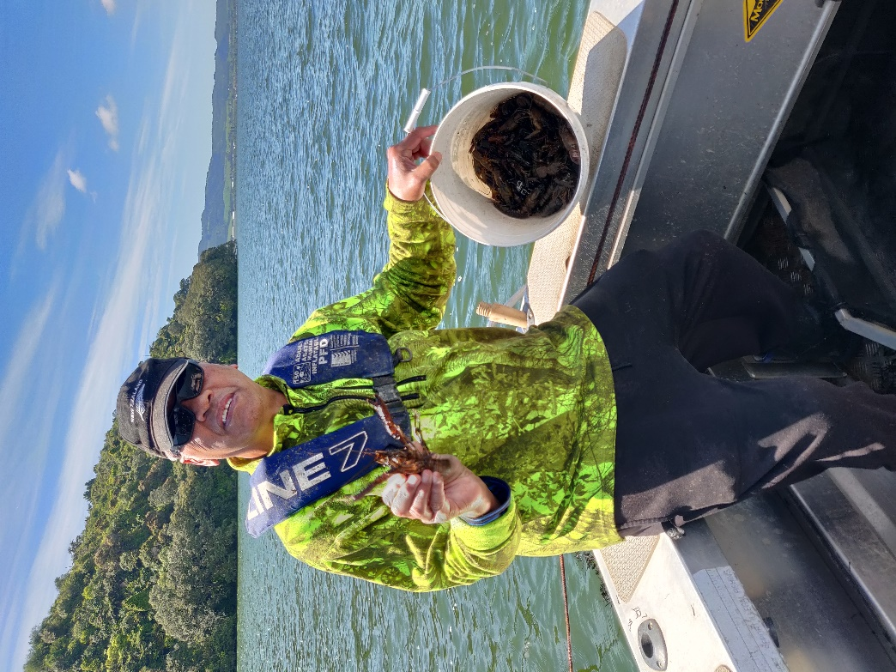

REPORT NUMBER 4 PREPARED FOR BAY OF PLENTY REGIONAL COUNCIL

Ian Kusabs & Associates Ltd

Rotorua, New Zealand

December 2020

Citation

Kusabs, I.A. 2020. Lake Rotorua kōura and kākahi monitoring programme 2020. Report number 4 prepared for Bay of Plenty Regional Council. Ian Kusabs and Associates Ltd, Rotorua, New Zealand.

Cover image

Anthony Waiomio with a large kōura collected from the tau kōura deployed off Mokoia Island. 17 November 2020. Photo: I. Kusabs).

Table of Contents

EXECUTIVE SUMMARY iii

List of Figures v

List of Tables v

INTRODUCTION 1

Background and Objectives 1

Lake Rotorua 1

Aims and Objectives 1

METHODS 2

Tau kōura construction and use 2

Kōura measurements 4

Comparison of kōura data with previous surveys in Lake Rotorua 4

Kākahi surveys 4

Dissolved oxygen 5

Data analysis 5

RESULTS 6

Water quality 6

Kōura 6

Kōura abundance and biomass 6

Kōura abundance and biomass - comparison with previous surveys 6

Kōura size 9

Kōura size - comparison with previous surveys 9

Percentage females, breeding kōura and soft shells 11

Percentage females, breeding kōura, soft shells - comparison with previous surveys 11

Kākahi 12

Sampling conditions 12

Kākahi abundance 12

DISCUSSION 15

Kōura 15

Kākahi 16

CONCLUSIONS AND RECOMMENDATIONS 16

ACKNOWLEDGEMENTS 17

REFERENCES 17

APPENDIX 18

# EXECUTIVE SUMMARY

Lake Rotorua is a eutrophic lake that has suffered from water quality issues since the 1960s. The Bay of Plenty Regional Council is leading the restoration and protection programme for the lake and have implemented a number of in lake treatments and nutrient management strategies in the catchment to improve water quality.

Kōura (freshwater crayfish) and kākahi (freshwater mussels) are considered taonga (treasured) species by Te Arawa iwi. Freshwater crayfish are also widely recognised as an important ecological component of freshwater ecosystems as they have a dominating influence on community structure. Freshwater mussels are important to aquatic ecosystems as their filter-feeding ability enables them to improve water quality by filtering organic matter, bacteria, algae and pollutants, as well as stabilising suspended sediments.

The principal aims of this monitoring programme is to determine trends in kōura population characteristics and kākahi abundance in Lake Rotorua. This report provides an in-depth analysis of Lake Rotorua kōura and kākahi monitoring data for 2020 and a comparison with previous surveys carried out in 2009, 2010, 2011, 2016, 2017, 2018 and 2019.

The Lake Rotorua kōura population was sampled using the tau kōura a traditional Māori method of harvesting kōura in Te Arawa and Taupō lakes. Two tau kōura were located on the western side of Mokoia Island each composed of 10 whakaweku (bracken fern bundles). The kākahi monitoring methodology developed by NIWA specifically for community and iwi groups, was used to determine kākahi densities at seven sites in the shallow (< 1 m) littoral zone around the Lake Rotorua shoreline.

Results of data analysed show that kōura abundance (-21%) and biomass (-15%) in Lake Rotorua were lower in 2020 than 2019. Furthermore, kōura mean CPUE has decreased by -85% and mean BPUE by -59%, since the 2009 baseline surveys. Length frequency analysis of kōura data shows that this is due to a decline in the numbers of small-sized kōura (<22 mm) OCL recorded.

The decrease in the Lake Rotorua kōura population has coincided with the establishment of brown bullhead catfish (*Ameiurus nebulosus*) and an improvement in water quality. Catfish, are well known predators of kōura and were officially recorded in Lake Rotorua in December 2018, however, it is highly probable that they had been present for quite some time but at densities too low to be detected using standard trapping methods. In Lake Rotorua the trophic level index (TLI) has decreased from 5.0 in 2004/05 to 4.1 in 2019/20. This has resulted in a decrease in algae production and an increase in water clarity. The reduced primary production may have resulted in a decrease in food supply for kōura (and therefore kōura abundance), while increased water clarity may have led to an increase in the growth (and extent) of introduced macrophytes which could have decreased available habitat for kōura.

Kākahi were abundant in the littoral zone with mean densities (range 1.0 to 12.1 kākahi m-2) similar to those recorded in neighbouring Lake Rotoiti. Kākahi were least abundant at Waikawau (Holden’s Bay) and Te Ruapeka (Ohinemutu), both influenced by geothermal inputs. Kākahi abundance has remained relatively stable at most sites since surveys began in January 2017, with the exception of Waerenga where kākahi abundance has declined, and at Ruapeka, where kākahi numbers have increased.

It is recommended that kōura and kākahi monitoring surveys continue in Lake Rotorua given the ecological and cultural importance of these taonga species. Monitoring of the kōura population in Lake Rotorua is particularly important given the continued decline in kōura abundance and biomass.

# List of Figures

**Figure 1** Schematic diagram of the tau kōura. The depth and length of tau are indicative and can be varied depending on lake bathymetry. 2

**Figure 2** Approximate locations of Lake Rotorua kōura (A &B) and kākahi (1 -7) monitoring sites. 3

**Figure 3** (A) Catch per unit effort (mean number + SD) and (B) estimated biomass per unit effort (mean grams + SD) of kōura captured on tau kōura (composed of 10 to 20 whakaweku at two sites) deployed in Lake Rotorua in 2009, 2010, 2011, 2016, 2017, 2018, 2019, 2020. 7

**Figure 4** Relationship between (A) Catch per unit effort (mean CPUE) (B) estimated biomass per unit effort (mean BPUE) and (C) orbit carapace length (mean OCL) of kōura captured on tau kōura (composed of 10 to 20 whakaweku at two sites) deployed in Lake Rotorua in 2009, 2010, 2011, 2016, 2017, 2018, 2019, 2020. 8

**Figure 5** Box-and-whisker plot showing mean (x), median (horizontal line), interquartile range (box), distance from upper and lower quartiles times 1.5 interquartile range (whiskers), outliers (>1.5× upper or lower quartile) of kōura captured on tau kōura (composed of 10 to 20 whakaweku x two sites) deployed in Lake Rotorua in 2009, 2010, 2011, 2016, 2017, 2018 and 2019. 10

**Figure 6** Length-frequency distributions of kōura collected from two tau kōura each composed of 10 whakaweku set in Lake Rotorua and retrieved on 14 April 2009 and 23 May 2020. OCL = orbit carapace length. Bars coloured blue show kōura <22 mm OCL. 10

**Figure 7** Relationship between kākahi density at seven sites (0.5 m x 40 m transects) situated in Lake Rotorua and time, January 2017 to November 2020. 14

# List of Tables

**Table 1** Sampling site and grid reference of kōura monitoring sites, Lake Rotorua. 3

**Table 2** Survey year/month(s) sampled and source of kōura data for surveys carried out in Lake Rotorua from 2009 to 2020. 4

**Table 3** Sampling site, description and grid reference of kākahi monitoring sites, Lake Rotorua. 5

**Table 4** Survey date, sampling site, mean catch per unit effort (mean CPUE (± SD) and estimated mean biomass per unit effort (BPUE) of kōura collected from two tau kōura each composed of 10 whakaweku, deployed in Lake Rotorua and retrieved from 12 February 2020 to 17 November 2020. 6

**Table 5** Survey date, sampling site, mean orbit carapace length (OCL; mm) of kōura sampled from two tau kōura each composed of 10 to 20 whakaweku deployed in Lake Rotorua and retrieved from 12 February 2020 to 17 November 2020. 9

**Table 6** Maximum, minimum, mean (SD = standard deviation), first (Q1), second (median; Q2) and third (Q3) quartile values for orbit carapace length (mm) of kōura collected from Lake Rotorua from 2009 to 2020. 9

**Table 7** Sampling site, sampling date, number of kōura sampled, mean percentage of females, mean percentage of breeding size females with eggs, young or spermatophores (defined as >21 mm OCL) and mean percentage of kōura with soft shells, in subsamples taken from 2 tau kōura comprised of 10 whakaweku (fern bundles) in Lake Rotorua, 2020. 11

**Table 8** Sampling month and year, number of kōura sexed, mean percentage of; females, breeding size females with eggs, young or spermatophores and kōura with soft shells. Samples collected from two tau kōura comprised of 10 whakaweku each, set in Lake Rotorua, 2010 to 2020. Shaded areas show the 2020 survey period. 12

**Table 9** Mean (± SD) densities of kākahi (m-2) at seven sites (20 m2) in Lake Rotorua, January 2017 to November 2019. Shaded area shows the 2020 survey period. 13

# INTRODUCTION

The Bay of Plenty Regional Council (BOPRC) is leading the restoration and protection programme for Lake Rotorua. Monitoring is an essential component of this programme and the BOPRC monitor; algae, aquatic plants (LAKESPI), water quality (temperature, dissolved oxygen, nutrients), sediments and zooplankton. In 2016, the BOPRC committed to regular monitoring of kōura (freshwater crayfish, *Paranephrops planifrons*) and kākahi (freshwater mussel, *Echyridella menziesii*) due to their cultural and ecological importance.

Kōura are a taonga and mahinga kai species for Te Arawa iwi and an important ecological component of Lake Rotorua where large numbers are present (Kusabs et al. 2015a). Kōura abundance and distribution in Lake Rotorua is known to be influenced by benthic substrate composition, fish predation (Kusabs, et al. 2015b) and hypolimnetic deoxygenation (Kusabs and Butterworth 2011). Kākahi have important cultural, ecological and conservation values. In pre-European times, kākahi were a highly valued food source (Hiroa 1921). Freshwater mussels are important to aquatic ecosystems as their filter-feeding ability enables them to improve water quality by filtering organic matter, bacteria, algae and pollutants, as well as stabilising suspended sediments. Furthermore, freshwater mussels are under threat and are declining, both in New Zealand and worldwide therefore they have significant conservation values (Walker et al. 2001). Little is known about kākahi in Lake Rotorua, the only source of published information is from conventional benthic macroinvertebrates studies that did not specifically target kākahi.

## Background and Objectives

### Lake Rotorua

Lake Rotorua is a large (80.9 km2), relatively shallow polymictic lake with an average depth of 10 m. The lake has pressures from urban and rural landuses. Since the 1960’s, Lake Rotorua has experienced water quality problems associated with eutrophication. Recent management interventions to improve the water quality of Lake Rotorua include: land disposal of the city’s wastewater since 1991, sewage reticulation of smaller communities, trial of nitrogen removal of water from Tikitere geothermal field (2011), alum dosing to lock phosphorus from Utuhina Stream (2006) and Puarenga Stream (2010), and regional rules to cap land-based inputs (Rule 11).

### Aims and Objectives

The principal aim of this study is to to determine trends in kōura population characteristics and kākahi abundance in Lake Rotorua. The objectives were to carry out the fourth year of seasonal kōura and kākahi monitoring (2020) and to compare the results with previous surveys carried out in 2009, 2010, 2011, 2016, 2017, 2018 and 2019.

# METHODS

## Tau kōura construction and use

The Lake Rotorua kōura population was sampled using the tau kōura (Fig. 1), a traditional Māori method of harvesting kōura in Te Arawa and Taupō lakes (Hiroa 1921; Kusabs and Quinn 2009). The two tau kōura were located on the western side of Mokoia Island (Table 1, Fig. 2). Each tau kōura was comprised of 10 whakaweku each with c. 10 bracken fern (*Pteridium esculentum*) fronds per bundle. The fronds were bound together using 250 mm length industrial strength cable ties and were attached using twine (~ 2.5 m long) to a 450 m length of sinking anchor rope. One end of the bottom line was attached to a large boulder near Mokoia Island while the lake-end was anchored to the lake bottom using a concrete-filled car tyre. Whakaweku were deployed at water depths ranging from 3 to 15 m.

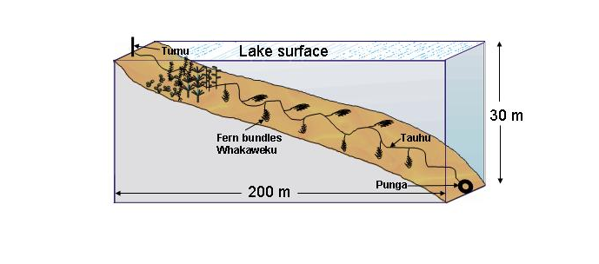

**Figure 1** Schematic diagram of the tau kōura. The depth and length of tau are indicative and can be varied depending on lake bathymetry.

The two tau kōura in Lake Rotorua were retrieved on 12 February, 22 May, 13 August and 17 November 2020. Owing to fern decomposition, whakaweku were replaced (with fresh bracken fern) on 13 August 2020.

Sampling was achieved by lifting the shore end of the rope and successively raising each whakaweku while moving along the tauhu (bottom line) in a boat. A kōrapa (landing net) was placed beneath the whakaweku before it was lifted out of the water. The whakaweku was then shaken to dislodge all kōura from the fern into the kōrapa. The whakaweku were then returned to the water. The kōura were then collected and placed into labelled (2 litre) plastic containers to keep kōura shaded before processing.

**Table 1** Sampling site and grid reference of kōura monitoring sites, Lake Rotorua.

|  |  |  |
| --- | --- | --- |
| Sampling site | Site description | Grid reference (WGS84) |
| Kōura A | Mokoia Island | 38° 04′ 66″S 176° 16′ 79″ E |
| Kōura B | Mokoia Island | 38° 04′ 88″S 176° 16′ 78″ E |



**Figure 2** Approximate locations of Lake Rotorua kōura (A &B) and kākahi (1 -7) monitoring sites.

## Kōura measurements

Kōura were assessed for size, sex, reproductive state (presence of eggs or young) and shell softness (soft or hard). Orbit-carapace length (OCL, mm) of each kōura was measured using Vernier callipers (± 0.5 mm) and the sex of kōura (OCL >12 mm) assessed. A power regression equation (previously determined by B. Hicks and P. Riordan, University of Waikato) was used to estimate kōura wet weight:

*W*(g) = 0.000648 L(mm)3.0743

where *W* is wet weight in g and L is OCL in mm.

After processing, all kōura were returned live to the water in close proximity to the tau kōura. Total sample handling time for two people to retrieve and process the samples from each tau was typically 2-3 hours. Catch Per Unit Effort (CPUE) was defined as the number of kōura per whakaweku and Biomass Per Unit Effort (BPUE) as estimated wet weight (g) of kōura per whakaweku.

## Comparison of kōura data with previous surveys in Lake Rotorua

Kōura population data for this study were compared with surveys carried out in 2009, 2010, 2011, 2016, 2017, 2018 and 2019 (Table 2).

**Table 2** Survey year/month(s) sampled and source of kōura data for surveys carried out in Lake Rotorua from 2009 to 2020.

|  |  |
| --- | --- |
| Year/Month sampled | Purpose & source |
| April, July, November 2009 | PhD study; Kusabs *et al.* (2015b) |
| December 2010 | Alum study; Kusabs & Butterworth (2012) |
| December 2011 | Alum study; Kusabs & Butterworth (2012) |
| June 2016 | Iwi liaison; Ian Kusabs; unpub. data |
| March, July & November 2017 | Kusabs (2018) |
| February, May, August & November 2018 | Kusabs (2019) |
| February, May, August & November 2019 | Kusabs (2020) |
| February, May, August & November 2020 | This report |

## Kākahi surveys

The kākahi monitoring methodology developed by NIWA specifically for community and iwi groups was used in this study to determine kākahi densities. Transects were located at seven sites in Lake Rotorua (Table 3, Fig. 2). At each site 40 m transects, 0.5 m wide, and perpendicular to the shore, were inspected out into the lake from standard points to a depth where the water was regularly wadeable. All kākahi in an area of 0.5 m wide running parallel to and up-current from a weighted survey line were counted using an underwater viewer. An “L” shaped measuring device constructed of 25 mm PVC pipe (1.2 m high x 0.5 wide) was used to measure water depth (to the nearest 1 cm) and to maintain the 0.5 m distance from the survey line. Counts were summed for each 1 m interval.

Sediment type was visually assessed along the transect lines as mud, mud-sand, clean sand, gravely sand etc. Where possible, surveys were carried out when weather conditions and water clarity allowed good visual observations to be made. In some instances, two days were required to complete surveys at all seven sites. Kākahi surveys were carried out on 10 February, 28 April, 4 August and 12/20 November 2020.

**Table 3** Sampling site, description and grid reference of kākahi monitoring sites, Lake Rotorua.

|  |  |  |  |
| --- | --- | --- | --- |
| Sampling site | Site name | Location | Grid reference (WGS 84) |
| Kākahi 1 | Waikawau | Holden’s Bay | 38° 06′ 46″ S 176° 18′ 28″ E |
| Kākahi 2 | Te Pohue | Park Cliff Road | 38° 04′ 08″ S 176° 19′ 33″ E |
| Kākahi 3 | Waerenga | Mission Bay | 38° 02′ 14″ S 176° 18′ 35″ E |
| Kākahi 4 | Kaikaitahuna | Hamurana | 38° 02′ 04″ S 176 ° 15′ 21″ E |
| Kākahi 5 | Waimihia | Keith Road | 38° 03′ 29″ S 176° 13′ 00″ E |
| Kākahi 6 | Parawai | Ngongotaha | 38° 05′ 37″ S 176° 13′ 27″ E |
| Kākahi 7 | Te Ruapeka | Whittaker Road | 38° 07′ 27″ S 176° 14′ 36″ E |

## Dissolved oxygen

A HOBO dissolved oxygen data logger (model: U26-001) was deployed at Rotorua A site to determine dissolved oxygen (DO) concentrations and water temperatures from the period 12 February to 22 May 2020. The logger was attached to the tau kōura approximately 3 m past the last, and deepest, whakaweku at a depth of 12.4 m. Net floats were used to ensure that the sensor end of the logger was suspended above the lake bed.

## Data analysis

Linear regression was used to determine trends in kōura population parameters (CPUE, BPUE and OCL) and kākahi density data. ANOVA with post hoc Bonferroni-Holm comparisons were used to determine whether there were any statistically significant differences between mean kākahi densities at the seven survey sites.

The Kolmogorov-Smirnov test for normality was used to determine whether the variables were normally distributed. Where necessary, data were transformed (log10 or square root) to approximate the normal distribution. Data analysis and visualization was performed using Daniel’s XL Toolbox add in for Excel, version 7.3.2 (Kraus, 2014).

# RESULTS

## Water quality

An examination of data from the dissolved oxygen logger deployed at the Rotorua A site, from 12 February to 22 May 2020, showed that dissolved oxygen (DO) concentrations consistently fell below 5 mg l-1 on 17, 21 and 22 February 2020. The lowest DO concentration recorded was 1.3 mg l- 1at 1200 hrs on 21 February 2020, whereas water temperatures ranged from 13.5 to 22.7°C.

## Kōura

### Kōura abundance and biomass

A total of 760 kōura were captured in 2020 at a mean CPUE of 9.5 (SD 9.2) kōura whakaweku-1 and an estimated mean BPUE of 330.7 g (SD 392.2) koura whakaweku-1. Relative abundance and biomass were highly variable between sites and seasons with mean CPUE ranging from 3.8 to 22.8 kōura whakaweku-1 and mean BPUE from 120.4 to 703.5 g kōura (Table 4). Kōura abundance and biomass were lower in 2020 compared to the 2019 survey. Mean CPUE decreased (*p* .49) by -20.8% from 12 kōura whakaweku-1 (2019) to 9.5 kōura whakaweku-1 (2020) (Fig. 3a). While mean BPUE decreased by 15.4% from 331 g kōura whakaweku-1 (2019) to 280.1g kōura whakaweku-1 (2020) (*p* = .99) (Fig. 3b).

**Table 4** Survey date, sampling site, mean catch per unit effort (mean CPUE (± SD) and estimated mean biomass per unit effort (BPUE) of kōura collected from two tau kōura each composed of 10 whakaweku, deployed in Lake Rotorua and retrieved from 12 February 2020 to 17 November 2020.

|  |  |  |  |  |  |  |
| --- | --- | --- | --- | --- | --- | --- |
| Survey date |  | Mean CPUE (n; SD) | |  | Mean BPUE (g; SD) | |
|  |  | Rotorua A | Rotorua B |  | Rotorua A | Rotorua B |
| 12 February 2020 |  | 16.1 (12.5) | 22.8 (12.5) |  | 440.3 (394.1) | 703.5 (393.4) |
| 22 May 2020 |  | 5.4 (5.0) | 7.9 (3.1) |  | 212.2 (228.0) | 252.2 (120.3) |
| 13 August 2020 |  | 4.8 (2.9) | 3.8 (1.6) |  | 143.8 (108.3) | 120.4 (88.6) |
| 17 November 2020 |  | 8.8 (5.7) | 6.4 (3.4) |  | 199.3 (143.5) | 169.2 (118.7) |

### Kōura abundance and biomass - comparison with previous surveys

Monitoring data recorded from 2009 to 2020 shows that there have been significant declines in kōura mean CPUE (*p* < .01) and estimated mean kōura BPUE (*p* < .01) in Lake Rotorua (Figs. 4 a & b; Appendix A1). Mean CPUE has declined by -84.9% from 63 kōura whakaweku-1 in 2009) to 9.5 kōura whakaweku-1 in 2020 (*p* < .01) (Fig. 4a). While mean BPUE has declined by 59% from 683 g kōura whakaweku-1 in 2009 to 280.1 g kōura whakaweku- 1 in 2020 (*p* < .001) (Fig. 4b).

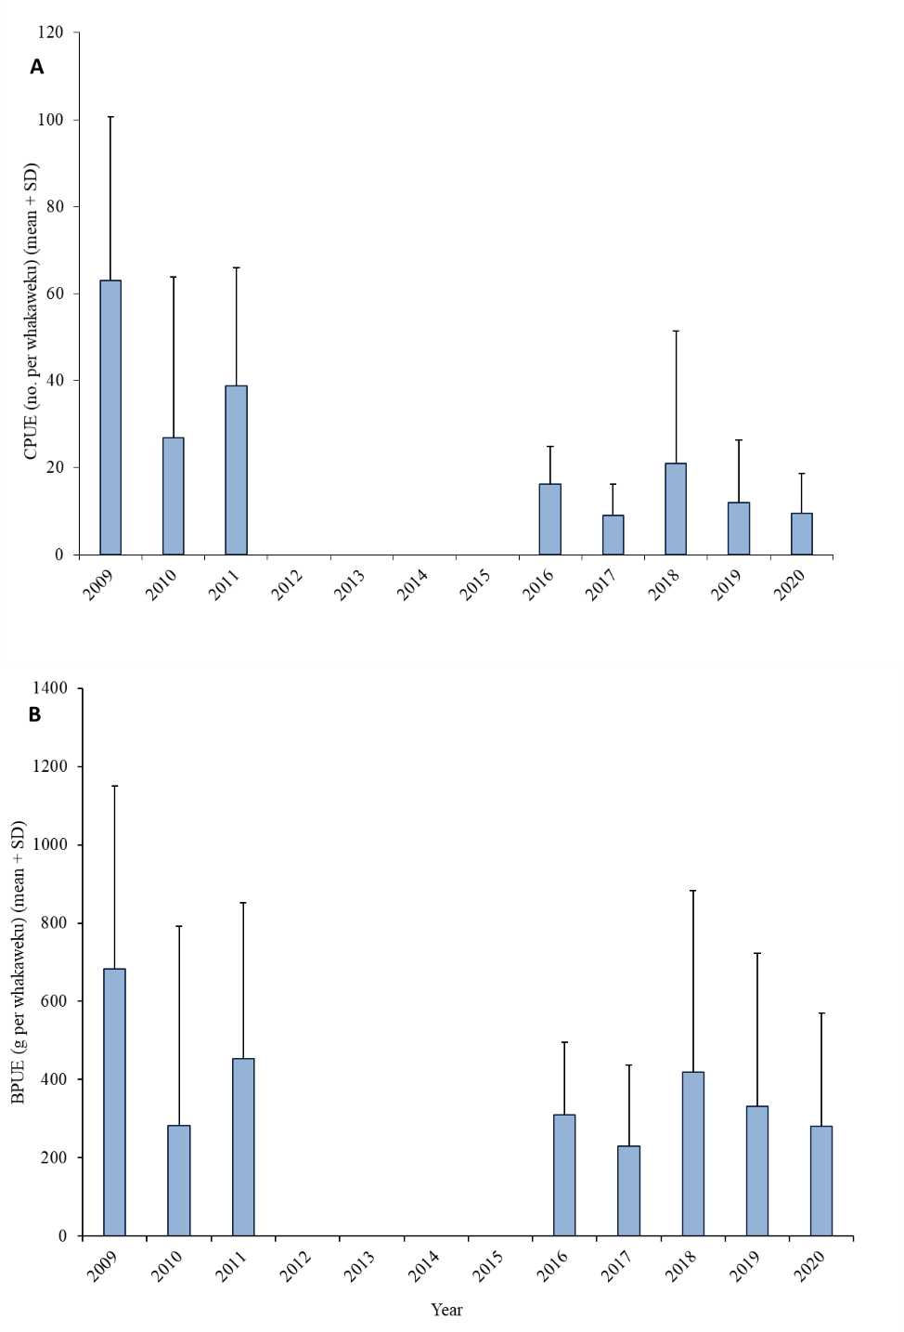

**Figure 3** (A) Catch per unit effort (mean number + SD) and (B) estimated biomass per unit effort (mean grams + SD) of kōura captured on tau kōura (composed of 10 to 20 whakaweku at two sites) deployed in Lake Rotorua in 2009, 2010[1], 2011, 2016, 2017, 2018, 2019, 2020.

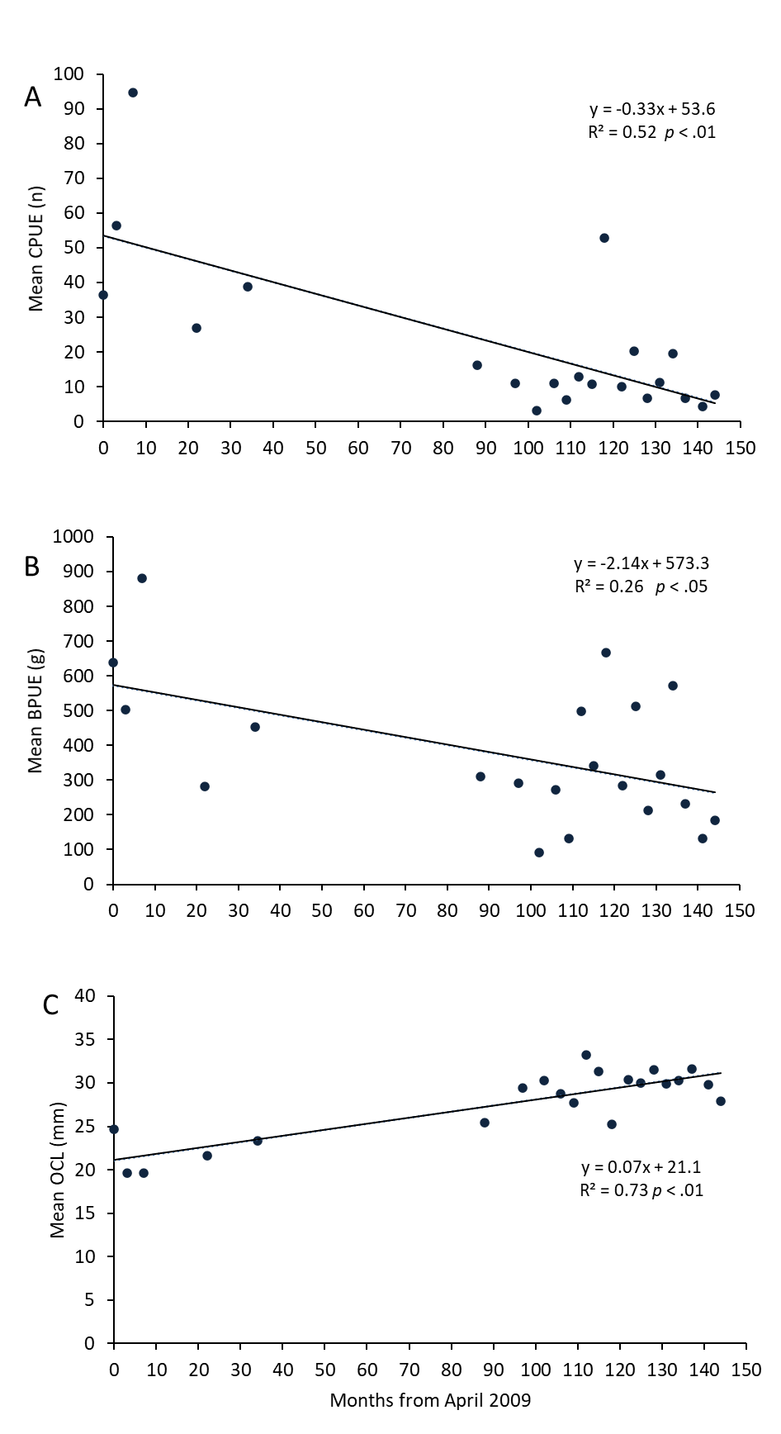

**Figure 4** Relationship between (A) Catch per unit effort (mean CPUE) (B) estimated biomass per unit effort (mean BPUE) and (C) orbit carapace length (mean OCL) of kōura captured on tau kōura (composed of 10 to 20 whakaweku at two sites) deployed in Lake Rotorua in 2009, 2010[2], 2011, 2016, 2017, 2018, 2019, 2020.

## Kōura size

Kōura mean size ranged from 29.4 to 31.7 mm OCL in the 2020 survey period with mean sizes varying little between the four seasons (Table 5). The smallest kōura recorded was 9 mm OCL and the largest 55 mm OCL (Table 6).

**Table 5** Survey date, sampling site, mean orbit carapace length (OCL; mm) of kōura sampled from two tau kōura each composed of 10 to 20 whakaweku deployed in Lake Rotorua and retrieved from 12 February 2020 to 17 November 2020.

|  |  |  |
| --- | --- | --- |
| Date | Mean size (OCL; mm) | |
| 2020 | Rotorua A | Rotorua B |
| 12 February | 29.4 (8.6) | 31.0 (8.4) |
| 22 May | 32.4 (10.9) | 31.0 (9.2) |
| 13 August | 29.1 (10.7) | 30.5 (9.7) |
| 17 November | 27.4 (8.6) | 28.6 (9.3) |

### Kōura size - comparison with previous surveys

Monitoring data recorded from 2009 to 2020 shows that there has been a significant increase (*p*< .01) in kōura mean size since baseline surveys were carried out in 2009 (Fig. 4c; Appendix A2). Kōura mean OCL has increased by 47% from 20.4 mm OCL in 2009 (April, July, November) to 30.0 mm OCL in 2020 (February, May, August, November) (Table 6; Fig. 5). Length frequency analysis of the April 2009 and May 2020 kōura samples show that this increase is mainly due to the reduction in small-sized kōura <~22 mm OCL (Fig. 6).

**Table 6** Maximum, minimum, mean (SD = standard deviation), first (Q1), second (median; Q2) and third (Q3) quartile values for orbit carapace length (mm) of kōura collected from Lake Rotorua from 2009 to 2020.

|  |  |  |  |  |  |  |  |  |
| --- | --- | --- | --- | --- | --- | --- | --- | --- |
|  | 2009 | 2010 | 2011 | 2016 | 2017 | 2018 | 2019 | 2020 |
| Minimum | 7 | 11 | 11 | 12 | 16 | 14 | 10 | 9 |
| Q1 | 15 | 16 | 17 | 17 | 23 | 23 | 25 | 23 |
| Median | 18 | 20 | 21 | 25 | 27 | 28 | 30 | 28 |
| Q3 | 25 | 26 | 29 | 30 | 34 | 35 | 35 | 30 |
| Maximum | 51 | 49 | 50 | 54 | 53 | 56 | 56 | 55 |
| Mean (SD) | 20.4 (8.0) | 21.6 (6.8) | 23.3 (7.9) | 25.4 (9.2) | 29.1 (7.9) | 29.4 (8.5) | 30.3 (8.3) | 30.0 (9.1) |

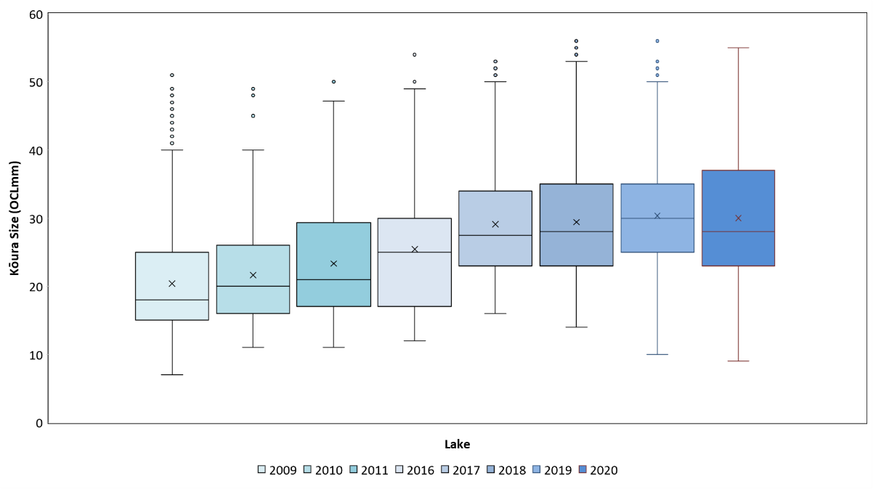

**Figure 5** Box-and-whisker plot showing mean (x), median (horizontal line), interquartile range (box), distance from upper and lower quartiles times 1.5 interquartile range (whiskers), outliers (>1.5× upper or lower quartile) of kōura captured on tau kōura (composed of 10 to 20 whakaweku x two sites) deployed in Lake Rotorua in 2009, 2010, 2011, 2016, 2017, 2018, 2019, 2020.

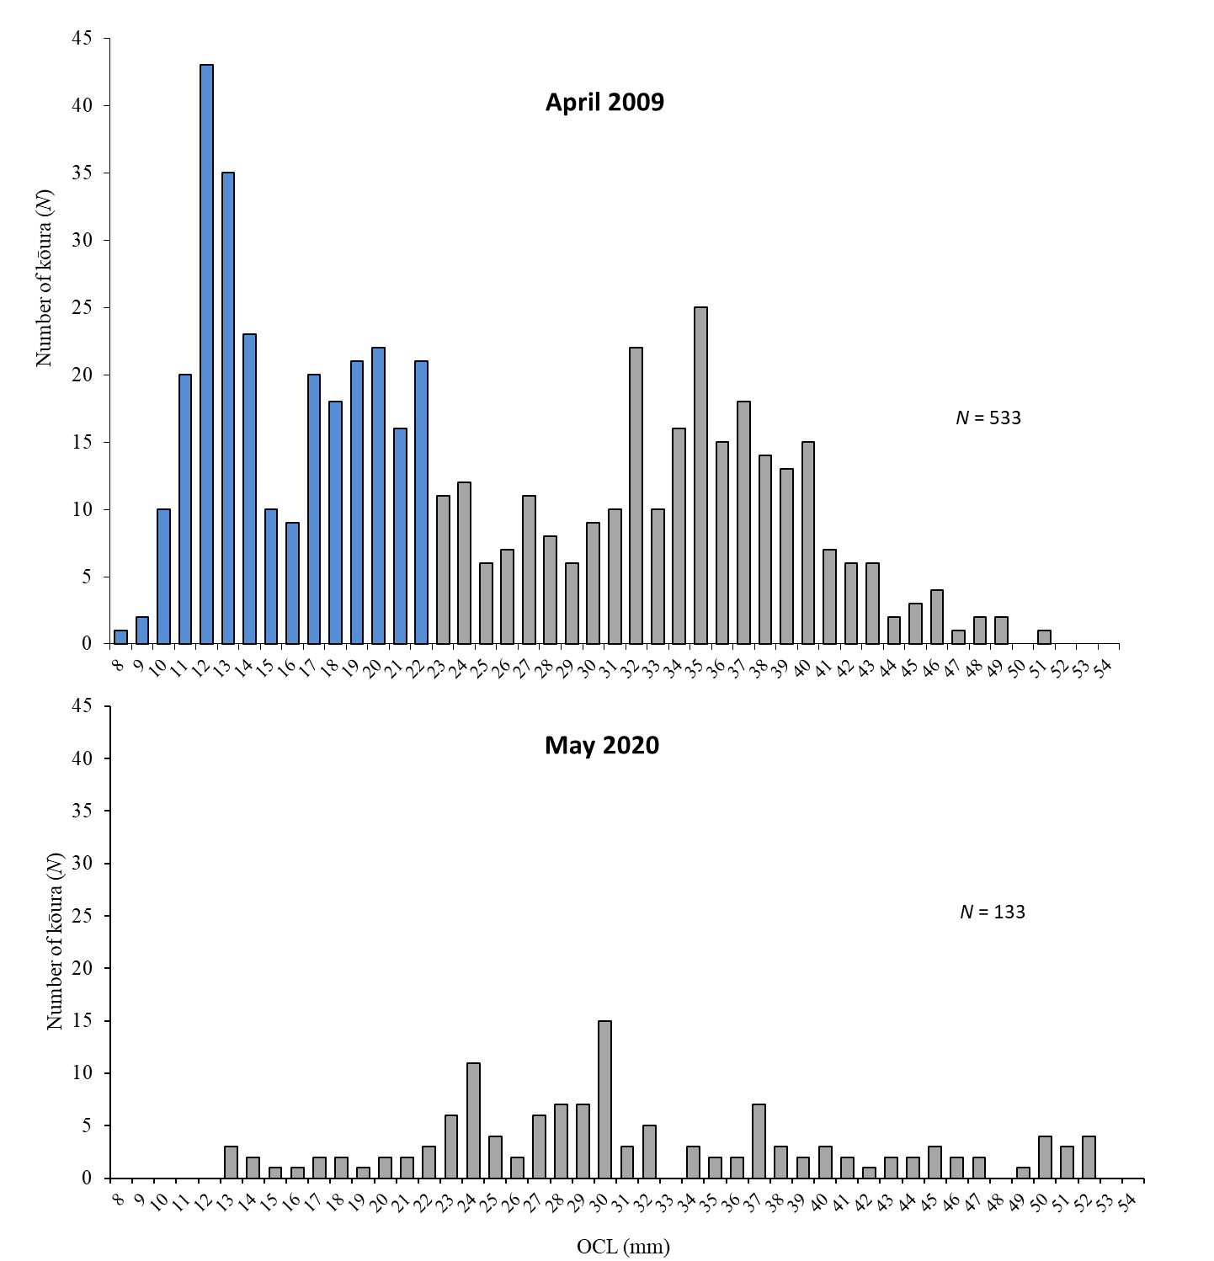

**Figure 6** Length-frequency distributions of kōura collected from two tau kōura each composed of 10 whakaweku set in Lake Rotorua and retrieved on 14 April 2009 and 23 May 2020. OCL = orbit carapace length. Bars coloured blue show kōura <22 mm OCL.

## Percentage ­ females, breeding kōura and soft shells

Female kōura comprised 47% of the population over the 2020 survey period, ranging from 41 to 53% (Table 7). The ratio of female to male kōura was consistent throughout the year (Table 7). Breeding sized females with eggs or hatchlings were present in May, August and November with none recorded in February (Table 7). The proportion of kōura with soft shells ranged from 9 to 23% (Table 7). This shows that kōura continue to grow throughout the year.

**Table 7** Sampling site, sampling date, number of kōura sampled, mean percentage of females, mean percentage of breeding size females with eggs, young or spermatophores (defined as >21 mm OCL) and mean percentage of kōura with soft shells, in subsamples taken from 2 tau kōura comprised of 10 whakaweku (fern bundles) in Lake Rotorua, 2020.

|  |  |  |  |  |  |  |  |  |  |  |  |
| --- | --- | --- | --- | --- | --- | --- | --- | --- | --- | --- | --- |
| Date | Number of kōura sampled | |  | % Female | |  | % Breeding size females with eggs | |  | % Soft shells | |
| 2020 | Rotorua A | Rotorua B |  | Rotorua A | Rotorua B |  | Rotorua A | Rotorua B |  | Rotorua A | Rotorua B |
| 12 February | 162 | 227 |  | 47.2 | 45.8 |  | 0.0 | 0.0 |  | 14.2 | 10.6 |
| 22 May | 54 | 79 |  | 46.3 | 46.8 |  | 43.5 | 48.5 |  | 18.5 | 22.8 |
| 13 August | 48 | 38 |  | 41.7 | 47.4 |  | 45.5 | 20.0 |  | 16.7 | 18.4 |
| 17 November | 88 | 64 |  | 53.4 | 40.6 |  | 13.9 | 41.2 |  | 22.7 | 9.4 |

### Percentage­ females, breeding kōura, soft shells - comparison with previous surveys

Female kōura comprised 51% of the samples collected over the 10-year sampling period with the highest proportions most often recorded in autumn (Table 8). The percentage of breeding size females was lowest in summer and highest in autumn and winter (Table 8).

Interestingly, there appears to have been a decrease in the percentage of breeding size females collected in spring, from 67% in 2009 to 23% in 2020 (Table 8). There has also been a corresponding increase in the minimum breeding size over the sampling period, particularly in winter (21 to 29 mm OCL) and spring (21 to 32 mm OCL) (Table 8).

The percentage of kōura with soft shells was always highest in summer, with most of these being male kōura (Table 8).

**Table 8** Sampling month and year, number of kōura sexed, mean percentage of; females, breeding size females[3] with eggs, young or spermatophores and kōura with soft shells. Samples collected from two tau kōura comprised of 10 whakaweku each, set in Lake Rotorua, 2010 to 2020. Shaded areas show the 2020 survey period.

|  |  |  |  |  |  |  |  |
| --- | --- | --- | --- | --- | --- | --- | --- |
| Year | Season | Months sampled | Number kōura sexed | Female  % | Breeding size females % | Min breeding size OCL mm | Soft shells  % |
| 2010 | Summer | December | 556 | 48 | 2 | 23 | 20 |
| 2011 | December | 554 | 47 | 5 | 27 | 16 |
| 2018 | February | 111 | 44 | 0 | - | 15 |
| 2019 | February | 201 | 57 | 0 | - | 7 |
| 2020 |  | February | 161 | 46 | 0 | - | 23 |
| 2009 | Autumn | April | 531 | 72 | 55 | 22 | 1 |
| 2017 | March | 222 | 56 | 7 | 36 | 14 |
| 2018 | May | 267 | 57 | 60 | 25 | 7 |
| 2019 | May | 190 | 51 | 44 | 23 | 6 |
| 2020 |  | May | 133 | 47 | 46 | 20 | 21 |
| 2009 | Winter | July | 1118 | 50 | 35 | 21 | 6 |
| 2016 | June | 283 | 52 | 42 | 23 | 2 |
| 2017 | July | 58 | 41 | 13 | 24 | 0 |
| 2018 | August | 216 | 42 | 60 | 28 | 6 |
| 2019 | August | 126 | 35 | 23 | 27 | 6 |
| 2020 |  | August | 86 | 44 | 31 | 29 | 17 |
| 2009 | Spring | November | 1780 | 54 | 67 | 21 | 7 |
| 2017 | November | 310 | 45 | 25 | 25 | 9 |
| 2018 | November | 291 | 44 | 28 | 28 | 9 |
| 2019 | November | 223 | 41 | 21 | 28 | 10 |
| 2020 |  | November | 152 | 48 | 23 | 32 | 17 |

## Kākahi

### Sampling conditions

Water clarity is an important consideration when counting kākahi in the shallow littoral zone of lakes. Rotorua is an exposed lake open to wind from all directions, therefore on some occasions two days (and multiple visits) were required to complete the surveys. However, when conditions were suitable, kākahi were clearly visible in the clean (algae-free), sandy substrates present at the seven sampling sites. Kākahi surveys were carried out on 10 February, 28 April, 4 August and 12/20 November 2020.

### Kākahi abundance

Kākahi mean density for the 2020 survey was 4.0 kākahi m-2 higher than 2019 (3.9 kākahi m-2), but lower than 2017 (4.2 kākahi m-2) and 2018 (4.4 kākahi m-2). The highest densities of kākahi this year were recorded at Parawai with a mean density 5.6 kākahi m-2 and at Kaikaitahuna with a mean density of 5.3 kākahi m-2 (Table 9). Kākahi were least abundant at Waikawau with a mean density of 1.5 kākahi m-2 (Table 9).

There were no statistically significant differences in kākahi abundance between the four sampling years (2017 to 2020) (F (3, 105) = .32, *p* = .81). However, ANOVA for the 2017 to 2020 kākahi data showed that there were statistically significant differences between the seven sampling sites (F (6,102) = 21.9, *p* < .001). As with last year’s analysis, a Bonferroni-Holm post hoc test showed that kākahi density at the Waikawau and Te Ruapeka sites were significantly lower (*p* < .05) than at the Kaikaitahuna, Parawai, Te Pohue and Waerenga sites. In addition, kākahi density at Waimihia was significantly (*p* < .05) lower than at Kaikaitahuna and Te Pohue.

Kākahi abundance has remained relatively stable at most sites since surveys began in January 2017, with the exception of Waerenga where there has been a significant decrease (*p* < .05), and Ruapeka where there has been a significant increase (*p* < .05) in kākahi abundance (Fig. 7, Table 9).

**Table 9** Mean (± SD) densities of kākahi (m-2) at seven sites (20 m2) in Lake Rotorua, January 2017 to November 2019. Shaded area shows the 2020 survey period.

|  |  |  |  |  |  |  |  |  |
| --- | --- | --- | --- | --- | --- | --- | --- | --- |
| Date | Waikawau | Te Pohue | Waerenga | Kaikaitahuna | Waimihia | Parawai | Te Ruapeka | Mean ± SD |
| January 2017 | 2.6 | 6.9 | 8.2 | 8.2 | 3.5 | 3.3 | 0.9 | 4.8 ± 2.9 |
| May 2017 |  |  |  | 4.1 | 0.5 | 4.4 | 0.9 | 2.5 ± 2.1 |
| August 2017 | 1.3 | 6.3 | 5.7 | 7.7 | 2.1 | 7.7 | 3.3 | 4.9 ± 2.6 |
| November 2018 | 1.6 | 4.3 | 6.9 | 9.9 | 4.4 | 5.5 | 2.1 | 5.0 ± 2.8 |
| January 2018 | 1.6 | 7 | 3.7 | 6.5 | 5.4 | 5.5 | 0.9 | 4.4 ± 2.4 |
| May 2018 | 2.2 | 7.6 | 2.1 | 3.1 | 0.7 | 3.4 | 0.9 | 2.9 ± 2.3 |
| August 2018 | 1.2 | 10.8 | 6.9 | 9.5 | 4.2 | 4.1 | 0.9 | 5.4 ± 3.9 |
| November 2018 | 0.9 | 4 | 6.6 | 12.3 | 1.9 | 6.6 | 0.9 | 4.2 ± 4.2 |
| February 2019 | 1.0 | 3.8 | 3.2 | 10 | 4.7 | 5.8 | 0.9 | 3.2 ± 2.3 |
| May 2019 | 1.5 | 7.5 | 3.2 | 5.2 | 1.7 | 2.2 | 1.2 | 3.2 ± 2.3 |
| August 2019 | 1.2 | 6.6 | 4.7 | 5.0 | 2.7 | 5.0 | 3.3 | 4.1 ± 1.8 |
| November 2019 | 2.3 | 9.4 | 3.5 | 6.1 | 1.8 | 2.3 | 2.2 | 3.9 ± 2.8 |
| February 2020 | 1.4 | 2.5 | 3.0 | 4.1 | 3.3 | 1.9 | 1.6 | 2.5 ± 1.0 |
| April 2020 | 1.6 | 5.5 | 4.7 | 4.9 | 2.6 | 2.9 | 4.8 | 3.9 ± 1.0 |
| August 2020 | 1.9 | 5.8 | 2.4 | 3.9 | 3.0 | 5.6 | 3.8 | 3.8 ± 1.5 |
| November 2020 | 1.0 | 5.8 | 3.6 | 8.4 | 4.4 | 12.1 | 5.0 | 5.8 ± 3.6 |
| 2020 | 1.5 ± 0.4 | 4.9 ± 1.6 | 3.4 ± 1.0 | 5.3 ± 0.6 | 3.3 ± 0.8 | 5.6 ± 4.6 | 3.8 ± 1.6 | 4.0 ± 2.3 |
| 2019 | 1.5 ± 0.6 | 6.8 ± 2.3 | 3.7 ± 0.7 | 6.6 ± 2.3 | 2.7 ± 1.4 | 3.8 ± 1.8 | 1.9 ± 1.1 | 3.9 ± 2.5 |
| 2018 | 1.5 ± 0.6 | 7.4 ± 1.4 | 4.8 ± 2.3 | 7.9 ± 4.0 | 3.1 ± 2.1 | 4.9 ± 1.4 | 0.9 ± 0 | 4.3 ± 3.2 |
| 2017 | 1.9 ± 0.5 | 6.4 ± 1.3 | 5.3 ± 2.4 | 6.6 ± 2.6 | 2.8 ± 2.0 | 5.0 ± 1.7 | 1.5 ± 1.0 | 4.5 ± 2.7 |



**Figure 7** Relationship between kākahi density at seven sites (0.5 m x 40 m transects) situated in Lake Rotorua and time, January 2017 to November 2020.

# DISCUSSION

## Kōura

Kōura abundance and biomass were lower in 2020 than in 2019 continuing the long-term trend of kōura population decline in Lake Rotorua. Mean CPUE has declined by -84.9% from 63 kōura whakaweku-1 in 2009 to 9.5 kōura whakaweku-1 in 2020, while mean BPUE has declined by -59% from 683 g kōura whakaweku-1 in 2009 to 280 g kōura whakaweku- 1 in 2020. From 2011 to 2016, there was a sudden shift from a population dominated by small and medium sized kōura to one composed mainly of medium and large sized kōura. Length-frequency analysis of kōura size data shows that this is due to a decline in numbers of kōura <~22 mm OCL.

The reason for the decline in relative abundance is not certain as the kōura population is subjected to multiple stressors in Lake Rotorua including; increased predation by invasive fish, reduced lake productivity and prolific aquatic macrophyte growth. Brown bullhead catfish (*Ameiurus nebulosus*) were officially recorded in Lake Rotorua on 18 December 2018. Catfish have been reported to commonly consume kōura (particularly juvenile kōura) in Lake Taupō and are considered a more effective predator of kōura than trout (Barnes and Hicks 2003).

The drastic reduction in the numbers of kōura <~22 mm OCL in Lake Rotorua, between 2011 and 2016, is most likely due to catfish predation. A corresponding, and similar, decline has also occurred in Lake Rotoiti (Kusabs 2020b) where catfish were officially recorded in March 2016. In comparison, drastic declines in the numbers of small-sized kōura (<~22 mm OCL) have not occurred in those Te Arawa lakes (i.e., Ōkāreka, Rotoehu, Rotokakahi, Rotomā, Tarawera, and Tikitapu) where catfish have not established (Kusabs 2020c).

Nonetheless, the decline in kōura abundance, since 2009 in Lake Rotorua and 2007 in Lake Rotoiti, has also coincided with steadily improving water quality in both lakes. In Lake Rotorua the trophic level index (TLI) has decreased from 5.0 in 2004 to 4.1 in 2019/20 and in Lake Rotoiti from 4.5 in 2004 to 3.7 in 2019/20 (Scholes and Dare 2020). This has resulted in a decrease in algae production and an increase in water clarity. The reduced primary production may have resulted in a decrease in food supply and therefore reduced abundance of kōura in both lakes. Whereas, the increased water clarity may have led to an increase in the growth and extent of introduced macrophytes (e.g., hornwort). Weed proliferation and accumulation of decaying organic matter can markedly degrade the habitat quality of the surrounding lake bed.

An examination of DO data recorded at the Rotorua A site showed that that DO concentrations only fell below 5 mg l-1 occasionally (i.e., 17, 21 and 22 February 2020) in summer/autumn 2020. Devcich (1979) found strong correlations between kōura presence and DO concentrations in Lake Rotoiti, with an appreciable decline in abundance when DO fell below 5 mg L-1, with kōura absent when DO levels were below 1.2 mg L-1. This is consistent with other crayfish species which avoid levels below 5 mg L-1 (Westman 1985) and are adversely affected at DO levels near 1 – 2 mg L-1 (Hobbs and Hall 1974). In the laboratory, studies have shown that *P. planifrons* is tolerant of low oxygen levels with a DO LC50 of 0.77 mg L-1 (duration 48 hours at 15 oC) (Landman*, et al.* 2005). Dissolved oxygen data suggests that there was sufficient DO for kōura at depths of at least 12.5 m throughout the summer/autumn period.

The percentage of breeding size females was lowest in summer and highest in autumn and winter. There appears to have been a decrease in the percentage of breeding size females collected in spring, from 67% in 2009 to 23% in 2020. It is unclear whether this is due to lower sample sizes or if there has been a shift in kōura breeding times in Lake Rotorua. Future monitoring will reveal if this trend is real or perceived.

## Kākahi

This is the fourth year that kākahi monitoring surveys have been carried out in Lake Rotorua. Kākahi were found to be abundant in Lake Rotorua with mean kākahi densities (range 1.0 to 12.1 kākahi m-2) similar to those recorded in Lake Rotoiti (range 0.4 to 18.8 kākahi m-2) (Kusabs 2020b). Kākahi densities varied amongst the sites with kākahi more abundant at Parawai, Kaikaitahuna, Te Pohue, and Waerenga and least abundant at Waimihia, Waikawau and Te Ruapeka, the latter are both influenced by geothermal activity. Kākahi abundance has remained relatively stable at most sites since surveys began in January 2017, with the exception of Waerenga where kākahi abundance has declined and at Ruapeka where kākahi numbers have increased.

# CONCLUSIONS AND RECOMMENDATIONS

Kōura abundance and biomass have declined markedly in Lake Rotorua since baseline surveys were carried out in 2009. Length-frequency analysis of kōura data shows that this decline is mainly due to a reduction in the numbers of small-sized kōura <~22 mm OCL. The reasons for this decline are uncertain but could be due to increased predation by brown bullhead catfish, which were officially recorded in Lake Rotorua in December 2018. A similar change in the Lake Rotoiti kōura population has also coincided with the establishment of brown bullhead catfish.

This survey was the fourth year that kākahi abundance has been monitored in Lake Rotorua with mean densities similar to those recorded in Lake Rotoiti. Kākahi were least abundant at Waikawau (Holden’s Bay) and Te Ruapeka (Ohinemutu), both influenced by geothermal inputs.

It is recommended that kōura and kākahi monitoring surveys continue given the ecological and cultural importance of these taonga species. Monitoring of the kōura population is particularly important given the declining abundance of kōura in Lake Rotorua.

# ACKNOWLEDGEMENTS

Thanks to Joe Butterworth, David Fryxell, Anthony Waiomio and Martina Katipa for assistance with fieldwork. Thanks also to Paul Scholes for supplying the dissolved oxygen data logger and Andy Bruere for project liaison.

# REFERENCES

Barnes, G. E., and Hicks, B. J. 2003. Brown bullhead catfish (*Ameiurus nebulosus*) in Lake Taupo. In ‘Managing invasive freshwater fish in New Zealand’. Proceedings of a workshop hosted by Department of Conservation: Hamilton, New Zealand.

Devcich, A.A. 1979. An ecological study of *Paranephrops planifrons* (White) (Decapoda: Parastacidae) in Lake Rotoiti, North Island, New Zealand. PhD thesis, University of Waikato, Hamilton, New Zealand.

Hiroa, T. R. 1921. Māori food supplies of Lake Rotorua, with methods of obtaining them, and usages and customs appertaining thereto. Transactions of the New Zealand Institute 26.

Hobbs, H. H., Jr., and E. T. Hall. 1974. Crayfishes (Decapoda: Astacidae). Pages 195-214 in C. W. Hart and S. L. H. Fuller, eds. Pollution Ecology of Freshwater Invertebrates. Academic Press, New York, New York.

Kusabs, I. A. 2018. Lake Rotorua – kōura and kākahi monitoring programme for 2017/18. Report number 1 prepared for the Bay of Plenty Regional Council. Ian Kusabs and Associates Ltd. Rotorua, New Zealand.

Kusabs, I. A. 2019. Lake Rotorua – kōura and kākahi monitoring programme for 2018. Report number 2 prepared for the Bay of Plenty Regional Council. Ian Kusabs and Associates Ltd. Rotorua, New Zealand.

Kusabs, I. A. 2020. Lake Rotorua – kōura and kākahi monitoring programme for 2019. Report number 3 prepared for the Bay of Plenty Regional Council. Ian Kusabs and Associates Ltd. Rotorua, New Zealand.

Kusabs, I. A. 2020b. Ōhau River diversion wall; monitoring of kōura and kākahi populations in the Ōkere Arm and Lake Rotoiti. Report number 14 prepared for the Bay of Plenty Regional Council. Ian Kusabs and Associates Ltd. Rotorua, New Zealand.

Kusabs, I.A. 2020c. Lakes Tarawera and Ōkāreka - Rotorua Te Arawa lakes kōura monitoring programme 2020. Report number 4 prepared for Bay of Plenty Regional Council. Kusabs and Associates Ltd, Rotorua, NZ.

Kusabs, I. A., and Quinn, J. M. 2009. Use of a traditional Māori harvesting method, the tau kōura, for monitoring kōura (freshwater crayfish, *Paranephrops planifrons*) in Lake Rotoiti, North Island, New Zealand. New Zealand Journal of Marine and Freshwater Research 43.

Kusabs, I. A. and Butterworth, J. 2012. Kōura abundance and distribution in Lake Rotorua and potential effects of hypolimnetic dosing and sediment capping. Report prepared for the Bay of Plenty Regional Council. Ian Kusabs and Associates Ltd. Rotorua, New Zealand.

Kusabs, I. A., Hicks, B. J., Quinn, J. M., and Hamilton, D. P. 2015a. Sustainable management of freshwater crayfish (kōura, *Paranephrops planifrons*) in Te Arawa (Rotorua) lakes, North Island, New Zealand. Fisheries Research 168.

Kusabs, I. A., Quinn, J. M., and Hamilton, D. P. 2015b. Effects of benthic substrate, nutrient enrichment and predatory fish on freshwater crayfish (kōura, *Paranephrops planifrons*) population characteristics in seven Te Arawa (Rotorua) lakes, North Island, New Zealand. Marine and Freshwater Research 66.

Landman, M.J., Van Den Heuvel, M.R. and Ling, N. 2005. Relative sensitivities of common freshwater fish and invertebrates to acute hypoxia. New Zealand Journal of Marine and Freshwater Research 39.

Scholes, P. Dare, J. 2020. Rotorua Lakes 2019-2020 TLI Update. BOPRC Memorandum, 14 August 2020.

Walker, K. F., Byrne, M., Hickey, C. W., and Roper, D. S. 2001. Freshwater mussels (Hyriidae) of Australasia. In ‘Evolution of the freshwater mussels Unionoida’. (Eds G. Bauer and K. Wächtler.) pp. 5–31.

Westman, K. 1985. Effects of habitat modification on freshwater crayfish. In: Alabaster, J. S. ed. Habitat modification and freshwater fisheries. United Kingdom, Butterworths. Pp. 245-255.

# APPENDIX

**Table A1** Survey date, sampling site, mean catch per unit effort (CPUE) and estimated mean biomass per unit effort (BPUE) of kōura collected from two tau kōura each composed of 10 to 20 whakaweku, deployed in Lake Rotorua and retrieved from 14 April 2009 to 17 November 2020. Highlighted area shows the 2020 survey period. Figures highlighted in red denote the three highest CPUEs and BPUEs recorded over the entire sampling period. SD in brackets.

|  |  |  |  |  |  |  |
| --- | --- | --- | --- | --- | --- | --- |
| Survey date |  | Mean CPUE (n) | |  | Mean estimated BPUE (g) | |
|  |  | Rotorua A | Rotorua B |  | Rotorua A | Rotorua B |
| 14 April 2009 |  | 34.5(13.2) | 41.2 (12.7) |  | 490.4 (288.3) | 841.0 (405.3) |
| 10 July 2009 |  | 61.3 (45.0) | 51.6 (19.6) |  | 571.8 (683.6) | 432.8 (262.7) |
| 16 November 2009 |  | 99.3 (46.1) | 90.0 (23.4) |  | 967.6 (570.0) | 796.0 (255.5) |
| 8 December 2010 |  | 25.3 (35.2) | 28.5 (39.4) |  | 209.8 (301.5) | 355.9 (655.5) |
| 3 December 2011 |  | 42.0 (26.7) | 35.7 (28.2) |  | 439.9 (265.2) | 468.4 (390.4) |
| 13 June 2016 |  | 16.4 (7.2) | 15.9 (10.4) |  | 317.3 (131.6) | 301.8 (234.2) |
| 30 March 2017 |  | 9.2 (7.1) | 13.0 (10.7) |  | 224.2 (196.8) | 359.6 (335.8) |
| 11 July 2017 |  | 3.9 (3.4) | 2.6 (3.0) |  | 97.9 (95.3) | 85.1 (124.4) |
| 3 November 2017 |  | 9.3 (3.6) | 12.1 (6.3) |  | 246.3 (120.7) | 286.4 (175.4) |
| 18 February 2018 |  | 8.3 (5.7) | 4.5 (2.6) |  | 190.2 (165.5) | 85.2 (59.5) |
| 17 May 2018 |  | 9.0 (5.6) | 17.3 (12.9) |  | 309.7 (208.8) | 707.8 (814.7) |
| 29 August 2018 |  | 11.6 (5.7) | 9.7 (10.4) |  | 420.0 (217.0) | 263.2 (348.6) |
| 26 November 2018 |  | 24.0 (7.6) | 81.6 (51.7) |  | 388.1 (107.3) | 945.9 (581.3) |
| 28 February 2019 |  | 9.2 (6.0) | 10.9 (6.4) |  | 276.8 (227.0) | 289.7 (194.8) |
| 19 May 2019 |  | 5.8 (3.8) | 34.5 (26.7) |  | 173.2 (201.4) | 850.6 (685.2) |
| 9 August 2019 |  | 4.4 (4.2) | 8.9 (10.5) |  | 143.2 (83.3) | 297.4 (443.9) |
| 7 November 2019 |  | 8.0 (4.3) | 14.3 (11.1) |  | 224.9 (130.4) | 404.0 (361.3) |
| 12 February 2020 |  | 16.1 (12.5) | 22.8 (12.5) |  | 440.3 (394.1) | 703.5 (393.4) |
| 23 May 2020 |  | 5.4 (5.0) | 7.9 (3.1) |  | 212.2 (228.0) | 252.2 (120.3) |
| 13 August 2020 |  | 4.8 (2.9) | 3.8 (1.6) |  | 143.8 (108.3) | 120.4 (88.6) |
| 17 November 2020 |  | 8.8 (5.7) | 6.4 (3.4) |  | 199.3 (143.5) | 169.2 (118.7) |

**Table A2** Survey date, sampling site, mean orbit carapace length (OCL; mm) of kōura sampled from two tau kōura each composed of 10 to 20 whakaweku deployed in Lake Rotorua and retrieved from 14 April 2009 to 7 November 2019. Highlighted area shows the 2019 survey period.

|  |  |  |
| --- | --- | --- |
| Date | Mean size (OCL; mm) | |
| Site | Rotorua A | Rotorua B |
| 14 April 2009 | 24.4 (10.0) | 24.8 (10.7) |
| 10 July 2009 | 20.1 (6.9) | 19.1 (6.9) |
| 16 November 2009 | 20.1 (7.3) | 19.1 (7.4) |
| 8 December 2010 | 20.9 (6.4) | 22.2 (7.0) |
| 3 December 2011 | 22.6 (7.5) | 23.9 (8.1) |
| 13 June 2016 | 25.8 (9.5) | 25.1 (9.1) |
| 30 March 2017 | 28.7 (7.7) | 29.9 (8.0) |
| 11 July 2017 | 29.9 (6.0) | 31 (9.8) |
| 3 November 2017 | 29.5 (7.9) | 28.4 (7.8) |
| 18 February 2018 | 28.4 (7.0) | 26.6 (6.5) |
| 17 May 2018 | 33.1 (6.7) | 33.3 (8.0) |
| 29 August 2018 | 32.7 (8.8) | 29.5 (8.5) |
| 26 November 2018 | 26.0 (7.6) | 24.5 (7.5) |
| 28 February 2019 | 31.4 (6.8) | 29.5 (7.8) |
| 19 May 2019 | 29.4 (10.8) | 30.3 (7.0) |
| 9 August 2019 | 31.1 (9.4) | 31.7 (8.6) |
| 7 November 2019 | 29.8 (8.7) | 30.0 (8.5) |
| 12 February 2020 | 29.4 (8.6) | 31.0 (8.4) |
| 22 May 2020 | 32.4 (10.9) | 31.0 (9.2) |
| 13 August 2020 | 29.1 (10.7) | 30.5 (9.7) |
| 17 November 2020 | 27.4 (8.6) | 28.6 (9.3) |

1. Only single surveys were carried out in 2010 and 2011 (both in December). The kōura catch in 2010 was affected by lake stratification which occurred during November-December 2010.
2. Only single surveys were carried out in 2010 and 2011 (both in December). The kōura catch in 2010 was affected by lake stratification which occurred during November-December 2010.
3. defined as >21 mm OCL.