Guideline for setting up an OverseerFM Farm Account
Plan Change 10 (PC10) requires consent holders to submit regular Nutrient Budgets in the form of OverseerFM analyses to Bay of Plenty Regional Council (BOPRC). OverseerFM requires a registration and farm account in order for landowners to share Overseer information with BOPRC as required by PC10.
OverseerFM only works in Chrome rather than Internet Explorer. Therefore, to facilitate access to OverseerFM it is recommended that you set your default browser to Chrome. You can find instructions on how to do this by following this link:
https://support.google.com/chrome/answer/95417?co=GENIE.Platform%3DDesktop&hl=en
A landowner has the option of either setting up a registration and farm account or, alternatively, their chosen Land Use Advisor (LUA) can set up the farm account on their behalf, and request from the landowner or a Land Management Officer.
If the second option is chosen, an email will be sent to the landowner’s email to accept the farm account ownership set up by the LUA. It is important that the farm account owner accepts this invitation so that they can manage the farm account. As the creator of the farm account, the LUA will automatically be granted administration rights to the farm account.
If you do not have an internet connection and email address, please discuss with your LUA. The landowner is responsible for paying the subscription fees to Overseer. Payment must be made online through the Overseer website.

OverseerFM registration
There are two pathways for a landowner to set up an OverseerFM registration:
- Click link in email from noreply@overseer.org.nz if the LUA has created a farm account on the landowner’s behalf, or
- Landowner goes to the OverseerFM website https://fm.overseer.org.nz/#/ and completes the Register Page.
Either way, the following details are required for the landowner to be able to access their OverseerFM farm information.
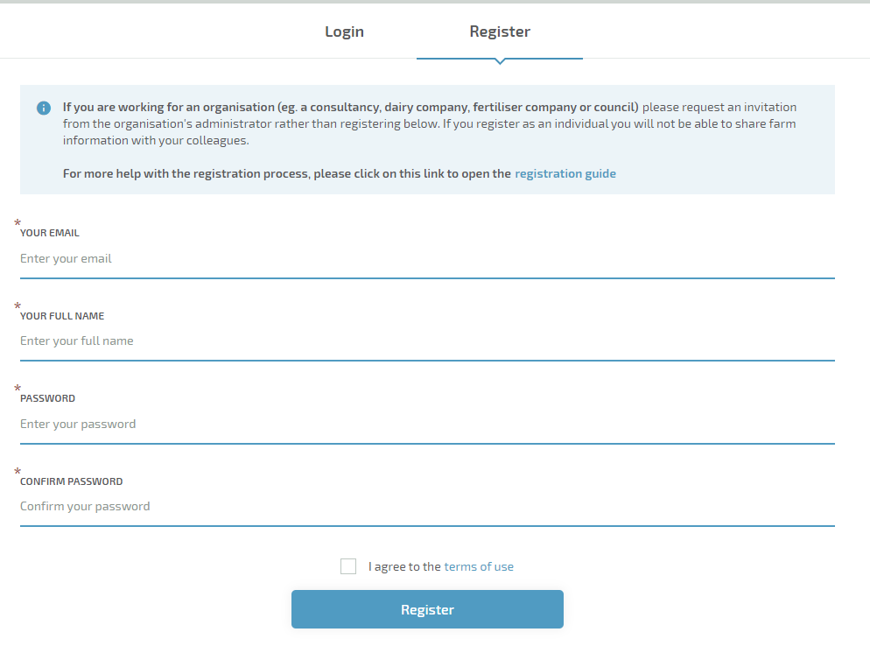

OverseerFM Farm Account setup
Once registration is complete, the following screen will show (unless the consultant has set up the farm account).
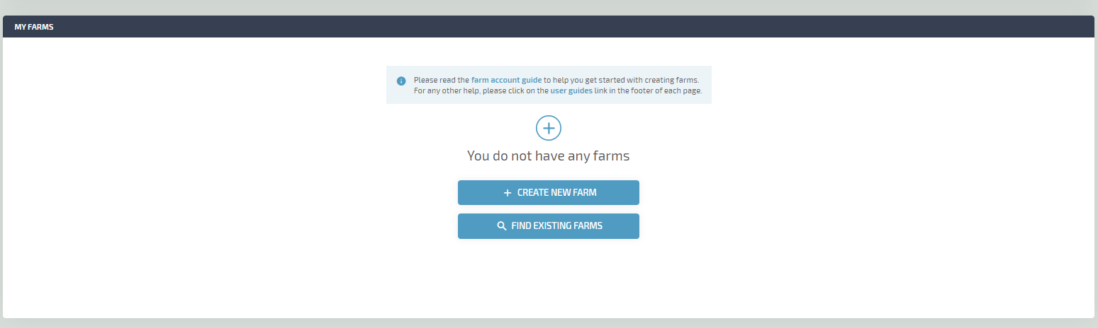
If the consultant created the farm account, the farm will show in the ‘Nominations’ area on the home screen within OverseerFM. The landowner will need to click the blue farm name on the screen and accept the invitation.
There are guides within OverseerFM to help the landowner understand the full processes around registration, farm account setup and subscription.

Bay of Plenty Regional Council protocols
If a landowner chooses to set up their farm account, BOPRC requires that the following steps are taken to ensure that the farm analysis will pass the QA process:

FM naming convention
To enable any analysis to be readily recognised by the landowner, LUA and BOPRC staff, the following ‘FM Naming Convention’ should be used in the farm account:
Farm name | PIN Farm Name e.g. 05 01 999 00 Sunny Pastures

Farm location
Please use Central Plateau under the ‘Region’ option. Do not use nearest town.
Using Central Plateau keeps all farm analyses for PC10 like with like and in line with allocation analysis settings.

Understanding OverseerFM jargon
With any system, jargon becomes commonplace for regular users and cause of confusion for new users. To assist with clarity, a summary of OverseerFM definitions are:
Overseer Analysis | The name (and data format) for a farm system, and associated results, from the OverseerFM model. Previously known as an Overseer ‘file’ (that was accompanied by an .xml extractable data set).
Publication | The way to submit data to another organisation in OverseerFM. Analysis should be published by the suitably qualified person i.e. agricultural consultant.
Farm account | There is one account per farm system. Where farms use multiple Overseer analyses to model their farm system, OverseerFM will require multiple ‘farm accounts’. Permissions are controlled by the farm account owner or by the farm account administrator(s).
XML | Previous Overseer Nutrient Budget farm system sharing format.
(See the Overseer Terms of Use for Overseer Limited formal definitions of these terms - https://docs.overseer.org.nz/OverseerFMTermsOfUse.pdf).

