ŌHAU RIVER DIVERSION WALL

Lake RotoITI - Kōura AND KĀKAHI MONITORING Programme

Kōura and Kākahi Monitoring Programme

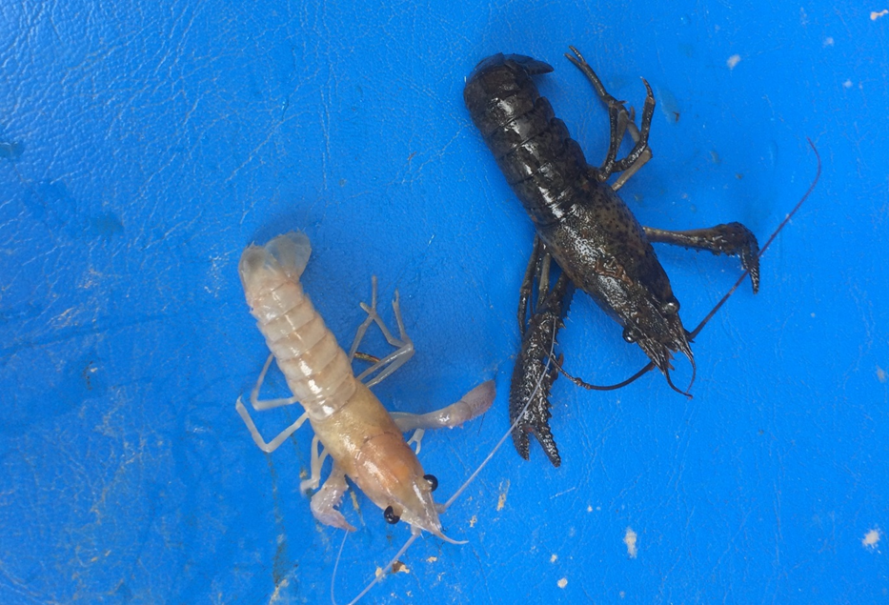

REPORT NUMBER 12 PREPARED FOR BAY OF PLENTY REGIONAL COUNCIL

Ian Kusabs & Associates Ltd
Rotorua, New Zealand
November 2018

Table of Contents

EXECUTIVE SUMMARY 1
1 INTRODUCTION 2
2 METHODS 2
2.1 Tau kōura location and lay out 2
2.1.1 Kōura measurements 4
2.2 Kākahi 4
2.3 Data analyses 4
3 RESULTS 5
3.1 Kōura 5
3.1.1 Kōura abundance 5
3.1.2 Kōura biomass 7
3.1.3 Kōura size 10
3.1.4 Female to male ratio 13
3.1.5 Egg-bearing times and moulting 13
3.2 Kākahi 14
3.2.1 Sampling conditions 14
3.2.2 Kākahi abundance 14
4 DISCUSSION 16
4.1 Kōura 16
4.2 Kākahi 17
5 SUMMARY 17
6 ACKNOWLEDGEMENTS 18
7 REFERENCES 18

Cover photo: A white-coloured kōura captured in the Ōkere Arm, Lake Rotoiti, March 2018. Most probably due to a recessive trait resulting from a mutation in the gene responsible for pigment formation. Ian Kusabs
List of figures

Figure 1 Kōura and kākahi monitoring sites, Lake Rotoiti, 2005-18. Numbers in red boxes (1 = Ōkere, 2 = Te Ākau, 3 = Manupirua) show the approximate locations of the kōura monitoring sites and numbers in black circles indicate kākahi sites (refer Table 1 for kākahi site names). 3
Figure 2 Schematic diagram of a tau kōura. The depth and length of tau are indicative and can be varied depending on lake bathymetry. 3
Figure 3 Mean catch per unit effort (CPUE) of kōura (± SD; n = 10) captured in tau kōura set in Ōkere Arm, Te Ākau and Manupirua, Lake Rotoiti, 8 December 2005 to 8 August 2018. Arrow indicates when the diversion wall was completed (July 2008). 5
Figure 4 Relationship between mean CPUE of kōura Ōkere, Te Ākau and Manupirua and time. The arrows indicate when the diversion wall was completed at month 30 (July 2008). 6
Figure 5 Mean Biomass Per Unit Effort (BPUE) of kōura (± SD; n = 10) captured in tau kōura set in Ōkere Arm, Te Ākau and Manupirua, Lake Rotoiti, 8 December 2005 to 8 August 2018. Arrow indicates when the diversion wall was completed (July 2008). 7
Figure 6 Relationship between estimated mean kōura biomass and time (sampling period beginning December 2005). The arrows indicate when the diversion wall was completed at month 30 (July 2008). 9
Figure 7 Length-frequency distributions of kōura captured from Te Ākau, Lake Rotoiti, in February 2007 and August 2017, December 2017 and May 2018 (combined) on two tau kōura comprised of 10 whakaweku. OCL = Orbital Carapace length. 11
Figure 8 Kōura collected from Manupirua, August 2018. 11
Figure 9 Relationship between mean OCL (mm) of kōura and time (sampling period beginning December 2005). The arrows indicate when the diversion wall was completed at month 30 (July 2008). 12
Figure 10 Mean annual densities of kākahi (m⁻² ± SD) at five sampling sites, Lake Rotoiti from 2005 to 2018 (47 surveys). The light bars represent those counts recorded prior to completion of the Ōhau channel diversion wall, dark bars, those counts after completion, and the orange bars represent this year’s count (15 October 2017 to 14 August 2018). 14
Figure 11 Kākahi density at five sites (0.5 m x 40 m transects) situated in Lake Rotoiti, over the sampling period June 2005 to August 2018. The arrows indicate when the diversion wall was completed at month 30 (July 2008). 15

List of tables

Table 1 Sampling site, number, location, grid reference and direction of transect for six kākahi monitoring sites located in Ōkere Arm and Lake Rotoiti. 4
Table 2 Mean CPUE (± SD) of kōura collected from tau kōura set at Ōkere, Te Ākau and Manupirua from 14 December 2017 to 8 August 2018 and mean CPUE for the 2017 to 2018 and 2005 to 2018 sampling periods. 5
Table 3 Estimated mean biomass (g; ± SD) per whakaweku of kōura collected from tau kōura (n =10) set at Ōkere, Te Ākau and Manupirua from 14 December 2017 to 8 August 2018 and mean BPUE for the 2017 to 2018 and 2005 to 2018 sampling periods. 7
Table 4 Mean OCL (mm ± SD) of kōura collected from tau kōura set at Ōkere, Te Ākau and Manupirua from 14 December 2017 to 8 August 2018 and mean of means OCL from 2005 to 2018. 11
Table 5 Number of kōura analysed and percentage of female kōura collected in samples from tau kōura set at Ōkere, Te Ākau and Manupirua from 14 December 2017 to 8 August 2018. Overall percentage of female kōura for 2017 to 2018 and mean of means for 2005 to 2018. 13
Table 6 Percentage (%) and actual number (n) of breeding sized females with eggs and percentage (%) of soft shelled kōura collected in samples from tau kōura set at Ōkere, Te Ākau and Manupirua from 14 December 2017 to 8 August 2018 (overall mean) and 2005 to 2018 (mean of means ± SD). 13
Table 7 Mean (± SD) densities of kākahi (m⁻²) at five sampling sites (20 m²), Lake Rotoiti from 15 October 2017 to 14 August 2018 and from 2005 to 2018. 14

EXECUTIVE SUMMARY
Kōura and kākahi are considered taonga species by Te Arawa iwi and are an important ecological component of Lake Rotoiti. The main purpose of this study is to monitor long term trends in the kōura and kākahi populations in Lake Rotoiti. Seasonal monitoring surveys of kākahi commenced in 2005 and kōura at Ōkere in 2005, Te Ākau in 2007 and Manupirua in 2009. The Ohau diversion wall was completed, and became fully operational in July 2008.
The Lake Rotoiti kōura population was sampled using the tau kōura a traditional Māori method of harvesting kōura in Te Arawa and Taupō lakes. Tau kōura were located at Ōkere, Te Ākau and Manupirua in Lake Rotoiti with each tau kōura composed of 10 whakaweku (bracken fern bundles). The kākahi monitoring methodology developed by NIWA specifically for community and iwi groups was used to determine kākahi densities at five sites around Lake Rotoiti (i.e., transects 40 m long x 0.5 wide).
The Ōkere Arm and Lake Rotoiti continue to support abundant kōura and kākahi populations a decade after the completion of the diversion wall. In December 2017, the third highest mean CPUE (77.2 kōura whakaweku⁻¹) was recorded at Ōkere the since surveys began in 2005. It is probable that kōura abundance at this site has always been highly variable because the population is composed mainly of small-sized juvenile kōura (the life stage most likely to experience large scale fluctuations). In contrast, there has undoubtedly been a significant decline in kōura abundance and biomass at Te Ākau since 2007 (when surveys commenced at this site). Length frequency analysis shows that this decline is due to a marked reduction in the numbers of kōura <29 mm OCL. The decline in Te Ākau kōura abundance and biomass could be due to (a) increased catfish predation particularly of juvenile kōura (b) reduced lake productivity and consequently a decrease in available food supply for kōura (c) increased aquatic macrophyte growth and accumulation of decaying organic matter that can degrade available lake-bed habitat for kōura. Interestingly, a similar shift to fewer, but larger kōura has also occurred in neighbouring Lake Rotorua, which has undergone similar improvements in water quality although it is uncertain whether catfish are also present in this lake.
Kākahi remain abundant in the Ōkere Arm and Lake Rotoiti where high densities are present. Kākahi abundance has remained relatively stable at all of the monitoring sites in Lake Rotoiti except at the ditch site (a treatment site) since surveys began in 2005.

1 INTRODUCTION
Kōura (Paranephrops planifrons) and kākahi (Echyridella menziesi) support important customary fisheries in Lake Rotoiti where they are harvested for human consumption by local Māori. As part of the efforts to improve water quality in Lake Rotoiti, the Bay of Plenty Regional Council has built a wall that diverts nutrient rich water from Lake Rotorua down the Kaituna River, preventing it from entering Lake Rotoiti. The wall has separated Lake Rotoiti into two ecologically separate waterways, an eastern basin (no Lake Rotorua influence) and a very small western basin (Lake Rotorua influence). Wall construction was completed, and became fully operational, in July 2008.
Baseline monitoring of kōura and kākahi populations in the Ōkere Arm and Lake Rotoiti from December 2005 to September 2007 and showed that kōura and kākahi were abundant in both the Ōkere Arm and Lake Rotoiti (Kusabs and Emery 2006; Kusabs and Quinn 2009). Following the completion of the diversion wall in July 2008 monitoring surveys of kōura and kākahi have been carried out on a seasonal basis in Lake Rotoiti. The principal aim of this study is to monitor long term trends in the kōura and kākahi populations in Lake Rotoiti.

2 METHODS

2.1 Tau kōura location and lay out
The Lake Rotoiti kōura population was sampled using the tau kōura, a traditional Māori method of harvesting kōura in the Te Arawa and Taupō lakes (Kusabs and Quinn 2009). Three tau kōura were set in Lake Rotoiti, located in the Ōkere Arm (Ōkere) at NZMG E 2803800 N 6348162, off Te Ākau Point (Te Ākau) at E 2803747 N 6346463, and near Manupirua hot pools (Manupirua) at E 2806499 N 6345889, (Fig. 1). Kōura surveys for this annual monitoring period were carried out on 14 December 2017, 18 February 2018 (Te Ākau & Manupirua), 15 March 2018 (at Ōkere), 10 May 2018 and 8 August 2018.
The methods used in this study are described in previous reports (see Kusabs et al. 2010). Each tau kōura was comprised of 10 whakaweku (dried bracken fern; Pteridium esculentum, bundles), with c. 10-14 dried fronds per bundle, which were attached to a bottom line (a 200 m length of sinking anchor rope) and set in the Ōkere Arm, Te Ākau and Manupirua in depths ranging from 4 to 7 m, 7 m to 17 m and 11 m to 27 m, respectively (Fig. 2).
The tau kōura were left for at least one month to allow kōura to colonise the fern and retrieved every three months. Tau kōura were returned to the water once kōura had been analysed. Owing to decomposition, whakaweku (particularly those in the Ōkere Arm) were replaced after six months.

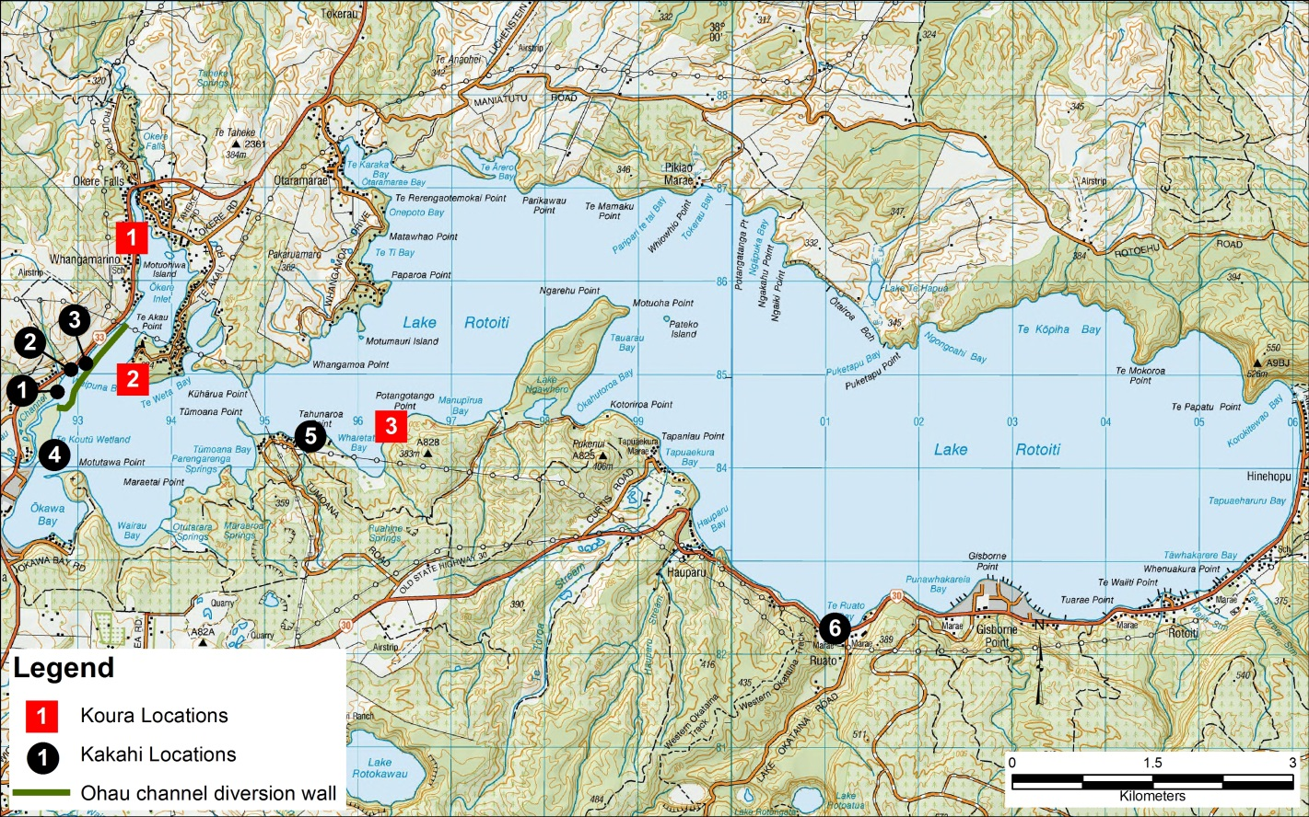
Figure 1 Kōura and kākahi monitoring sites, Lake Rotoiti, 2005-18. Numbers in red boxes (1 = Ōkere, 2 = Te Ākau, 3 = Manupirua) show the approximate locations of the kōura monitoring sites and numbers in black circles indicate kākahi sites (refer Table 1 for kākahi site names).

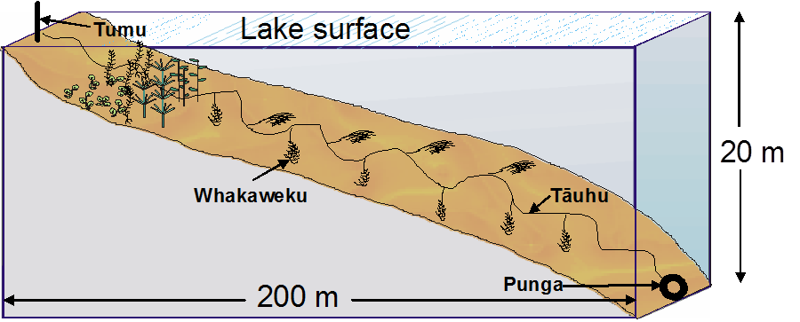
Figure 2 Schematic diagram of a tau kōura. The depth and length of tau are indicative and can be varied depending on lake bathymetry.

2.1.1 Kōura measurements
Orbit-carapace length (OCL, mm) of each kōura was measured using vernier callipers (± 0.5 mm) and the sex of kōura (OCL > 11 mm) assessed. A power regression equation (previously determined by B. Hicks and P. Riordan, University of Waikato) was used to determine kōura wet weight (Kusabs et al. 2015a). After processing, all kōura were returned to the water in close proximity to the tau kōura. Catch Per Unit Effort (CPUE) was defined as the number of kōura per whakaweku and Biomass Per Unit Effort (BPUE) as estimated wet weight (g) of kōura per whakaweku (Kusabs et al. 2015b).

2.2 Kākahi
Kākahi transects were located at five sampling sites in Lake Rotoiti (Fig. 1, Table 1) . At each site 40 m transects, 0.5 m wide, and perpendicular to the shore, were inspected out into the lake from standard points to a depth where the water was regularly wadeable. All kākahi in an area of 0.5 m wide running parallel to and up-current from a weighted survey line were counted using an underwater viewer. Counts were summed for each 1 m interval. Where possible, surveys were carried out when weather conditions and water clarity allowed good visual observations to be made. Kākahi surveys for this annual monitoring period were carried out on an approximate three-monthly basis from 15 October 2017 to 14 August 2018.

2.3 Data analyses
Time series analyses were performed using Time Trends (version 6, 2016) for kōura and kākahi data. Where necessary, data were log₁₀ or Sqrt transformed to approximate the normal distribution.

Table 1 Sampling site, number, location, grid reference and direction of transect for six kākahi monitoring sites located in Ōkere Arm and Lake Rotoiti.
Sampling site | Location | Grid reference (NZ Geodatum)
1. Boat Ramp | Ōkere Arm | E 2802931 N 6346315
2. Rest area | Ōkere Arm | E 2803075 N6346554
3. Ditch | Ōkere Arm | E 2803237 N 6346621
4. Ōkawa Bay | Lake Rotoiti | E 2802903 N 6345642
5. Ruato Bay | Lake Rotoiti | E 2811245 N 6343779

3 RESULTS

3.1 Kōura

3.1.1 Kōura abundance
A total of 2457 kōura were collected at Ōkere (n = 1433), Te Ākau (n = 208) and Manupirua (n = 816) in 2017/18, an increase of 139% on 2016/17 (Table 2). This was mainly due to an increase in the number of kōura captured at Ōkere, although counts were also higher at Te Ākau and Manupirua. As in previous years, kōura abundance varied markedly amongst the seasons, with the highest mean CPUEs once again recorded in Spring (December 2017) (Table 2). Only eight kōura were captured at Te Ākau in February 2018, the lowest number ever recorded (Table 2). The mean CPUEs recorded at Ōkere and Manupirua for 2017-18 were above the long-term means (2005-2018); however, the mean CPUE at Te Ākau for 2017-2018 remains far below the long-term average (Table 2).
Table 2 Mean CPUE (± SD) of kōura collected from tau kōura set at Ōkere, Te Ākau and Manupirua from 14 December 2017 to 8 August 2018 and mean CPUE for the 2017 to 2018 and 2005 to 2018 sampling periods.
 |  | Mean CPUE
Date |  | Ōkere | SD |  | Te Ākau | SD |  | Manupirua | SD
14 December 2017 |  | 72.2 | 62.8 |  | 13.7 | 9.5 |  | 38.4 | 10.6
February/March 2018 |  | 10.6 | 7.7 |  | 0.9 | 1.2 |  | 9.9 | 4.2
10 May 2018 |  | 26.7 | 16.5 |  | 3.9 | 2.3 |  | 22.7 | 12.6
8 August 2018 |  | 33.8 | 13.3 |  | 3.2 | 2.5 |  | 38.4 | 10.6
2017 - 2018 |  | 35.8 | 39.4 |  | 6.7 | 7.3 |  | 27.1 | 15.4
2005 - 2018 |  | 31.9 | 29.8 |  | 18.0 | 23.7 |  | 21.0 | 17.3

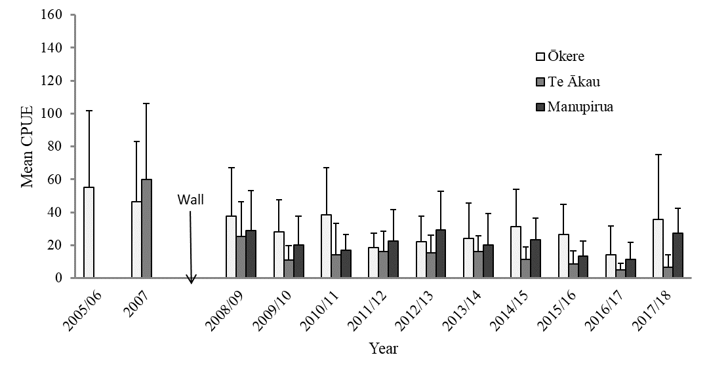
Figure 3 Mean catch per unit effort (CPUE) of kōura (± SD; n = 10) captured in tau kōura set in Ōkere Arm, Te Ākau and Manupirua, Lake Rotoiti, 8 December 2005 to 8 August 2018.

Over the entire sampling period (2005 to 2018) there have been declines in mean CPUE at Ōkere (P < 0.05) and Te Ākau (P < 0.01) but not at Manupirua (P = 0.35) (Fig. 4). An analysis of post 2008 data (after wall completion) also shows significant declines in kōura CPUE at Ōkere (P = 0.03) and Te Ākau (P = 0.004).

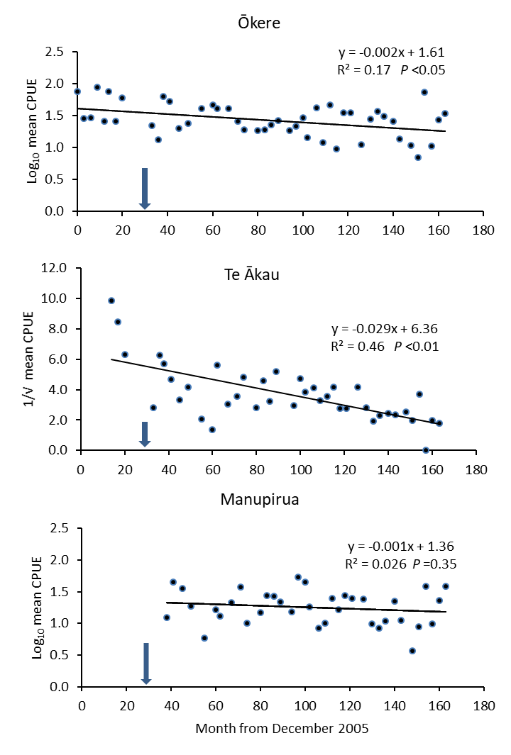
Figure 4 Relationship between mean CPUE of kōura Ōkere, Te Ākau and Manupirua and time. The arrows indicate when the diversion wall was completed at month 30 (July 2008).

3.1.2 Kōura biomass
Mean biomass estimates (BPUE) for the 2017/18 surveys ranged from; 567 g per whakaweku at Manupirua to 24.3 g per whakaweku at Te Ākau (Table 3). The highest BPUEs at Ōkere and Te Ākau were recorded in December 2017 and in August 2018 at Manupirua (Table 3, Fig. 5).

Table 3 Estimated mean biomass (g; ± SD) per whakaweku of kōura collected from tau kōura (n =10) set at Ōkere, Te Ākau and Manupirua from 14 December 2017 to 8 August 2018 and mean BPUE for the 2017 to 2018 and 2005 to 2018 sampling periods.
 | Estimated mean biomass (g)
Date | Ōkere |  | SD |  |  | Te Ākau |  |  | SD |  |  | Manupirua |  | SD
14 December 2017 |  | 506.8 |  | 431.7 |  |  |  | 539.8 |  | 397.3 |  |  | 401.2 |  | 212.6
February/March 2018 |  | 65.1 |  | 53.9 |  |  |  | 24.3 |  | 36.6 |  |  | 143.8 |  | 77.7
10 May 2018 |  | 73.1 |  | 39.8 |  |  |  | 207.8 |  | 123.7 |  |  | 428.3 |  | 252.5
8 August 2018 |  | 124.9 |  | 47.0 |  |  |  | 122.7 |  | 91.7 |  |  | 566.6 |  | 148.8
2016 - 2017 |  | 192.5 |  | 280.8 |  |  |  | 268.7 |  | 293.7 |  |  | 397.7 |  | 234.3
2005 - 2017 |  | 147.7 |  | 170.8 |  |  |  | 428.8 |  | 412.7 |  |  | 332.2 |  | 283.1

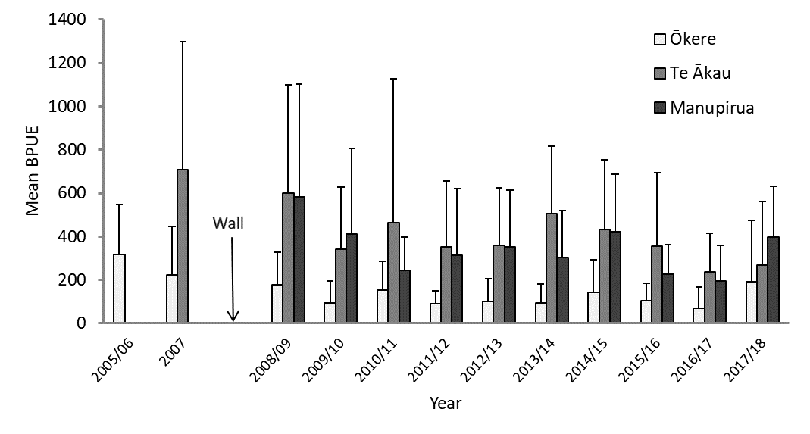
Figure 5 Mean Biomass Per Unit Effort (BPUE) of kōura (± SD; n = 10) captured in tau kōura set in Ōkere Arm, Te Ākau and Manupirua, Lake Rotoiti, 8 December 2005 to 8 August 2018. Arrow indicates when the diversion wall was completed (July 2008).
.

Monitoring data from 2005 to 2018 suggests that there have been declines in BPUE at Ōkere (P = 0.001), Te Ākau (P = 0.029) but not at Manupirua (P > 0.05) (P = 0.08) (Fig. 6). However, an analysis of post 2008 data showed no significant changes in mean BPUE at Ōkere (P = 0.10) or Te Ākau (P = 0.14) .

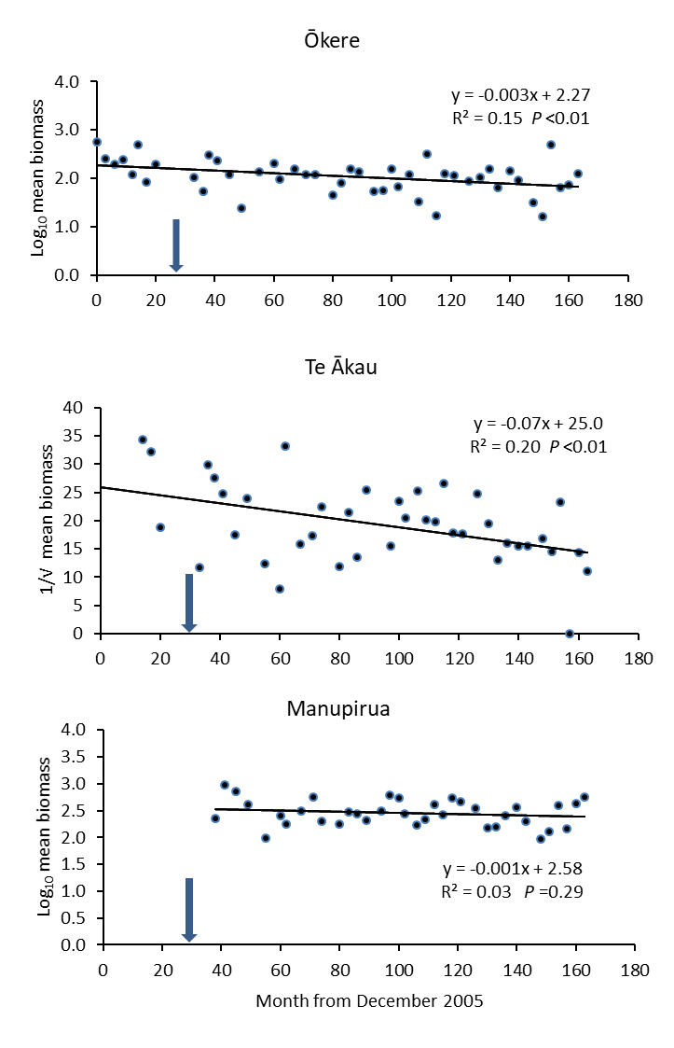
Figure 6 Relationship between estimated mean kōura biomass and time (sampling period beginning December 2005). The arrows indicate when the diversion wall was completed at month 30 (July 2008).

3.1.3 Kōura size
As in previous years, the largest kōura were found at Te Ākau, followed by Manupirua, and the smallest at Ōkere (Table 4). Kōura ranged in size from 10 to 40 mm at Ōkere, 11 to 54 mm at Te Ākau and 11 to 45 mm at Manupirua.
There have been no significant changes in kōura size at Ōkere (P = 0.15) or Manupirua (P = 0.64) since surveys began in 2005 and 2009, respectively (Fig. 9). However, at Te Ākau kōura mean size has increased significantly (P < 0.01) since 2007 (Fig. 8). Length frequency analysis of Te Ākau kōura size data for February 2007 and 2017 (August 2017, December 2017 and May 2018) shows that the increase in kōura OCL is mainly due to the reduction kōura <29 mm OCL, with a moderate increase in the numbers of kōura >35 mm OCL (Fig. 7).
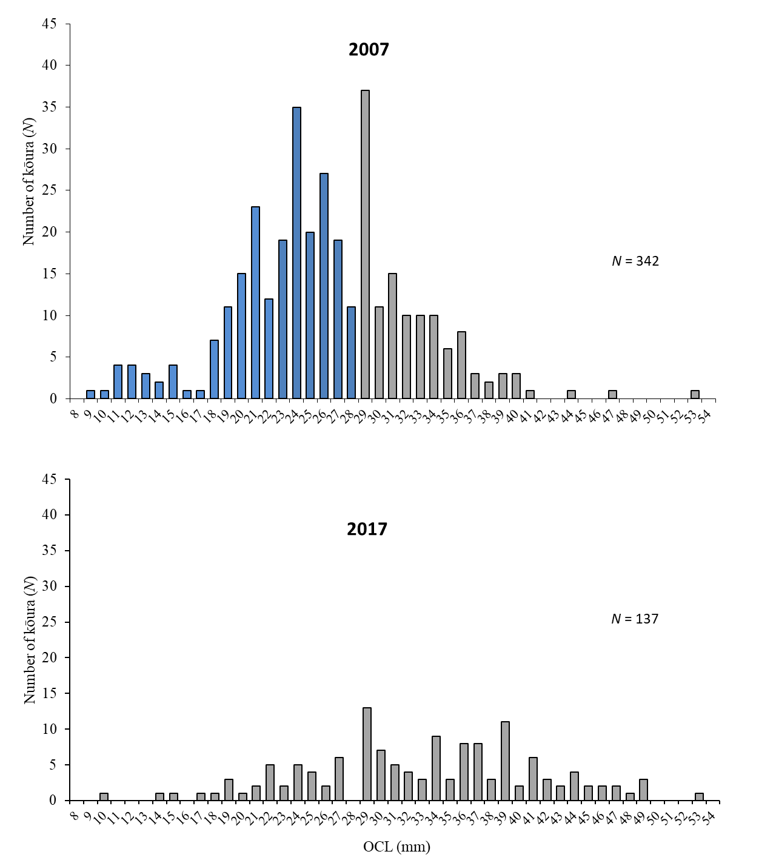
Figure 7 Length-frequency distributions of kōura captured from Te Ākau, Lake Rotoiti, in February 2007 and August 2017, December 2017 and May 2018 (combined) on two tau kōura comprised of 10 whakaweku. OCL = Orbital Carapace length.

Table 4 Mean OCL (mm ± SD) of kōura collected from tau kōura set at Ōkere, Te Ākau and Manupirua from 14 December 2017 to 8 August 2018 and mean of means OCL from 2005 to 2018.
 | Mean OCL (SD) |  |  |  |  |  |  |  |  | OCL Range (mm)
Date | Ōkere | SD |  | Te Ākau | SD |  | Manupirua | SD |  |  | Ōkere | Te Ākau | Manupirua
14 December 2017 | 20.3 | 4.6 |  | 34.1 | 8.3 |  | 23.0 | 6.6 |  |  | 14 - 40 | 11 - 54 | 11 - 40
February/March 2018 | 18.1 | 5.5 |  |  |  |  | 24.5 | 6.1 |  |  | 11 - 31 |  | 15- 40
10 May 2018 | 14.4 | 4.3 |  | 39.4 | 6.3 |  | 27.4 | 6.3 |  |  | 10 - 37 | 28 - 52 | 11 - 45
8 August 2018 | 16.5 | 3.0 |  | 34.5 | 8.7 |  | 25.7 | 6.6 |  |  | 12 - 28 | 15 - 46 | 13- 45
2017 - 2018 | 17.5 | 5.0 |  | 35.0 | 8.2 |  | 24.9 | 6.7 |  |  | 10 - 40 | 11 - 54 | 11- 45
2005 - 2018 | 16.4 | 2.6 |  | 31.7 | 4.5 |  | 26.3 | 2.1

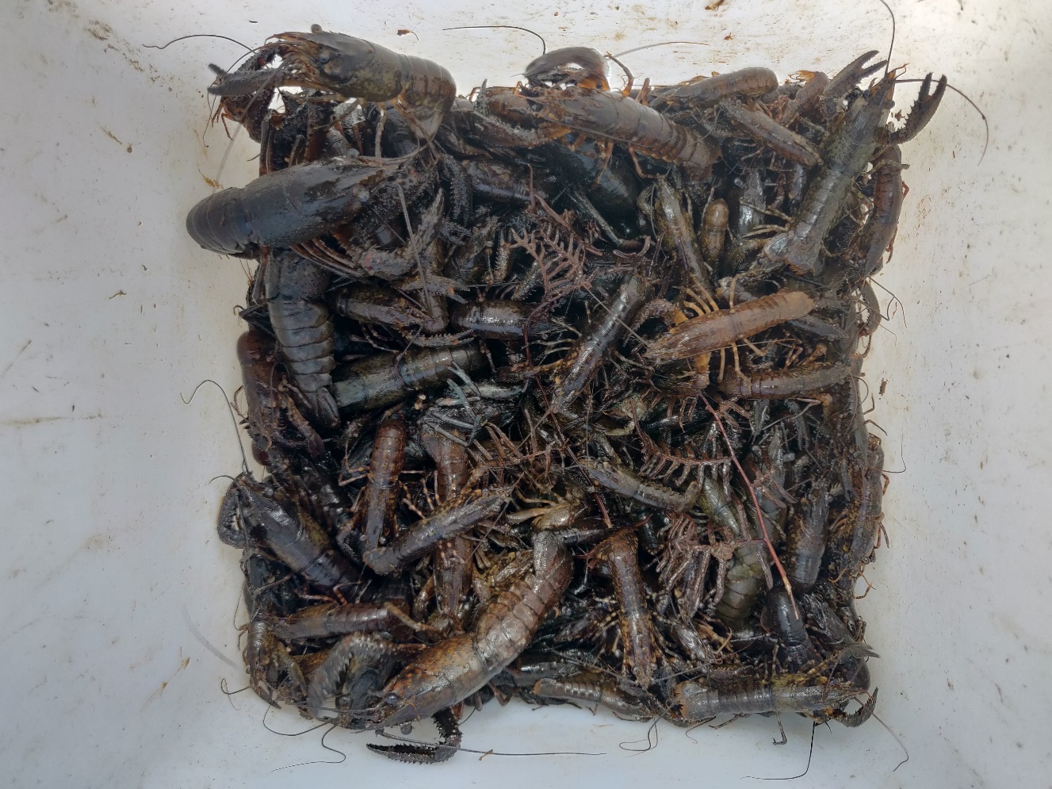

Figure 8 Kōura collected from Manupirua, August 2018.

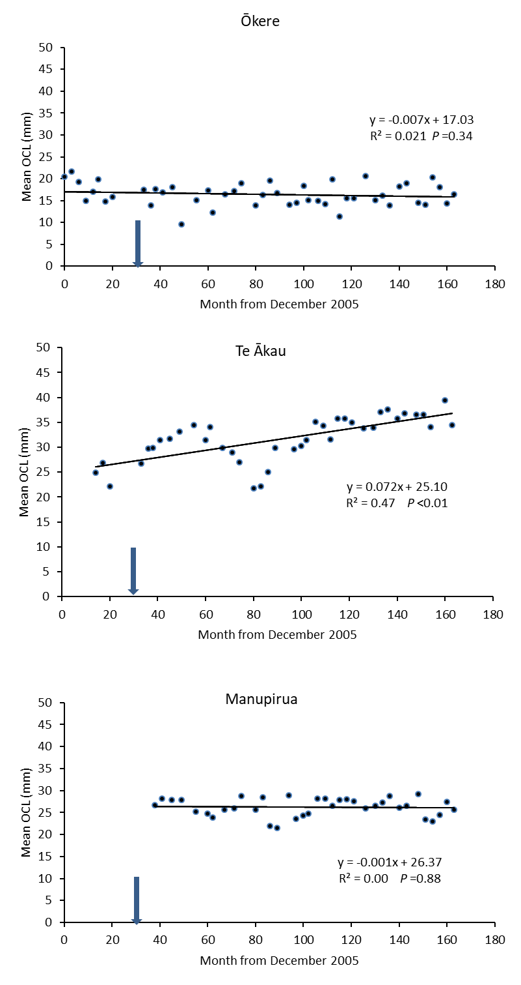
Figure 9 Relationship between mean OCL (mm) of kōura and time (sampling period beginning December 2005). The arrows indicate when the diversion wall was completed at month 30 (July 2008).

3.1.4 Female to male ratio
The mean percentage of females in subsamples from Ōkere Arm, Te Ākau and Manupirua in the 2017 - 2018 surveys were 57%, 51 and 45%, respectively. Female kōura comprised approximately 50% of all kōura analysed over the 2005 to 2018 study period (Table 5).
Table 5 Number of kōura analysed and percentage of female kōura collected in samples from tau kōura set at Ōkere, Te Ākau and Manupirua from 14 December 2017 to 8 August 2018. Overall percentage of female kōura for 2017 to 2018 and mean of means for 2005 to 2018.
 |  | Number of kōura analysed |  |  |  | % female
Date |  | Ōkere | Te Ākau | Manupirua |  | Ōkere | Te Ākau | Manupirua
14 December 2017 |  | 171 | 137 | 219 |  | 56.7 | 46.3 | 46.6
February/March 2018 |  | 106 | 8 | 79 |  | 50.0 |  | 49.4
10 May 2018 |  | 135 | 37 | 143 |  | 57.1 | 67.6 | 45.1
8 August 2018 |  | 111 | 30 | 146 |  | 59.1 | 46.7 | 40.4
2017 - 2018 |  | 523 | 212 | 587 |  | 57.1 | 51.2 | 45.0
2005 - 2018 |  | 6937 | 4372 | 5246 |  | 53.5 ± 5.4 | 47.6 ± 9.9 | 47.7 ± 5.3

3.1.5 Egg-bearing times and moulting
Females with eggs or young were present throughout the year, particularly in May, August and December with few in February/March (Table 6). The mean percentage of kōura with soft shells from Ōkere Arm, Te Ākau and Manupirua in the 2017/18 season were, 3.9%, 19% and 7.4%, respectively (Table 6). The percentage of kōura with soft shells in 2017/18 was similar to that recorded over the 2005 - 2018 monitoring period (Table 6). There was, however, an unusually high percentage of soft shelled kōura recorded at Te Ākau in May 2018 (27%) which may be due to the low sample size (n = 39) (Table 2).
Table 6 Percentage (%) and actual number (n) of breeding sized females with eggs and percentage (%) of soft shelled kōura collected in samples from tau kōura set at Ōkere, Te Ākau and Manupirua from 14 December 2017 to 8 August 2018 (overall mean) and 2005 to 2018 (mean of means ± SD).
 |  | % Breeding size females with eggs (n) |  |  |  | % soft shells
Date |  | Ōkere | Te Ākau | Manupirua |  | Ōkere | Te Ākau | Manupirua
14 December 2017 |  | 0.0 (0) | 36.2 (21) | 0.0 (0) |  | 4.7 | 13.9 | 4.0
February/March 2018 |  | 0.0 (0) |  | 3.6 (1) |  | 6.6 |  | 6.3
10 May 2018 |  | 25.00 (2) | 44.0 (11) | 35.7 (20) |  | 2.2 | 27.0 | 4.2
8 August 2018 |  | 40.0 (5) | 69.2 (9) | 56.3 (27) |  | 3.6 | 13.3 | 5.5
2017 - 2018 |  |  |  |  |  | 3.9 | 19.0 | 7.4
2005 - 2018 |  |  |  |  |  | 5.0 ± 5.6 | 10.6 ± 8.3 | 11.3 ± 6.9

3.2 Kākahi

3.2.1 Sampling conditions
Water clarity is an important consideration when counting kākahi and there has been a noticeable improvement in water clarity in Lake Rotoiti and the Ōkere Arm since monitoring began in 2005. However, this has been offset somewhat by the prolific growth of benthic algae over the past four years, which has compromised kākahi counts at all sites particularly in Okawa Bay and at the Boat Ramp site.

3.2.2 Kākahi abundance
The highest densities of kākahi in this year’s survey were once again recorded at Okawa Bay (control) and at the Ditch (treatment) sites (Table 7, Fig. 10). Kākahi abundance has remained relatively stable over the sampling period (2005 to 2018, Fig. 11) except at the ditch site (treatment) where there has been a significant decline (P < 0.01) (Fig. 11).
Table 7 Mean (± SD) densities of kākahi (m⁻²) at five sampling sites (20 m²), Lake Rotoiti from 15 October 2017 to 14 August 2018 and from 2005 to 2018.
Date | Boat ramp | Rest Area | Ditch | Ōkawa Bay | Ruatō Bay
15 October 2018 | 4.40 | 5.60 | 13.45 | 8.25 | 0.75
25 January 2018 | * | 7.55 | 10.05 | 11.15 | 1.50
21 May 2018 | 2.45 | 1.60 | 7.00 | 13.95 | 1.05
14 August 2018 | 1.80 | 5.75 | 7.25 | 8.70 | 0.90
2017 - 2018 | 2.88 ± 1.35 | 5.13 ± 2.51 | 9.43 ± 3.01 | 10.51 ± 2.62 | 1.05 ± 0.32
2005 - 2018 | 2.67 ± 1.39 | 5.51 ± 2.99 | 12.66 ± 10.47 | 13.53 ± 5.60 | 1.84 ± 1.04
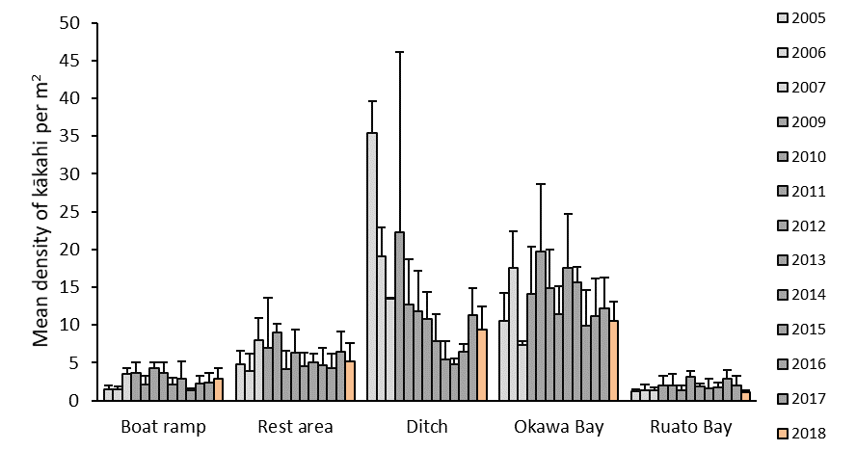
Figure 10 Mean annual densities of kākahi (m⁻² ± SD) at five sampling sites, Lake Rotoiti from 2005 to 2018 (47 surveys). The light bars represent those counts recorded prior to completion of the Ōhau channel diversion wall, dark bars, those counts after completion, and the orange bars represent this year’s count (15 October 2017 to 14 August 2018).
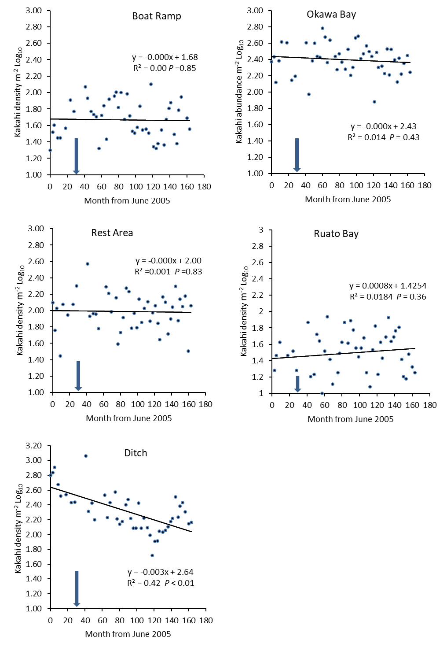
Figure 11 Kākahi density at five sites (0.5 m x 40 m transects) situated in Lake Rotoiti, over the sampling period June 2005 to August 2018. The arrows indicate when the diversion wall was completed at month 30 (July 2008).

4 DISCUSSION

4.1 Kōura
A decade after the installation of the Ōhau Channel diversion wall koura are still abundant in the Ōkere Arm and Lake Rotoiti. In December 2017, the third highest mean CPUE (77.2 kōura whakaweku⁻¹) was recorded at Ōkere the since surveys began in 2005.
Monitoring data shows that there is considerable variability in mean CPUE and BPUE at Ōkere since surveys began in 2005, both before and after installation of the wall in July 2008. This may be due to the large numbers of juvenile kōura at this site; the life stage most susceptible to large fluctuations.
At Manupirua, the kōura population has remained relatively stable with no change in abundance or biomass since 2009 (when this site was added to the monitoring programme). In contrast, at Te Ākau (control) there has been a significant kōura abundance and biomass since July 2008. There was also considerable variation in kōura abundance at Te Ākau in 2017/18 with a mean CPUE of 13.7 kōura whakaweku⁻¹ recorded in December 2017 and 0.9 kōura whakaweku⁻¹ in February 2018; the lowest number ever recorded at this site. Upon retrieval it was noted that the whakaweku (which were deployed at depths ranging from 7 m to 17 m) had been affected by hypoxia. Future increases in summer water temperatures may further exacerbate seasonal variations in kōura abundance at Te Ākau and in other shallow, lentic areas in Lake Rotoiti.
Length frequency analysis of kōura data shows that the decline in the Te Ākau kōura population is due to a marked reduction in the numbers of kōura <29 mm OCL. The reasons for this decline are unknown but it could be due to increased predation of kōura by brown bullhead catfish (Ameiurus nebulosus), reduced lake productivity or increased aquatic macrophyte growth. Interestingly, there has been a similar decline in kōura abundance (~80%) in Lake Rotorua since 2009 (Kusabs 2018). Live, brown bullhead catfish were officially recorded in Lake Rotoiti in March 2016 (however, they could have been present as early as 2009) and are now well established in the lake and the Ōhau River. Catfish have been reported to commonly consume kōura (particularly juvenile kōura) in Lake Taupō and are considered a more effective predator of kōura than trout (Barnes and Hicks 2003). It maybe coincidence, but the Te Ākau monitoring site is in close proximity to Te Weta Bay, which has the highest abundance of catfish in Lake Rotoiti, with >7000 catfish captured in one night in 2018 (pers. comm. S Grayling, BOPRC).
The change in kōura population since 2005 in Lake Rotoiti and 2009 in Lake Rotorua has coincided with steadily improving water quality in both lakes. In Lake Rotoiti the trophic level index (TLI) has decreased from 4.4 in 2004 to 3.8 in 2017 and in Lake Rotorua from 5.03 in 2004 to 4.06 in 2017 and (BOPRC data). This has resulted in a decrease in algae production and an increase in water clarity. The reduced primary production may have resulted in a decrease in food supply and therefore reduced abundance of kōura in both lakes. Conversely, increased water clarity may have led to an increase in the growth and extent of introduced macrophytes (e.g., hornwort). Weed proliferation and accumulation of decaying organic matter can markedly degrade the habitat quality of the surrounding lake bed.

4.2 Kākahi
Kākahi abundance examined over the sampling period has remained relatively stable at all of the monitoring sites in Lake Rotoiti except at the ditch site (a treatment site). Sediment type is an important determinant of mussel density in lakes (James 1985). Since the diversion wall has been in place there has been a noticeable accumulation of silt in the Ōkere Arm monitoring sites particularly at the Ditch site where the mean silt depth has increased 10-fold (I. Kusabs, unpublished data). Interestingly, over the past three years or so this silt has been colonised by extensive growths of low growing turf species e.g. Glossostigma elatinoides. This has resulted in the consolidation of the lake bed, creating habitat more suitable to kākahi. It is possible that the establishment and proliferation of these turf plants is due to the shelter provided by the diversion wall, which has markedly reduced easterly wave action.

5 CONCLUSIONS
- The Ōkere Arm and Lake Rotoiti continue to support abundant kōura and kākahi populations a decade after the completion of the diversion wall.
- Monitoring data shows that there is considerable variability in mean CPUE and BPUE at Ōkere since surveys began in 2005, both before and after installation of the wall in July 2008. This may be due to the large numbers of juvenile kōura at this site.
- At Manupirua, the kōura population has remained relatively stable with no significant change in abundance or biomass since 2009
- There has been a significant decline in kōura abundance and biomass at Te Ākau since 2007. Length frequency analysis shows that this decline is due to a marked reduction in the numbers of kōura <29 mm OCL.
- Kākahi remain abundant in the Ōkere Arm and Ōkawa Bay where high densities are present. Kākahi abundance has remained relatively stable at all of the monitoring sites in Lake Rotoiti except at the ditch site (a treatment site) since surveys began in 2005.

6 ACKNOWLEDGEMENTS
Thanks to Te Whaeoranga Smallman, Laura Francis, and Joe Butterworth for assistance with fieldwork. Thanks also to Andy Bruere for project liaison.

7 REFERENCES

Barnes, G. E., and B. J. Hicks. 2003. Brown bullhead catfish (Ameiurus nebulosus) in Lake Taupo. Page 27–35. in D. of C. 2003, editor. Managing invasive freshwater fish in New Zealand. Proceedings of a workshop hosted by Department of Conservation, Hamilton, New Zealand.
James, M. R. 1985. Distribution, biomass and production of the freshwater mussel, Hyridella menziesi (Gray), in Lake Taupo, New Zealand. Freshwater Biology 15:307–314.
Kusabs, I. A. 2015. Kōura (Paranephrops planifrons) populations in the Te Arawa lakes: an ecological assessment using the traditional Māori tau kōura harvesting method and recommendations for sustainable management. University of Waikato, Hamilton, New Zealand.
Kusabs, I. A., and W. Emery. 2006. Ohau Channel Diversion Wall - An assessment of the kōura and kākahi populations in the Okere Arm and Lake Rotoiti. Report prepared for Bay of Plenty Regional Council. Ian Kusabs and Associates Ltd, Rotorua, New Zealand.
Kusabs, I. A., B. J. Hicks, J. M. Quinn, and D. P. Hamilton. 2015a. Sustainable management of freshwater crayfish (kōura, Paranephrops planifrons) in Te Arawa (Rotorua) lakes, North Island, New Zealand. Fisheries Research 168.
Kusabs, I. A., and J. M. Quinn. 2009. Use of a traditional Māori harvesting method, the tau kōura, for monitoring kōura (freshwater crayfish, Paranephrops planifrons) in Lake Rotoiti, North Island, New Zealand. New Zealand Journal of Marine and Freshwater Research 43(3).
Kusabs, I. A., J. M. Quinn, and D. P. Hamilton. 2015b. Effects of benthic substrate, nutrient enrichment and predatory fish on freshwater crayfish (kōura, Paranephrops planifrons) population characteristics in seven Te Arawa (Rotorua) lakes, North Island, New Zealand. Marine and Freshwater Research 66(7).
Kusabs, I. A. 2018. Lake Rotorua – kōura and kākahi monitoring programme. Report prepared for Bay of Plenty Regional Council. Ian Kusabs and Associates Ltd, Rotorua, New Zealand. 17 pp.

Note: Kākahi counts at Tumoana Bay were discontinued in 2011 due to the very low numbers present.
Sampling was carried out on 18 February 2018 at Te Ākau and Manupirua and 15 March 2018 at Ōkere; this was to allow more time for kōura to colonise the whakaweku which were replaced at the Ōkere site in January 2018.
Manupirua is not included as there was no pre-wall monitoring at this site.
Manupirua is not included as no pre-wall monitoring was conducted there.
Note: Although the Ōkawa monitoring site is shallower than Te Ākau, there is continual movement of water towards the Kaituna River.

