# Memo

|  |  |
| --- | --- |
| From | Cindy Baker |
| To | Bay of Plenty Regional Council Fisheries Advisory Panel |
| CC |  |
| Date | 22 November 2017 |
| Subject | Summary of smelt monitoring data |
| File path  *(right click to update)* | *C:\Users\karlak\AppData\Local\Microsoft\Windows\Temporary Internet Files\Content.Outlook\Q6JWZNCF\171122 NIWA Memo FAP smelt summary data.docx* |

Overview

At the request of the Fisheries Advisory Panel (14th November meeting), the smelt monitoring data collected from 2005 to 2017 has been summarised to inform the structure of the future monitoring programme under the new resource consent (RM16-0527-AP). To provide detail around the timing of the juvenile and adult smelt migrations up the Ohau River, the trapping data (Trap 1 and 2 only) has been displayed as monthly catches. The site-specific catch rates of larval smelt for each sampling season are also provided.

Smelt migration up the Ohau River

With the exception of June, where sampling has occurred six times since 2010, there has been between 10 and 13 sampling occasions in each month since 2007 (Table 1).

Table 1: Number of sampling occasions carried out in each month between 2007 and 2017. Note April 2017 has been omitted because of the reduced sampling effort.

|  |  |
| --- | --- |
| Month | Sample size |
| January | 11 |
| February | 10 |
| March | 11 |
| April | 10 |
| May | 11 |
| June | 6 |
| September | 12 |
| October | 13 |
| November | 10 |
| December | 11 |

The threshold catch rate of smelt that constitutes a ‘run’ is 120 fish per hour. Since 2007, smelt runs have occurred in all months except June (Figure 1). The largest runs have occurred in March, April, May, and October. The two largest runs (>1200 smelt per hour) seen in October 2013 and May 2017 consisted of adults and juveniles, respectively.

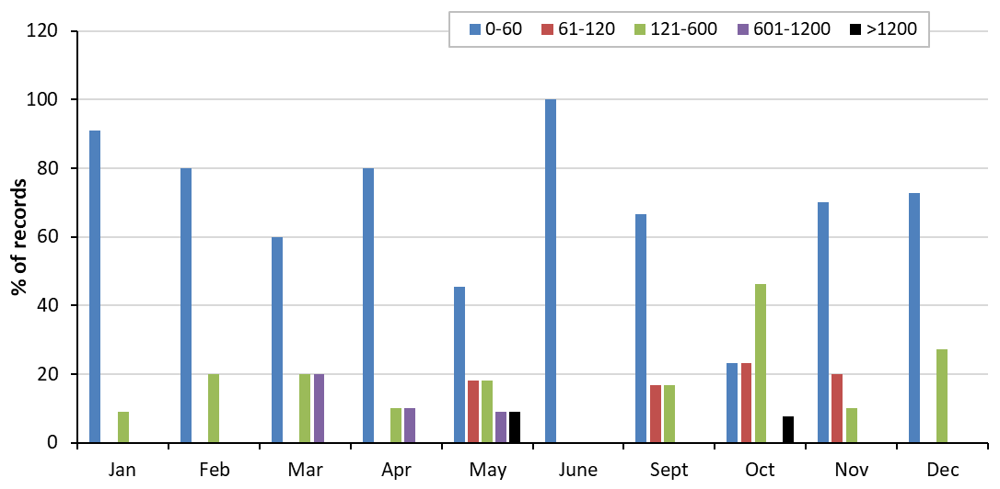

No. smelt per hour

Figure 1: The size of smelt runs (No. smelt/hour) recorded in each of the sampling months. Data represents 2007 through 2017 and displayed as the percentage of records in each of the five run size categories. Note the April 2017 data has not been included because of its lower sampling effort.

Larval smelt catch rates in Lake Rotoiti

The location of the 31 sampling sites for larval smelt are shown in Figure 2.



Figure 2: Location of the 31 sampling sites in Lake Rotoiti where drop netting for larval smelt is carried out.

The average larval catch at each site for December and April highlight December is the more productive sampling month, with higher catches occurring in the middle of Lake Rotoiti compared to the east and west sections of the lake (Figure 3). In contrast, a flatter catch rate is seen across all 31 sites in April, with sites in the east side of the lake the only locations where average catches are above 2 larvae per vertical haul (Figure 4).

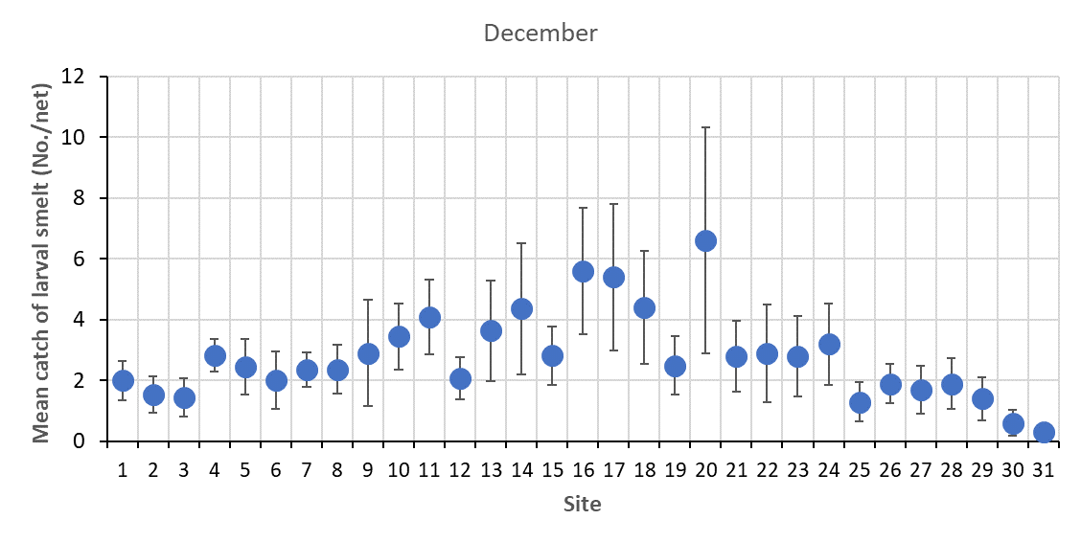

Figure 3: Average catch of larval smelt in December at each of the 31 sampling sites. Error bars represent ± 1 standard error. Data represents 2005 through 2017.

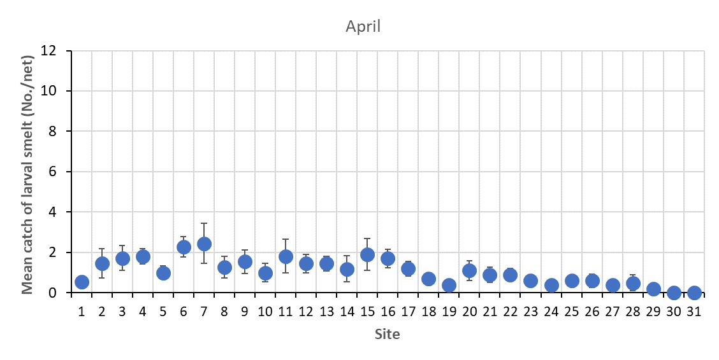

Figure : Average catch of larval smelt in April at each of the 31 sampling sites. Error bars represent ± 1 standard error. Data represents 2005 through 2017.