Assessing lake actions, risks and other actions

Prepared for Bay of Plenty Regional Council
August 2015
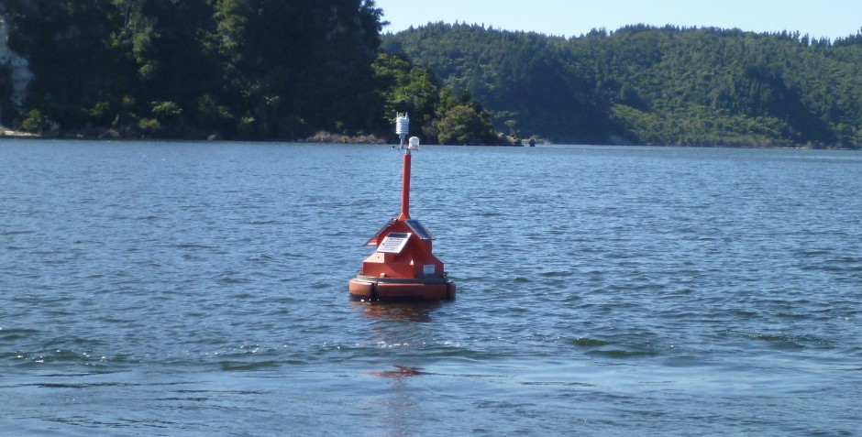

Authors/Contributors:
Max Gibbs
For any information regarding this report please contact:
Max Gibbs
Water Quality Scientist
Freshwater Ecology
+64-7-856 1773
max.gibbs@niwa.co.nz

National Institute of Water & Atmospheric Research Ltd
PO Box 11115
Hamilton 3251
Phone +64 7 856 7026
NIWA Client Report No: NIWA2015-102
Report date: August 2015
NIWA Project: BOP15214

Cover Photo: Lake Monitoring Buoy on Lake Rotoehu. Having good data in real time improves understanding of in-lake processes, which is fundamental to designing and implementing management strategies from improving lake water quality. [Photo by Max Gibbs]

Contents
Executive summary 6
1 Introduction 10
2 Background 12
3 Intervention assessment by lake 14
3.1 Lake Rotorua – (TLI target 4.2) 15
3.1.1 P-Locking 15
3.1.2 Removal of N from Tikitere 19
3.1.3 Floating wetlands 19
3.1.4 Sewage reticulation and treatment 20
3.1.5 Long-term land use P and N reductions 20
3.1.6 Weed harvesting in the lake. 21
3.1.7 Research needed 25
3.2 Lake Rotoiti – (TLI target 3.5) 26
3.2.1 Diversion wall 26
3.2.2 Sewage reticulation and treatment 26
3.3 Lake Rotoehu – (TLI target 3.9) 27
3.3.1 Land use change 27
3.3.2 Weed harvesting 27
3.3.3 P-Locking 28
3.3.4 Floating wetlands 28
3.3.5 Aeration 28
3.4 Lake Ōkāreka – (Target TLI 3.0) 30
3.4.1 Sewage reticulation and treatment 30
3.4.2 Land use change 30
3.5 Lake Ōkaro – (TLI target 5.0) 31
3.5.1 Constructed wetland 31
3.5.2 Detention dams 31
3.5.3 Land use change 32
3.5.4 Alum dosing 32
3.5.5 Aqual-P 33
3.5.6 Land management 33
3.5.7 Other potential interventions to try 34
3.6 Lake Tikitapu – (Target TLI 2.7) 38
3.6.1 Sewage reticulation 38
3.6.2 Stormwater 38
3.6.3 Catchment management 38
3.6.4 Other issues 39
3.7 Lake Okataina – (Target TLI 2.6) 40
3.8 Lake Rotoma – (Target TLI 2.3) 41
3.9 Lake Rerewhakaaitu – (Target TLI 3.6) 42
3.10 Lake Tarawera – (Target TLI 2.6) 43
3.11 Lake Rotokakahi – (Target TLI 3.1) 43
3.12 Lake Rotomahana – (Target TLI 3.9) 44
4 Discussion and future work 45
5 Acknowledgements 47
6 References 48

Tables
Table 1: Lake area, annual average outflow, TLI target, TLI observed and TLI difference, TP and TN concentrations in the lake and TP and TN output loads. 11
Table 2: Weed harvesting calculations. 23

Figures
Figure 1: Sketch map of the distribution of exotic macrophyte weed beds in Lake Rotorua in 1990. 22
Figure 2: Bay of Plenty Regional Council owned weed harvester on Lake Rotoehu. 24
Figure 3: PAM slow release blocks secured in the outwards current flow from the SolarBee mixer. 31
Figure 4: Schematic deployment of a PAM log in an aeration bubble stream. 36
Figure 5: Lists of American laundry powders in order of decreasing P per wash. 46

Reviewed by Approved for release by

……………………………………… ………………………………

Formatting checked by

………………………………………

Executive summary
Management strategies developed for the improvement of water quality in the Te Arawa Rotorua lakes and implemented by Bay of Plenty Regional Council (BoPRC) have generally been successful, with the water quality in most lakes getting close to their trophic level index (TLI) goals. The most spectacular success has been the renovation of the water quality in Lake Rotorua, where algal blooms are now uncommon and the water clarity has increased substantially.
The success of some strategies in some lakes suggests that similar strategies could work in other lakes where interventions have yet to be implemented. However, with success comes a risk that the recovery in the lakes that have interventions may not be stable yet and stopping the interventions may allow the lake water quality to deteriorate and revert back towards its previous poor quality. Stopping the intervention could be due to consents around the intervention not being renewed because there is a perception that the job is done and the intervention is no longer needed.
It is generally agreed that this would not be acceptable to the public. Consequently, BoPRC has commissioned the National Institute of Water and Atmospheric Research Ltd (NIWA) to provide an assessment of current lake actions and interventions for the Te Arawa Rotorua lakes, and to determine what other options might be used to manage the water quality in these lakes should the present actions stop.
In this report consideration is given to:
- the consequences of interventions being stopped in lakes where they are being used, or not starting in other lakes with similar problems;
- investigating alternative management strategies;
- identifying what other monitoring and research might be needed to pre-empt allegations of environmental damage that might block the future use of an intervention, and
- assessing options for nutrient removal from any of the lakes using a weed harvester.
Long-term interventions in the catchments of most lakes focus on nutrient reduction through land use change and best management practice. These interventions will take a long time to be effective and are not covered in this report unless there is specific action that might improve a catchment intervention. Consequently, this report focusses on the short-term interventions designed to manage water quality in the lakes until the long-term interventions become effective.
The following table presents a brief summary, by lake, of the current interventions, the target, the risks of intervention stopping and alternative or additional strategies that might be used on the Te Arawa / Rotorua lakes by the Bay of Plenty Regional Council. The interventions are those currently being used. The Targeting is for nitrogen (N) and/or phosphorus (P). The Risks identifies issues that could lead to the stopping of the intervention. The Alternatives identifies potential interventions that have yet to be tried and could be implemented to augment the current interventions or could be used in place of the current interventions, where these offer an improvement over current interventions. The descriptions in each cell are short and are covered in more detail in the report. Note that while an extensive range of practical and potential interventions are covered in this report, the list is not preclusive and the science of lake restoration may provide new methods and approaches in the future.

Lake | Interventions | Targeting | Risks | Alternatives
Rotorua | P-Locking;  Removal of N from Tikitere;  Floating wetlands;  Sewage reticulation and treatment;  Land use changes;  Weed harvesting in the lake;  Watercress in streams;  Detention bunds | P  N  N and P  N and P  N and P  N and P  N and P  P | Resource consent not renewed; intervention not as effective as expected;  insufficient reductions;  higher than expected inputs;  Heavy metals in weed affect options for disposal of harvested weed;  by-catch fish kill in the weed;  tilled land and farm tracks | A range of alternative flocculants – e.g., PAM;  Nanobubbles;  Aerator driven destratification;  Na ion activated zeolite;  Restrict P-based detergents and washing powders;  Remove or replace N-fixing plants, trees, crops
Rotoiti | Diversion wall;  sewage reticulation and treatment | N and P  N and P | Resource consent issues 2017;  Failure of wall due to corrosion | Model potential risk to lake;  Restrict in-sink waste disposal of food scraps;  Weed harvest rather than spray in Okawa Bay;
Rotoehu | Land use change;  weed harvesting;  P-locking;  floating wetlands;  aeration / destratification;  Bio-treatment Otautu Bay  (nitrification/denitrification) | N and P  N and P  P  N and P  N and P  N | May not be enough;  Availability or harvester / breakdown;  Resource consent not renewed;  Nutrient pulses from forest rotational harvesting | Mixing trials with aeration machine;  Try alternative aerator design for destratification  - type,  - timing  - operating protocols
Ōkāreka | Sewage reticulation and treatment;  land use change | N and P  N and P | Insufficient N and P reduction;  Monitoring required to check | Further land use changes;  Extend riparian buffer zones and wetlands
Ōkaro | Constructed wetland;  Land use change;  Alum dosing;  Aqual-P;  Land management;  Detention bunds;  Other interventions to be tried | N and P  N and P  P  P  N and P  P  N and P | Insufficient N and P removal;  Flood events by-pass wetland adding sediment with more P into the lake;  Resource consent not renewed;  Timing of Alum or Aqual-P dosing wrong | Increase wetland area  Add more detention dams;  Use flocking additive (PAM) to enhance fine sediment settling;  Convert more land to lower nutrient land use;  Cut and carry on land near lake;  Aeration with destratification;  Hypolimnetic oxygenation without destratification;  Weed harvesting (conditions apply);  Calcite applications in littoral zones;  Cyanocides, e.g., Barley straw
Tikitapu | Sewage reticulation;  stormwater;  catchment management;  other issues | N and P  N and P  N and P  N and P | Lake users bringing rubbish;  Contaminants from cars and boats;  Sewerage pump failure;  Storm event causing washouts and high sediment loads;  Forest harvesting letting sediment into the lake | Staged harvesting of pine forests;  Include buffer zones between forests and lake as mandatory when replanting;  Do not permit land use change farming in catchment;  Develop rules for non-rule 11 lakes
Okataina | Land use change;  Pest control in catchment;  Study of native bush understory health on lake water quality;  Weed barrier booms at ramp | N and P  N and P  N and P | Land slips;  shoreline erosion due lake level fluctuations;  introduction of exotic weeds | Investigate P source;  Change land use and management;  Manage pests and aquatic weeds;  Weed harvesting may be an option
Rotoma | Riparian protection;  Sewage reticulation and treatment | N and P  N and P | Damage by slips, stock;  Forest harvesting | Extend riparian planting;  Weed harvesting may be an option but strict conditions apply;  Investigate effects of lake level change on lake water quality;  Monitor bottom water oxygen depletion rate;  Investigate the role of the lagoons
Rerewhakaaitu | Farming community catchment plan | N and P | Failure to get community agreement | Develop nutrient budget;  Lake Rerewhakaaitu model;  Denitrification wall;  Weed harvesting may be an option;  Maize cropping to reduce soil N loads

Tarawera | Sewage reticulation and treatment;  N control by plant management – Acacias, gorse, broom | N and P  N | P stimulation of cyanobacteria due to N-limitation in lake;  Land slips;  shoreline erosion due lake level fluctuations;  Geothermal inputs | Detention bunds;  Land management of P;  Develop land use change rules for non-rule 11 lakes
Rotokakahi |  |  |  | Manage forest harvesting to reduce sediment load;  Develop land use change rules for non-rule 11 lakes
Rotomahana |  |  |  | Develop action plan

Fundamental to the success of the short-term interventions has been the management strategy of deploying telemetered lake monitoring buoys on these lakes to provide good data in real time (15 minute intervals). While the telemetered lake monitoring buoys are not interventions, the data they provide underpins the science and the understanding of how individual lakes work. The real time data informs management decisions and allows adaptive management strategies to be implemented while the changes over time provide the measurement of the success of each intervention. Should the lake monitoring buoys fail, the lack of data could jeopardise interventions that have specific timed elements and substantially increase monitoring costs to obtain the data required. Failure could be due to extreme weather events, vandalism or lack of funding to run an appropriate level of maintenance to keep the sensors running or replacing those that have been damaged. This risk is applicable to all lakes with monitoring buoys and is not included in the summary table above.

Introduction
Bay of Plenty Regional Council (BoPRC) asked the National Institute of Water and Atmospheric Research Ltd (NIWA) to provide an assessment of BoPRC’s current lake actions and interventions for the Te Arawa Rotorua lakes, and to determine what other options might be used to manage the water quality in the these lakes.
With the success of some interventions for mitigating and/or restoring the water quality in several of the Te Arawa Rotorua lakes, there is an inherent risk that these interventions may not have resulted in a permanent or long term improvement and that the water quality may deteriorate again after the intervention is stopped or removed. Also, the success of some interventions appears to be lake-specific and may not be applicable to other lakes due to morphological or biological differences. For example, different water depths and basin shapes may affect mixing and thus how an engineered intervention performs; different aquatic macrophyte species may have different growth strategies; and different phytoplankton species composition and succession of species may have different critical times when an intervention would have the greatest effect. Wherever possible the interventions have targeted both nitrogen (N) and phosphorus (P) although some interventions are specific for N or P only.
The specific tasks included in this assessment are:
- Consideration of the consequences of interventions being stopped in lakes where they are being used, or not starting in other lakes with similar problems.
- Investigating alternative management strategies.
- Identifying what other monitoring and research might be needed to pre-empt allegations of environmental damage that might block the future use of an intervention.
- Assessing options for nutrient removal from any of the lakes using a weed harvester, including the likely levels of undesirable elements from geothermal sources that might affect the disposal of the harvested weed.
Bay of Plenty Regional Council has established lake action plans that use the Trophic Level Index (TLI) as a measure of the water quality of each lake. The TLI is also being used as a measure for the success of interventions being used on a lake and as a guide for the changes in nutrient budgets required to achieve a specific TLI goal, based on the objective for the lake (Table 1). Within this latter context, interventions, for example, may be land-based to reduce the nutrient load entering the lake, or in-lake by immobilising a nutrient recycled through the water column from the sediments or removing nutrients from the lake by harvesting aquatic macrophytes. BoPRC owns a weed harvester.
Table 1 presents a summary of key parameters for each of 12 lakes in the Te Arawa Rotorua lakes area including lake area, annual average outflow (derived from the model of Woods (2006)), the TLI target that has been set for each lake and the observed TLI between 2009-2011 as estimated using the method of Burns (1999) and presented in the Rotorua Te Arawa lakes programme annual report 2012-2013 (BoPRC et al. 2013). The difference between the target and observed TLI is calculated. Table 1 also gives the mean annual surface water N and P concentrations for the period 2009 to 2014 (BoPRC unpubl. data), and the estimated outflow load from each lake. These data can be used to estimate the changes in nutrient loads in the lake that are required to shift the TLI to the TLI target.
Table 1: Lake area, annual average outflow, TLI target, TLI observed and TLI difference, TP and TN concentrations in the lake and TP and TN output loads.
(Table from McBride et al. 2015).
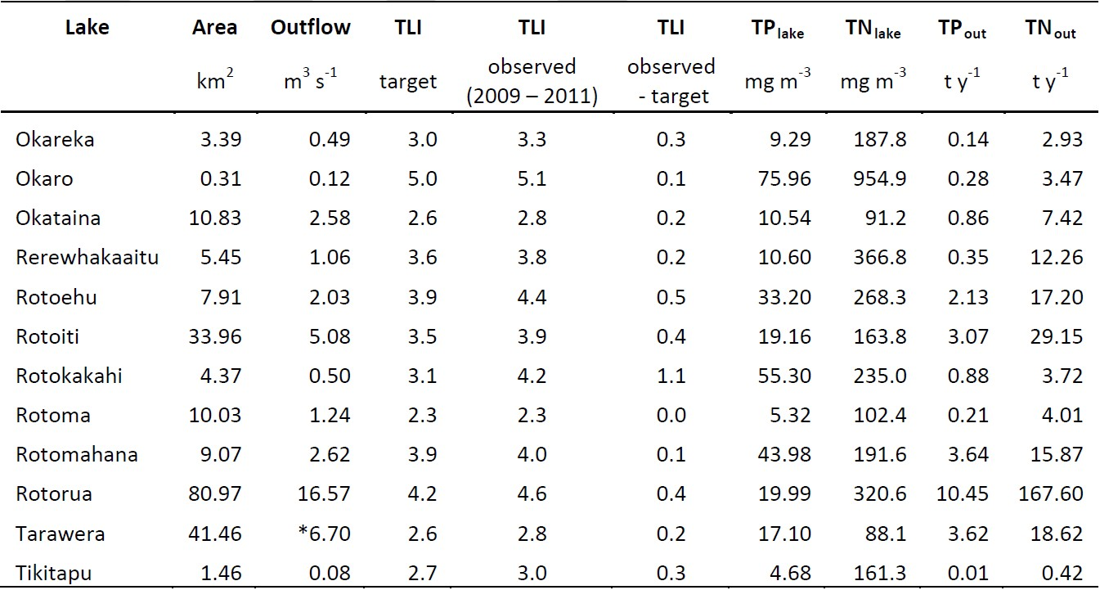

Using Lake Rotorua as an example, to achieve the TLI goal of 4.2, a nutrient load budget has been developed that requires a reduction of about 320 t N y⁻¹ from all inputs to the lake. This is made up of 140 t N y⁻¹ from pastoral land use changes, 30 t N y⁻¹ from gorse removal, 40 t N y⁻¹ from Tikitere and 100 t N y⁻¹ from other incentives. That leaves a shortfall requiring a further 30 to 50 t N y⁻¹ to be removed from the lake or catchment. Because of the already large component of land-based interventions, it is preferred that engineering options such as weed harvesting or in-stream watercress beds are used rather than more land use change. The feasibility of this action is considered.
This report presents a “desk-top” review of all available information on the Te Arawa Rotorua lakes focussing on remedial actions that have been implemented, including successes and limitations. Requirements for further research has been identified but not undertaken. The assessment also includes a review of recent advances in lake remediation from the international literature and whether any new techniques might be applicable to this group of lakes. Other factors such as the potential effects of forestry and changes in the health of native forest understory have also been considered as they apply to different lakes.

Background
Rotorua lakes protection and restoration action programme (hereafter referred to as the programme) is now experiencing a level of success not expected more than three years ago. The four lakes funded by the crown - Lakes Rotorua, Rotoiti, Rotoehu and Ōkāreka - are showing significant improvement to such an extent that they are now meeting or very close to meeting their Water and Land Plan TLI objective targets (Table 1). Lake Rotorua met its TLI objective in 2012 and was marginally higher in 2013. Lake Rotoiti has now met its TLI objective mainly as a result of the diversion wall. Lake Rotoehu is close to its TLI objective as a result of a number of interventions. Lakes Ōkāreka and Ōkaro have also been the subject of restoration interventions, but the improvements have not been as significant as observed for Lakes Rotorua, Rotoiti and Rotoehu.
For each lake the type of intervention has been selected to suit the specific needs of the lake and its catchment. Not all interventions are suitable for every lake, and success from any action is likely to have been lake-specific. For example the main intervention for Lake Ōkāreka has been sewage reticulation, whereas for Rotoiti it has been the diversion wall, for Rotorua it has been P-locking with continuous low doses of alum in the inflow streams. This latter approach was implemented as a stop-gap action while waiting for the effects of catchment management strategies to become manifest. For Rotoehu the main intervention has been weed harvesting and P-locking in the geothermal inflow stream with a continuous low dose of alum.
With the rapid success experienced, it is now becoming clear that the community would find it unacceptable to think that the water quality in the lakes could be allowed to decline. There is, however, a risk that water quality could decline in any of the lakes either because of factors outside BoPRC control such as climate, incursion of a new algae species and/or pest fish, weed growth as a result of improved light penetration, or a failure of any of the current interventions. For example, P-locking in the inflow streams with continuous low doses of alum is a major component of water quality improvement in Lake Rotorua. However, although BoPRC continues to undertake research to test for risks to the aquatic fauna from the use of alum, resource consents are required for the dosing programme and there is a risk in the future that resource consent may not be obtained.
It should be noted that the BoPRC Lake Action Plan programme is ultimately based on long term management of each lake’s contributing catchment to ensure that land use within its catchment is sustainable and will result in the lake reaching its target TLI. Other in-lake interventions are, in many circumstances, designed to accelerate the improvement of water quality within any lake and so are generally targeted at the more eutrophic lakes.
To ensure that BoPRC lake managers are well informed as to available remediation options it is important for the programme to be identifying alternative options not only for the protection of the other lakes not yet subject to any interventions but also identifying better or alternative options that could be substituted for current interventions. This could be because the alternatives may provide a better solution, or may be necessary because the initial option has become unacceptable or fails for some reason.
It is opportune to review the actions being implemented on each of the lakes and identify potential risks and potential solutions or options to replacement actions to avoid those risks. This may also identify the need to research new techniques that could emerge as alternatives to current actions.
This report does not consider the land use component of the lake restoration strategy, except where a change in the current land use may pose a significant threat to the water quality of a lake e.g., clear fell production forest harvesting to the lake edge, or research has identified a promising mitigation technique not previously considered. A summary is provided for each of the Te Arawa Rotorua lakes for each intervention in terms of the intended remedial effect, the potential risk to the lake’s water quality if the intervention stopped or a change occurred, and possible alternative interventions that might be used or could be developed. This includes the possibility of using an intervention on a lake where there is none at present.

Intervention assessment by lake

Lake Monitoring Buoys
On the maxim of “understand before intervention”, BoPRC have implemented the management strategy of deploying telemetered lake monitoring buoys on several of the Te Arawa Rotorua lakes to provide good data in real time (15 minute intervals). While the monitoring buoys have no direct effect on the water quality of the lakes, the availability of this data is fundamental to the evaluation of the success of the short-term interventions. The high frequency monitoring data underpins the science and understanding of how individual lakes work, and allows adaptive management strategies to be evaluated as well as measuring the success of each intervention.

Risk
Should the lake monitoring buoys stop providing data, e.g., there was insufficient funding for maintenance, upkeep and replacement of sensors; loss of skilled staff; vandalism or unforeseen events that necessitate replacement at rates beyond planned budgets for upkeep, that lack of data could jeopardise interventions that have specific timed elements and substantially increase monitoring costs to obtain the data required. This risk is applicable to all lakes with monitoring buoys.

Lake Rotorua – (TLI target 4.2)

Current 2009-2011 TLI = 4.6 but has since moved closer to 4.2.
To meet community expectations for Lake Rotorua, N and P inputs to the lake need to be reduced by a total of 320 tonnes and 10 tonnes per year, respectively, and there is also need to reduce the impact of nutrients already in the lake (Rotorua Te Arawa Lakes Programme Annual Report 2012-2013).
To achieve water quality targets for Lake Rotorua, BoPRC is undertaking both short-term and long-term interventions. Whereas long-term interventions for reducing the amount of nutrients entering the lake from the catchment are the solution to sustainable improvements, these improvements will take time to be realised. Meanwhile, short-term interventions have resulted in the best water quality in several decades. However, it is these short-term interventions that present a risk to lake water quality because the lake water quality is likely to decline again if these interventions are not continued.

P-Locking

Targeting P
All natural spring-fed streams flowing into Lake Rotorua have naturally elevated concentrations of dissolved reactive P (DRP), which represents a direct input to each lake of several tonnes of P each year. P-locking refers to the application of a continuous low dose of alum to an inflow stream in order to reduce that P load before it reaches the lake. This technique has been successfully used overseas (Harper 2013, Davenport and Drake 2011) and appears to be working on Lake Rotorua where the Utuhina and Puarenga Streams have been treated.

Risk
P-locking requires a resource consent. If for any reason the resource consent was not renewed, P-locking would have to stop. Because the streams contain naturally elevated concentrations of DRP, if the P-locking stopped, the expectation would be for the lake water quality to deteriorate as the DRP load returned to the lake. Renewal of resource consents may be challenged if public concerns were raised about ecological risks from the use of alum as the active P-binding agent. Such concerns may be from misinformation or in the form of perceptions from the way the science community talks about the use of alum. The choice of language in framing discussions about the science of lake restoration can have significant impacts on public and policy debate. For example, discussions about P-locking prefaced with statements such as “To minimise adverse effects, dose concentrations used are low”, implies that we, the science community, know that there are adverse effects from the use of alum and we are trying to minimise them. The alternative statement could be “The P-locking dose used conforms to the EPA guidelines for treating raw water”, which implies that we are running the dosing within the guidelines set down by the EPA for safe use of alum in the environment.
The EPA guidelines (EPA 2014) are not a simple statement of how much alum can be used in the environment. Rather it is based on the amount of soluble aluminium in the water after treatment. Alum dispensed into the streams rapidly forms a floc of insoluble aluminium oxyhydroxide and therefore the low dose rate of alum is not in breach of the guidelines which state: “The guideline value for aluminium (an aesthetic determinand) is 0.1 mg / L as Al, which is approximately equivalent to 1.1mg / L as solid weight alum.”
The convention for describing alum dosing is to refer everything to the active ingredient, aluminium. For example, the nominal dose of alum into the Utuhina Stream is at 1mg / L as Al. Hamilton et al. (2015) report that “A one-month ‘rolling average’ showed that the combined dose to the streams [Utuhina and Puarenga] was up to 400 kg Al per day”. However, because the alum immediately forms a floc as insoluble aluminium oxyhydroxide the amount of soluble Al is negligible. Consequently, when discussing the use of alum, it is important to be very clear whether we are referring to the insoluble Al floc or the soluble Al concentration in the water.
Other statements that could raise public concerns are that “we are dosing the lake with alum”. That would be unacceptable to some iwi. We are only dosing two streams to reduce the DRP load before it reaches the lake. Anything else is speculation (See unknowns).

Unknowns
The assumption with P-locking is that the P load in the stream is reduced thereby stopping that P entering the lake. However, because only two of the nine inflows (representing about 30% of the total stream inflow volume to the lake) have P-locking, and there was a rapid improvement in the lake water quality, there is a possibility that excess binding capacity in the alum floc produced may be having an effect in the lake, either by sequestering DRP from the water column and/or capping the sediment (Hamilton et al. 2015).
Since the P-locking began in 2007, the total amount of alum applied to the stream inflows has been equivalent to the amount required to block all P release from the lake sediment (McIntosh 2012). However, an investigation by Özkundakci (2014) failed to find conclusive evidence of increased Al in the lake water. That is consistent with the alum dosing producing an insoluble Al floc with no soluble Al component.
He commented “In comparison with sediment samples collected in 2006, sediment Al concentrations in 2012 were lower in the main basin of the lake. Phosphorus concentrations in the sediments were reduced at four sites located near to the discharges of the Utuhina and Puarenga Streams, but sites further from the stream (i.e. deep basin and close to the Ohau Channel outlet) showed increased concentrations of phosphorus in the sediment.”
Özkundakci commented further that “There was a low probability that a large proportion of the dosed Al would have reached the sediments in Lake Rotorua” and “There was a high probability that a large fraction of the Al reached the lake water column with the potential to reduce in-lake water column P concentrations.”
He concluded that “This study suggests that direct effect of dosing Al to the Puarenga and Utuhina streams is unlikely on its own to explain the improvement of water quality in Lake Rotorua over the study period. It is likely that some in-lake inactivation of P has occurred, with stream dosing resulting in P-binding capacity over and above the inorganic P content of these two inflows.”
Information from the Lake Rotorua monitoring buoy contained in the McIntosh (2012) report indicates any change in hypolimnetic oxygen demand during this period has been small and that conditions for sediment nutrient release have occurred but with much lower P release than during pre-dosing events. However, investigations of the circulation currents in Lake Rotorua (Gibbs et al. 2011) found that, during windy conditions, current velocities near the bed of the lake were sufficient to disturb the surficial sediments and thereby release DRP in sediment pore water. In contrast, DRP is continuously released from the sediments by diffusion and this provides a persistent low concentration release of DRP rather than a large pulse. If the alum floc is being dispersed around the lake by lake currents, it may be having a “sediment capping effect” by sequestering the DRP from the sediment pore water release, both by diffusion and disturbance, which may be at concentrations similar to the residual binding capacity in the alum floc.
The positive effect would be an improvement in water quality and a slow deterioration of the lake water quality if the P-locking stopped. The time scales for the residual effects are not known.
This aspect of the Lake Rotorua recovery requires further investigation.
A key consideration for the continued use of alum in stream dosing is whether there are potential toxic effects of the floc on benthic biota. An ecotoxicity study (Clearwater 2014) found no acute or chronic effect of alum floc on crayfish, freshwater mussels or fish over a 2 month mesocosm study, but aluminium accumulation was measurable in some treatments. Survival and reburial rates of fingernail clams decreased with increasing alum dose and were significantly decreased at the highest alum dose. This may have been due smothering with the thick floc layer rather than a direct toxic effect. In natural lake situation the floc would become incorporated in the sediment due to mixing and is unlikely to present this scenario.

Alternative materials
Alternative P-locking materials include iron (ferric salts) and calcium treatments, and the use of flocculants such as poly aluminium chloride (PAC) and anionic polyacrylamide (PAM).
- Iron dosing is used extensively overseas for managing P in storm water flows. It has a relatively rapid uptake of P but does not bind P as strongly as alum. It will release P under anoxic conditions. Most of the Te Arawa Rotorua lakes have low iron content. The exception is Lake Rerewhakaaitu. The main drawback of iron dosing is the health and safety issue around using the concentrated solutions, which are toxic until diluted.
- Calcium as precipitated lime, is an effective P-locking agent but it has a slower uptake rate than either alum or ferric iron. It doesn’t release P under anoxic conditions or high pH. Consequently, calcium may be a way to extend the working pH range of other P-inactivation agents. For example, aluminium bound P begins to be released at about pH 8.5 whereas iron bound P begins to release at about pH 9 and has less P binding as the pH rises. Conversely, calcium begins to bind P at about pH 8 and binds it more strongly as the pH rises. This overlap means that, if a capping layer of calcium is applied, as the pH rises from circumneutral (pH 7) during photosynthesis in summer, iron or aluminium bound P will be released from the sediment into a calcium layer, which will bind it. As the pH decreases back to circumneutral in autumn, the process will reverse with the P transferring from calcium back to iron or aluminium.
- PAC is a flocculant used in drinking water and waste water treatment and industrial stormwater settling ponds. It can be used in place of alum. This product must only be used at circumneutral conditions. At low pH (<5) it releases trivalent aluminium (Al³⁺) ions which are toxic. As with alum, at high pH (<8.5) PAC releases bound P.
- PAM (anionic form) is a flocculant normally used to stabilise soils in agricultural land to stop sediment runoff in America and China, which are the largest users worldwide. It is also used as a coagulant in sediment detention ponds on construction sites including road stormwater runoff (Geosyntec and Venner 2012) and was found to outperform PAC for reducing suspended sediment loads from earthworks in construction sites in an Auckland Regional Council (now Auckland Council) study (Beca 2004; Boffa Miskell 2004). The anionic form is non-toxic and is safe to use in food production and clarification of drinking water. It is reported to reduce both N and P as TN and TP (Sojka and Lentz 1997). This product warrants further investigation for managing sediment runoff from farm land. It may also have a place as a flocculent in bunds designed to trap sediment on land, accelerating the settling of fine sediment that would otherwise flow into surface stream.
PAM can be applied in liquid form in place of alum, or solid blocks can be suspended in the water where the flowing water can slowly dissolve it. The solid block application can also be used in applications where there is intermittent flow such as storm water outfalls or on the inflows to pastoral bunds used for sediment trapping.
- Chitosan – is a flocculant derived from shellfish exoskeletons, and is widely accepted as a natural polymer for stormwater treatment. It is regarded as nontoxic because it has no effect on animals / humans and is typically used in very small amounts (Geosyntec and Venner 2012).
- Aeration driven destratification. This concept is being tested in Lake Rotoehu but the efficiency would need to be improved to make this a viable solution in Lake Rotorua. Disadvantages are the cost of the numerous aerators required to treat the lake.
- Nanobubbles. This is a new technique developed in China. The product is a mixture of chitosan and local soil in which nanobubbles of oxygen have been incorporated. The action of this product is to floc the fine suspended particulate matter from the water column and cap the sediment with the nanobubble treated local soil, which prevents the release of DRP from the sediment. The process is being tested at UOW and in small mesocosms and larger ponds in China. The development of this technology should be watched to find out the optimum use. At present it works for shallow ponds but may not be suitable for large lakes.
With some of these materials, a limiting factor to their use is low or high pH. Low pH is an issue where alum or PAC is dosed into low alkalinity water, which has low buffering capacity. The use of a buffer should be considered on a case by case basis. High pH can occur in summer when there is high light and strong photosynthesis. Under these conditions, cyanobacteria and some exotic macrophytes have the ability to strip both carbonate and bicarbonate from the water causing the pH to rise above 10. These plants are referred to as bicarbonate-adapted plants. Products affected by high pH should only be applied when the ambient pH is below 8.5. This includes alum.

Removal of N from Tikitere
Natural zeolites adsorb ammonium-nitrogen (NH₄-N) and are currently being successfully used to remove NH₄-N from the geothermal water flowing from Tikitere hot springs into Waiohewa Stream

Targeting
An estimated 20-25 t N per year in the ammoniacal form.

Risks
Zeolite not as effective as expected.
This could happen if the type of zeolite source changed from mordenite to clinoptilolite. A study by Nguyen and Tanner (1998) found that mordenite has a greater NH₄-N cation exchange capacity (CEC) than clinoptilolite. Mordenite can remove ~8.2 g NH₄-N kg⁻¹ compared with ~5.7 NH₄-N kg⁻¹ for clinoptilolite and is confirmed by Scion testing (Gielen et al. 2014). This would represent a 30% reduction in efficiency or the failure to capture 10 t of the N from Tikitere with the current system. Currently the zeolite supplied for this project is not pure mordenite and there is a proportion of clinoptilolite mixed throughout. The adsorption efficacy will decrease as the proportion of clinoptilolite increases.

Alternatives
In overseas studies, the NH₄-N uptake rate by zeolite was almost doubled by pre-treating the zeolite with sodium chloride, because the uptake of NH₄⁺ ions proceeds by an ion-exchange mechanism. This option may warrant further study with respect to its use in New Zealand. The disadvantage may be in the cost of pre-treatment. Scion (Gielen et al. 2014) suggest this may offer a way of regenerating the loaded zeolite by converting the adsorbed NH₄-N directly into nitrogen gas in the presence of NaCl.
Denitrification process trialled and discounted. The major issue was getting sufficient nitrification to convert the NH₄-N to NO₃-N before denitrification processes could reduce the NO₃-N to N₂ gas.
Diversion of the Waiohewa Stream through the natural shoreline wetland may be possible rather than letting the N-rich water disperse directly out into the lake. These wetlands are already stripping N from the groundwater (Gibbs & Lusby 1995, 1996). In this case the stream channels would need to include plant communities such water cress to take up the NH₄-N for growth and promote nitrification before the water reached lake edge wetlands where denitrification could occur.

Floating wetlands

Targeting
N and P in the lake

Risks
May have a minor impact on nutrients in the lake

Alternatives
Natural land-based wetlands still exist around the edges of Lake Rotorua. These were identified as being important for reducing the groundwater nutrient load on Lake Rotorua (Gibbs and Lusby 1995; 1996) and should be protected from damage or removal by land developers who want lake views. The issue of willows around the lake may see the trees removed over time. The trees should be replaced with wetland native species.
Alders should not be planted near water ways as these trees are nitrogen fixers enriching the groundwater with nitrate nitrogen. Existing Alder trees should be removed.

Sewage reticulation and treatment

Targeting
N and P sources to the lake

Risks
Exceedance of the 30 tonne load and an increase in P inputs.
Closing the land treatment disposal system. i.e., Rotorua Lakes Council will stop spray irrigation of treated wastewater in Whakarewarewa Forest by 2019 and has yet to decide on alternative disposal options. Potential disposal sites include the Puarenga Stream, Lake Rotorua and land elsewhere, but not the Kaituna River.

Alternatives
Being assessed by sewage working party and the Sewage Technical Advisory Group
There should be a ban on the sale of P-based washing detergents, laundry powders and automobile cleaning products in the greater Te Arawa Rotorua lakes area.

Long-term land use P and N reductions
Nitrogen fixing plant species augment the groundwater with nitrate. Action: Removal of gorse, broom and lupin from marginal land. Removal or replacement of nitrogen fixing trees such as Alder and Acacia (Wattles) and discourage Lucerne cropping in lake catchments over shallow groundwater tables.

Targeting
N and P sources to the lake

Risks
Insufficient reductions in N-fixing plants may mean that actual inputs are higher than predicted.

Alternatives
Other N-fixing species such as Alder are often planted beside streams. A list of undesirable N-fixing plants should be prepared, and should be accompanied by a list of preferred non-N-fixing species equivalents.
Storm water sediment traps and pastoral bunds may benefit from the use of anionic PAM to accelerate settling of suspended fine sediments. In general, fine sediment has the highest concentration of P and it is the slowest material to settle in a slowly flowing system. Fine sediment <20 µm may travel many kilometres before settling, if it does. The use of a flocculant such as PAM (see section 3.1.1 above) coagulates the fine particles into larger particles which settle faster.
In stormwater systems, the solid “floc log” form of this product could be attached inside the stormwater drain (at the grating) allowing the slow dissolution and thus treatment of the water down the pipe when it rains.
With pasture bunds, influent runoff water might be channelled to flow over some floc logs (possibly set in a culvert designed for the purpose) to dose the water accumulating behind the bund. Because the PAM residue is not toxic (it is used as a soil conditioner in America) the sediment left behind when the bund is drained will become part of the pasture soil. In contrast, the use of aluminium based flocculants for this purpose would leave the pasture inside the bund with a potentially toxic aluminium residue as the water drained away. Aluminium-based flocculants should not be used.
More work required on this option.

Weed harvesting in the lake.
Aquatic macrophytes (lake weeds) take their nutrients from the sediments and the water column, to a lesser extent. Consequently, cutting and removing the weed from the lake also removes nutrients from the lake. While this is an option for removing nutrients towards meeting the estimated 30 to 50 t N reduction required for Lake Rotorua (A. Bruere, BoPRC pers. comm.).
A survey in 1990 (Clayton et al. 1990) showed that the majority of the aquatic macrophytes beds In Lake Rotorua occurred around the southern and south-western shores of the lake (Figure 1). There is no more recent information available for the whole lake. In 1990 the weed beds comprised mostly Lagarosiphon major as tall, near surface-reaching walls of weed with the beds extending from around 3 m depth down to 7 m or more and with the tallest plants around the 5m depth contour.
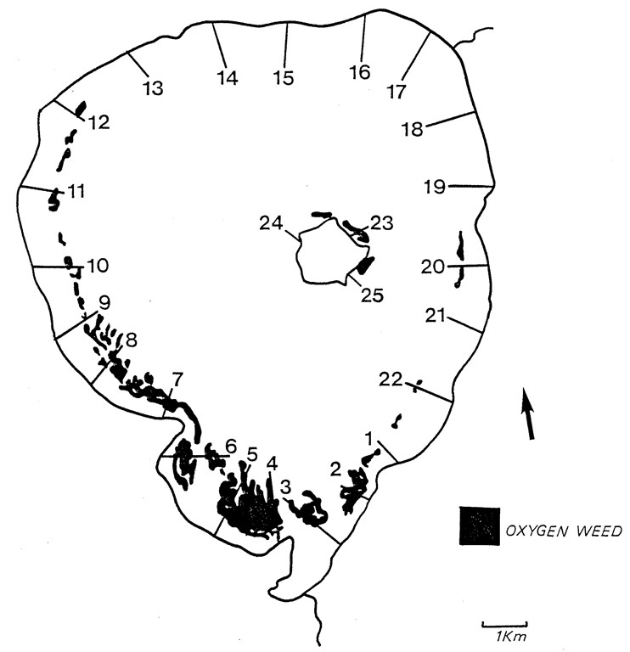
Figure 1: Sketch map of the distribution of exotic macrophyte weed beds in Lake Rotorua in 1990.
(Redrawn from Clayton et al. 1990, with permission).
The macrophyte weed beds pose a periodic problem to lake users by blocking access of boats to the lake, and to lake shore residents when the plants break off and drift to shore during storms, leaving the unpleasant sight and smell of rotting vegetation. In the past, management of macrophytes has been achieved by spraying with herbicides. While this is effective in reducing the amount of macrophytes, it returns the nutrients in those macrophytes back to the lake where they can be used for phytoplankton growth.
If the same spatial and depth distribution as occurred in1990 was still present in the lake, the plants could be cropped using a weed harvester and the plant biomass could be removed from the lake along with their nutrient content. Initial weed beds to target would be those off Kawaha Point and across the southern shoreline (Figure 1).

Feasibility
Based on the weed harvesting information from Lake Rotoehu, weed harvesting can remove 1.2 kg N and 0.16 kg P per tonne wet weed. These values were used to estimate the feasibility of removing 50 t N per year from Lake Rotorua (Table 2):-
Table 2: Weed harvesting calculations.

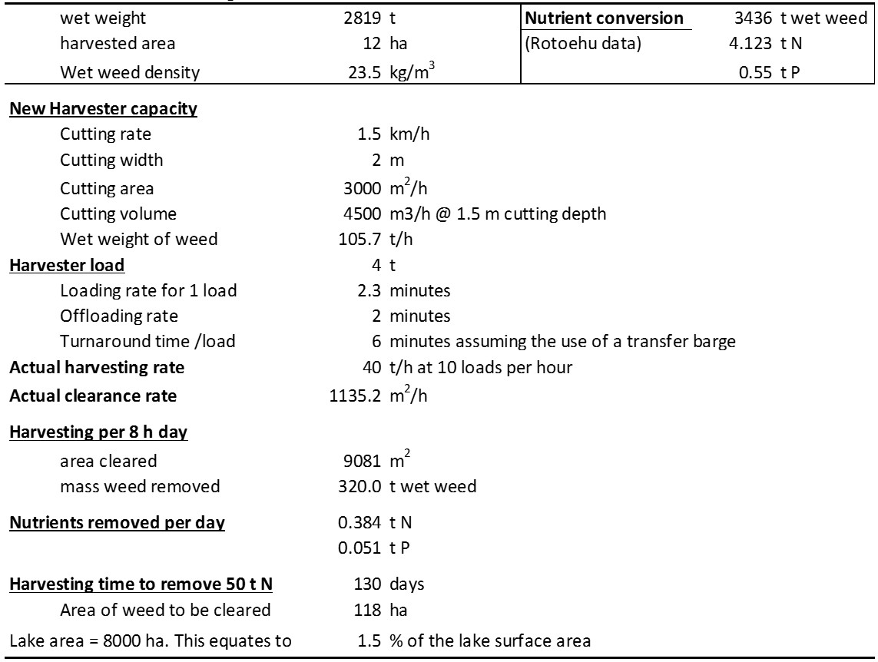
Based on the calculations above (Table 2), it is not feasible to achieve all of the required 50 t N removal by this method with the present equipment, even if a transfer barge was available to reduce the down-time associated with off-loading the harvester after each cut.

Risks
Although theoretically possible to remove up to 50 T N per year by harvesting, the time required to achieve this would be at least 130 days. It is unlikely that suitable weather conditions would allow harvesting for that length of time on Lake Rotorua.
The hired harvester may not be available for that period of time. It is primarily used for weed removal in the Waikato hydro lakes and that work would take precedence over lake clearance. To ensure a continuity of weed harvesting on the Rotorua lakes, BoPRC have purchased a new weed harvester (Figure 2). Even so, the new harvester may not be used continuously on Lake Rotorua as there are other Rotorua lakes where its use will be required e.g., Lake Rotoehu.
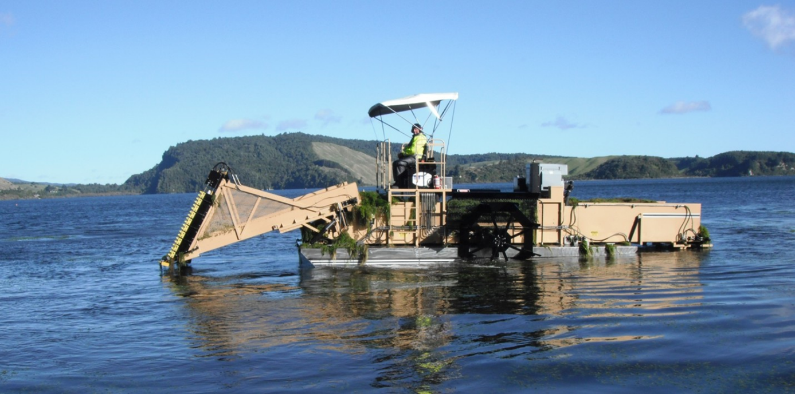
Figure 2: Bay of Plenty Regional Council owned weed harvester on Lake Rotoehu.

Weed disposal: This operation would require the disposal of 41,590 t of wet weed. Heavy metal contaminant content (unknown) could affect where the weed is disposed of and how.
Availability of the weed to harvest. While there is an estimated 150 ha of weed around Kawaha Point (Richard Mallinson, BoPRC, pers. comm.), the area of lake covered by weed beds in Lake Rotorua is not consistent from year to year and can vary from >400 ha in some years to almost nothing in others (John Clayton, NIWA, pers. comm.). The variability comes from wind-driven wash-outs destroying the beds and allowing weed to drift and wash up on shore.
Notwithstanding this, as the water quality improves and light penetration can support germination of weed beds at greater depths further from shore, the amount of weed in the lake is likely to increase. The issue then is “are the tops of the weed beds in the depth range of the harvester i.e., <2m below the surface?”
With this in mind, if weed harvesting has the ability to achieve the nutrient reduction targets, it may be unable to achieve actual weed control due to the rapid re-growth.

Alternatives
Purchase a larger weed harvester specifically for Lake Rotorua. An 8 t capacity harvester with a 3 m cutting bar and a cutting speed of 3 km /h would reduce the harvest time to about 54 days. (Costs not checked).
A report by Matheson and Clayton (2002) indicates that a realistic removal rate with the present size harvester would be in the order of around 6 T N and 0.8 T P per year. Even this amount of nutrients would be worth removing. This might be achieved over a period of a month.
Collect and remove the weed from the lake shore after a wind-driven washout event, rather than letting the nutrients drain back into the lake.
Given that macrophyte weed beds can remove nutrients from the water column either directly or due to presence of epiphytes attached to their leaves, an expansion of the weed beds by of ~35 ha for a depth of 5 m deep to lock up and additional 50 t N while still in the lake. Then the weed harvester could be used to maintain the health of the weed beds by mowing off the surface reaching areas and thereby achieve some removal of nutrients from the lake at the same time.

Research needed
- Determine chemical characteristics of the harvested weed;
- Determine the re-growth rate of harvested weeds in the lake.
- Determine the uptake rate of nutrients from lake water by growing macrophytes.
- Determine the kinetics of using anionic polyacrylamide to accelerate settlement of fine sediment in detention bunds and its likely effect on N and P loads flowing into the lake.

Lake Rotoiti – (TLI target 3.5)
Current (2009-2011) TLI = 3.9

Diversion wall
Prior to the installation of the Ohau Channel diversion wall, an estimated 25% of the volume of Lake Rotoiti was replaced with water from Lake Rotorua each year. Because of the previously poor water quality in Lake Rotorua, the water quality in Lake Rotoiti was substantially degraded. The Ohau Channel diversion wall is now protecting the water quality in Lake Rotoiti while nutrient reductions Lake Rotorua are achieved.

Targeting
N and P sources to the lake.

Risks
Resource consent issues in 2017. Failure to renew the consent could mean the diversion wall would need to be removed. Although the water quality in Lake Rotorua has improved, the removal of the diversion wall could degrade Lake Rotoiti water quality.
Failure of the diversion wall due to corrosion.
Loss of Lake Rotorua fish spawning via the Ohau Channel (trout, smelt)
Water level controls (Rotorua weir, Kaituna gates) reducing the effectiveness of the wall.

Alternatives
Modelling to check the risk to Lake Rotoiti water quality while Lake Rotorua TLIs varying.

Sewage reticulation and treatment
Reduction in nutrients from septic tanks entering the lake

Targeting
N and P sources to the lake.

Risks
Only about half the lake shore residences reticulated.

Alternatives
Sewage working party advising currently.
Adding baking soda weekly to non-reticulated septic tanks to assist buffering to neutral pH
Restricting the use of phosphorus-based detergents and laundry powders
Restricting the use of in-sink waste disposal units in houses on non-reticulated septic tanks and encouraging the use of composting or biodegradable recycling. (Could apply to all reticulated houses in the Rotoiti catchment to reduce organic loads on the waste water treatment plant.)
Use weed harvesters to clear boat ramps and Okawa Bay rather than spraying or mulching the weed and levelling it to decay in situ.

Lake Rotoehu – (TLI target 3.9)
Current 2009-2011 TLI = 4.4
The main long-term intervention in Lake Rotoehu is land management change complemented by some short-term interventions.

Land use change
Land use change agreement for 668 ha has been completed and audited

Targeting
N and P

Risks
May not be sufficient for lake to meet the TLI objective. Needs monitoring for time lags in nutrient load changes
Rotational harvesting of exotic forests around lake may give pulsed inputs of nutrients and organic carbon that can have short-term negative impacts on water quality.

Alternatives
Gorse removal
Remove / replace N-fixing plants and trees with non N-fixing species.
Do not grow Lucerne in the lake catchment. Note that clover used to be included in pasture to fix atmospheric nitrogen to assist grass growth. Because the nitrogen fixed was largely used immediately by the grass, leakage of N was minimal. Conversely, Lucerne is a crop with deep roots and nothing to remove the fixed N so it can leak N into the groundwater.

Weed harvesting
Cut and remove weed from the lake using mechanical means such as weed harvesting and collection of weed drift from the shore. Relatively successful for removal of N

Targeting
N and P in the lake

Risks
Availability of weed harvester at critical times.
Strong wind can prevent operation of the harvester on the lake.
Breakdown
Inability to dispose of safely or through landfill if metal concentrations too high. Arsenic is the most likely contaminant

Alternatives
BoPRC now has its own weed harvester
Collecting weed drift from shore is not wind-dependent and can be achieved even in strong winds.

P-Locking
(See P-locking in streams entering Lake Rotorua for more details of this technique)

Targeting P
P-locking in the hot Soda Springs outflow into the lake is thought to have been moderately effective but is difficult to quantify in conjunction with other interventions. The P bound to the alum floc is likely to be caught in the weed drifts across the stream inflow to the lake.

Risks
(See Lake Rotorua)

Alternatives
(See Lake Rotorua)

Floating wetlands

Targeting
N and P in the lake

Risks
May have a minor impact on nutrients in the lake

Alternatives
(See Lake Rotorua)
Enhance natural wetlands and marginal vegetation as groundwater nutrient buffer zones. Early land development tended to remove the riparian wetlands as aesthetically unpleasant or blocking lake views and access.
Manage spread of some species by “mowing” and removing the cut weed with the weed harvester rather than spraying. The weed will continue to grow, removing more nutrients from the lake water.

Aeration
Aeration can mix and destratify the lake and keep the sediment surface well oxygenated, thus promoting P-binding to iron and manganese in the sediment and coupled nitrification-denitrification at the sediment surface. An aeration system is being trialled in the lake.

Targeting
N and P in the lake

Risks
Lower than expected mixing efficiency of aerator machines
Incomplete destratification may leave the bottom water deoxygenated and thereby nutrient-enriched. Under these conditions the aerator system becomes a nutrient siphon, bringing nutrient rich bottom water to the surface where it can enhance phytoplankton growth.

Alternatives
Trials to optimise the performance of the aerator machines and determine the number of aerators needed to mix the lake are being undertaken with the University of Waikato.
An alternative aerator design such as the air curtain from an aerator bar could be tested.

Lake Ōkāreka – (Target TLI 3.0)
Current 2009 -2011 TLI = 3.3

Sewage reticulation and treatment
Reduction in nutrients from septic tanks entering the lake

Targeting
N and P sources to the lake.

Risks
Estimates of nutrient removal may not align with reality and may not remove enough N and P

Alternatives
N/A

Land use change

Targeting
N and P

Risks
Only 100 ha completed, which may not be enough. Monitoring required to check

Alternatives
Further land use change and gorse removal
Extend buffer zones and constructed wetlands around shoreline
Weed harvesting

Lake Ōkaro – (TLI target 5.0)
Current 2009-2011 TLI = 5.1.

Constructed wetland
Constructed wetlands can reduce dissolved inorganic N loads to the lake through biological processes and reduce suspended solids, which can carry P to the lake.

Targeting
N and P

Risks
Insufficient nutrient removal
Flood events bypass the main wetland, recharging the lake with fine sediment containing P

Alternatives
Increase wetland area including in wet areas of the catchment
Enhance riparian wetlands around lake edge
Use PAM as an additive in wetland to enhance find sediment settling (see Rotorua) or
Use SolarBee-type aerators to apply PAM dosing in the wetland (Figure 3).
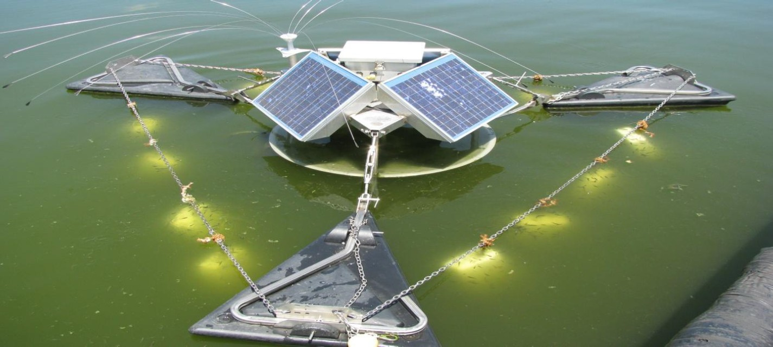
Figure 3: PAM slow release blocks secured in the outwards current flow from the SolarBee mixer.

Detention dams
These are shallow bunds across the main surface runoff flow paths designed to trap runoff in heavy rainfall events. This slows the water velocity and reduces the sediment erosion and thereby the sediment load into the wetland or, when it bypasses the wetland, directly into the lake. Fine sediment is the main vector for transporting P into the lake.

Targeting
N and P

Risks
Insufficient time in dam to settle fine sediment
Not enough area to hold all runoff for 24 hours.

Alternatives
Use PAM slow release blocks for automatic dosing of inflows to detention dams to enhance sedimentation rates and thereby reduce sediment loads (TP) to the lake (See Rotorua).

Land use change
Plantation forestry – 28 ha converted to forestry.

Targeting
N and P

Risks
Insufficient land area converted.
Same issue mentioned previously for harvesting

Alternatives
Convert more land to a lower nutrient footprint land use. Plant maize and use cut and carry for feeding dairy. Care required with timing of maize harvesting to manage soil erosion immediately after harvest.

Alum dosing
Applied at the correct time when the pH in the lake is <8.5, alum can floc out both free DRP in the water column and the cyanobacteria that are beginning to grow before they cause the elevated pH. Note that bicarbonate adapted macrophytes in the shallow littoral zone can also raise the pH above 10 when strongly photosynthesising in spring and summer. At pH above 9.2, P desorbs from iron binding in the sediment and between pH 8.5 and 9.2, P bound to aluminium begins to desorb. Consequently, alum should not be dosed when the lake pH is >8.5.

Targeting
Phosphorus and cyanobacteria

Risks
Timing too late and the pH exceeds 9, floc won’t form and P won’t be inactivated

Alternatives
Dose the hypolimnion with buffered alum before lake turn over when the DRP concentrations are at their highest. The buffer is required to ensure the alum forms a floc. Alum and the buffer can be mixed in a surface chamber and pumped down to the hypolimnion.
Alum dose soon after lake turn over in winter to sequester DRP released from the sediments that has accumulated in the hypolimnion, as it is mixed into the surface waters.
Treat the littoral zones and shallow weed bed areas with precipitated lime. Calcium begins to bind P when the pH increases above 8.5 and will intercept P released from the iron or Al in the littoral zone sediments as the pH rises due to plant photosynthesis. This process is reversible and as the pH reduces in autumn the P desorbs from the calcium but binds with the iron or aluminium again.

Aqual-P
Aqual-P is a modified zeolite designed to be an active sediment capping agent to sequester DRP as it is released from the sediment under anoxic conditions. While fine-grained Aqual-P has some flocking capability, that is secondary to its primary role as a sediment capping agent. For optimum efficiency the Aqual-P should be applied at the end of the winter mixed period when the majority of the DRP has been sequestered from the water column by iron in the sediment and before thermal stratification has become established.

Targeting
Dissolved reactive phosphorus

Risk
Timing too late and the lake stratifies releasing some of the DRP from the sediment.
High pH >9 could cause aluminium-bound P to release from the Aqual-P.
Variability in the binding capacity of the Aqual-P may be a manufacturing issue.

Alternatives
Bicarbonate adapted exotic macrophytes can cause local pH >9.2, thereby releasing naturally iron-bound DRP from the shallow sediments around the edge of the lake, thereby providing the P needed for cyanobacteria to grow. Weed harvesting of these littoral zone weed beds may reduce photosynthesis and the concomitant release of P.
Without weed harvesting, treat the littoral zones and shallow weed bed areas with precipitated lime to lock up the P released from iron or aluminium.
Note: Acidifying the littoral zone waters to lower the pH is not a valid option and, at best, would be extremely risky ecologically.
A long term alternative may be to induce P-limitation so that algal species other than cyanobacteria can become dominant.

Land management
Stock management and the use of herd-homes with cut-and-carry feeding can be effective in reducing nutrient loads to the lake.

Targeting
N and P in the lake

Risks
Insufficient area for land changes to achieve targets
Increased stock numbers can surpass nutrient reductions from land use change.

Alternatives
More land use change
Rely more on in-lake interventions

Other potential interventions to try
These may be used individually or in combination for best effect

Aeration with destratification after initial floccing
A major problem in Lake Ōkaro is thermal stratification in summer. During this phase the bottom water becomes anoxic allowing DRP to be released from the sediments into the hypolimnion, where it accumulates. During the stratified period, short term wind-induced mixing events can lift some of that DRP into the surface waters where the DRP can stimulate and sustain the growth of cyanobacteria.
At autumn-winter mixing, stratification disappears and the nutrients that accumulated in the hypolimnion are mixed up through the whole water column where they are able to stimulate algal growth. However, during the low light period in winter, algal growth reduces and much of the DRP returns to the sediment. The residual DRP supports the spring growth of cyanobacteria.
Between autumn-winter mixing and spring stratification, there is a short window of opportunity during which a flocculant could be applied to clear the water column of fine sediment and algal biomass before turning on an aeration system to keep the water column mixed. If the timing is wrong at turn on and the lake has stratified in spring, the aerator will need to supply sufficient energy to destratify the lake again. Destratification is not difficult in early stratification but becomes more difficult when a strong thermocline develops.
When stratification begins, the hypolimnion is well oxygenated and it takes several weeks before sediment oxygen demand (SOD) and hypolimnetic oxygen demand (HOD) can remove all of the oxygen and produce an anoxic hypolimnion that will cause DRP release from the sediments. Consequently, at the beginning of stratification, the nutrient concentrations in the hypolimnion are low.
Aeration-driven mixing at this time would prevent thermal stratification occurring or would cause destratification. In both cases aeration will circulate well oxygenated water down to the bottom of the lake and thereby prevent the release of DRP from the lake bed sediments.
Because the aeration causes deep mixing, it also serves to reduce algal biomass by circulating the algal cells below their critical depth (i.e., if the algal cells spend longer below the euphotic zone than in the euphotic zone, they become light-limited for growth) and they die.
The aeration system best suited Lake Ōkaro could be decided based on criteria to suit the lake. A simple air bar could be used or an aerator machine as is being trialled in Lake Rotoehu. Simple aerator bars are being used in the 10 Auckland water supply reservoirs and can mix lakes as deep as 59 m and with areas up to 170 ha. Note that these aeration bars as used in reservoirs are installed on the reservoir bed parallel to and near the dam wall, giving additional reflection of the circulation currents along the length of the lake from the dam wall. In a near circular lake such as Lake Okaro, the aeration bar would probably need to be installed on the lake bed at right angles to (across) the prevailing wind. This would induce full depth mixing on each side of the aeration bar and make use of any wind to enhance the down-wind surface circulation current flow from the aerator.
Advantage of aeration-driven mixing is that the habitat suitable for fish and benthic animals is enlarged.
Disadvantage is that the whole lake becomes warmer during summer. While this could be seen as an issue for trout in summer, before mixing the trout were confined to surface 0-5 m layer because of bottom water anoxia and the surface layer would likely be warmer then than the average temperature in the lake after mixing.

Hypolimnetic Aeration without destratification
This technique uses compressed air or pure oxygen to oxygenate the water in the hypolimnion. Excess gas is carried to the surface via a vent tube thereby preventing destratification. Very fine oxygen bubbles can totally dissolve in water to raise the DO level. This method of oxygenation uses a Speece cone type hypolimnetic oxygenator. This technique is called a downflow bubble contact (DBCA) hypolimnetic aerator and uses pure oxygen bled into a fast flowing stream of water pumped from a narrow tube into a widening cone facing down. The velocity draws the oxygen into the water (like air into a water vacuum pump) and the sudden expansion causes the bubbles to become very small so that they dissolve.
This technique when effective (i.e., achieving complete dissolution) does not raise the water temperature in the hypolimnion. It is more expensive to run than aeration with destratification because it requires an oxygen generation plant for highest oxygenation efficiency. Using compressed air reduces the oxygenation efficiency by 80% – the proportion of oxygen in the air.

Floc blocks (PAM) in the bubble plume
Floc blocks / logs suspended in the bubble plume of an aerator mixer (Figure 4) slowly dissolve causing fine suspended solids, including algae, to aggregate and settle. This technique has been used in small ponds but may be worth trying where an aerator system is in operation. The flow of water over the block / log causes the slow dissolution fundamental to the dosing of the water with anionic PAM.
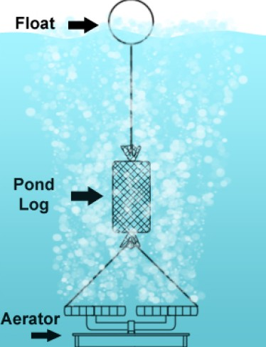
Figure 4: Schematic deployment of a PAM log in an aeration bubble stream.

Weed harvesting
Whereas traditional limnology would suggest that the hypolimnion going anoxic is the major source of DRP in the water column of Lake Ōkaro, there is an additional source of DRP in the littoral zone of the lake. Exotic species of aquatic macrophytes around the edge of the lake in the littoral zone can utilise both the CO₂ (carbonate) and the bicarbonate from the water during photosynthesis cause a shift in pH in spring to >9.2. These macrophyte species, including cyanobacteria, are in a class of plants referred to as ‘bicarbonate adapted’ plants. Most New Zealand native aquatic macrophytes are not bicarbonate adapted and can only raise the pH to around 8.5.
Above pH 9.2 the photosynthesis in the non-bicarbonate adapted plants stops and the plants will die. In addition the biogeochemistry between iron and P changes and P desorbs from the iron and is released into the fully oxygenated surficial waters. This P then stimulates the growth of cyanobacteria in the inshore zone. The bicarbonate adapted cyanobacteria continue the high pH process providing positive feedback by mining the P from the sediments.
Unlike DRP, nitrogen is continuously released from the sediment as ammonium, which is nitrified to nitrate at the sediment surface and may be lost from the lake as N₂ gas during denitrification at the sediment surface. At pH above 9.2, the nitrification bacteria appear to be inhibited so nitrification stops and denitrification also stops because there is no nitrate being produced. At this pH, the ammonium is converted to ammonia which is toxic to small fish and zooplankton. Because there is no N loss through denitrification, the enhanced ammonia together with the DRP released from the littoral sediments sustains the growth of the cyanobacteria.
This process requires bicarbonate-adapted aquatic macrophytes to push the pH very high during their photosynthesis in mid-afternoon. The release of P into the surface water can trigger the growth of cyanobacteria which augment the high pH process and become self-sustaining in the shallow edge water. This process has been documented in Lake Horowhenua and is probably occurring in Lake Ōkaro. This process explains why cyanobacteria can get established in Lake Ōkaro before there is significant hypolimnetic deoxygenation to release DRP from the bottom of the lake. This process could be checked by comparing lake monitoring buoy data for timing of pH versus bottom water anoxia.
Mowing the tops off the near shore weed beds in spring may be sufficient to reduce the pH effect and thereby stop cyanobacteria becoming established.

Bentonite and dyes
Treatments of some lakes in Europe with lanthanum modified bentonite (PhoslockTM) have resulted in a reduction in macrophytes. In these cases there is an indication that high turbidity was the cause and that may be attributable to the bentonite carrier of the lanthanum. Consequently, a layer of fine bentonite on the macrophyte leaves may suppress photosynthesis as the critical time. Alternatively, blue dye can suppress photosynthesis in algae including cyanobacteria.

Calcium
Calcium carbonate (calcite, CaCO₃) or calcium hydroxide (lime, Ca(OH)₂) could be applied to the lake as phosphorus precipitants. Calcite sorbs P especially when the pH exceeds 8.5 and results in significant P removal from the water column. Phosphate adsorbs at the calcite surface, or binds inside a crystal during the CaCO₃ formation when calcium hydroxide is applied.
If the pH increase is caused by near-shore macrophyte beds as postulated, then calcite or lime applied to the littoral zone may be sufficient to block the release of P when the pH rises.

Cyanocides
There are a range of products that have selective toxicity to cyanobacteria. These could be used to prevent cyanobacteria growth at the beginning of spring. At that time there is less chance of toxin release and the level of treatment can be lower. For example, hydrogen peroxide will kill cyanobacteria, however, a high biomass increases the rate of hydrogen peroxide degradation and decreases the effectiveness of hydrogen peroxide in the selective suppression of dominant cyanobacteria (Weenink et al. 2015). Selective application of hydrogen peroxide requires usage of low doses only, accordingly this defines the limits for use in lake mitigation.
Derivatives of 9,10-anthraquinone selectively inhibit cyanobacteria growth at low concentrations.

Allelochemicals
An allelochemical is a chemical produced by a living organism that exerts a detrimental physiological effect on individuals of another species when released into the environment.
- Barley straw, after 4-6 weeks of aerobic decay in water, releases compounds which stop cyanobacteria growth. The barley straw extract also exhibits this inhibitory effect. Suspending barley straw bales in the lake during winter mixing and in to spring may inhibit the development of cyanobacteria blooms in spring (Everall & Lee 1996; 1997; Ferrier et al. 2005).
- Decomposing leaves from several other plants also show the same inhibitory effects on the growth of cyanobacteria, e.g. water soluble fraction of dead eel grass (Zostera marina L.) less than two weeks old was lethal at concentrations of as little as 0.25g /L (Harrison & Chan 1980). Some ferns were also effective at inhibiting algal growth. Bracken fern is known to produce and release allelopathic chemicals into soil. These may also affect algae in water but there is no literature on this.

Lake Tikitapu – (Target TLI 2.7)
Current 2009 -2011 TLI = 3.0
Three major concerns identified for Lake Tikitapu are the impact of tree harvesting on amenity values and water quality, nutrients from stormwater (reserve, car park and road) and the potential effects from increasing numbers of lake users.

Sewage reticulation
Completed in 2010. Annual P and N load has decreased and water clarity has improved >1 m.

Targeting
N and P inputs to the lake.

Risks
Pump failure
Increase in lake users in summer may exceed the sewerage capacity.
Additional weed growth in the clearer water

Alternatives
N/A

Stormwater
Stormwater from the reserve, car park, and roads have been estimated to be adding about 4kg of phosphorous and about 310 kg of nitrogen to the lake each year (BOPRC 2011).

Targeting
N and P inputs to the lake.

Risks
Large storm flow causing road-side washouts
Additional contaminants in the storm water system from visitors, their vehicles and boats

Alternatives
N/A

Catchment management
Forestry. Current tree harvesting around the lake had a District Council resource consent, with conditions protecting the amenity value of the lake. While the Action Plan could recognise the amenity value of the lake, its focus was solely on improving water quality.

Targeting
There were no feasible nutrient reduction options that could be generated from either native or exotic forests. This is, however, the null option of using a low-nutrient footprint land-use close to the lake to protect the lake. Converting forest into farm land would have a higher nutrient footprint.

Risks
Harvesting of exotic forest (Pinus radiata, Douglas fir, Redwoods) to the lake edge may adversely impact on the lake through soil erosion until the replanting protects the soil again – potentially 5-6 years of enhanced sediment input.

Alternatives
Use staged harvesting to reduce exposed bare soil area.
Include lake edge buffer zones when planting around lakes.

Other issues

Riparian protection
With increasing numbers of lake users and the use of powerful boats on the lake for water skiing and wakeboarding, there is a potential risk to the shallow littoral zones and shore line from sediment disturbance by the action of boat wakes. There will also be fuel and oil spills, and elevated PAHs in the lake from such intensive use.

Lake Okataina – (Target TLI 2.6)
Current 2009 -2011 TLI = 2.8.
Lake Okataina action plan was adopted in April 2013.
The water quality does not meet the water quality standard set by the community, with nitrogen and phosphorus entering the lake from a range of natural sources and human activities. These nutrients contribute to the growth of phytoplankton and aquatic weeds in the lake. While the long-term data suggest that the lake water quality and TLI are steady relative other lakes, a more detailed analysis indicates that the nitrogen levels entering the lake are reducing while phosphorus levels are increasing. Dissolved oxygen levels are decreasing in the deep water (maximum depth 79 m) at the end of summer stratification and this may cause sediment release of DRP as a new source of P which will raise the P levels in winter.
Main actions include:
- Investigate where the P is coming from and what can be done to reduce this.
- Changing land uses and management
- Managing animal pests and aquatic weeds
- Investigating and measuring the effects of exotic grazing animals, including Wallabies, on native bush understory health and how that impacts on lake water quality
- Weed harvesting may be an option to reduce N and P. This should also include exotic weed exclusion around the boat ramp.

Targeting
N and P

Risks
The lake will degrade as algal biomass increases and cyanobacteria blooms may develop as the P concentrations increase

Alternative
If the hypolimnion is becoming oxygen depleted by the end of stratification, the cause may be related to increased carbon loads from leaves and surface soil erosion.
Deciduous trees should not be planted in the catchment
Aeration may need to be considered

Lake Rotoma – (Target TLI 2.3)
Current 2009 -2011 TLI = 2.3.
The key actions for Lake Rotoma are sewerage reticulation and riparian protection and exotic weed exclusion.

Interventions
Recently a decision was made to implement in-catchment sewage reticulation as some nutrients may enter the lake.
Riparian protection
Exotic weed exclusion

Risks
Lake shore and banks may be damaged by slips and direct stock access to the lake. Recreational boating may produce damaging wakes.
Forest harvesting in the catchment may allow organic debris and fine sediment to be washed into the lake
Land use change (intensification) with no rules in place.

Alternatives
Extend riparian planting as buffer zones against land-based nutrient sources into the lake and lake derived wave action causing erosion of the shore
Aquatic macrophyte management with appropriate sprays (not weed harvesting due to risk of introducing hornwort). Potential to transform exotic weed beds to native weed beds by selective spraying.
Investigate effects of water level change in embayments (bed/bank erosion / sediment resuspension redistribution of pore-water DRP)
Monitor for bottom water oxygen depletion
Investigate the role of the lagoons for intercepting N and P from farm land
May need to develop land use rules for non-rule 11 lakes.

Lake Rerewhakaaitu – (Target TLI 3.6)
Current 2009 -2011 TLI = 3.8.
No action plan has been developed for Lake Rerewhakaaitu as BoPRC agreed to support the Rerewhakaaitu farmers in developing their own plan to improve the lake’s water quality. The primary focus of their Catchment Plan is to prepare and implement a nutrient management plan for each farm. Farmers have committed to undertake all actions and independent auditing by 2015. Actions for managing land uses include:
- Measure current nutrient levels
- Develop a nutrient budget
- Develop individual nutrient management plans to identify where reductions could be met
- Implement agreed mitigations
- Independent mitigation auditing
Other actions and issues include:
- Lake Rerewhakaaitu water quality model
- Lake sediments are iron rich and have a nepheloid layer on the sediment surface, which appears to sequester any DRP released from the anoxic sediment below. If the bottom waters of the lake went anoxic during summer stratification, this layer is likely to release substantial amounts of DRP into the overlying water column. This could trigger a proliferation of cyanophytes, which could achieve bloom proportions.
The risk element is associated with increasing the carbon load into the lake. This could be from weed spraying or organic matter in runoff from farms.
- Installation of a lake monitoring buoy to improve understanding of stratification / mixing and dissolved oxygen loss, and provide data for the lake model.
- Weed harvesting with cut weed removal (not spraying) may be an option for managing weed in selected areas especially in the main inflow stream area.
- Investigate suggestions that planting maize on land adjacent to a lake reduces the nitrogen load to the lake (Rohan Wells, NIWA, pers. comm.). If so this could allow conversion of dairy land close to lake to cut and carry with maize being grown as a fodder crop.
- Trial of a denitrification wall in the main stream leading to the lake
- McDowell “socks” of P-inactivation material for in-stream P removal.

Lake Tarawera – (Target TLI 2.6)
Current 2009 -2011 TLI = 2.8.
A draft lake restoration plan for Lake Tarawera was released in November 2014.
Geological model is ongoing with critical bores being installed.
Nutrient budget has been completed and suggests that phosphorus is a concern, and that resources should focus on reducing phosphorus. It is estimated that 44% of the phosphorus flowing to Lake Tarawera is from seven surrounding lakes as well as the inner lake catchment. Based on the nutrient budget, the phosphorus inputs need to be reduced by at least 1200 kg y⁻¹.
Key actions include:
Reticulation of sewage from the Lake Tarawera settlement by 2020. This should reduce inputs of N by 2,829 kg and P by 283 kg y⁻¹.
Better management of agricultural land-use (inner catchment) may reduce N inputs but should reduce P inputs by 389 kg y⁻¹.
Control of nitrogen fixing plants, such as gorse and acacias is expected to reduce N inputs by about 230 kg y⁻¹ but have little effect on P.
Better management of agricultural land-use (outer catchment i.e., 7 lakes) is expected to reduce the P load by 528 kg y⁻¹.
Develop capping rules for the inner catchment to prevent land use changes for intensification

Lake Rotokakahi – (Target TLI 3.1)
Current 2009 -2011 TLI = 4.2.
The lake experienced severe algal blooms in 2009 coincident with elevated phosphorus concentrations. The water quality has improved since then and continues to show improvement with lower nitrogen and chlorophyll a concentrations and a slight decrease in phosphorus concentrations.
A draft action plan is being developed with the Lake Rotokakahi Board of Control.
Risks
A report has been completed on groundwater near the lake to assess the risk to the lake from the Whakarewarewa sewage disposal area. This was found not to be an issue.
Forest harvesting close to the lake can exacerbate sediment erosion and needs to be managed.
The loss of abundant kākahi is thought to be due to low dissolved oxygen and aquatic weeds (dominant species Potamogeton crispus). This represents a loss of some filtration capacity.
Anecdotal evidence of a fish (trout) kill has been reported.
The combination of Potamogeton crispus, low oxygen, loss of kākahi and possible fish kills fit the pattern of high pH changing non-toxic ammonium released from the sediment into toxic ammonia. Potamogeton crispus is also capable of inducing desorption of P from the sediment which, may result in a proliferation of cyanobacteria. This may have happened in 2009.

Lake Rotomahana – (Target TLI 3.9)
Current 2009 -2011 TLI = 4.0.
No actions have been taken as Lake Rotomahana has not yet reached a trigger point to need an action plan, but the TLI is changing.

Issues
High geothermal inputs of N and P
Bottom waters warm to a greater extent than most other lakes and the lake is generally warm.
There are large areas of exotic pine forest harvesting in the catchment.
There has been a progressive increase in pastoral land with time
There are no rules on land use change in the lake catchment. These need to be developed as for other non-rule 11 lake catchments.

Discussion and future work
Many of the lake actions and interventions are common sense strategies for reducing nutrient loads from a catchment to a lake or reducing nutrient loads in a lake. Consequently, the same intervention will work on a range of lakes although the risks may be different. For example, using the weed harvester on Lake Rotoehu has been effective because of the way the hornwort drifts rather than the harvester having to move to the weed beds. This would not happen on lakes with different densities and species of weed so the harvest time per load would increase along with the cost of harvesting, unless a transfer barge was purchased as a support vessel.
Harvesting weed is not elimination of weed but managing the weed beds. The macrophytes grow and take the nutrients from the water, allowing nutrient removal from the lake when they are harvested. The rooted macrophytes act as sediment traps, causing fine particles to accumulate in the weed beds. They are also habitats for fish and other aquatic organisms in the lake and therefore have an important role in maintaining the health of the lake. However, too much weed causes problems such as stem break off and drift to shore and loss of habitat for species such as koura.
The feasibility study suggests weed harvesting could work on Lake Rotorua with the right sized harvester. However, the chemistry associated with the harvested weed is unknown.
The weed from all the Te Arawa Rotorua lakes needs to be analysed to inform decisions on weed harvesting and disposal of the harvested weed.
There is a biosecurity risk of transferring invasive weed species between infected and non-infected lakes unless an adequate cleaning system is devised. Because it has a stainless steel hull, hot saline water would be an effective cleanser and, together with steam cleaning the trailers, should manage the biosecurity concerns.
There is a range of flocculation agents available that could improve the efficacy of sediment detainment bunds and wetlands, and may be able to replace the alum used for P-locking in streams. A non-aluminium-based product, anionic polyacrylamide or PAM is promising and is used widely around the world, but there is no information on its efficacy in lakes. This product is worth investigating for use in the catchment around Lakes Rotorua and Ōkaro and as an enhancement treatment in constructed wetlands.
The effect of aquatic macrophytes on lake water pH needs to be investigated with respect to initiating cyanobacteria blooms in spring when hypolimnion accumulation of DRP released from the sediment is unlikely to be the source of P in the surface waters and the residual P from winter mixing has been completely used.
The timing of alum and Aqual-P treatments is important to achieve optimum efficacy from these treatments. Similarly, the timing of weed harvesting to control pH in the littoral zone is important. In this respect the lake monitoring buoys are fundamental to the success of these interventions but represent a risk that they may be out of service at critical times. Cleaning and replacement of sensors needs to be scheduled at times other than September through to December unless there is an unforeseen failure.
There is no Rule 11 in some lake catchments where major costs incurred. Rules need to be developed for these lake to reduce the risk of intensification.
Other issues that could be addressed are the use of in-sink waste disposal systems, which can place large loads of organic matter in the waste water treatment plants. Also the use of P-based detergents and washing powders as these increase the P load on the waste water treatment plant. These two nutrient sources may represent substantial N and P loads on the waste water treatment plants and associated costs for removal.
According to the Lanfax Lab website on the internet, http://www.lanfaxlabs.com.au/phosphorus.htm the industry standard for phosphorus in laundry detergents is a maximum of 7.8 g phosphorus per wash. Taking the case of one wash per day, that equates to about 2.8 kg P per household per year. Census data (2006) suggests there are around 23,580 permanently occupied urban dwellings in Rotorua. If half of these did a daily wash, this would represent and annual load of about 33 t P on the waste water treatment plant. There is a wide range of laundry powders with different amounts of phosphorus as recommended for front loading (FL) or top loading (TL) washing machines (Figure 5). If lower P washing powders are used, say with a P per wash of around 1 g, the annual load on the waste water treatment plant would be in the order of 4 t P. There are laundry powders with even lower P per wash values. Note that some brands listed may not be available in New Zealand and there may be brands only found in New Zealand not on these lists. Banning P-based detergents and washing powders could reduce the P load on the waste water treatment plant by up to > 30 t per year. Recent observations in the Warehouse store found that they were selling cheap high P-based washing powders.

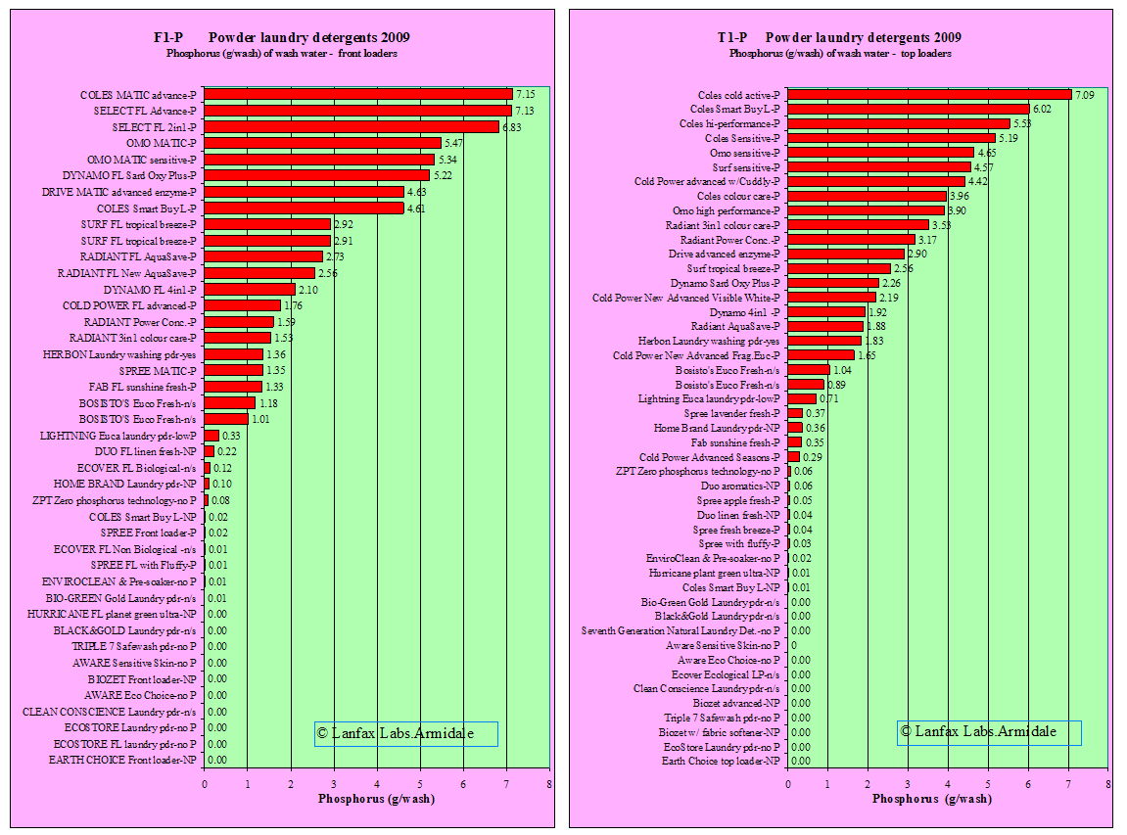
Figure 5: Lists of American laundry powders in order of decreasing P per wash.
(FL = front loading, TL = top loading). (From the Lanfax Lab website).

Acknowledgements
I thank Andy Bruere for helpful discussions on the approach needed for this desktop study.

References
Bay of Plenty Regional Council, Rotorua District Council and Te Arawa Maori Trust Board (2013). Rotorua Te Arawa lakes programme annual report 2012-2013. Rotorua, New Zealand. 32 pp.
BOPRC 2011. Lake Tikitapu (the Blue Lake) Action Plan. Bay of Plenty Regional Council Environmental Publication 2011/09. June 2011.
Beca 2004. The Use of Flocculants and Coagulants to Aid the Settlement of Suspended Sediment in Earthworks Runoff : Trials, Methodology and Design. Beca Carter Hollings & Ferner Ltd draft report to Auckland Regional Council. Technical Publication 227.
Boffa Miskell 2004. Overview of the Effects of Residual Flocculants on Aquatic Receiving Environments. Boffa Miskell Ltd. report to Auckland Regional Council. Technical Publication 226.
Bottcher, D., DeBusk, T., Harper, H., Iwinski, S., O’Connor, G., Wanielista, M. (2009) Technical assistance for the northern Everglades chemical treatment pilot project. Final report to South Florida Water Management District, Project ID#: PS 100093. Pp 186. Available from www.stormwater.ucf.edu
Burns, N., Rutherford, CJ., Clayton, JS. 1999. A monitoring and classification system for New Zealand lakes and reservoirs. Journal of Lakes Research and Management 15: 225-271.
Clayton, JS., de Winton, M., Wells, RDS., Tanner, CC., Miller, ST., Evans-McCleod, D. 1990. The aquatic vegetation of 15 Rotorua lakes. 2nd edition. Aquatic Plant section, Minitry of Agriculture Fisheries, Hamilton.
Clearwater, SJ., Hickey, CW., Thompson, KJ. 2014. The effect of chronic exposure to phosphorus-inactivation agents on freshwater biota. Hydrobiologia 728: 51–65.
Clearwater, SJ. 2014. Supplementary Information For “The effect of chronic exposure to phosphorus-inactivation agents on freshwater biota” S. J. Clearwater, C.W. Hickey, K.J. Thompson. National Institute of Water & Atmospheric Research, PO Box 11-115, Hamilton, New Zealand 3251.
EPA 2014. Guidelines for Drinking Water Quality Management for New Zealand 2013, Chapter 13: Treatment processes, coagulation – January 2014. P9.
Everall NC., Lees DR. (1996). The use of barley straw to control general and blue-green algae in a Derbyshire reservoir. Water Research 30: 269-276.
Everall NC., Lees DR. (1997). The identification and significance of chemicals released from decomposing barley straw during reservoir algal control. Water Research 31: 614-620.
Davenport, T., Drake, W. (2011). The Case for Source Water Protection: Nutrients and Algae Blooms. Lakeline, Fall 2011: 44-46.
Ferrier MD., Butler Sr. BR., Terlizzi DE., Lacouture RV. (2005). The effects of barley straw (Hordeum vulgare) on the growth of freshwater algae. Bioresource Technology 96: 1788–1795.
Geosyntec and Venner 2012. Turbidity reduction and monitoring strategies for highway construction projects. Report prepared by Geosyntec Consultants, Inc. and Venner Consulting, Inc. for American Association of State Highway and Transportation Officials Standing Committee on Environment as part of NCHRP Project 25-25, Task 74, National Cooperative Highway Research Program. July 2012
Gibbs, M., Budd, R., Hart, C., Stephens, S., Wright-Stow, A., Edhouse, S. (2011) Current measurements in Lakes Rotorua and Rotoehu 2010 and 2011. NIWA client report HAM2011-015 to Bay of Plenty Regional Council. Project code BOP11203. 29pp.
Gibbs, MM., Lusby, F. (1995) Lake edge wetlands: a preliminary report. Hamilton. NIWA Consultancy Report BPR005/1, prepared for Environment Bay of Plenty.
Gibbs, MM., Lusby, FE. (1996) Lake edge wetlands: their environmental significance to the Rotorua lakes. NIWA Report No. BPR005/2 to Environment Bay of Plenty.
Gielen, G., Wijeyekoon, S., Gapes, D. 2014. Scientific review of zeolite technology for ammonium removal from the Waiohewa stream. Scion Research report to Bay of Plenty Regional Council. 23pp.
Hamilton, DP., McBride, CG., Jones, HFE. 2015. Assessing the effects of alum dosing of two inflows to Lake Rotorua against external nutrient load reductions: Model simulations for 2001-2012. Environmental Research Institute Report X, University of Waikato, Hamilton, 56 pp
Harrison, PG., Chan, AT (1980). Inhibition of the growth of micro-algae and bacteria by extracts of eelgrass (Zostera marina) leaves. Marine Biology, 61: 21–61.
Harper, H. (2013) Control of watershed loadings using chemical treatment. Lakeline, Fall 2013: 19-22.
Matheson, F., Clayton, J. 2002. Aquatic plant harvesting in lakes for nutrient renovation. NIWA client report HAM2002-010 prepared for Environment Bay of Plenty. 29p.
McBride, CG., Verburg, P., Bloor, M., Hamilton, DP. (2015). Estimates of nitrogen and phosphorus loads to twelve Bay of Plenty Lakes: Part 1: Land use and atmospheric deposition. Report prepared for Bay of Plenty Regional Council by Environmental Research Institute, The University of Waikato. April 2015. 73p.
McIntosh, J. (2012) Alum Dosing of two stream discharges to Lake Rotorua. Report to Bay of Plenty Regional Council
Nguyen, ML., Tanner, CC. (1998) Ammonium removal from wastewaters using natural New Zealand zeolites. New Zealand Journal of Agricultural Research. 41: 427-446.
Sojka, RE., Lentz, RD. (1997) PAM Primer: A brief history of PAM and PAM-related issues. Northwest Irrigation and Soils Research pp 7. Available on line at http://www.ars.usda.gov/Research/docs.htm?docid=18876
Weenink EFJ., Luimstra VM., Schuurmans JM., Van Herk MJ., Visser PM., Matthijs HCP. (2015). Combatting cyanobacteria with hydrogen peroxide: a laboratory study on the consequences for phytoplankton community and diversity. Frontiers in Microbiology, Vol 6, article 714: 1-15. doi: 10.3389/fmicb.2015.00714
Woods, R., Hendrikx, J., Henderson, R., Tait, A. (2006). Estimating the mean flow of New Zealand rivers. Journal of Hydrology. New Zealand 45(2): 95-110.

Note that when testing for Al downstream of the dosing point, the water must be gently pressure filtered not vacuum filtered, because the later will pull the floc through the filter media and give erroneously high Al concentrations.
This is the window used for applying Aqual-P (section 3.5.5).

