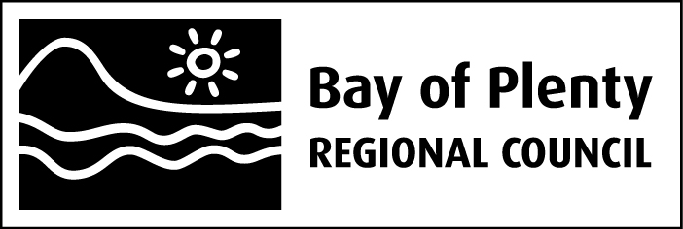

Ohau Channel Diversion Wall Monitoring

Internal Report

June 2014

Bay of Plenty Regional Council
5 Quay Street
PO Box 364
Whakatane 3158
NEW ZEALAND

Prepared by John McIntosh, Environmental Consultant

Introduction
Six years after construction of the Ohau Channel diversion wall and exclusion of Lake Rotorua water from Lake Rotoiti, Lake Rotoiti has undergone recovery to a point where the internal load of nutrients from the bottom sediments has been reduced to a low level. In 2012/13, the objective Trophic Level Index (TLI) of 3.6 for Lake Rotoiti, in the Regional Water & Land Plan, was bettered, with a TLI of 3.4. Concentrations of nitrogen and phosphorus may still be decreasing.
The Ohau Channel was diverted from flowing into the main body of Lake Rotoiti to improve the quality of Rotoiti and to ensure that the incidence of blue-green algal blooms was curtailed to protect human health and aesthetic aspects of the lake. Since the Ohau Diversion Wall was completed on 1 August 2008, a number of actions have become effective in improving the environmental quality of Lake Rotorua. Sewerage reticulation of the communities on the eastern and northern margin of the lake has been completed, Wharenui Dairy farm has been converted to dry stock farming with some maize cropping, alum dosing of the Puarenga Stream was initiated in 2010, which has complemented the Utuhina Stream plant where alum dosing began in 2007. The outcome has been an improvement in the quality of Lake Rotorua. Removal of Rotorua treated sewage in 1991 has also contributed to improvements in Lake Rotorua, although this has taken many years to be realised. Coupled with the improvement in Lake Rotoiti, the quality of water flowing to the Kaituna River has also improved.
A range of water quality parameters have been regularly monitored in the affected water bodies so that changes can be documented and reported from before and after construction of the Ohau Channel diversion wall. Only one adverse effect has been recorded and that is the presence of blue-green algal blooms in Okawa Bay and the Okere Arm of Lake Rotoiti, which have resulted in health warnings concerning recreational use of water bodies in summer 2013/2014. The diversion wall has changed the local environment, in that blue-green algal blooms in Lake Rotorua now do not affect the whole of Lake Rotoiti, but they still potentially affect the Okere arm of Lake Rotoiti and the Kaituna River system. Since the wall was constructed blue-green algal blooms have been absent from the main body of Lake Rotoiti and the downstream waters have benefited from this improvement.

Algal chlorophyll in the Kaituna River system
Rivers draining lakes benefit from the ability of the lake basin to sediment out bacteria and other organisms, as well as other particulate solids, but they may gain phytoplankton at levels that reflect the quality of the headwater lake. The Kaituna River has a green hue due to the influence of the algae in the head-water lakes. To a lesser extent the upper Tarawera demonstrates the same phenomenon.
Blue-green algal blooms have been transported down the Kaituna River from both or either of Lakes Rotorua and Rotoiti in the past. Its takes about a day for algae to flow from the lakes’ outlets to the coast so there is little die-off until they reach saline waters, but there is dilution by inflowing streams. When the blooms have been greater than the threshold for a health warning in the Okere Arm of Lake Rotoiti, the threshold has sometimes been exceeded at Kaituna River sites also. This is the only issue that has affected the Kaituna River while the two lakes have been eutrophic. Consequently, chlorophyll a levels have been monitored as an indication of the quantity of algae transported down the Kaituna River system.

The chlorophyll a series is plotted below, for the lake outlets, Kaituna River and Maketu monitoring sites, from 2007, with about a year of data before the diversion wall construction (shown as a vertical line). A longer time series is plotted for the Kaituna/ Maketu diversion site. Chlorophyll a is the pigment in algal (and plant) cells and is used as a measure of the amount of algae present in the water.
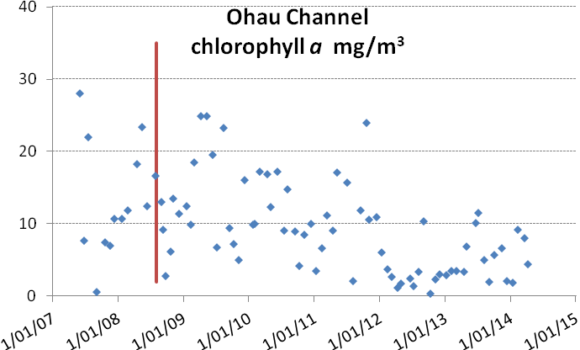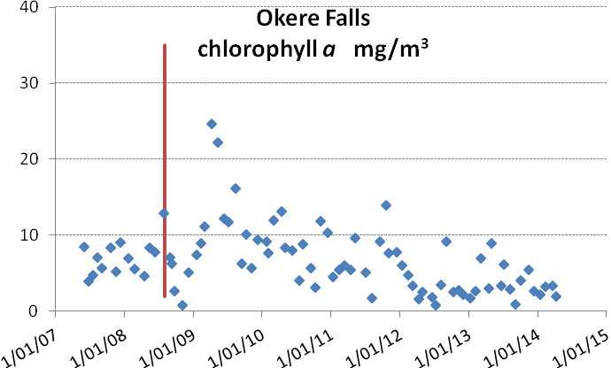
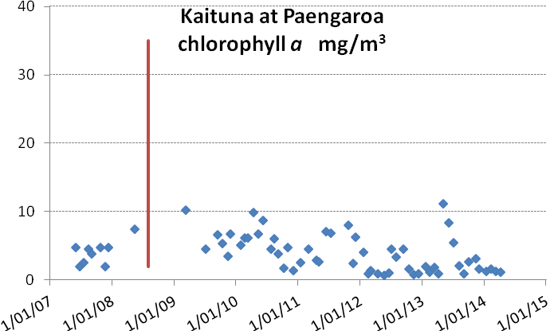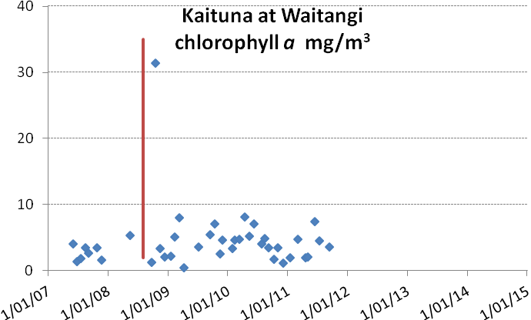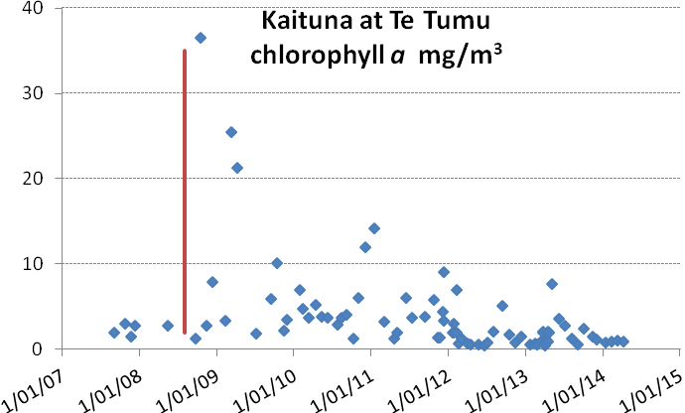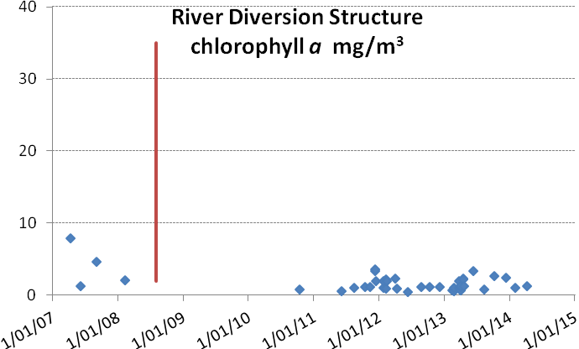
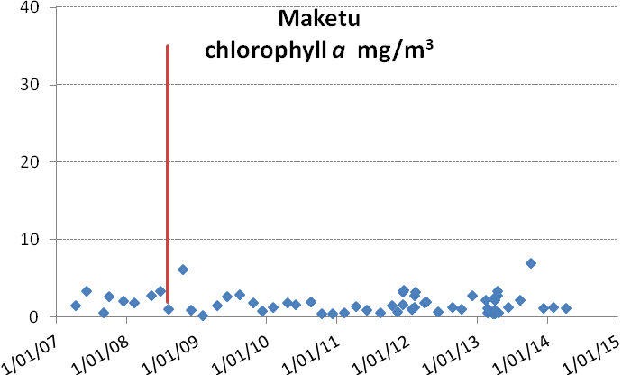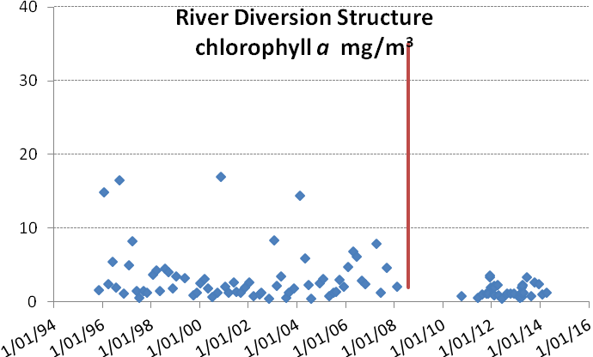
Chlorophyll a levels have been consistently at or below 10 mg/m³ in the Ohau Channel over 2013/14. The objective chlorophyll a for Lake Rotorua is 10 mg/m³. A reduction appears to have occurred in the Okere Arm as well after a mid-winter peak in 2013. Mid-winter peaks are usually associated with diatoms rather than nuisance blue-green algae. Monitoring sites along the Kaituna River displayed a similar pattern of chlorophyll a concentrations to the Okere Arm.
The diversion wall has resulted in improvement to the water of Lake Rotoiti, and alum dosing, septic tank reticulation, treated sewage diversion to Whakarewarewa Forest in 1991 and other actions have resulted in an improvement to Lake Rotorua. In the saline environment freshwater algae quickly die and at Maketu chlorophyll a is derived from marine algae.
The sample site at the river diversion structure to Maketu Estuary has a longer data record than the other sites. The long term data shows that the chlorophyll a levels have not deteriorated (i.e. increased) at that site since the Ohau diversion wall was built.

Suspended solids in the Kaituna River
The suspended solids concentrations in the Ohau Channel are generally greater than in the main body of Lake Rotorua due to the large area of shallows near the entrance to the Ohau Channel. Wind action stirs the bottom sediments putting fine material into suspension. This settles out in the Okere Arm, possibly behind the wall and the discharge at Okere has a very low content of suspended solids. In the Kaituna River system suspended solids increase due to climatic events, affecting the lower catchment.

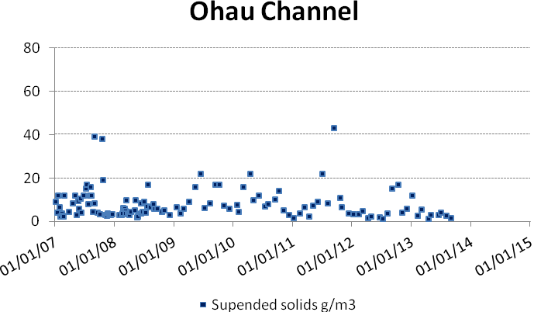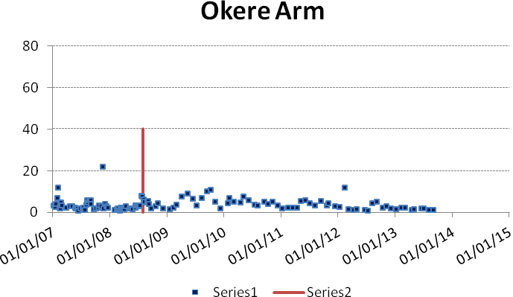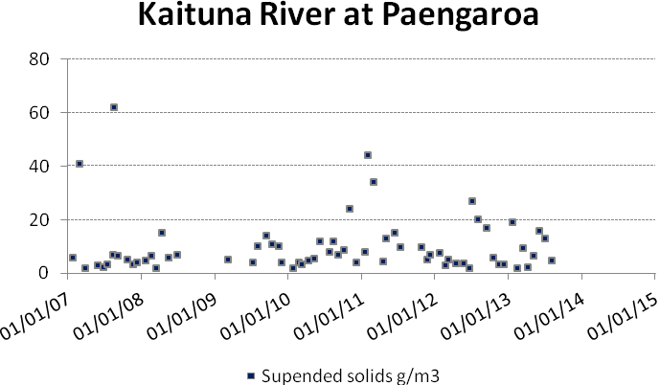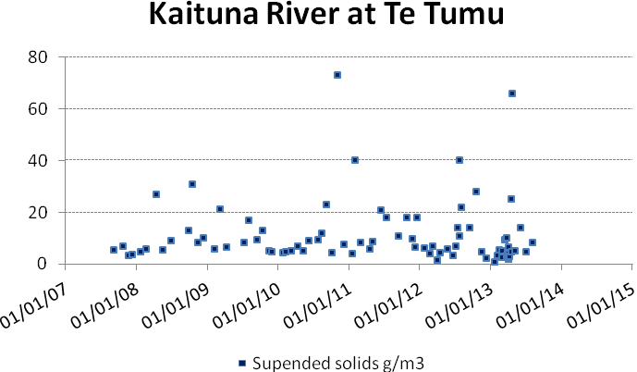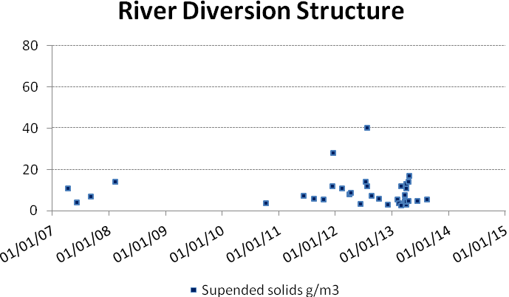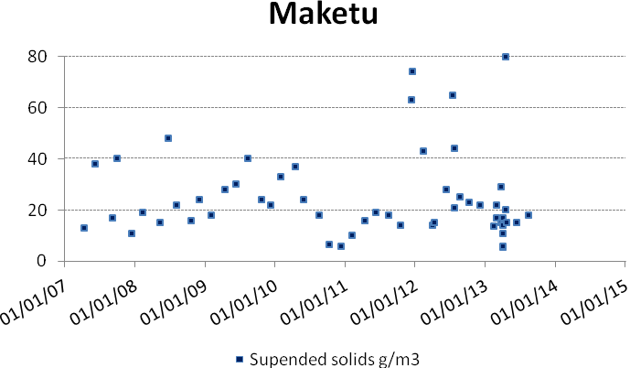

Blue-green algal bloom health warnings
Blue-green algal blooms are an important indicator of the environmental quality of lakes. Objective 12 of the Bay of Plenty Regional Council’s Water and Land Plan is that there is a reduced incidence of blue-green algal blooms in the Rotorua lakes. Objective 11 underwrites Objective 12 by setting an environmental bottom line for each lake in the form of a lake-specific value of the Trophic Level Index (TLI).
There was an absence of blue-green algal blooms and health warnings for Rotorua and Rotoiti over the summer of 2012/13 (previous report) but in February 2014 a prolonged bloom occurred in Okawa Bay and for a lesser period in the Okere Arm. A low dose of alum was applied to Okawa Bay which reduced the phosphorus concentration of the bay waters but did not immediately subdue the bloom. Aquatic weed spraying preceded the bloom and may have inadvertently caused the conditions which eventually stimulated the bloom by increasing levels of nutrients from breakdown of the weeds.
Blue-green algal warnings for Lakes Rotorua, Rotoiti and the Kaituna River in 2013/14, showing that the threshold for a health warning did occur in Okawa Bay and the Okere Arm of Lake Rotoiti.
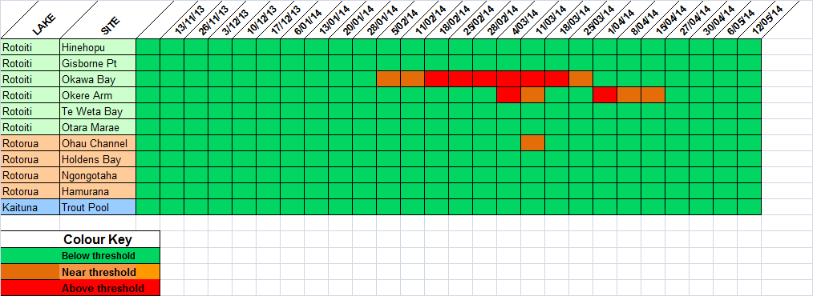
The Trout Pool site at the head of the Kaituna River was the only river site monitored for blue-green algae in 2014. The threshold for a health warning was never exceeded at the Trout Pool.

Ohau and Okere comparison
A series of graphs is shown below contrasting some water quality parameters at the Ohau Channel with the quality at Okere Falls. Note that the wall does not affect the quality of Lake Rotorua and the Ohau Channel.

In the period since the wall was constructed the phosphorus level has fallen in Lake Rotorua to near the long-term target (0.020 g/m³), due to a range of factors. Decreasing seasonal peaks can be seen at the Okere Falls site. These peaks occurred in the late summer/early autumn and likely coincided with nutrient release events from Lake Rotorua. Blue-green algal blooms have been associated with these events in past years. The peak was attenuated over the past 2 years.

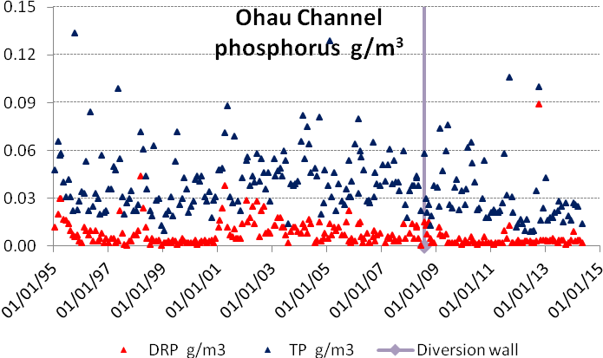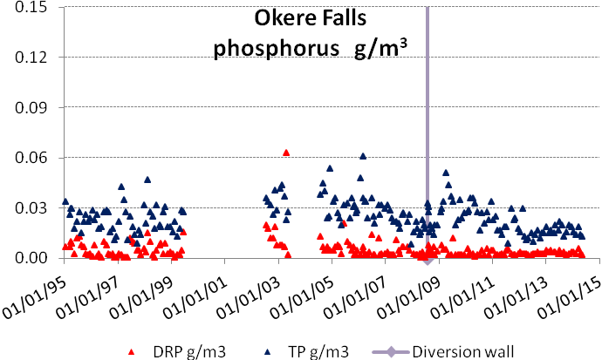

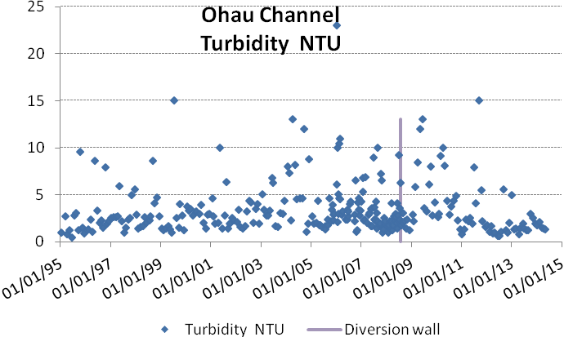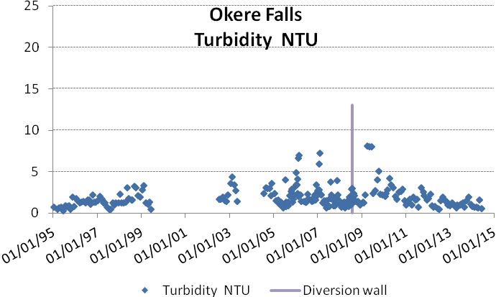
Higher turbidity coincides with higher algal biomass in the water or higher levels of organic solids. The high turbidities at the Okere Falls site just after the wall was constructed were related to blue-green algal blooms in Lake Rotorua. A trend of decreasing turbidity is consistent with the improving quality of both Lakes Rotorua and Rotoiti.
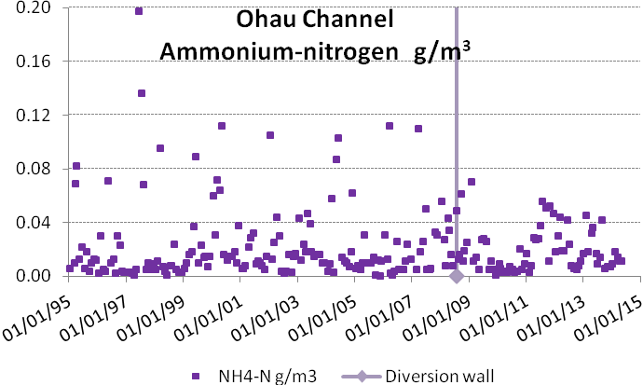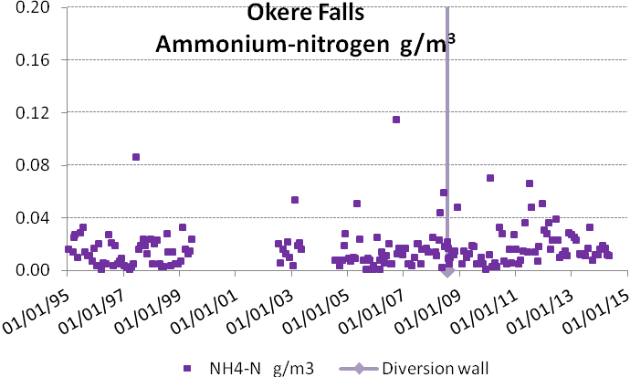
In the second half of 2011 through to the end of 2014, increased concentrations of ammonium nitrogen were discharged from Lake Rotorua through the Ohau Channel. This was also detected at the Okere site. It is possible that a reduction in algal biomass in Rotorua due to lower phosphorus availability resulted in dissolved nitrogen accumulating in the water column. However, below it can be seen that the total nitrogen concentration of both lakes is decreasing as well as the annual peaks decreasing.

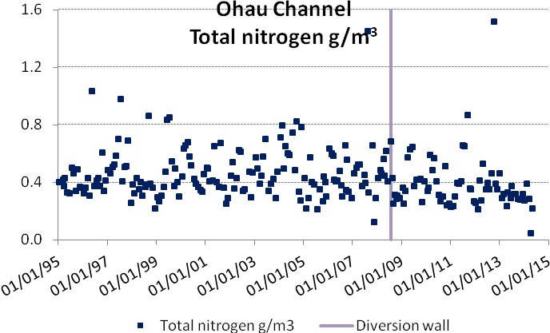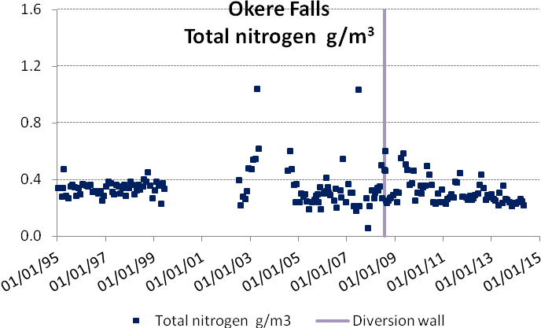
After the wall was constructed the Okere site more closely resembled the Ohau Channel water with respect to total nitrogen levels. This was due to the reduced mixing with Rotoiti water. A decrease in total nitrogen at Okere indicates an improvement in the quality of water at that site, possibly due to improvements in both lakes.
Although the Ohau Channel, the Okere Arm and the Kaituna River were subjected to autumn blooms of blue-green algae after construction of the wall, these blooms have diminished in intensity and frequency. No blooms affected the Kaituna River in 2013/14. Evidence shows that both lakes are improving in quality and this is discussed in the next few sections.

Lake Rotoiti
When the temperature of top and bottom water is identical for about two to three months in the middle of the year, the lake becomes fully mixed with nutrient concentrations homogenous throughout the main body of lake water. As the surface waters warm in the spring the lake stratifies into separate top and bottom layers and remains in that mode for the next nine months. Nutrients in the surface water (top layer) are used by algae which eventually sink into the bottom layer and decay, which utilises oxygen and can reduce it to zero through time. In the resulting anoxic conditions of the bottom waters, nitrogen and phosphorus can be released in large quantities from the bottom sediments. This can be seen in the phosphorus plot as the rising portion of the graph. In the plots below the bottom and top waters of Lake Rotoiti are plotted on the same graph. In 2002 the rising portion of the graph shows that a lot of phosphorus was released into the bottom water that year and the next summer the lake suffered a huge blue-green algal bloom in the New Year once conditions became favourable for blue-green algae. In the plots below the bottom and top waters of Lake Rotoiti are plotted on the same graph to demonstrate release events and the mid-year mixed condition.

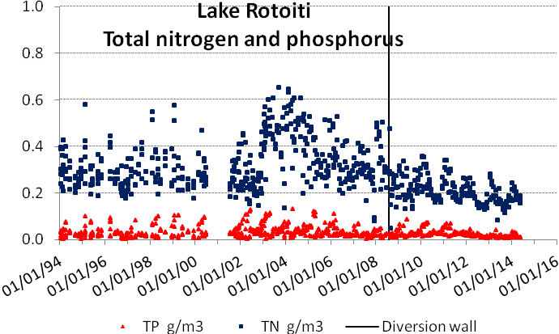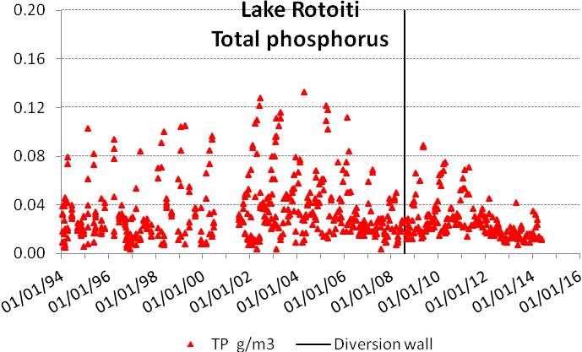

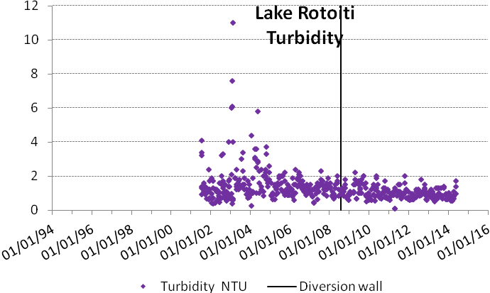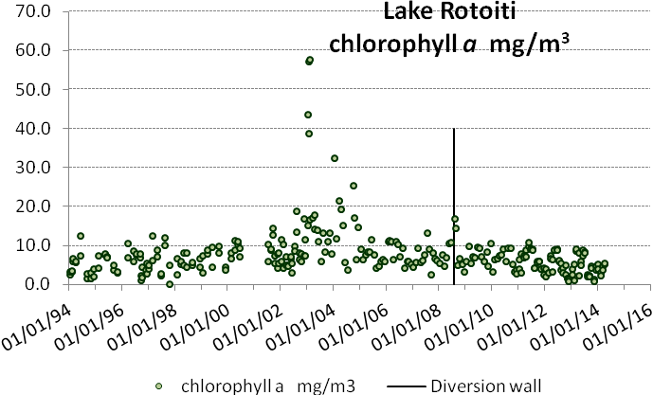
Since the wall was constructed there has been a slow decrease in the phosphorus released into the bottom waters, likely to be partly due to the phosphorus supply to Rotoiti not being replenished from Lake Rotorua. The total nitrogen concentration shows a similar trend. The Regional Council’s monitoring shows that the bottom waters of Lake Rotoiti still become anoxic but the time taken to reach anoxia has extended from 230 days in 2009 to 280 days in 2013 (Paul Scholes comment). 280 days is about the total time of stratification in Rotoiti.
In 2013, very little phosphorus was released into the lake from the bottom sediments. This is the best indication that the wall is effective in remediating the quality of Lake Rotoiti, five years after construction.
After 2010, the peaks in nitrogen and phosphorus reach a maximum about February and then decline. This suggests that the algae which become abundant in the lake in summer settle out and are concentrated into the bottom water as they settle, and eventually sediment out.
It is possible that nitrogen and phosphorus are now being sequestered in the bottom sediments of Rotoiti and not being released during stratification.
The turbidity has reduced in Lake Rotoiti since the wall was constructed and chlorophyll a levels have generally been less than 10 mg/m³, which is close to the long term objective for chlorophyll a in Rotoiti.

Okawa Bay
Although the bay is only 5 m deep it has stratified in the past and in the early 2000s annual nutrient releases occurred which resulted in blue-green algal blooms.
Since sewerage reticulation has been carried out at Okawa Bay a general improvement in the quality of the bay waters has been apparent. All of the graphs below show the improvement from 2005 to 2010. In 2011 an event can be observed where nitrogen and phosphorus levels rose in the lake, turbidity increased and chlorophyll a levels increased.
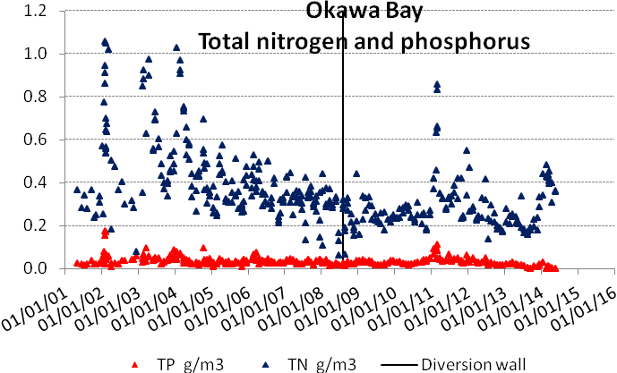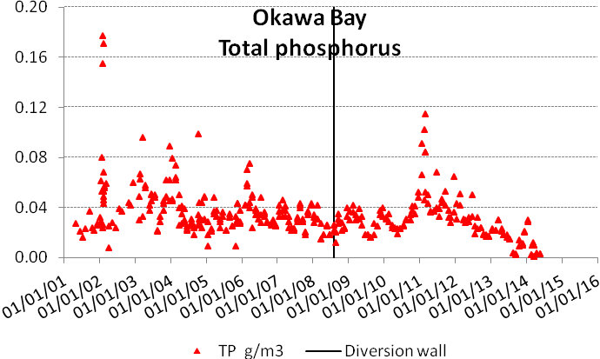
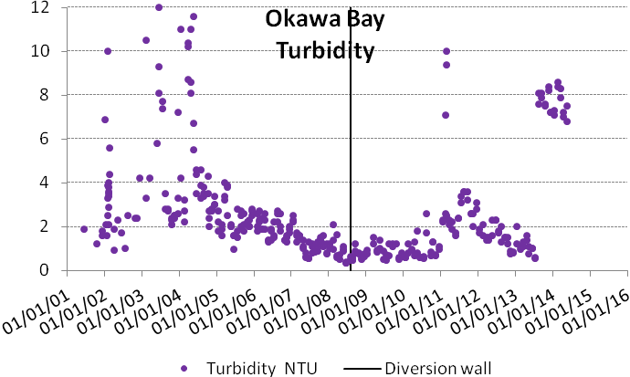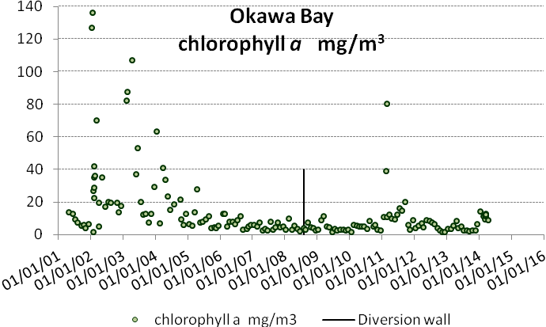
In February 2011 an aerial application of 5 tonne of Aqual P was added to Okawa Bay to disperse a developing algal bloom. The bay waters recovered until February 2014 when blue-green algal blooms reoccurred. The bay was dosed with 5 tonnes of alum (aluminium sulphate) and although the bloom persisted for several weeks it eventually subsided. Aquatic weed spraying preceded both this event and the previous one in 2011. Science investigations into alternative methods of weed control have been discussed by the Regional Council.
The diversion wall is shown as a vertical line on the graphs. There is considered to be a large exchange of water between the bay and western Lake Rotoiti, but the main improvement in bay water quality is most likely to be as a result of the sewerage reticulation scheme diverting septic tank nutrients from the bay water.

Lake Rotorua
In the graph below, the Ohau Channel diversion wall is represented by a vertical line. The wall does not affect the quality of Lake Rotorua at all and the line merely shows the time of construction of the downstream wall.
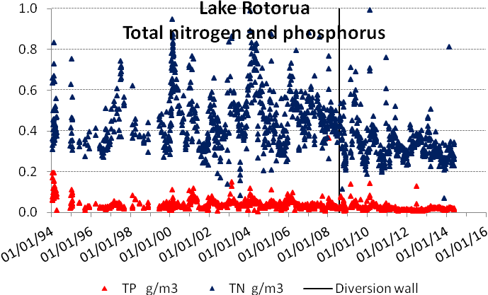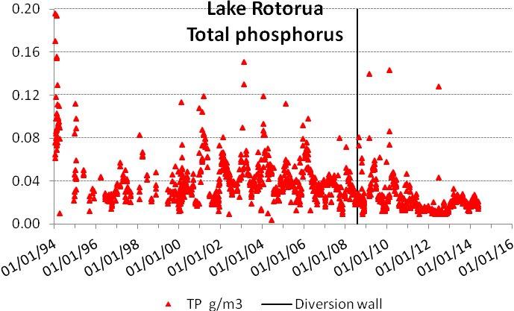
Lake Rotorua stratifies for short periods of days to a couple of weeks, usually in the summer, and the top and bottom waters temporarily become separate entities. Some of the high nitrogen and phosphorus concentrations will be from nutrients released from the bottom sediments into the bottom waters during these events, if the oxygen content was reduced to a low level or zero. Once the lake mixes again these layers mix and the dissolved portion becomes available to promote algal growth.
Since 2012, the total phosphorus concentration for Lake Rotorua has been below or close to 0.02 g/m³, which is the long term objective for the lake. Alum dosing of the Utuhina and Puarenga Streams played a part in the most recent reduction in lake phosphorus levels.
Total nitrogen levels are also close to the long-term objective concentration for Lake Rotorua. Sewerage reticulation of Rotorua communities at Hamurana, and from Mourea to Hinemoa Point, as well as land use change, have likely contributed to reduced nitrogen input to Lake Rotorua. Nitrogen has decreased in Lake Rotorua at the same time that the phosphorus concentration has been reduced by alum dosing.
The largest single action to remove nitrogen and phosphorus from Lake Rotorua was the diversion of treated sewage effluent in 1991, with a nett removal of 120 tonnes nitrogen and 30 tonnes phosphorus. Diversion of treated sewage effluent from Lake Rotorua to Whakarewarewa Forest in 1991 was predicted to take 20 years to be effective in reducing the phosphorus concentration in Lake Rotorua.
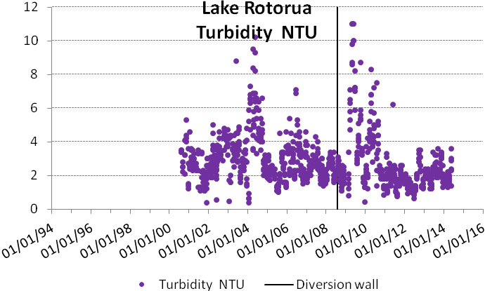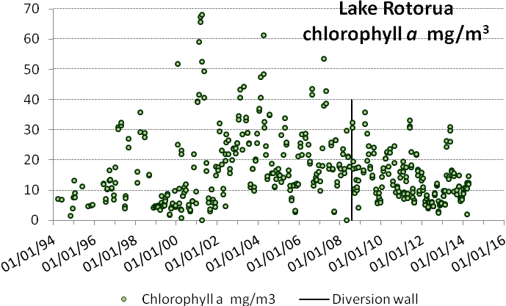
Nitrogen, phosphorus and chlorophyll a concentrations in Lake Rotorua have shown a general improvement over the past decade. Alum dosing has undoubtedly been effective in reducing the phosphorus concentration of the lake water since 2010. At Lake Okaro alum applications have been effective in reducing phosphorus but have had no effect on nitrogen. It is unlikely that nitrogen reduction in Rotorua is related to alum dosing directly, unless flocculation of particular matter in the lake is occurring. The other possibilities are listed above, i.e. sewerage reticulation since 2000, land use change, diversion of treated sewage effluent to Whakarewarewa Forest in 1991.

Rotorua and Rotoiti comparison
The annual nitrogen and phosphorus concentrations in lakes Rotorua and Rotoiti are shown below as well as the annual TLI for both lakes.
In Lake Rotorua the two actions which have registered immediate changes in the nutrient concentrations have been the removal of treated sewage effluent from the lake in 1991 and alum dosing, which became effective in reducing the phosphorus concentration of the lake in 2010 when the Puarenga dosing plant began operation.
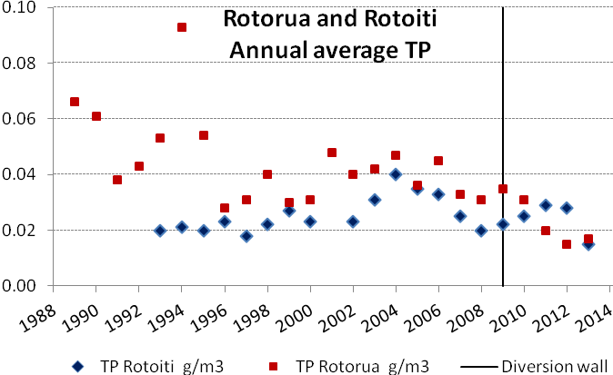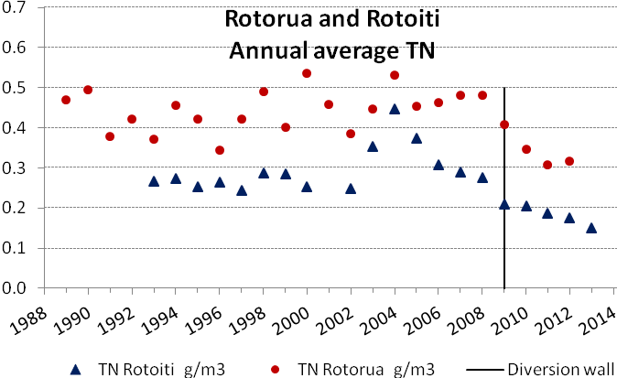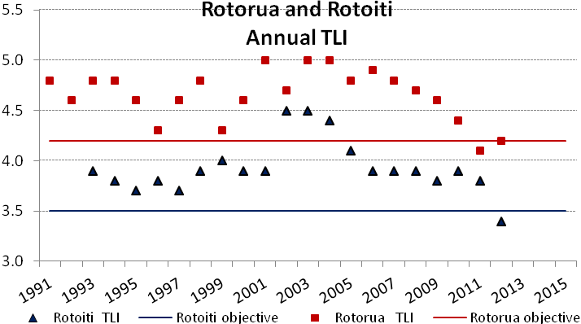
Before the wall was constructed in August 2008, (marked by the vertical line) the nutrient concentrations in Rotorua appear to be the driving force that resulted in the widespread blooms that affected Rotoiti from 2002. The diversion wall is the major action that has been instrumental in remediation of Rotoiti.
Before 1991, the phosphorus load on Lake Rotorua could be divided into three approximately equal portions, the catchment load, the sewage load and the sediment load. The hypothesis was that, removal of treated sewage effluent would result in the internal load eventually diminishing to an low amount and the lake would stabilise at an average annual total phosphorus concentration of 0.02 g/m³. After removal of treated sewage effluent, the phosphorus concentration in the lake fluctuated from 1991 to 2000.

Conclusion
The Ohau Diversion Wall has resulted in a continuing improvement in Lake Rotoiti with the input load of nitrogen and phosphorus restricted by excluding the majority of Ohau Channel water. Algal blooms have been absent from the main body of Lake Rotoiti since the wall construction. Decreasing amounts of phosphorus are being released from the bottom sediments of Lake Rotoiti during the annual 9 months of stratification and in fact net sequestration may be occurring. Lake nutrient levels may continue to decline over the next few years if sediment nutrient releases have been reduced to low levels and if a proposed sewerage reticulation scheme is implemented for the southern and eastern parts of Rotoiti.
Algal blooms have been the sole adverse effect emanating from Lakes Rotorua and Rotoiti that have had an impact on the Kaituna River since lake blooms were first recorded in the 1960s. The diversion wall has eliminated that effect from Lake Rotoiti but algal blooms in Lake Rotorua still potentially affect the Ohau Channel, Okere Arm and the Kaituna River, although blooms did not occur in the summers of 2011/12, 2012/13 or 2013/14.
Construction of the Ohau Channel diversion wall increased the risk of blue-green algal blooms from Lake Rotorua flowing to the Okere Arm and the Kaituna River. Remediation of Lake Rotorua by reducing the nutrient load became urgent to prevent the health risk and wider environmental degradation that are caused by blue-green algal blooms. Alum dosing of two streams flowing into Lake Rotorua appears to have been effective in lowering the phosphorus concentration of Lake Rotorua since 2010 and lowering the internal load of phosphorus. The effects of diversion of treated sewage effluent to irrigation in Whakarewarewa Forest may still be helping to reduce the nitrogen and phosphorus concentrations in Lake Rotorua as the internal load declines. The effect of all remedial actions has resulted in Lake Rotorua meeting its TLI target in 2011/12 and 2012/13. In 2012/13, the quality of Lake Rotoiti was superior to its TLI objective.
The diversion wall has not resulted in adverse effects on lake or river water quality but the need for long-term maintenance of low nitrogen and phosphorus concentrations in Lake Rotorua to manage algal blooms (objective 12 of the Water and Land Plan) still exists.

