

Ohau Channel Diversion Wall Monitoring

Internal Report

June 2012

Bay of Plenty Regional Council
5 Quay Street
PO Box 364
Whakatane 3158
NEW ZEALAND

Prepared by John McIntosh, Environmental Consultant

Introduction
The Ohau Channel was diverted from flowing into the main body of Lake Rotoiti to improve the quality of Rotoiti and to ensure that the incidence of blue-green algal blooms was curtailed to protect human health and well-being. Since the Ohau Diversion Wall was completed on 1 August 2008, a number of actions have become effective in improving the environmental quality of Lake Rotorua. Sewerage reticulation of the communities on the eastern margin of the lake has been completed, Wharenui Dairy farm has been converted to dry stock farming and alum dosing of the Puarenga Stream, which was initiated in 2010, has complemented the Utuhina Stream plant where alum dosing began in 2007. The outcome has been an improvement in the quality of Lake Rotorua. Coupled with the improvement in Lake Rotoiti the quality of water flowing to the Kaituna River has also improved.
A range of water quality parameters have been regularly monitored in the affected water bodies so that changes can be documented and reported from before and after construction of the Ohau Channel diversion wall. These parameters do not represent adverse effects but can indicate the degree of any affect. Only one adverse effect has been recorded and that is the presence of blue-green algal blooms which have resulted in health warnings concerning recreational use of water bodies. The diversion wall has changed the local environment in that blue-green algal blooms in Lake Rotorua now do not affect the whole of Lake Rotoiti but they still potentially affect the Okere arm of Lake Rotoiti and the Kaituna River system. Since the wall was constructed blue-green algal blooms have been absent from the main body of Lake Rotoiti and the downstream waters have benefited from this improvement.

Algal chlorophyll in the Kaituna River system
Chlorophyll a levels at the monitored sites are shown below as an indication of the quantity of algae throughout the Kaituna River system. The general series is plotted from 2007 with about a year of data before the diversion wall construction (shown as a red line). A longer time series is plotted for the Kaituna/ Maketu diversion site. Chlorophyll a is the pigment in algal (and plant) cells and is used as a measure of the amount of algae present in the water.
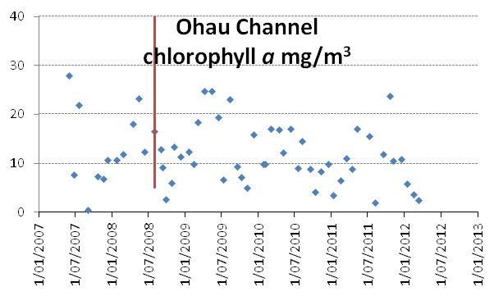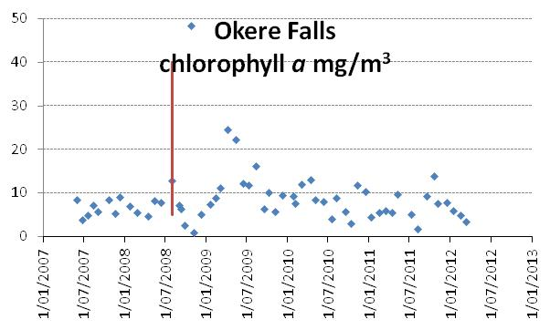
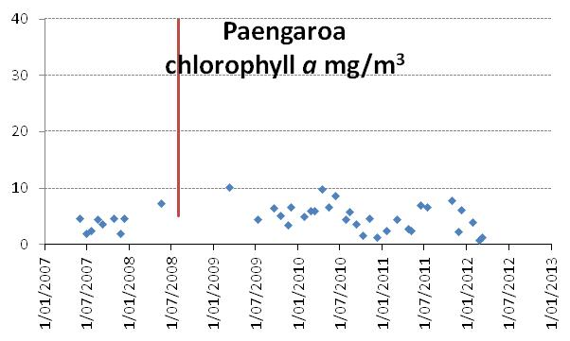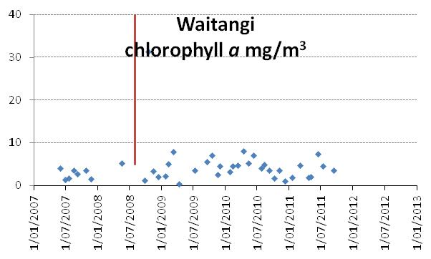
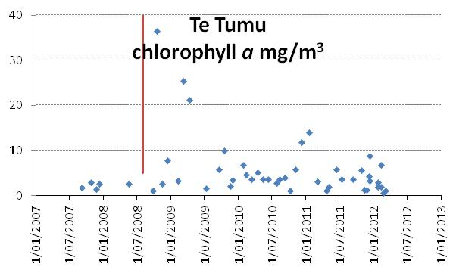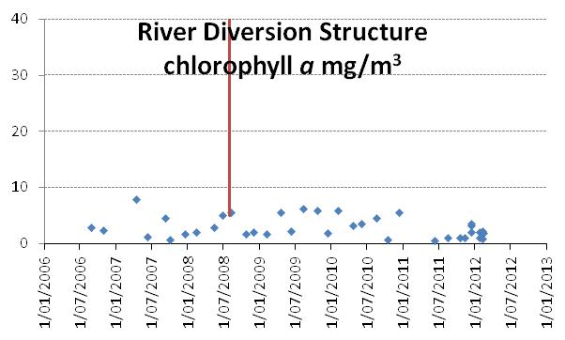
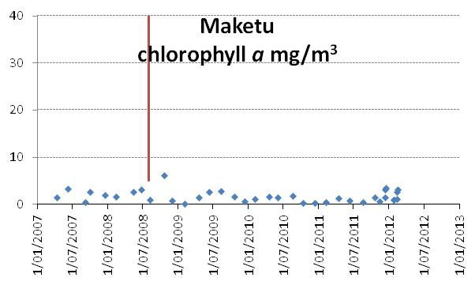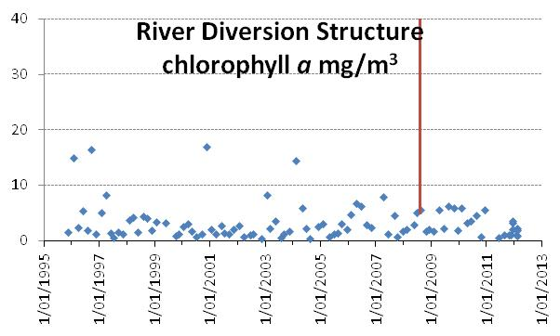
Rivers draining lakes benefit from the ability of the lake basin to sediment out bacteria, debris and solids but they gain a complement of free floating algae reflecting the quality of the headwater lake. The Kaituna River has a green hue due to the influence of lake water. To a lesser extent the upper Tarawera demonstrates the same phenomenon.
Over the summer of 2012 low chlorophyll a levels have been recorded in the Ohau Channel and Okere Arm. This is reflected at the monitoring sites along the Kaituna River. Extreme high rainfalls have occurred over the past two years which may have resulted in greater dilution but it is likely that remediation measures have had considerable influence. The diversion wall has resulted in improvement to the water of Lake Rotoiti and alum dosing and other actions may have resulted in an improvement to Lake Rotorua.
In the saline environment freshwater algae quickly die and at Maketu chlorophyll a is from marine algae.

Blue-green algal bloom health warnings
Blue-green algal blooms are an important indicator of the environmental quality of lakes. Objective 12 of the Bay of Plenty Regional Council’s Water and Land Plan is that there is a reduced incidence of blue-green algal blooms in the Rotorua lakes. Objective 11 underwrites Objective 12 by setting an environmental bottom line for each lake in the form of a lake-specific value of the Trophic Level Index (TLI).
Remedial actions have resulted in an absence of blue-green algal blooms and health warnings for Rotorua and Rotoiti over the summer of 2011/12. This was not universal for the Rotorua lakes and warnings were posted for Lake Okaro.
A early winter bloom did affect Lake Rotorua in 2011 and flowed on to affect the Okere Arm and the Kaituna River. The bloom appears to have occurred after a surplus of nitrogen accumulated in the water of Lake Rotorua.

In the table below, some weeks with all results below the warning threshold have been omitted, but the lack of blooms on Rotorua and Rotoiti is well demonstrated.
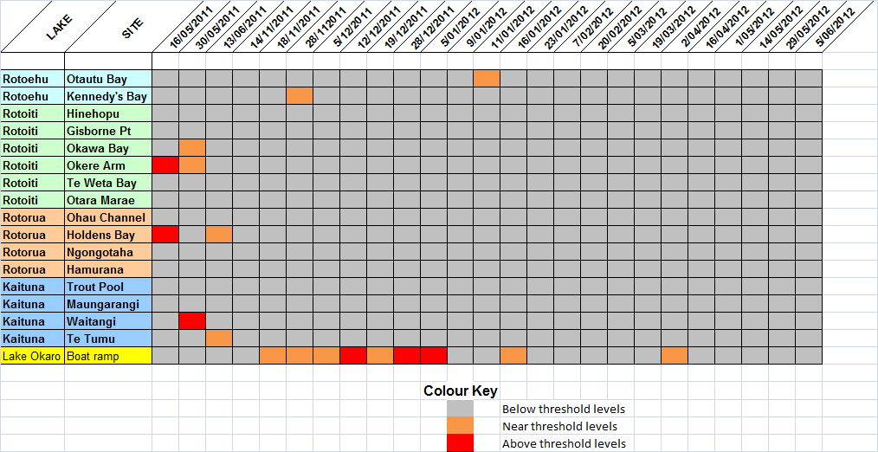

Ohau and Okere comparison
A series of graphs is shown below contrasting the quality of the Ohau Channel and the quality at Okere Falls.

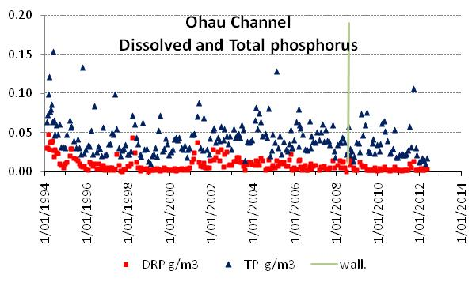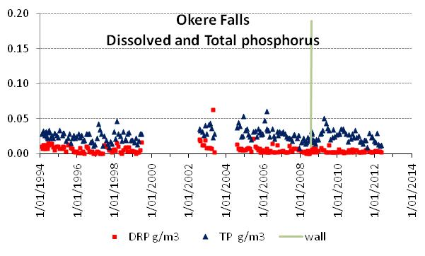

In the period since the wall was constructed phosphorus levels have fallen in Lake Rotorua. Decreasing seasonal peaks can be seen at the Okere Falls site. These occur in the late summer/early autumn and are consistent with nutrient release events from Lake Rotorua. Blue-green algal blooms have been associated with these events in past years.

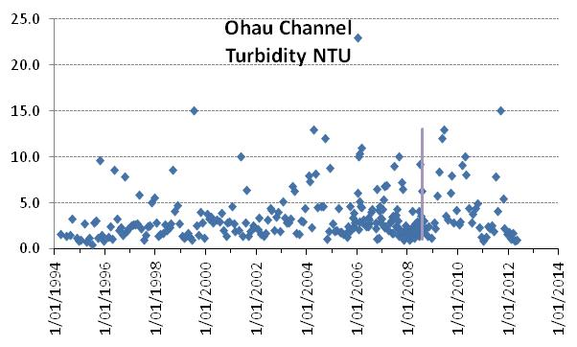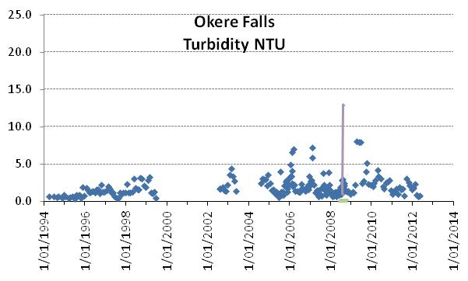
Higher turbidity coincides with higher algal biomass in the water or greater organic debris. The high turbidity at the Okere Falls site just after the wall was constructed was related to blue-green algal blooms. A trend of decreasing turbidity is consistent with the improving quality of both Lakes Rotorua and Rotoiti.
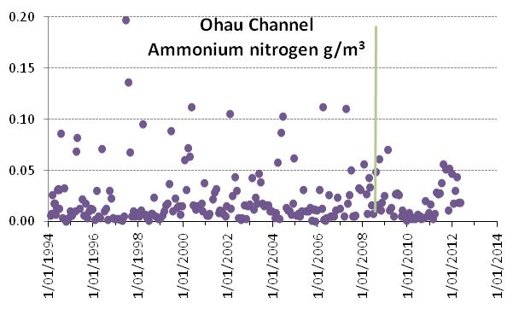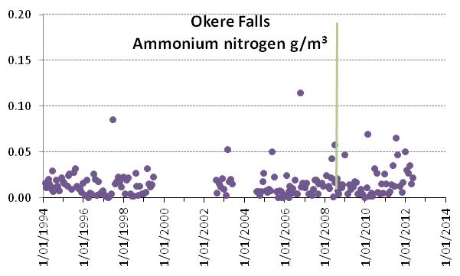
In the second half of 2011 increased concentrations of ammonium nitrogen were discharged from Lake Rotorua through the Ohau Channel. This was also detected at the Okere site. It is possible that a decrease in phosphorus concentration in Lake Rotorua resulted in dissolved nitrogen accumulating in the water column that algae were unable to utilise.
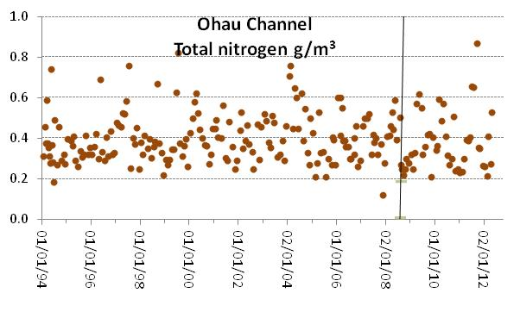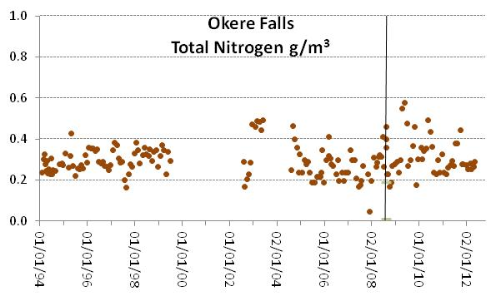
After the wall was constructed The Okere site more closely resembled the Ohau Channel water with respect to total nitrogen levels. A decrease in total nitrogen at Okere indicates an improvement in the quality of water at that site.
Although the Ohau Channel, the Okere Arm and the Kaituna River have been subjected to autumn blooms of blue-green algae since construction of the wall, these blooms are diminishing in intensity and frequency. That could be related to recent climatic patterns rather than an improvement in the quality of either lakes. However, alum dosing of the Puarenga Stream which began in early 2010 may be reducing phosphorus levels in Lake Rotorua. This could also be acting to reduce the intensity of blooms.

Lake Rotoiti
In the plots below the bottom and top waters of Lake Rotoiti are plotted on the same graph. At mid-year, when the temperature of top and bottom water equilibrates, the lake becomes fully mixed for about two to three months with nutrient concentrations homogenous throughout the main body of lake water. As the surface waters warm in the spring the lake stratifies into separate layers and remains in that mode for the next nine months. Nutrients in the surface water are used by algae which sink into the bottom and decay utilising the oxygen and reducing it to zero. In the resulting anoxic conditions nitrogen and phosphorus are released from the bottom sediments. This can be seen in the phosphorus plot as the rising portion of the graph. In 2002 the rising portion shows that a lot of phosphorus was released into the bottom water that year and the next summer the lake suffered a huge blue-green algal bloom in the New Year once conditions became favourable for blue-green algae.
Since the wall was constructed there is a slow decrease in the phosphorus released into the bottom waters as the phosphorus supply to Rotoiti is not being replenished from Lake Rotorua. The total nitrogen concentration shows a similar trend although the pattern of annual nutrient release is less defined than for phosphorus, with the nitrogen concentration data from top and bottom water blending together.

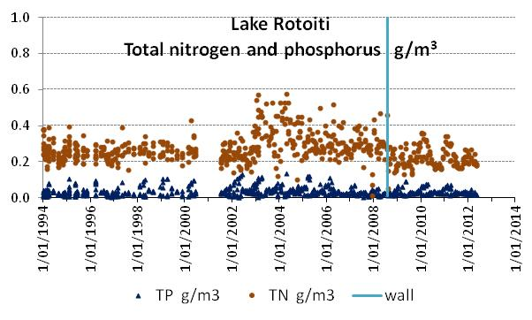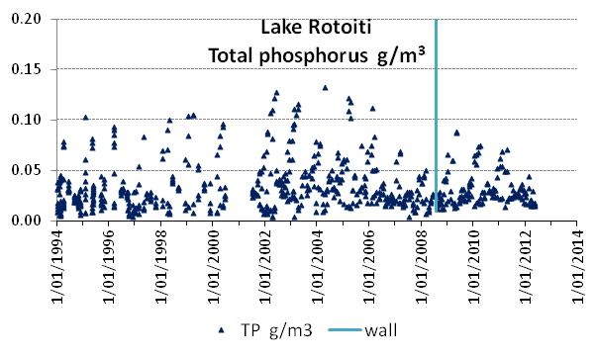
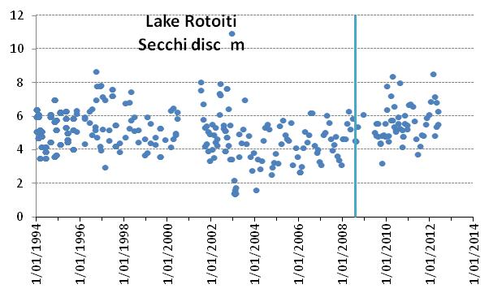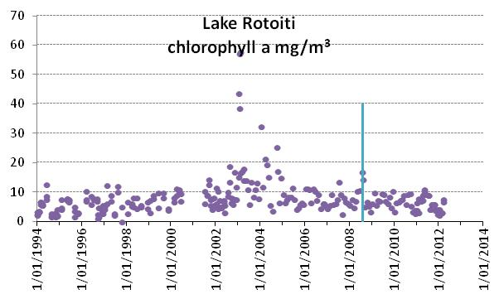
The secchi disc clarity has improved in Lake Rotoiti since the wall was constructed and chlorophyll a levels have been generally less than 10 mg/m³ which is close to the long term objective for chlorophyll a in Rotoiti.

Okawa Bay
Since sewerage reticulation has been carried out at Okawa Bay a general improvement in the quality of the bay waters has been apparent. All of the graphs show the improvement from 2005 to 2010. In 2011 an event can be observed where nitrogen and phosphorus levels rose in the lake, secchi disc clarity declined and chlorophyll a levels increased.
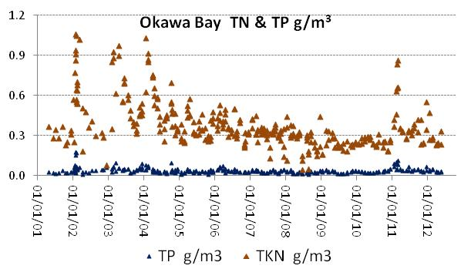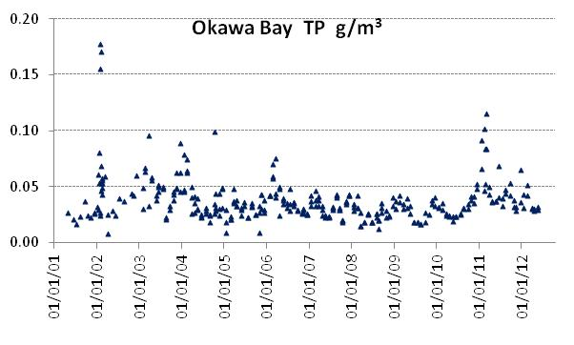
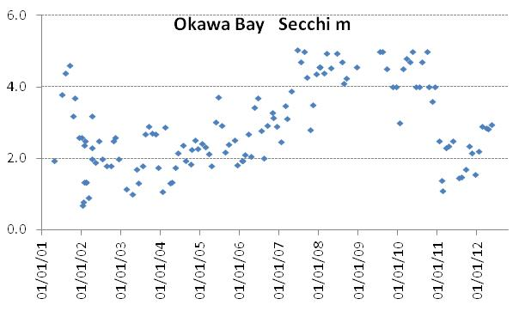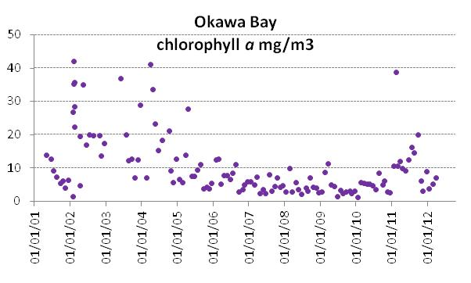
Three possible causes have been put forward;
- Decaying plant material after aquatic weed spraying in November caused nutrient release into the bay waters.
- A nutrient release occurred into the bottom waters of the bay during a period of stratification and anoxia of the bottom waters.
- Ohau Channel water flowed around the diversion wall when the Rotoiti outlet was restricted by lowering the Okere gates and this water affected the quality of Okawa Bay.
Although the bay is only 5 m deep it has stratified in the past and in the early years of this century annual nutrient releases occurred which resulted in blue-green algal blooms.
In January 2011 an aerial application of 5 tonne of Aqual P was added to Okawa Bay to successfully disperse a developing algal bloom. The bay waters have recovered but clarity is still lower than it was before the bloom indicating that algal growth is dominating over aquatic plant growth.

Lake Rotorua
On the graphed data below, the Ohau Channel diversion wall is represented by a line. The wall does not affect the quality of Lake Rotorua at all and the line merely shows the time of construction.
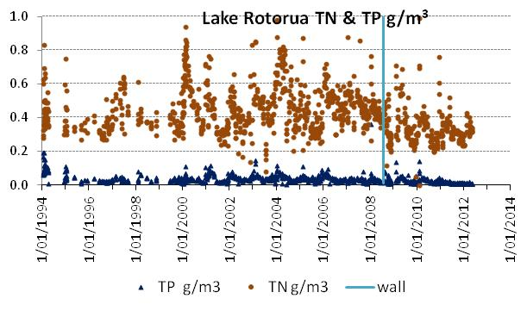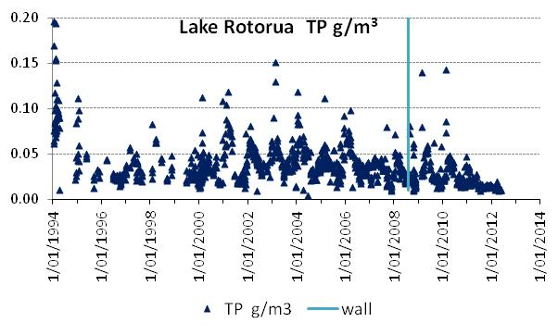
Data from the top and bottom waters are plotted together. Lake Rotorua stratifies for short periods of days to a couple of weeks and the top and bottom waters become separate entities. Some of the high nitrogen and phosphorus concentrations will be of nutrient released from the bottom sediments into the bottom waters. Nutrient releases generally occur over the summer period in Lake Rotorua. Once the lake mixes again these become diluted into the whole water body and the dissolved portion becomes available to promote algal growth.
In Lake Rotoiti, the release occurs continuously once the bottom waters become low in oxygen until the annual mixing event around the end of May or early June. At that time the nutrients released from the sediment are injected into the whole water body.
Up to the time of reporting the total phosphorus concentration for the last 12 months had been below 0.02 g/m³, which is below the long term objective for the lake. The alum dosing of the Utuhina and Puarenga Streams has almost certainly been effective in reducing lake phosphorus levels. Climatic effects have a large impact on lake quality so a longer data record will be needed to determine the exact magnitude of the alum effect.
Total nitrogen levels also appear to be slightly in decline. Sewage reticulation of eastern Rotorua from Mourea to Hinemoa Point and the land use change at Wharenui where dry stock farming has replaced dairying may be effective actions that have reduced nitrogen input to Lake Rotorua. It is possible that with the low phosphorus concentration in Lake Rotorua, denitrification has been enhanced.
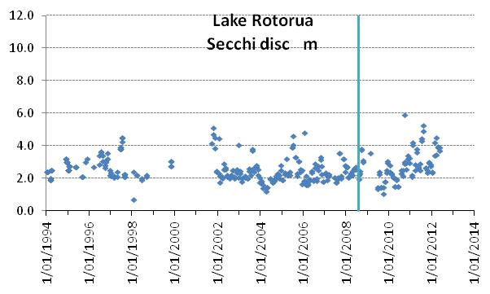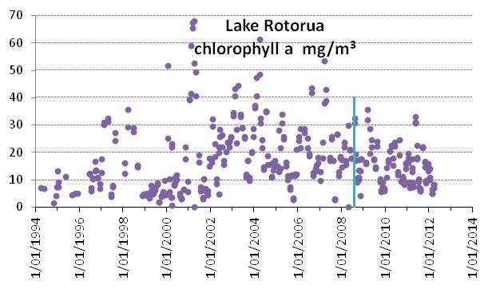
The lake displayed very low clarity in 2009 but this has improved with the secchi disc clarity being greater than 2 m and greater than 4m for a number of sampling occasions in 2011.
Despite annual autumn blooms of blue-green algae in Lake Rotorua the chlorophyll a levels have been lower on average than over most of the last decade. However, lake quality has fluctuated over annual and decadal periods for a long time so no conclusions can be drawn on future outcomes and modelling shows that the lake quality objectives will not be reached without more significant reductions in nutrient inputs. However, the lake is progressing towards its long term objective for an annual average chlorophyll a concentration of 10 mg/m³.

Conclusion
The Ohau Diversion Wall has resulted in a continuing improvement in Lake Rotoiti with the input load of nitrogen and phosphorus restricted by excluding the majority of Ohau Channel water. Algal blooms have been absent from the main body of Lake Rotoiti. Decreasing amounts of phosphorus are being released from the bottom sediments of Lake Rotoiti during the annual 9 months of stratification. Lake nutrient levels can be expected to continue declining over the next decade as the stored nutrients in the bottom sediments become dissipated and if a proposed sewerage reticulation scheme is implemented.
Algal blooms have been the sole adverse effect emanating from Lakes Rotorua and Rotoiti that has had an impact on the Kaituna River since lake blooms were first recorded in the 1960s. The diversion wall has eliminated that effect from Lake Rotoiti but algal blooms in Lake Rotorua still potentially affect the Ohau Channel, Okere Arm and the Kaituna River.
Construction of the Ohau Channel diversion wall increased the risk of blue-green algal blooms from Lake Rotorua flowing to the Okere Arm and the Kaituna River. Remediation of Lake Rotorua by reducing the nutrient load became urgent to prevent the health risk and wider environmental degradation that are caused by blue-green algal blooms. Alum dosing of two streams flowing into Lake Rotorua appears to have been the major action that has been effective in reaching this objective, so far, in the four years since the diversion wall was constructed. Phosphorus levels in Lake Rotorua have been reduced below the concentration for the phosphorus component of the target TLI for Lake Rotorua.
A change in weather pattern seems to have resulted in calm conditions that favour blue-green algal bloom formation occurring in Lake Rotorua in autumn and even into winter over the past three years. Events that may occur over the winter of 2012 will be watched with interest, but the La Nina weather pattern is said in NIWA’s May climate update to be over and a neutral pattern is predominating now.
The diversion wall has not resulted in any adverse effects on lake or river quality but the need for a long term reduction in the nutrient load on Lake Rotorua to manage algal blooms is still apparent.
An Addendum is attached with links to reports on fish, koura and kakahi monitoring.

ADDENDUM
Below is a list of associated reports that provide information on the monitoring of the effects of the Ohau Channel diversion wall on fisheries and koura (fresh-water crayfish) and kakahi (fresh-water mussels) populations.

University of Waikato electro-fishing of the Ohau Channel to 2009.
http://www.boprc.govt.nz/media/33670/RotoruaLakes-CBERContractReport112DEC09.pdf
University of Waikato electro-fishing of the Ohau Channel to 2010/11.
http://www.boprc.govt.nz/media/33478/Report-090529-BoatelectrofishingsurveyofcommonsmeltandcommonbullyintheOhauChannel.pdf
NIWA (2006) Potential effects on Smelt in the Ohau Channel.
http://www.boprc.govt.nz/media/34437/TechReports-061101-Potentialeffectsonsmeltdivertingohauchannel.pdf
NIWA (2009) Smelt monitoring in the Ohau Channel 2008 – 2009.
http://www.boprc.govt.nz/media/34512/TechReports-090806-NIWASmeltmonitoringOhauChannel.pdf
NIWA (2010) Smelt monitoring in the Ohau Channel and Rotoiti 2009 – 2010.
http://www.boprc.govt.nz/media/32488/Lakes-NIWASmeltReport-July2010.pdf
Ian Kusabs and Associates (2006) Koura and kakahi monitoring.
http://www.boprc.govt.nz/media/33319/Report-061000-OhauChannelKouraKakahiReport.pdf
Ian Kusabs and Associates (2009) Koura and kakahi monitoring.
http://www.boprc.govt.nz/media/34233/TechReport-091105-Ohauchannelkourakakahireport.pdf
Eastern Region Fish & Game Council information on the Ohau Channel.
http://www.nzfishing.com/FishingWaters/Eastern/ERFishingWaters/EROhauChannel.htm
Eastern Region Fish & Game Council. Trout fishery survey – Ohau Channel.
http://www.boprc.govt.nz/media/125535/2011_ohau_channel_fisheries_report_2010-11season.pdf

