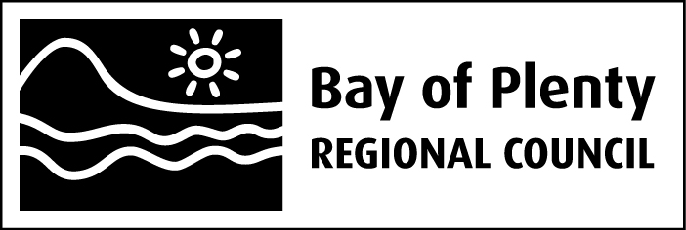

Ohau Channel Diversion Wall Monitoring

Internal Report

June 2015

Bay of Plenty Regional Council
5 Quay Street
PO Box 364
Whakatane 3158
NEW ZEALAND

Prepared by John McIntosh, Environmental Consultant

Introduction
The Ohau Channel was diverted from flowing into the main body of Lake Rotoiti to improve the quality of Rotoiti and to ensure that the incidence of blue-green algal blooms was curtailed to protect human health and aesthetic aspects of the lake. Since the Ohau Diversion Wall was completed on 1 August 2008, a number of actions have been undertaken to improve the environmental quality of Lake Rotorua and the Ohau Channel. Sewerage reticulation of the communities on the eastern and northern margin of the lake has been completed, Wharenui Dairy farm has been converted to dry stock farming with some maize cropping, alum dosing of the Puarenga Stream was initiated in 2010, which has complemented the Utuhina Stream plant where alum dosing began in 2007. The outcome has been an improvement in the quality of Lake Rotorua. Removal of Rotorua city treated sewage in 1991 should be considered amongst the improvements in environmental quality of Lake Rotorua. Coupled with the improvement in water quality of Lake Rotoiti, the quality of water flowing to the Kaituna River has also improved.
A range of water quality parameters have been regularly monitored in the affected water bodies, as required by resource consent 63209, so that changes can be documented and reported from before and after construction of the Ohau Channel diversion wall. Blue-green algal blooms resulted in adverse water quality effects that affected users of Lakes Rotorua and Rotoiti before the diversion wall was constructed. In the summer 2013/2014, blooms occurred in Okawa Bay and the Okere Arm of Lake Rotoiti, which resulted in health warnings concerning recreational use of the water body. In March 2015 there was one event for the Rotorua/Rotoiti area, in the Ohau Channel, where the health warning threshold was exceeded.
Since the wall was constructed blue-green algal blooms have been absent from the main body of Lake Rotoiti and the downstream waters have benefited from this improvement.
Over the summer of 2014/15, Lake Rotorua stratified for a long period and nitrogen and phosphorus were released into the lake water from the bottom sediments. The lake stratifies once or several times each summer, for varying lengths of time, commonly a few days to a week. The previous stratification event of this magnitude was in 2010 when a similar magnitude of nutrient release was recorded. Recent improvements in water quality of Lake Rotorua have not precluded these events from occurring but the rate of de-oxygenation of the bottom waters is lower now so that it takes longer for the stratified waters to become anoxic. It is during the anoxic condition that nutrient release from the bottom sediments occurs. Analysis of Ohau Channel water revealed some increase in phosphorus concentration as a result of the these nutrient release events in Lake Rotorua.
Nutrient concentrations were higher in the bottom waters of Lake Rotoiti during the stratification period of 2014/15. This is more surprising than the event in Lake Rotorua. Lake Rotoiti has demonstrated a trend of reducing nutrient release into the bottom water during stratification since construction of the diversion wall. This has been taken as evidence of the effectiveness of the wall. The change in this trend may be related to the same climatic conditions which resulted in the prolonged stratification of Lake Rotorua in the summer of 2014/15. A cyclical change in climate may be occurring and affecting lake physical processes. There may be some variations in lake nutrient concentrations over the next few years but the magnitude of variations should not be as great as in the previous decade due to the construction of the diversion wall and other actions.

Algal chlorophyll in the Kaituna River system
Rivers draining lakes benefit from the ability of the lake basin to sediment out bacteria and other organisms, as well as other particulate solids from storm runoff, but they may have elevated phytoplankton levels that reflect the quality of the headwater lake. The Kaituna River has a green hue due to the influence of the algae in the head-water lakes. To a lesser extent the upper Tarawera demonstrates the same phenomenon.
High levels of blue-green algae have been transported down the Kaituna River from both or either of Lakes Rotorua and Rotoiti in the past. Its takes about a day for algae to flow from the lakes’ outlets to the coast with dilution by inflowing streams and rivers occurring. When the levels of blue-green algae in the Okere Arm of Lake Rotoiti have been greater than the threshold for a health warning, the threshold has sometimes been exceeded at Kaituna River sites also. This is the only adverse environmental effect on water quality that has affected the Kaituna River from Lakes Rotorua and Rotoiti while the two lakes have been eutrophic. Chlorophyll a is the pigment in algal (and plant) cells and is used as a measure of the amount of algae present in the water transported down the Kaituna River system as required by the consent conditions.
The chlorophyll a time series is plotted below, for the lake outlets, Kaituna River and Maketu monitoring sites, from 2007, including about a year of data before the diversion wall construction (shown as a vertical line). A longer time series is plotted for the Kaituna/ Maketu diversion site.
Chlorophyll a levels have been consistently close to or below 10 mg/m³ in the Ohau Channel since 2012. The objective chlorophyll a used for Lake Rotorua's target TLI is 10 mg/m³. A reduction appears to have occurred in the Okere Arm. A mid-winter peak occurred in 2013 and 2014. Mid-winter peaks are usually associated with diatoms rather than nuisance blue-green algae. Monitoring sites along the Kaituna River displayed a similar pattern of chlorophyll a concentrations to the Okere Arm.

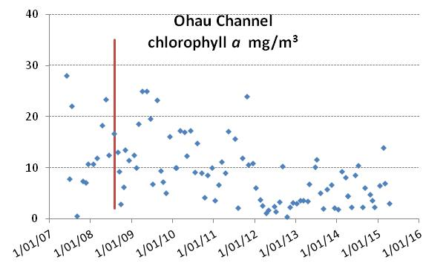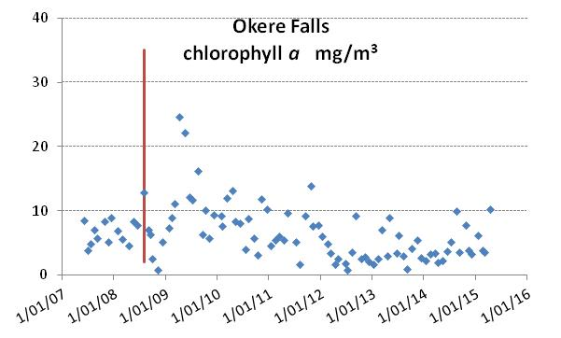
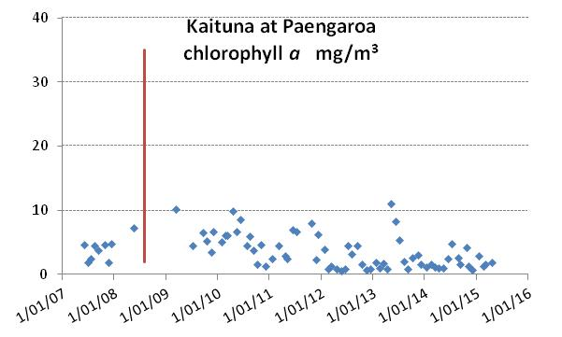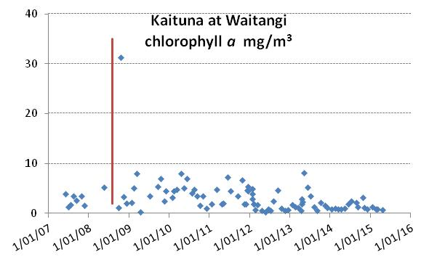
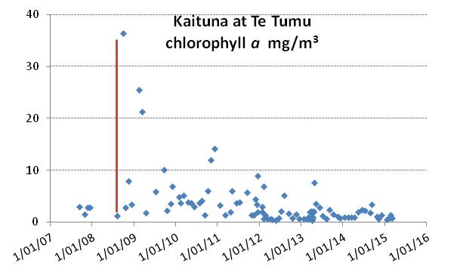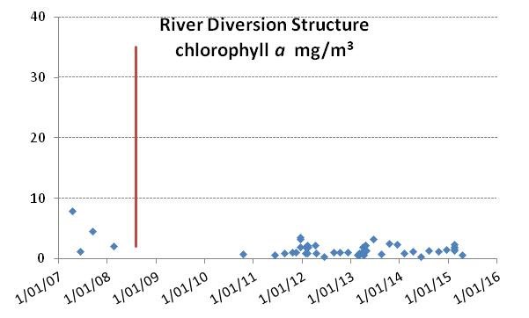
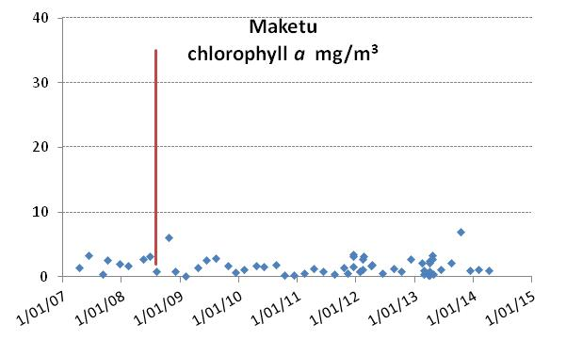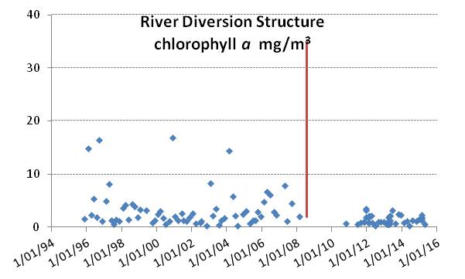
The sample site at the river diversion structure to Maketu Estuary has a longer data record than the other sites. The long term data shows that the chlorophyll a levels have not increased at that site since the Ohau diversion wall was built. The chlorophyll a level in Maketu Estuary reflects the coastal marine environment.
The diversion wall has resulted in improvement to the water of Lake Rotoiti, and alum dosing, septic tank reticulation, treated sewage diversion to Whakarewarewa Forest in 1991 and other actions are likely to have collectively contributed to an improvement in Lake Rotorua water quality. This has been detected as a general reduction in chlorophyll a concentration at all monitoring sites required by resource consent 63209.

Suspended solids in the Kaituna River
The suspended solids concentrations in the Ohau Channel are generally greater than in the main body of Lake Rotorua due to the large area of shallows near the entrance to the Ohau Channel. Turbulence from prevailing westerly winds, stirs the bottom sediments of the shallows, putting fine material into suspension. This settles out in the Okere Arm, possibly behind the wall and the discharge at Okere has a low content of suspended solids. In the Kaituna River system suspended solids increase due to climatic events, affecting the lower catchment with runoff and suspended sediment from storm flows. The majority of the water in Maketu Estuary is from the coastal marine area.

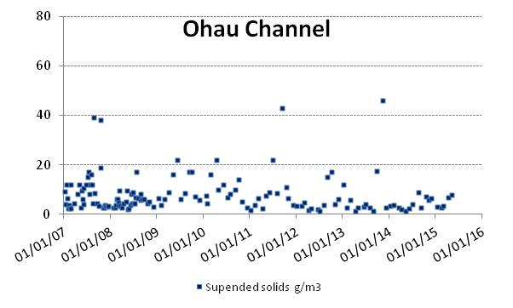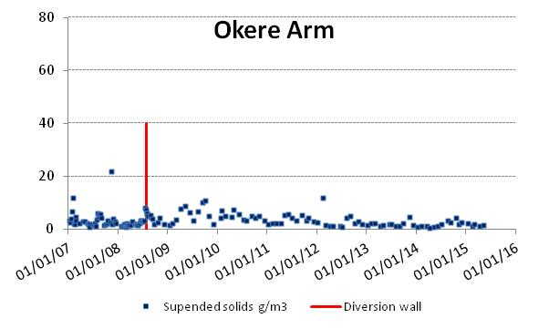
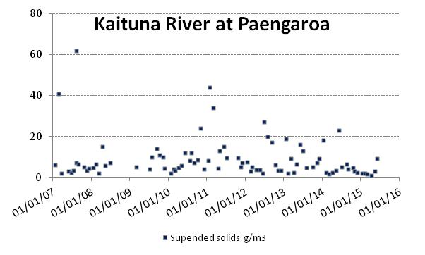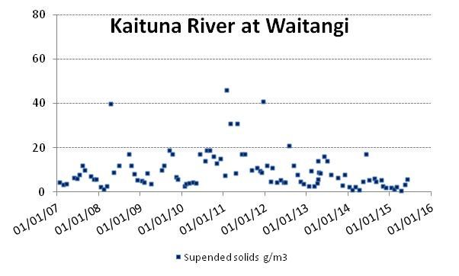
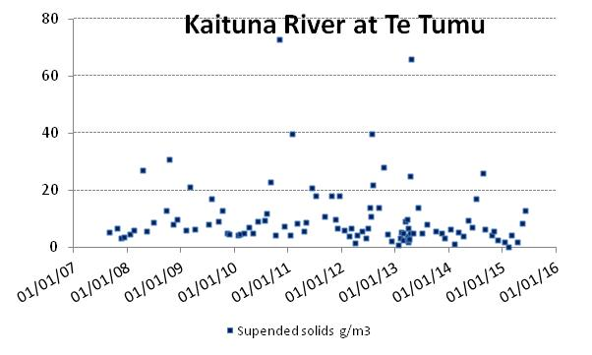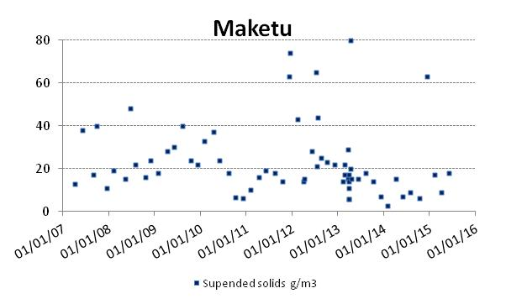

Blue-green algal bloom health warnings
Blue-green algal blooms are an important indicator of the overall environmental quality of lakes. Objective 12 of the Bay of Plenty Regional Council’s Water and Land Plan is that there is a "reduced occurrence of blue-green algal blooms in the Rotorua lakes". Objective 11 underwrites Objective 12 by setting an environmental bottom line for each lake in the form of a lake-specific value of the Trophic Level Index (TLI).
In 2014/15 there was only one occasion when the health warning threshold was triggered for Lakes Rotorua and Rotoiti. That was for one sample of the Ohau Channel. The Trout Pool site at the head of the Kaituna River approached the threshold level once, after which time a site further downstream at Waitangi was sampled. By that time the blue-green algal numbers had reduced.
Blue-green algal recreational threshold categories for Lakes Rotorua, Rotoiti and the Kaituna River in 2014/15. Results show that the threshold for a health warning did occur once in the Ohau Channel.

Ohau Channel and the Okere Arm
A series of graphs is shown to compare water quality parameters at the Ohau Channel with the quality at Okere Falls. Note that the wall does not affect the quality of Lake Rotorua and the Ohau Channel.

In the period since the wall was constructed the average phosphorus level has fallen in Lake Rotorua to near the long-term target (0.020 g/m³) appropriate to a target TLI of 4.2, due to a range of factors. Decreasing magnitude of seasonal peaks can be seen at the Okere Falls site. These peaks occurred in the late summer/early autumn and likely coincided with nutrient release events from Lake Rotorua. The peak was lower in 2013 and 2014 but occurred again in 2015, likely in conjunction with the nutrient release event in Lake Rotorua.

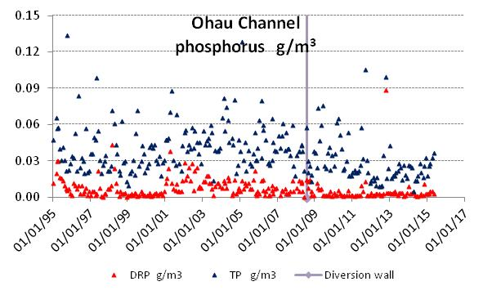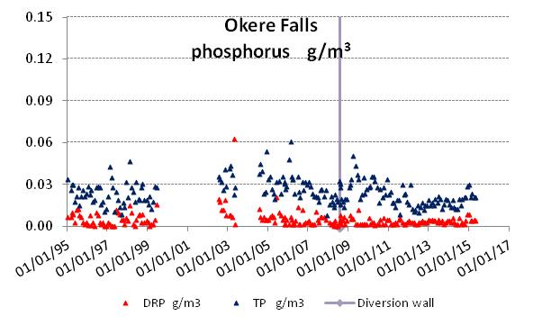

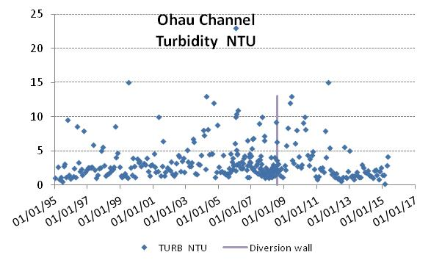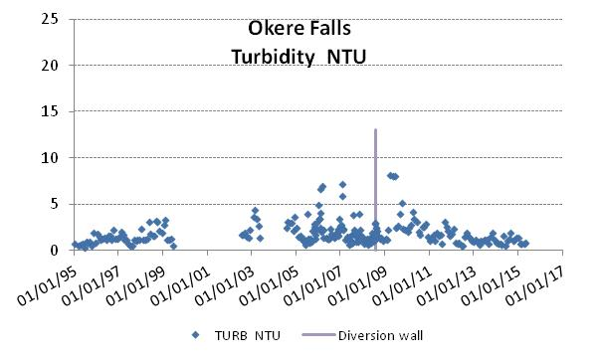
Higher turbidity coincides with higher algal biomass in the water or higher levels of re-suspended solids from the extensive shallows around the entrance to the Ohau Channel. The high turbidity at the Okere Falls site just after the wall was constructed coincided with blue-green algal blooms in Lake Rotorua. A trend of decreasing turbidity is consistent with the improving quality of both Lakes Rotorua and Rotoiti.
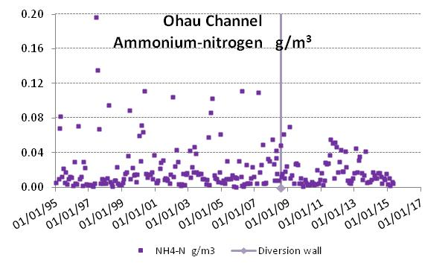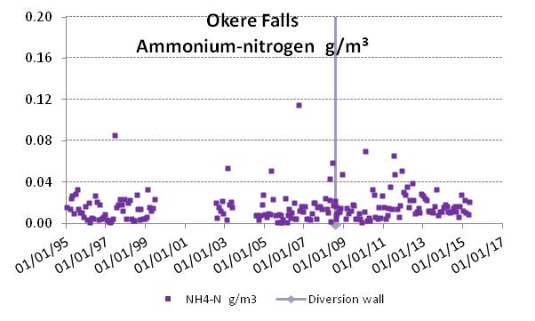
In the second half of the year in 2011 through to the end of 2014, concentrations of ammonium nitrogen became elevated in the Ohau Channel after being low since construction of the wall. Elevated concentrations also occurred at the Okere site. It is possible that a reduction in algal biomass in Rotorua due to lower phosphorus availability resulted in dissolved inorganic nitrogen accumulating in the water column and flowing through the Ohau Channel. Nitrate nitrogen concentrations show a similar occurrence.
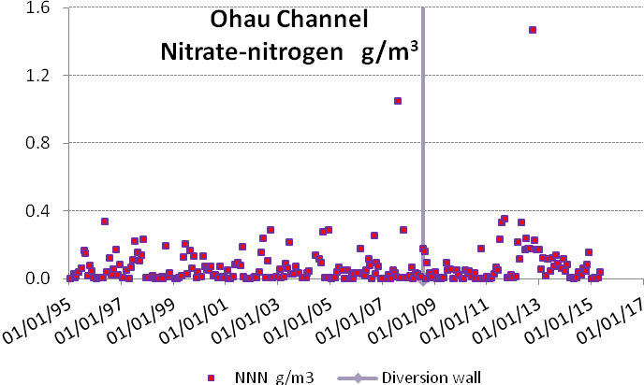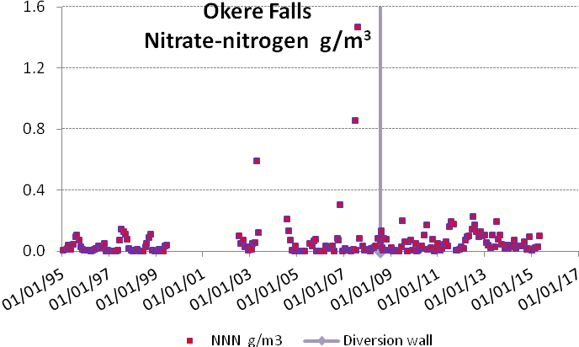
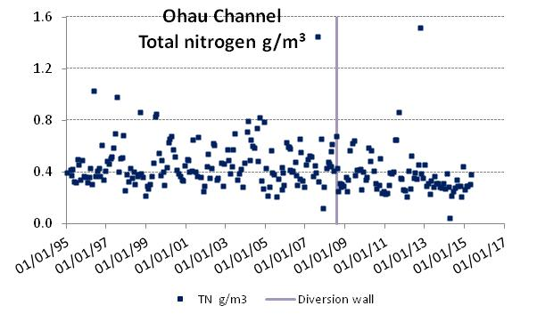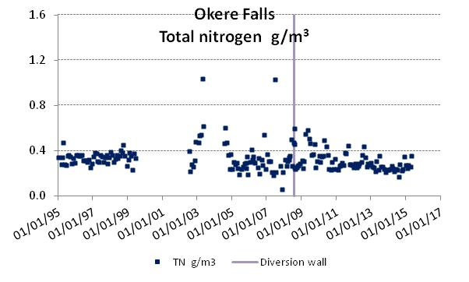
After the wall was constructed the Okere site more closely resembled the Ohau Channel water with respect to total nitrogen levels. This was due to the reduced mixing with Rotoiti water. A decrease in total nitrogen at Okere indicates an improvement in the quality of water at that site, possibly due to reduced levels of total nitrogen in both lakes.
Although the Ohau Channel, the Okere Arm and the Kaituna River were subjected to occasional autumn blooms of blue-green algae after construction of the wall, these blooms have diminished in intensity and frequency and have been absent from the Kaituna River in recent years. Evidence shows that both lakes are improving in quality and this is discussed in the next few sections.

Lake Rotoiti
When the temperature of top and bottom water in Lake Rotoiti becomes uniform in the winter, the lake water column becomes fully mixed. Mixing occurs for about two to three months and the nutrient concentrations become homogenous throughout the main body of lake water. As the surface waters warm in the spring the lake stratifies into separate top and bottom layers and remains in that mode for the next nine to ten months. Nutrients in the surface water (top layer) are used by algae which eventually sink into the bottom layer and decay, which utilises oxygen in the bottom water and can reduce it to zero through time. The bottom waters are isolated from atmospheric re-oxygenation. In the resulting anoxic conditions of the bottom waters, nitrogen and phosphorus can be released in large quantities from the bottom sediments. This can be seen in the phosphorus plot below, as the rising portion of the graph. In the plots below the bottom and top waters of Lake Rotoiti are plotted on the same graph. In 2002 the rising portion of the graph shows that a lot of phosphorus was released into the bottom water that year and the next summer (c. New Year 2002-3) the lake suffered a major blue-green algal bloom once conditions became favourable for blue-green algae. In the plots below the bottom and top waters of Lake Rotoiti are plotted on the same graph to demonstrate nutrient release events (the rising portion of the graph) and the mid-year mixed condition (the concentrations are identical at all depths).

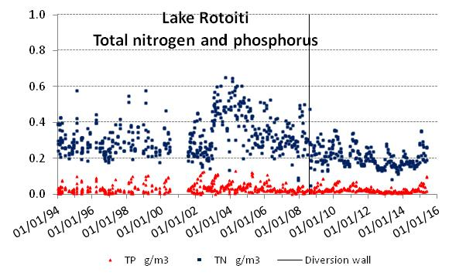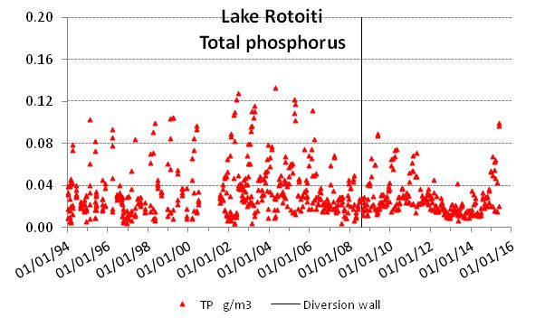

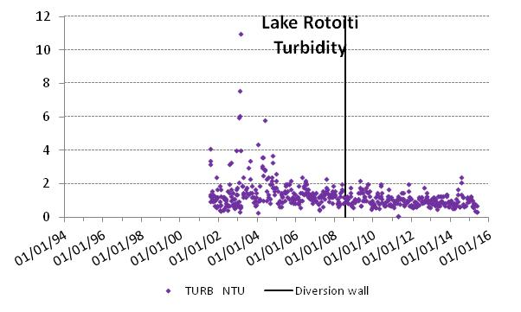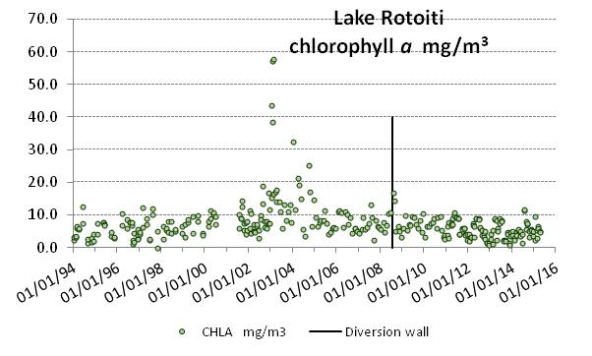
Since the wall was constructed there has been a slow decrease in the phosphorus released into the bottom waters, likely to be partly due to the phosphorus supply to Rotoiti not being replenished from Lake Rotorua. The total nitrogen concentration shows a similar trend. In 2013, very little phosphorus was released into the lake from the bottom sediments.
After 2010, the peaks in nitrogen and phosphorus reach a maximum about February and then decline. This shows the algae, which become abundant in the lake in spring, settling out into the bottom water and sedimenting out rather than a release event. Up to May 2015, nitrogen and phosphorus continued to concentrate in the bottom water suggesting these nutrients (specifically phosphate and ammonium) were being released from the sediments into the water. Until the June 2015 and subsequent analyses become available, the effect of this on overall lake quality will not be known.
The turbidity has reduced in Lake Rotoiti since the wall was constructed and chlorophyll a levels have generally been less than 10 mg/m³, and close to the long term objective for chlorophyll a to meet the TLI objective for Lake Rotoiti.

Okawa Bay
Although Okawa Bay is only 5 m deep it has stratified in the past and in the early 2000s nutrient releases occurred annually during summer, and coincided with blue-green algal blooms. Poor water quality in Okawa Bay was thought to affect other parts of western Lake Rotoiti so monitoring data is included in the consent 63209 reporting.
Since sewerage reticulation has been carried out at Okawa Bay a general improvement in the quality of the bay waters has been apparent. All of the graphs below show the improvement from 2005 to 2010. In January 2011 nitrogen and phosphorus levels rose in the bay, turbidity increased and chlorophyll a levels increased.
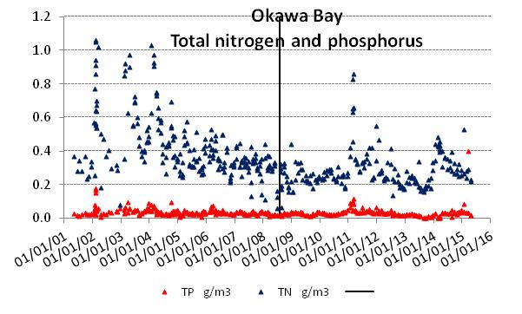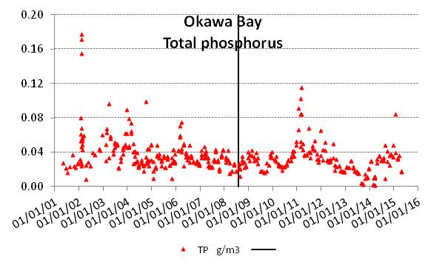
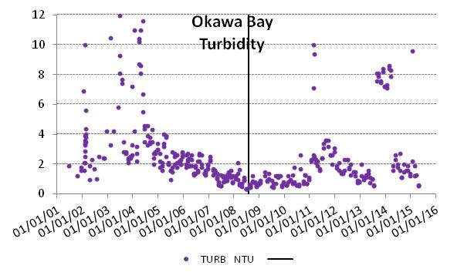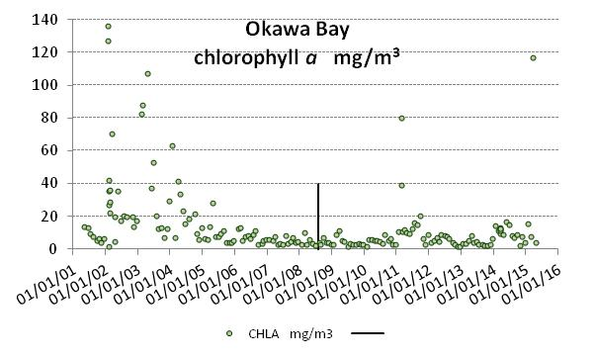
In February 2011 an aerial application of 5 tonne of Aqual P was added to Okawa Bay to prevent the further development of an algal bloom. In February 2014 a blue-green algal bloom occurred. The bay was dosed with 5 tonnes of alum (aluminium sulphate) and although the bloom persisted for several weeks it eventually subsided. Aquatic weed spraying preceded both this event and the previous one in 2011.

Lake Rotorua
In the graphs below, the Ohau Channel diversion wall is represented by a vertical line. The wall does not affect the quality of Lake Rotorua at all and the line merely shows the time of construction of the downstream wall.
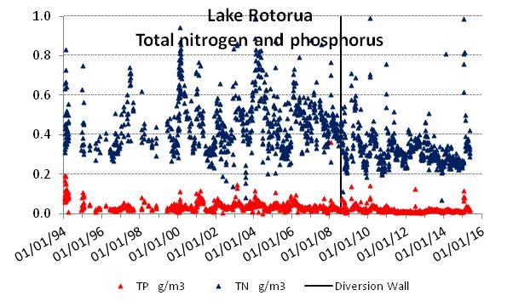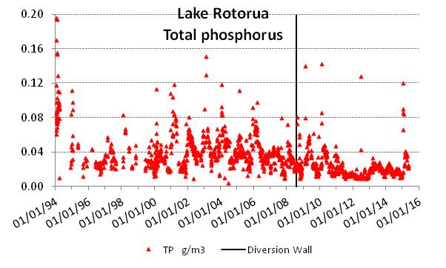
Lake Rotorua stratifies for short periods of days to a couple of weeks, usually in the summer, and the top and bottom waters temporarily become separate entities. Some of the high nitrogen and phosphorus concentrations will be from nutrients released from the bottom sediments into the bottom waters during these events, particularly if the oxygen content is reduced to a low level or zero. Once the wind energy is sufficient again to completely stir the lake, the separated layers mix and the released dissolved nutrients become available to promote algal growth.
Since 2012, the total phosphorus concentration for Lake Rotorua has been below or close to 0.02 g/m³, which is the long term chlorophyll a objective consistent with the TLI objective for the lake

The largest single action to remove nitrogen and phosphorus from Lake Rotorua was the diversion of treated sewage effluent in 1991, with a nett removal of 120 tonnes nitrogen and 30 tonnes phosphorus. Diversion of treated sewage effluent from Lake Rotorua to Whakarewarewa Forest in 1991 was predicted to take 20 years to be effective in reducing the phosphorus concentration in Lake Rotorua.
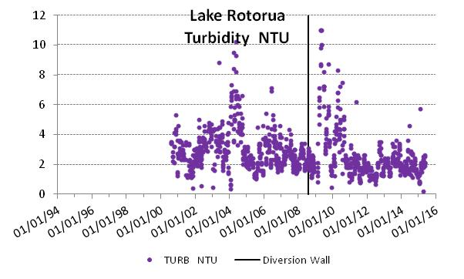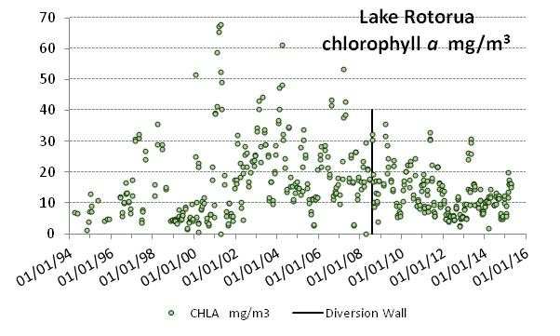
Nitrogen, phosphorus and chlorophyll a concentrations in Lake Rotorua have shown a general improvement over the past decade. Alum dosing has undoubtedly been effective in reducing the phosphorus concentration of the lake water. The other possibilities are sewerage reticulation since 2000, land use change, diversion of treated sewage effluent to Whakarewarewa Forest in 1991.
A long period of stratification from December 2014 through all of January 2015 resulted in a sediment nutrient release event in early February. The previous occasion when a stratification event occurred for a similar period was in 2010 when a similar nutrient release event is apparent from the sampling record.

Conclusion
The Ohau Diversion Wall has resulted in a continuing improvement in Lake Rotoiti with the input load of nitrogen and phosphorus restricted by excluding the majority of Ohau Channel water. Algal blooms have been absent from the main body of Lake Rotoiti since the wall construction. Decreasing amounts of phosphorus have been released from the bottom sediments of Lake Rotoiti since the diversion wall was constructed, but during the stratification period of 2014/15 a nutrient release event has occurred which has reversed that trend. This may have been caused by the same climatic conditions that resulted in the prolonged stratification event on Lake Rotorua.
Climate is cyclical and the sediment releases in Rotorua and Rotoiti in 2014/15 highlight that a long period of monitoring is required to draw firm conclusions as to trends in lake quality. In the past there have been large fluctuations in nutrient levels in Lakes Rotorua and Rotoiti. The prevailing climate played a part in those fluctuations and when large nutrient release events happen in succeeding years algal bloom conditions become more likely. With the remediation methods of the past decade including the diversion wall in place, the frequency of occurrence of any adverse events should be less than it has been in the past.
Algal blooms have been the sole adverse water quality effect emanating from Lakes Rotorua and Rotoiti that have had an impact on the Kaituna River since lake blooms were first recorded in the 1960s. The diversion wall has, so far, eliminated that effect from Lake Rotoiti. Blooms did not occur in Lake Rotorua in the summers of 2011/12, 2012/13, 2013/14 or 2014/15.
Construction of the Ohau Channel diversion wall increased the risk of blue-green algal blooms from Lake Rotorua flowing to the Okere Arm and the Kaituna River. Remediation of Lake Rotorua by reducing the nutrient load became urgent to prevent the health risk and wider environmental degradation that is caused by blue-green algal blooms. Alum dosing of two streams flowing into Lake Rotorua appears to have been effective in lowering the phosphorus concentration of Lake Rotorua, particularly since 2010. The effects of diversion of treated sewage effluent to irrigation in Whakarewarewa Forest may still be helping to reduce the nitrogen and phosphorus concentrations in Lake Rotorua as the internal load declines. The effect of all remedial actions has resulted in Lake Rotorua meeting its TLI target in 2011/12, 2012/13 and 2013/14. In 2012/13 and 2013/14, the quality of Lake Rotoiti was less than its TLI objective.
The diversion wall has not resulted in adverse effects on lake or river water quality but the need for long-term maintenance of low nitrogen and phosphorus concentrations in Lake Rotorua to manage algal blooms (objective 12 of the Water and Land Plan) still exists.

